NW Dashboard User Manual

Owner: Nationwide EY Team

Created on: 07/12/22

Version: 0.2

# Version history

|  |  |  |
| --- | --- | --- |
| **Version** | **Updated by** | **Changes** |
| 0.1 | Sreedev Sreedharan | Vacation tracker manual |
| 0.2 | Sreedev Sreedharan | UI changes |

Contents

1. Dashboard functionalities 4

1.1 Marking vacations/leaves on tracker 4

2. Glossary 7

# Dashboard functionalities

# Marking vacations/leaves on tracker

1. Visit the dashboard in the URL mentioned in Glossary index 1.
2. Login using the credentials provided by your lead
3. Click the submission menu on top and click track vacation link

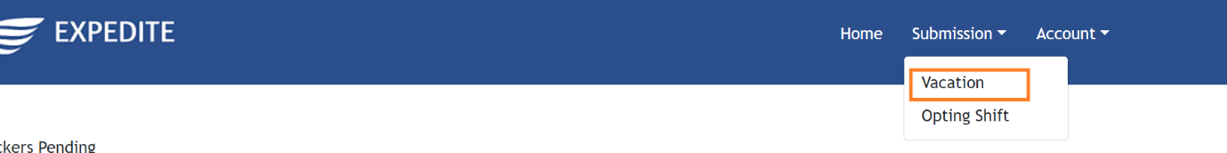

1. Search your name from the employee drop down

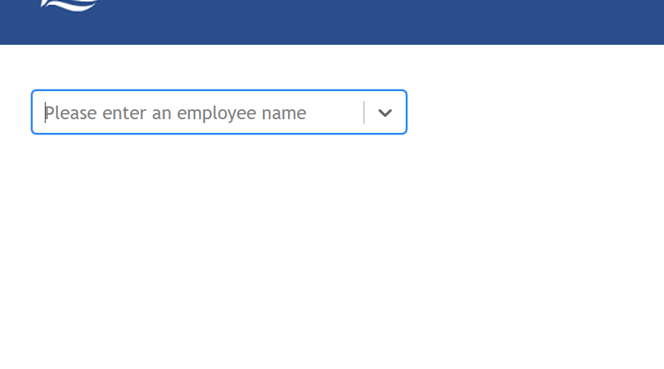

1. Click the date selection area mentioned in the screenshot below

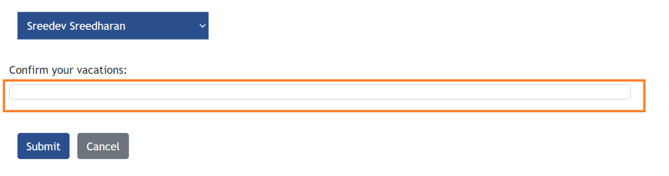

1. Select your vacations from date picker. And post addition, click on confirm button

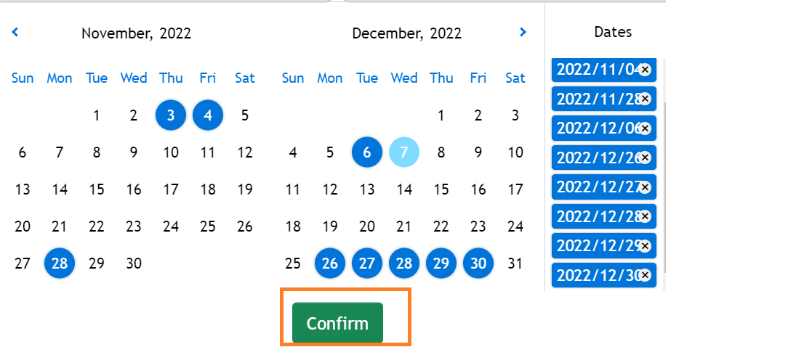

1. Click on the submit button after selecting your dates

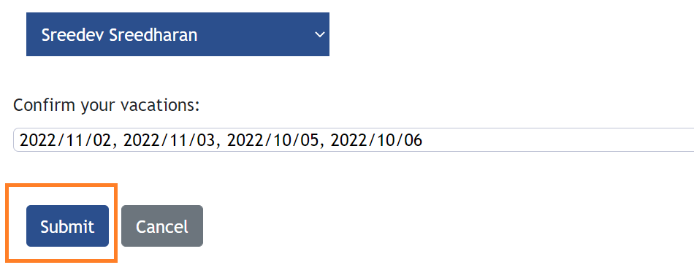

1. Mark the planned leave and full day by toggling the buttons for each date

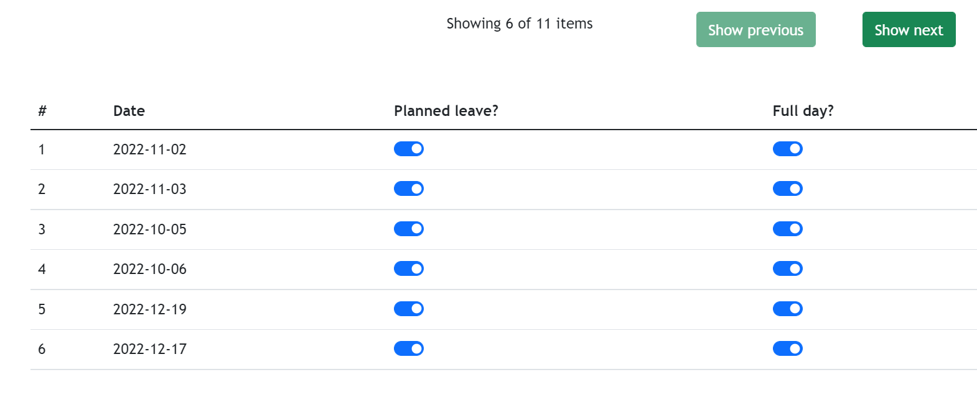

1. To see all the date, you have entered press show next button on the screen
2. Press confirm once all the type of leaves are entered

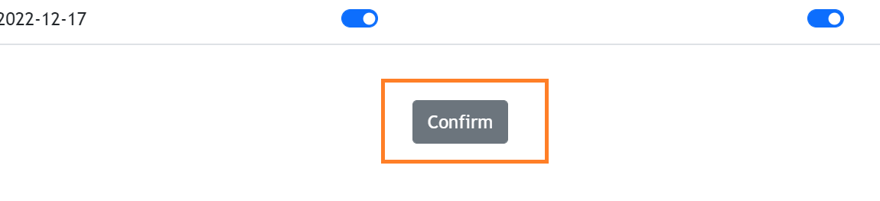

1. Ensure that you see below pop up once confirmed

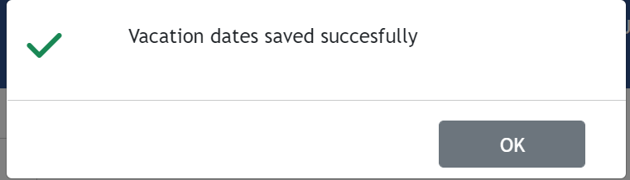

# Glossary

|  |  |
| --- | --- |
| Index | Item |
| 1 | <http://20.57.169.180:3030/> |