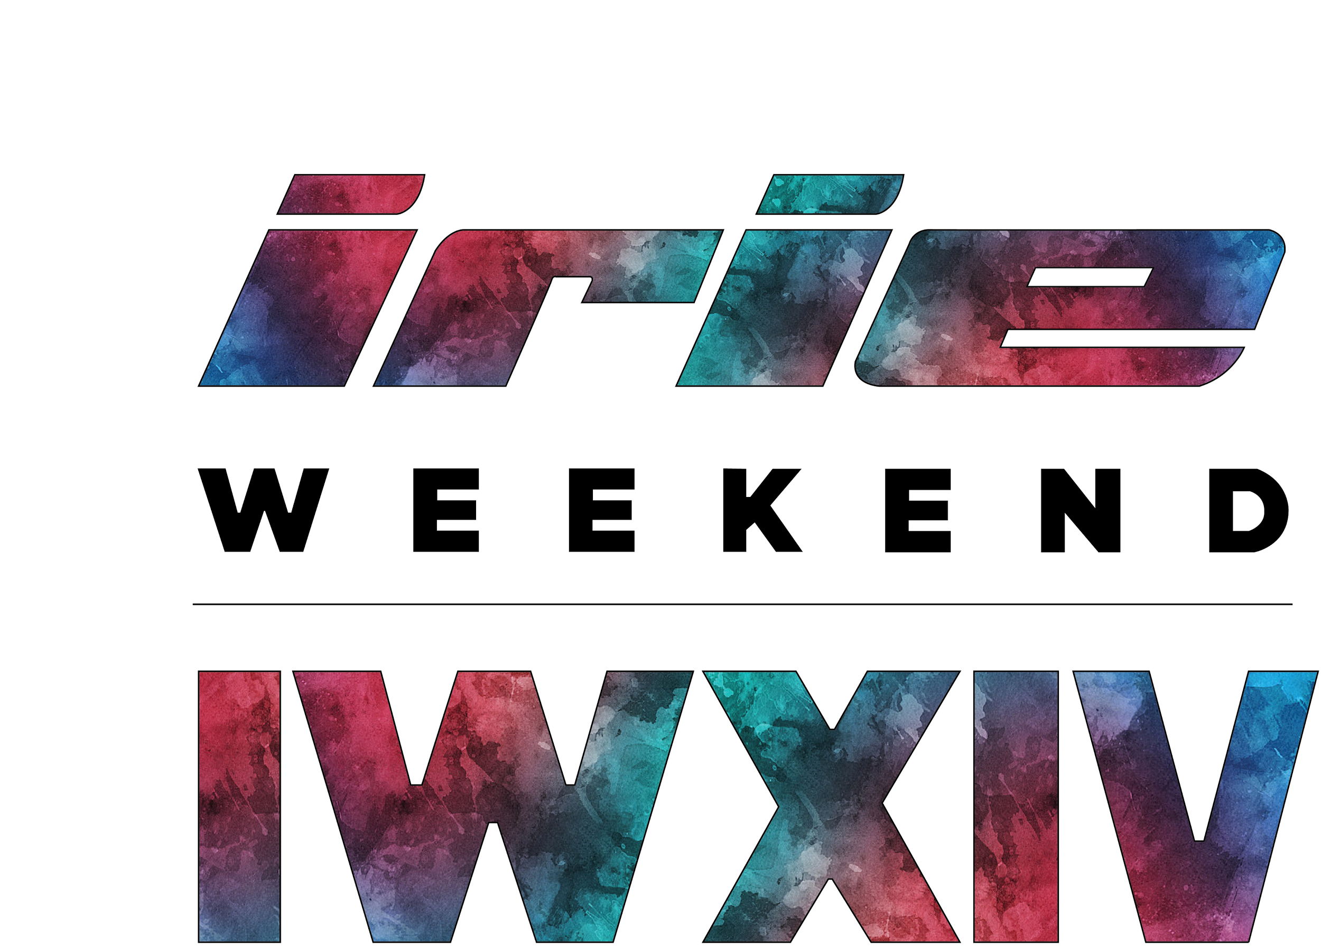

**TEMPO KIDS CARNIVAL PROCEEDS SURPASS EXPECTATIONS**

The 14th Annual Irie Weekend was a tremendous success. One new main event featured at Irie Weekend was the Tempo Kids Carnival held at Bayfront Park. The rides, celebrities and music fascinated the attendees, but the astounding donations for Irie Foundation really stole the show.

Based off of the donations raised at this event we are able to provide funding for Irie Foundation programs such as the Cultural Passport Program, Impact Scholarship Fund, My Life Mentoring and Irie Rhythms Academy. These programs have such a large impact on children in the local South Florida community and without these donation these programs would not be possible.

“I had so much fun at the Tempo Kids Carnival riding the carnival rides, playing the carnival games and listening to the music performance,” said 14-year-old Gabriel, an eighth grade student attending public school in Downtown Miami. “I would have never been able to experience this event without being a part of Irie Foundation.”

The Irie Foundation is an organization that works to benefit at-risk youth in South Florida. Through a number of proactive initiatives, we are committed to helping kids get on the right track and strive for successful futures. DJ Irie hopes that with this exposure, the students will develop a newfound sense of determination and strength, in order to persevere and work towards achieving a higher quality of life in their future.