Luma
Methodology, DSM-5 signal mapping and intervention design
Briefing document for the clinical review meeting
Project: Webcam-based distraction detection with adaptive interventions in an ADHD-friendly learning platform (undergraduate research project, IRP)
Prepared by: Kalhara
Meeting date: ____________________
Intended learners: students with ADHD (the platform is currently designed for roughly 14–18 years; to be confirmed with you)

Status of the work (please read first)
Luma estimates whether a learner's visible attention has left the lesson and responds with supportive prompts. It does not diagnose ADHD and is not a clinical tool. DSM-5 criteria are used only to choose which classroom behaviours are worth observing.
The interventions are informed by related educational research. Their suitability is what we are asking you to review, and their effectiveness in this platform has not yet been established.

Contents
1. Purpose of this meeting 3
2. Research methodology 3
2.1 Privacy and consent built into the method 4
3. Identifying distraction: the DSM-5 symptom mapping 4
3.1 Why DSM-5, and how it is used 4
3.2 The mapping table 5
3.3 What Luma measures today 6
3.4 Research behind each link 6
4. How the system decides whether the learner is distracted 7
4.1 Step by step 8
4.2 How reliable the decision is today 9
5. How the interventions happen, one by one 9
5.1 The rules in plain words 10
5.2 What a learner actually experiences 11
5.3 Each intervention and its research basis 12
5.4 Overall position 13
6. Questions for you 13
References 13

1. Purpose of this meeting
This document explains how Luma works from start to finish, so that you can judge whether its assumptions about attention in ADHD are reasonable. It covers four things:
- The research methodology: how the project was planned and built (Section 2).
- The DSM-5 symptom mapping: how the DSM-5 inattention criteria were turned into behaviours a computer could observe, and which of these Luma measures today (Section 3).
- How Luma decides whether a learner is focused or distracted at a given moment (Section 4).
- How the interventions happen, one after another, once distraction is detected, and the research behind each (Section 5).
Section 6 lists the questions we would most value your opinion on. References are at the end.

2. Research methodology
The project follows a design-science approach: a working system (the artefact) is designed to address a real problem, then evaluated and improved through feedback. The steps are shown in Figure 1.
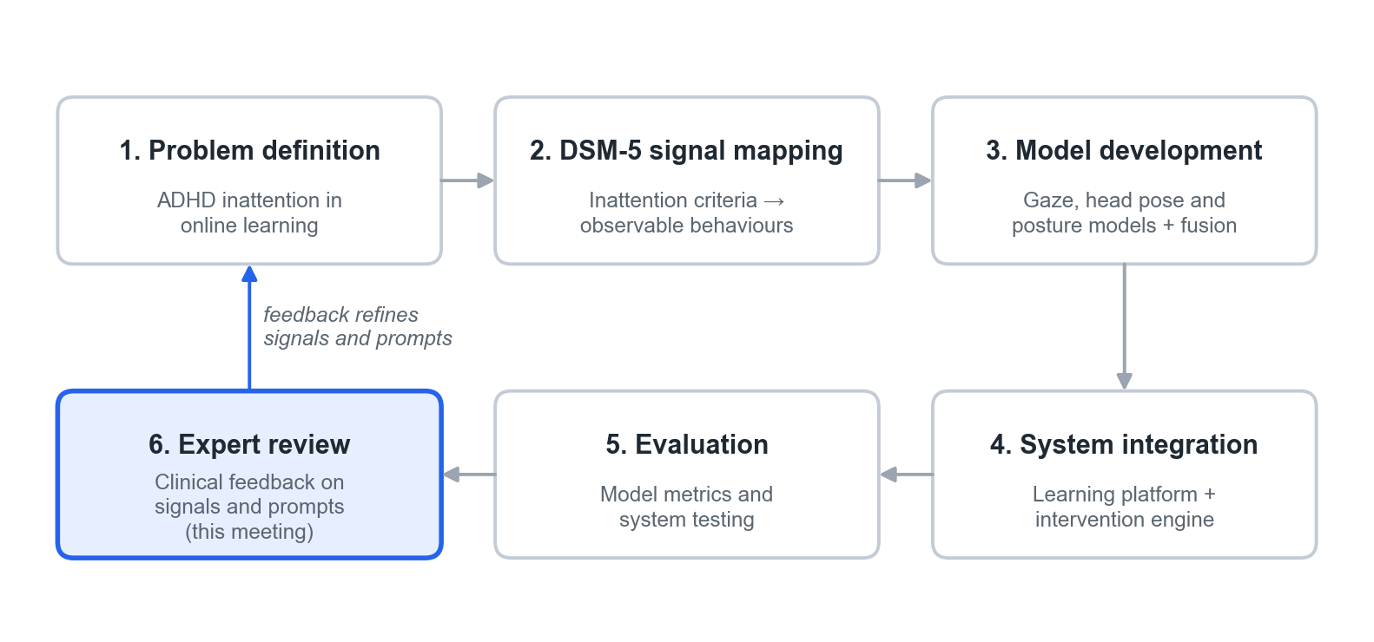
Figure 1. Research methodology. This meeting is step 6; its feedback feeds back into steps 1–4.
Step | What was done
1. Problem definition | Learners with ADHD often lose attention during self-paced online lessons, and nobody is present to notice. The aim is to notice drift early and offer gentle, supportive help.
2. DSM-5 signal mapping | The nine DSM-5 inattention criteria were reviewed and each was linked to a behaviour that can be seen in a classroom and, in principle, measured by a learning platform (Section 3).
3. Model development | Because no public dataset of distracted learners exists, the problem was split into three smaller models, each trained on a suitable public dataset: eye-gaze direction (MPIIGaze), head orientation (BIWI Kinect Head Pose), and upper-body posture (MediaPipe landmarks). A fourth, simple “fusion” model combines them into one decision; it was trained on webcam recordings made for this study.
4. System integration | The models were built into a full web learning platform (lessons, quizzes, teacher and admin tools) with an intervention engine that chooses a prompt when distraction lasts long enough.
5. Evaluation | Each model was tested on people it had not seen during training. The whole platform was tested with automated tests and scripted scenarios.
6. Expert review | Clinical review of the signals and prompts (this meeting), before any study with learners.

2.1 Privacy and consent built into the method
- Monitoring cannot start unless a guardian's consent is recorded. The learner is also asked for their own agreement during onboarding.
- One small, low-resolution webcam image is analysed every 2 seconds and then discarded. No video is stored; only the result (focused, distracted or unknown) and timings are saved.
- If a microphone is allowed, only a single loudness number is computed on the learner's own device. No audio is recorded or sent.
- An indicator is always visible when the camera is active. Detections lead only to supportive prompts, never to marks or penalties.

3. Identifying distraction: the DSM-5 symptom mapping

3.1 Why DSM-5, and how it is used
The DSM-5 (American Psychiatric Association, 2013; text revision 2022) lists nine symptoms of inattention, labelled (a) to (i). A diagnosis needs at least six of them (five from age 17), lasting at least six months, present in two or more settings, with several present before age 12, and clearly affecting functioning. Diagnosis is a clinical judgement.
Luma uses the criteria for a narrower purpose: to decide which observable behaviours are worth measuring during a lesson. Each criterion was linked to a behaviour a teacher could see in a classroom, then to a signal a learning platform could record, and finally to a simple starting threshold. A signal crossing its threshold is treated as a moment-to-moment sign of possible inattention, not as a symptom in the diagnostic sense. Luma never counts symptoms or labels a learner.
Two of the nine criteria were left out because a learning platform cannot observe them: (e) difficulty organising tasks and (g) losing things needed for tasks.

3.2 The mapping table
The first four columns are the mapping we designed. The last two columns add what Luma actually measures today and the research that supports linking each criterion to the behaviour.
DSM-5 inattention criterion | Classroom behaviour you can observe | System signal that can be captured | Simple starting threshold | Status in Luma today | Supporting references
(b) Difficulty sustaining attention in tasks | Long pauses mid-task | Idle time (no clicks, keys or touches) | Idle ≥ 8–10 s (younger) or ≥ 12–15 s (older) | Not yet built | APA (2013); Kofler et al. (2008); Kofler et al. (2013); Beck (2005)
(h) Easily distracted by extraneous stimuli | Looking away; reacting to noises | Gaze or head turned away from the screen (webcam, opt-in). Separately: sustained room noise (microphone) | Gaze off target ≥ 2–3 s, or > 5 times in 1 min | Live. Webcam: first prompt after 5 s of continuous distraction. Noise: one notice per session after ~8 s of loud noise | APA (2013); Kofler et al. (2008); Hutt et al. (2019); D'Mello et al. (2012); Söderlund et al. (2007)
(d) Does not follow through; fails to finish | Starts but does not complete modules | Incomplete items or abandoned steps | ≥ 2 abandons in a 10-min block | Not yet built | APA (2013); Loe & Feldman (2007); Frazier et al. (2007)
(a) Careless mistakes | Errors on material already known | Error streaks at an easy level | ≥ 3 wrong in a row below the learner's usual difficulty | Not yet built (quiz answers are stored, but streaks are not analysed) | APA (2013); Kofler et al. (2013); Frazier et al. (2007)
(c) Does not seem to listen when spoken to directly | Misses simple spoken or written prompts | Prompt repeats or help requests | ≥ 2 repeats of the same prompt | Not yet built | APA (2013); Martinussen et al. (2005); Kasper et al. (2012); Aleven et al. (2016)
(f) Avoids or dislikes sustained mental effort | Skips or scrolls rapidly through content | Rapid skipping | > 3 screens or items skipped within 60 s | Not yet built | APA (2013); Sonuga-Barke (2003); Baker et al. (2004); Beck (2005)
(i) Forgetful in daily activities | Forgets steps just learned | Re-teaching needed within a session | Same hint viewed ≥ 2 times within 3 min | Not yet built | APA (2013); Martinussen et al. (2005); Kasper et al. (2012)

About the thresholds
The thresholds are design starting points chosen by us, not values taken from research. No study we found gives a validated number of seconds or errors for these behaviours in learners with ADHD. They are meant to be calibrated with pilot data and with your advice, for example on how they should differ by age.

3.3 What Luma measures today
Figure 2 shows which signals are live. Only the “easily distracted” criterion (h) is implemented, through two channels: the webcam, which estimates whether gaze and head are turned away from the screen, and the microphone loudness check, which notices a persistently noisy room. The other five signals are planned extensions; the platform does not yet record idle time, abandoned items, error streaks, repeated prompts, skipping, or repeated hint views.
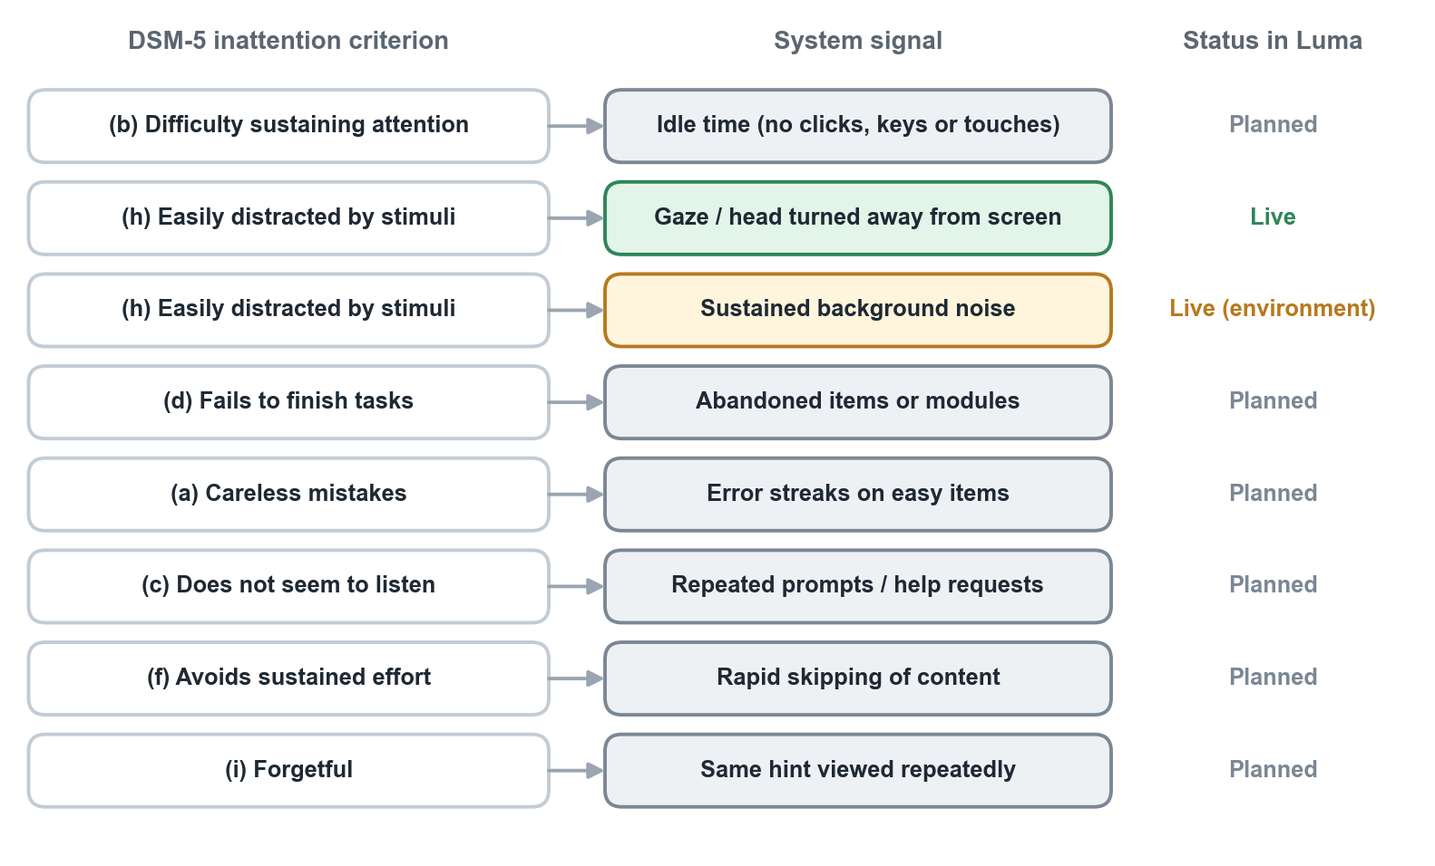
Figure 2. Coverage of the DSM-5 mapping in the current system.
The live webcam rule also differs slightly from the table. The table proposes “gaze off target for 2–3 seconds”. Luma averages its estimate over about 6 seconds to avoid reacting to blinks and quick glances, and only shows a first prompt once distraction has lasted 5 seconds or more without a break (Section 4).
The noise notice is about the environment, not the learner. Loudness cannot tell whether the learner is reacting to the noise, so the notice only describes the room and offers choices (headphones, a quieter place, or continue). It never escalates to stronger prompts.

3.4 Research behind each link
(b) Sustaining attention → idle time. In classroom observation studies, children with ADHD are off task noticeably more often than their peers (Kofler et al., 2008). Lab studies show more frequent brief lapses, seen as unusually slow responses scattered among normal ones (Kofler et al., 2013). In tutoring software, long gaps without any input are a standard sign of disengagement (Beck, 2005).
(h) Distracted by stimuli → gaze away, room noise. Looking away from the work is the most common off-task behaviour coded in ADHD classroom studies (Kofler et al., 2008). Eye-tracking systems can detect mind wandering in classrooms from gaze alone (Hutt et al., 2019), and gaze-reactive tutors use looking away as their trigger (D'Mello et al., 2012). For noise, the evidence is mixed: moderate white noise improved some cognitive performance in children with ADHD (Söderlund et al., 2007). This is one reason the noise notice offers choices rather than assuming noise is harmful.
(d) Fails to finish → abandoned items. ADHD is consistently associated with lower academic achievement and poorer work completion (Loe & Feldman, 2007; Frazier et al., 2007).
(a) Careless mistakes → error streaks on easy items. Errors on material a learner already knows are more likely to reflect a lapse than a gap in knowledge; attention lapses are linked to performance errors (Kofler et al., 2013). Achievement studies document the academic cost (Frazier et al., 2007).
(c) Does not seem to listen → repeated prompts. Working-memory difficulties are well documented in ADHD (Martinussen et al., 2005; Kasper et al., 2012), which makes instructions easy to lose. Help-seeking patterns in tutoring software are an established signal (Aleven et al., 2016). Note that DSM-5 (c) concerns being spoken to directly, so this is an on-screen analogue rather than the same behaviour.
(f) Avoids sustained effort → rapid skipping. Delay aversion, a preference to escape tasks that demand waiting or sustained effort, is one of the main explanatory models of ADHD (Sonuga-Barke, 2003). In tutoring software, rapid clicking through content without reading is a recognised disengaged behaviour (Baker et al., 2004; Beck, 2005).
(i) Forgetful → same hint viewed again. This also rests on working-memory research (Martinussen et al., 2005; Kasper et al., 2012). DSM-5 (i) refers to daily activities such as chores and errands, so an in-lesson measure is only an approximate analogue.

4. How the system decides whether the learner is distracted
While a monitored lesson is open, the learner's browser sends one webcam image to the server every 2 seconds. Each image goes through the steps in Figure 3 and produces one of three results: FOCUSED, DISTRACTED or UNKNOWN.
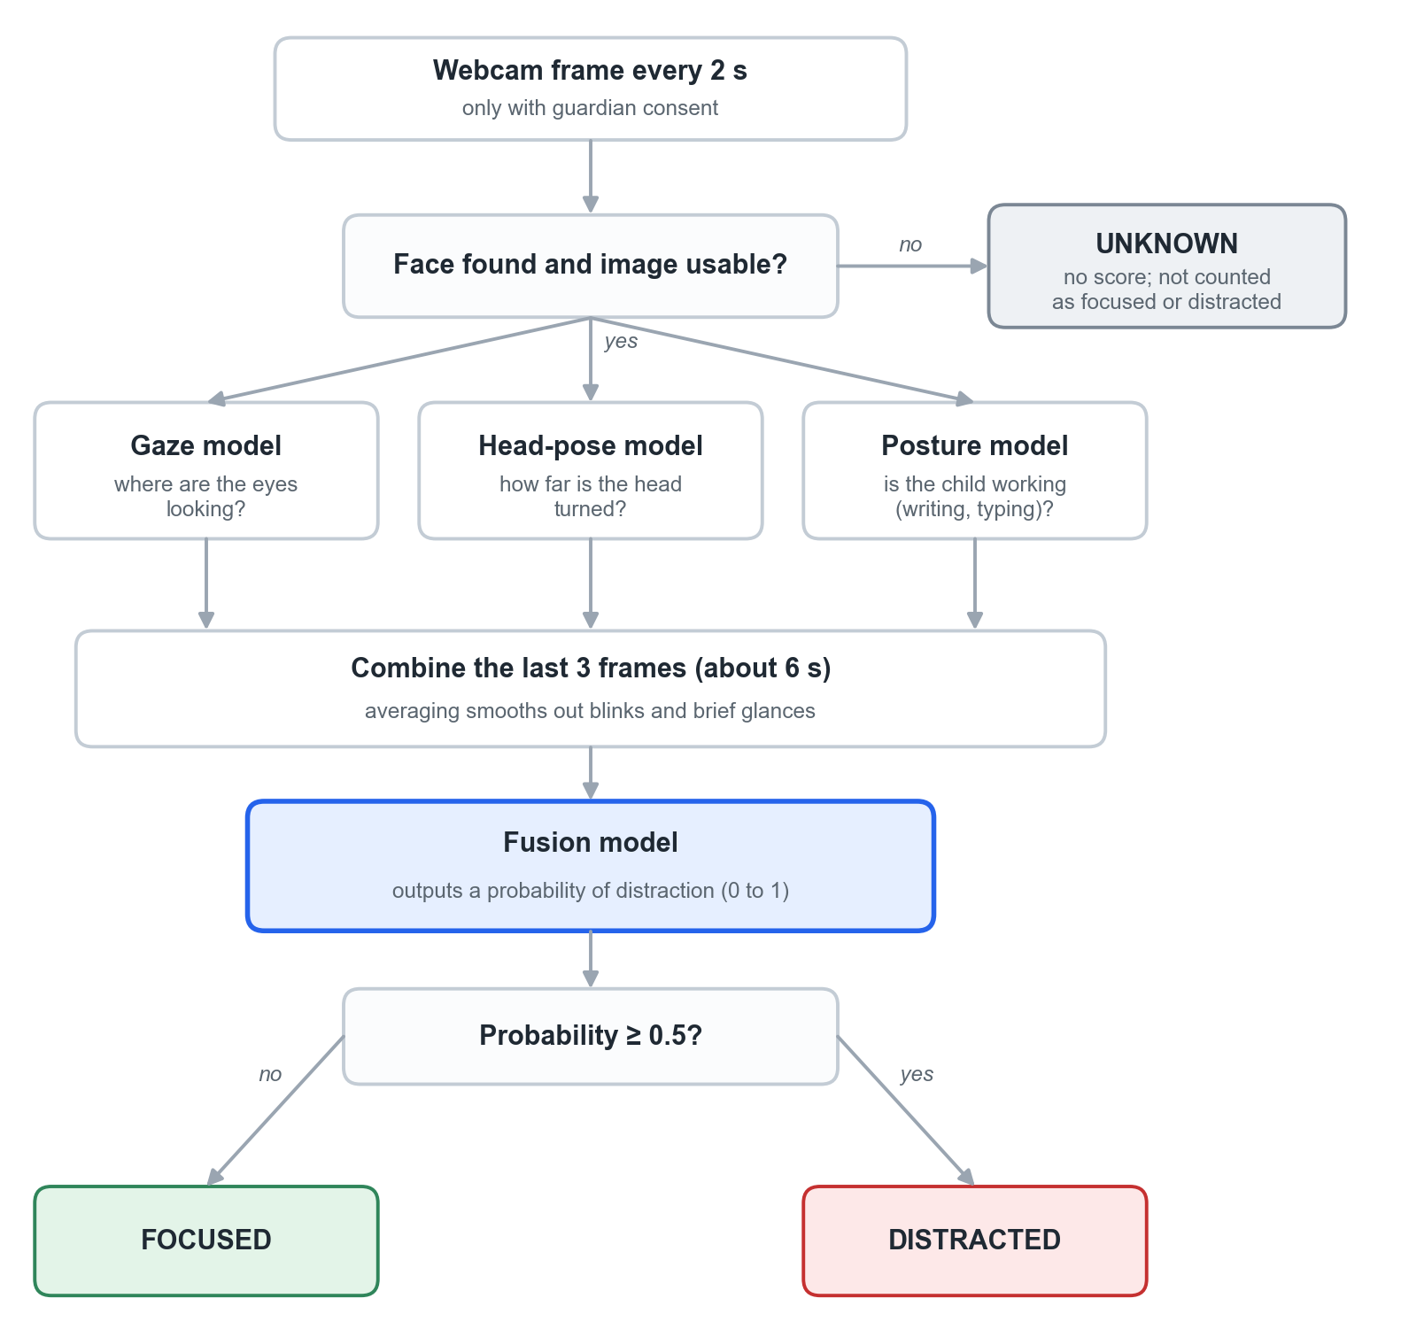
Figure 3. How one webcam image becomes a verdict.

4.1 Step by step
- Is the image usable? If no face is found (the learner has left, or the camera is covered or badly lit), the result is UNKNOWN. UNKNOWN is never counted as distraction and never triggers a prompt. It simply means the system cannot tell.
- Three questions are asked of the image. The gaze model estimates whether the eyes point at the centre of the screen, left, right or down. The head-pose model estimates how far the head is turned or tilted. The posture model estimates whether the hands and upper body look like active work (writing or typing), so that looking down at a notebook is not automatically treated as distraction.
- Short-term smoothing. The answers from the last three images (about 6 seconds) are averaged, so a blink or a quick glance does not change the result.
- One combined decision. A small, transparent statistical model (logistic regression) turns these values into a probability of distraction between 0 and 1. If it is 0.5 or above, the result is DISTRACTED; otherwise FOCUSED. A personal baseline taken at the start accounts for differences in camera position and posture.
- From moments to episodes. Luma does not react to single results. A run of DISTRACTED results forms a distraction episode with a start time and a length. A FOCUSED result ends the episode (the learner is counted as having returned). An UNKNOWN result also ends it, but is not counted as a return. Interventions depend on how long the current episode has lasted (Figure 4).
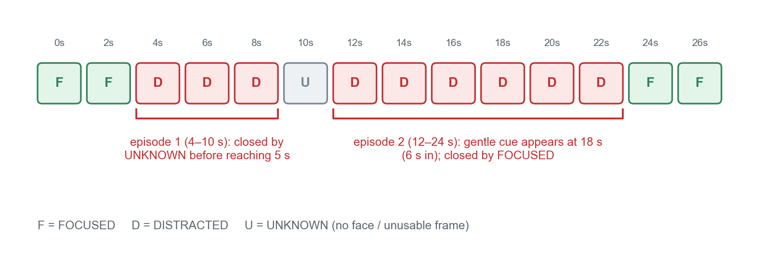
Figure 4. Example of how 2-second results form distraction episodes.

4.2 How reliable the decision is today
Current accuracy (honest summary)
The combined model was trained on webcam recordings of one participant in one setting. Tested on a recording it had not seen, it separated focused from distracted moments moderately well (ROC-AUC ≈ 0.77) but its overall correctness is modest (F1 ≈ 0.54). In practice this means some prompts will appear while the learner is actually attending, and some real drift will be missed.
The webcam can only estimate that the learner is not visibly looking at the lesson. It cannot tell why: boredom, confusion, tiredness, taking notes, a noise, or a model error all look the same. Retraining on recordings of more participants is planned.

5. How the interventions happen, one by one
Each time a new result arrives (every 2 seconds), the intervention engine goes through the checks in Figure 5. The idea is to start with the gentlest prompt and only become more interruptive if distraction continues.
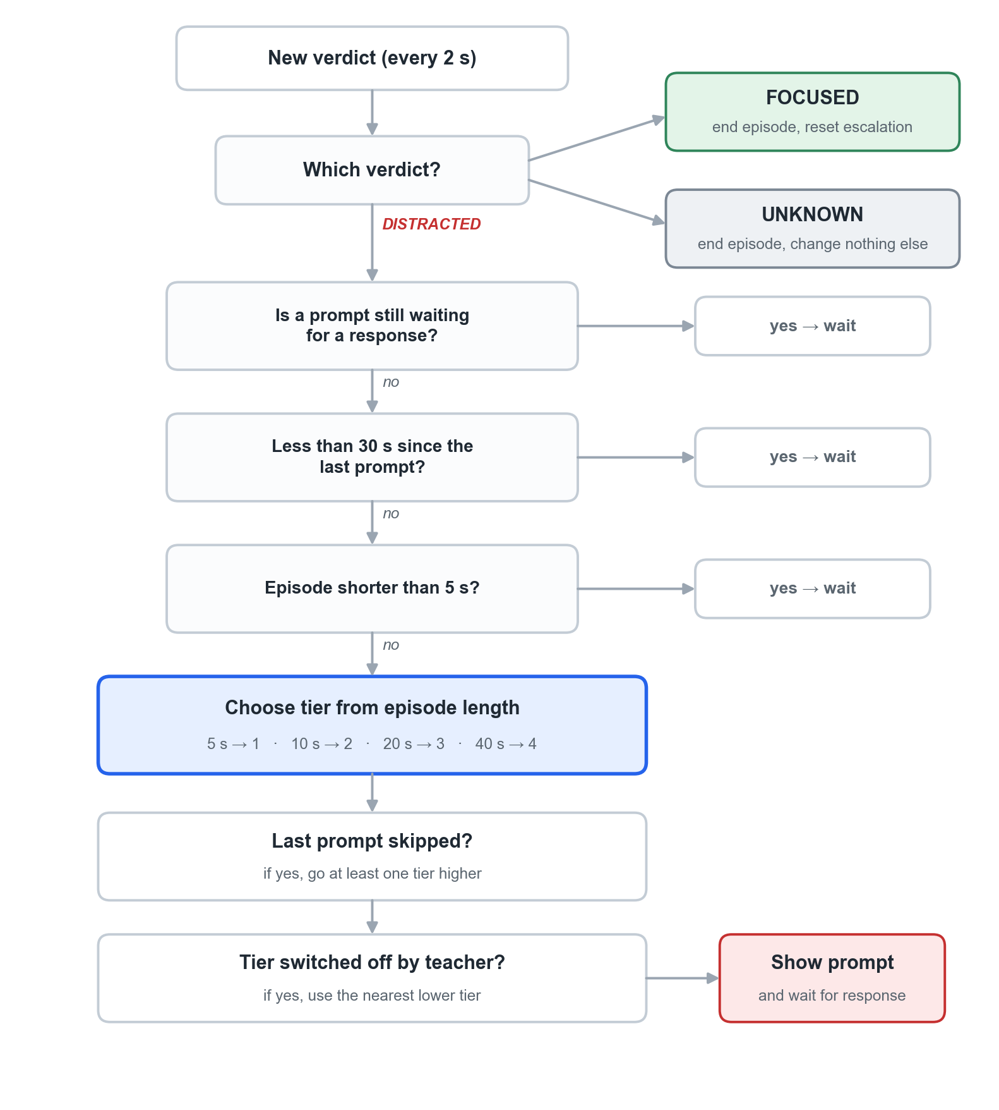
Figure 5. The checks made on every 2-second result.

5.1 The rules in plain words
- Short glances are ignored. Nothing happens until an episode has lasted 5 seconds.
- The longer the episode, the stronger the prompt: 5 s → gentle cue, 10 s → pacing pause, 20 s → brief quiz (or a hint during a quiz), 40 s → slow-down, and on later occasions a suggested break.
- One prompt at a time. No new prompt appears while one is still waiting for a response.
- At least 30 seconds between prompts (an administrator can change this).
- Skipping moves up a level. If the learner presses Skip or Dismiss, the next prompt is at least one level stronger.
- Returning resets everything. As soon as the learner is judged FOCUSED, the ladder starts again from the bottom.
- Teachers can switch levels off for their subject; a switched-off level falls back to the nearest gentler one.
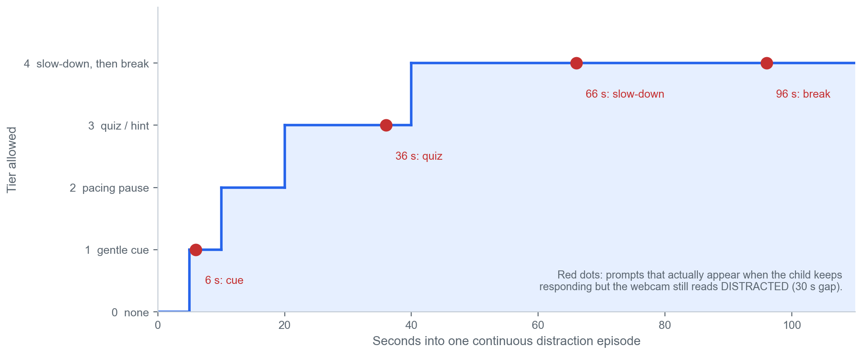
Figure 6. The escalation ladder during one continuous distraction episode, and the prompts that actually appear.

5.2 What a learner actually experiences
Because of the 30-second gap, one long, unbroken episode produces this sequence (red dots in Figure 6): gentle cue at about 6 s → brief quiz at about 36 s → slow-down at about 66 s → break at about 96 s, with further breaks possible every 30 seconds or so. Three consequences matter for your review:
- The pacing pause is rarely reached, because by the time the second prompt is allowed the episode is already past 20 seconds.
- Escalation follows elapsed time, not the learner's response. Pressing “I'm here” does not prevent a stronger prompt if the webcam still reads distraction.
- A learner who never touches the first banner receives no further prompts in that episode, while one who responds to every prompt moves up fastest.

5.3 Each intervention and its research basis
Intervention | What the learner sees | When it appears | Intended purpose | Related research | Where Luma differs from the research
Tier 1. Gentle cue | A small banner at the top: “Let's refocus together!” with an “I'm here” button. The video keeps playing. | Episode ≥ 5 s (≈ 6 s in practice) | Gives the learner a chance to notice that attention has drifted and return to the task (self-monitoring). | Rafferty et al. (2011); Wills & Mason (2014); Harris et al. (2005); Reid et al. (2005); D'Mello et al. (2012); Hutt et al. (2021) | The ADHD studies trained children to self-monitor and asked “Was I on task?” (yes/no) on a schedule. Luma only asks for an acknowledgement.
Tier 2. Pacing pause | Video pauses. “Quick check-in”, with three faces: 😀 Going well, 😐 Okay, 😩 Tough, and “Skip for now”. | Episode 10–20 s old when a prompt is allowed (rare in practice) | Gives time to catch up and choose when to continue. | Mayer & Chandler (2001); Rey et al. (2019); counter-evidence: Szpunar et al. (2013) | Studies split lessons at meaningful points; Luma pauses wherever drift is detected. The face chosen is not yet used.
Tier 3. Brief quiz | Video pauses. One multiple-choice question from the teacher's checkpoint questions, optional hint, gentle feedback either way. | Episode ≥ 20 s (≈ 36 s in practice) | Restores active involvement with the lesson: retrieving an answer is an active task. | Szpunar et al. (2013); Roediger et al. (2011); Knouse et al. (2016); Hutt et al. (2021) | Best-supported prompt, but research used questions about the part just studied. Luma currently uses the module's first checkpoint question each time.
Tier 3 in a quiz. Hint | Panel on the quiz page: “A hint for this question… Skim the heading and first sentence of the current section.” | Same timing, during a quiz | Content support when understanding may have been disrupted. | Mills et al. (2021); Aleven et al. (2016) | The hint is generic and triggered by looking away, not by any sign of difficulty.
Tier 4 (first). Slow-down | Video pauses. “Let's slow down a little”; video continues at 75% speed. | Episode ≥ 40 s (≈ 66 s), once per session | More processing time. | No direct support found. Caution: Zentall (1975); Murphy et al. (2022) | Weakest-supported prompt. Speed is reduced before the learner chooses and stays reduced for that video.
Tier 4 (later). Suggested break | “Stretch & breathe”: a 60-second breathing circle, then “Ready to continue”. | Next tier-4 moment (≈ 96 s), may repeat | A short rest to reset. | Pontifex et al. (2013); Mahar et al. (2006); Ariga & Lleras (2011) | Studies used 10–20 minutes of physical activity. A 60-second seated breathing break is untested.
Separate. Noise notice | Video pauses. “It's quite noisy around you”: headphones, move somewhere quieter, or continue anyway. | Room ≥ 12 dB louder than its starting level for ~8 s; once per session | Gives the learner control over the environment. | No direct study; see Söderlund et al. (2007) for why noise is not assumed harmful | Never escalates and never affects the webcam prompts.

5.4 Overall position
Summary of the evidence
The research supports three general mechanisms: helping a learner notice a lapse (self-monitoring studies, including children with ADHD), restoring active involvement with content (retrieval practice), and giving relevant support when understanding may have been disrupted (attention-aware tutoring). Attention-aware tutors that detect drift and respond have worked in classrooms (Hutt et al., 2021; Mills et al., 2021).
These results do not automatically transfer to Luma's webcam model, age group or ADHD population. The specific timings (5/10/20/40 s, 30 s gap) and the order of prompts are engineering choices with no direct research support; the closest classroom system used a 90-second minimum gap and about one prompt per session.

6. Questions for you
- DSM-5 mapping. Are the classroom behaviours and system signals in Section 3 reasonable proxies for each criterion? Are any misleading, especially (c) and (i)? Should any planned signal be built first?
- Thresholds. Are the starting thresholds sensible, and how should they differ by age? Is 5 seconds of continuous looking away a reasonable point for a first prompt?
- Mechanisms. For this age group, are the reasons each prompt might help plausible? Do any rest on a wrong assumption about ADHD?
- Interruption and wording. Is pausing the lesson acceptable, and for which prompts? Is the wording appropriate, given that the webcam may be wrong?
- Harm. When could a cue, question, hint, slow-down or break make things worse (frustration, anxiety, loss of momentum, reacting to a false alarm)?
- Choice. Should the learner be able to say “I was paying attention”, “I'm confused” or “I need a break”, with the next step depending on the answer?
- Escalation. Should prompts escalate with time at all? If so, what spacing between prompts would you consider acceptable?
- Outcomes. What would you accept as meaningful evidence that a learner has re-engaged: a click, the webcam reading focused again, the learner resuming the lesson themselves, or a correct answer afterwards?

References
Aleven, V., Roll, I., McLaren, B. M., & Koedinger, K. R. (2016). Help helps, but only so much: Research on help seeking with intelligent tutoring systems. International Journal of Artificial Intelligence in Education, 26(1), 205–223. https://doi.org/10.1007/s40593-015-0089-1
American Psychiatric Association. (2013). Diagnostic and statistical manual of mental disorders (5th ed.). https://doi.org/10.1176/appi.books.9780890425596
American Psychiatric Association. (2022). Diagnostic and statistical manual of mental disorders (5th ed., text rev.). https://doi.org/10.1176/appi.books.9780890425787
Ariga, A., & Lleras, A. (2011). Brief and rare mental “breaks” keep you focused: Deactivation and reactivation of task goals preempt vigilance decrements. Cognition, 118(3), 439–443. https://doi.org/10.1016/j.cognition.2010.12.007
Baker, R. S., Corbett, A. T., Koedinger, K. R., & Wagner, A. Z. (2004). Off-task behavior in the cognitive tutor classroom: When students “game the system”. In Proceedings of the SIGCHI Conference on Human Factors in Computing Systems (pp. 383–390). https://doi.org/10.1145/985692.985741
Beck, J. E. (2005). Engagement tracing: Using response times to model student disengagement. In Proceedings of the 12th International Conference on Artificial Intelligence in Education (pp. 88–95). IOS Press.
D'Mello, S., Olney, A., Williams, C., & Hays, P. (2012). Gaze tutor: A gaze-reactive intelligent tutoring system. International Journal of Human-Computer Studies, 70(5), 377–398. https://doi.org/10.1016/j.ijhcs.2012.01.004
Frazier, T. W., Youngstrom, E. A., Glutting, J. J., & Watkins, M. W. (2007). ADHD and achievement: Meta-analysis of the child, adolescent, and adult literatures and a concomitant study with college students. Journal of Learning Disabilities, 40(1), 49–65. https://doi.org/10.1177/00222194070400010401
Harris, K. R., Friedlander, B. D., Saddler, B., Frizzelle, R., & Graham, S. (2005). Self-monitoring of attention versus self-monitoring of academic performance: Effects among students with ADHD in the general education classroom. The Journal of Special Education, 39(3), 145–156. https://doi.org/10.1177/00224669050390030201
Hutt, S., Krasich, K., Brockmole, J. R., & D'Mello, S. K. (2021). Breaking out of the lab: Mitigating mind wandering with gaze-based attention-aware technology in classrooms. In Proceedings of the 2021 CHI Conference on Human Factors in Computing Systems (Article 52). https://doi.org/10.1145/3411764.3445269
Hutt, S., Krasich, K., Mills, C., Bosch, N., White, S., Brockmole, J. R., & D'Mello, S. K. (2019). Automated gaze-based mind wandering detection during computerized learning in classrooms. User Modeling and User-Adapted Interaction, 29(4), 821–867. https://doi.org/10.1007/s11257-019-09228-5
Kasper, L. J., Alderson, R. M., & Hudec, K. L. (2012). Moderators of working memory deficits in children with attention-deficit/hyperactivity disorder (ADHD): A meta-analytic review. Clinical Psychology Review, 32(7), 605–617. https://doi.org/10.1016/j.cpr.2012.07.001
Knouse, L. E., Rawson, K. A., Vaughn, K. E., & Dunlosky, J. (2016). Does testing improve learning for college students with attention-deficit/hyperactivity disorder? Clinical Psychological Science, 4(1), 136–143. https://doi.org/10.1177/2167702614565175
Kofler, M. J., Rapport, M. D., & Alderson, R. M. (2008). Quantifying ADHD classroom inattentiveness, its moderators, and variability: A meta-analytic review. Journal of Child Psychology and Psychiatry, 49(1), 59–69. https://doi.org/10.1111/j.1469-7610.2007.01809.x
Kofler, M. J., Rapport, M. D., Sarver, D. E., Raiker, J. S., Orban, S. A., Friedman, L. M., & Kolomeyer, E. G. (2013). Reaction time variability in ADHD: A meta-analytic review of 319 studies. Clinical Psychology Review, 33(6), 795–811. https://doi.org/10.1016/j.cpr.2013.06.001
Loe, I. M., & Feldman, H. M. (2007). Academic and educational outcomes of children with ADHD. Journal of Pediatric Psychology, 32(6), 643–654. https://doi.org/10.1093/jpepsy/jsl054
Mahar, M. T., Murphy, S. K., Rowe, D. A., Golden, J., Shields, A. T., & Raedeke, T. D. (2006). Effects of a classroom-based program on physical activity and on-task behavior. Medicine & Science in Sports & Exercise, 38(12), 2086–2094. https://doi.org/10.1249/01.mss.0000235359.16685.a3
Martinussen, R., Hayden, J., Hogg-Johnson, S., & Tannock, R. (2005). A meta-analysis of working memory impairments in children with attention-deficit/hyperactivity disorder. Journal of the American Academy of Child & Adolescent Psychiatry, 44(4), 377–384. https://doi.org/10.1097/01.chi.0000153228.72591.73
Mayer, R. E., & Chandler, P. (2001). When learning is just a click away: Does simple user interaction foster deeper understanding of multimedia messages? Journal of Educational Psychology, 93(2), 390–397. https://doi.org/10.1037/0022-0663.93.2.390
Mills, C., Gregg, J., Bixler, R., & D'Mello, S. K. (2021). Eye-Mind reader: An intelligent reading interface that promotes long-term comprehension by detecting and responding to mind wandering. Human–Computer Interaction, 36(4), 306–332. https://doi.org/10.1080/07370024.2020.1716762
Murphy, D. H., Hoover, K. M., Agadzhanyan, K., Kuehn, J. C., & Castel, A. D. (2022). Learning in double time: The effect of lecture video speed on immediate and delayed comprehension. Applied Cognitive Psychology, 36(1), 69–82. https://doi.org/10.1002/acp.3899
Pontifex, M. B., Saliba, B. J., Raine, L. B., Picchietti, D. L., & Hillman, C. H. (2013). Exercise improves behavioral, neurocognitive, and scholastic performance in children with attention-deficit/hyperactivity disorder. The Journal of Pediatrics, 162(3), 543–551. https://doi.org/10.1016/j.jpeds.2012.08.036
Rafferty, L. A., Arroyo, J., Ginnane, S., & Wilczynski, K. (2011). Self-monitoring during spelling practice: Effects on spelling accuracy and on-task behavior of three students diagnosed with attention deficit hyperactivity disorder. Behavior Analysis in Practice, 4(1), 37–45. https://doi.org/10.1007/BF03391773
Reid, R., Trout, A. L., & Schartz, M. (2005). Self-regulation interventions for children with attention deficit/hyperactivity disorder. Exceptional Children, 71(4), 361–377.
Rey, G. D., Beege, M., Nebel, S., Wirzberger, M., Schmitt, T. H., & Schneider, S. (2019). A meta-analysis of the segmenting effect. Educational Psychology Review, 31(2), 389–419. https://doi.org/10.1007/s10648-018-9456-4
Roediger, H. L., III, Agarwal, P. K., McDaniel, M. A., & McDermott, K. B. (2011). Test-enhanced learning in the classroom: Long-term improvements from quizzing. Journal of Experimental Psychology: Applied, 17(4), 382–395. https://doi.org/10.1037/a0026252
Söderlund, G., Sikström, S., & Smart, A. (2007). Listen to the noise: Noise is beneficial for cognitive performance in ADHD. Journal of Child Psychology and Psychiatry, 48(8), 840–847. https://doi.org/10.1111/j.1469-7610.2007.01749.x
Sonuga-Barke, E. J. S. (2003). The dual pathway model of AD/HD: An elaboration of neuro-developmental characteristics. Neuroscience & Biobehavioral Reviews, 27(7), 593–604. https://doi.org/10.1016/j.neubiorev.2003.08.005
Szpunar, K. K., Khan, N. Y., & Schacter, D. L. (2013). Interpolated memory tests reduce mind wandering and improve learning of online lectures. Proceedings of the National Academy of Sciences, 110(16), 6313–6317. https://doi.org/10.1073/pnas.1221764110
Wills, H. P., & Mason, B. A. (2014). Implementation of a self-monitoring application to improve on-task behavior: A high-school pilot study. Journal of Behavioral Education, 23(4), 421–434. https://doi.org/10.1007/s10864-014-9214-8
Zentall, S. (1975). Optimal stimulation as theoretical basis of hyperactivity. American Journal of Orthopsychiatry, 45(4), 549–563. https://doi.org/10.1111/j.1939-0025.1975.tb01185.x

