Project
An Adaptive Learning System for Children with ADHD: Real-Time Distraction Detection and Gamified Interventions Aligned with DSM-5 Inattention Symptoms.
Prepared by
HKN Kalhara
Index NO
D/BSE/23/0004

Meeting details
Date of meeting
Purpose of the meeting
Reviewing doctor (name)
Designation / specialty
Hospital / institution

Status of the work (please read first)
Luma estimates whether a learner's attention has left the lesson, using the webcam and the learner's activity on the platform, and responds with supportive prompts. It does not diagnose ADHD and is not a clinical tool. DSM-5 criteria are used only to choose which classroom behaviours are worth observing.
The interventions are informed by related educational research. Their suitability is what we are asking you to review, and their effectiveness in this platform has not yet been established.

Contents
1. Purpose of this meeting 3
2. Research methodology 3
2.1 Privacy and consent built into the method 4
3. Identifying distraction: the DSM-5 symptom mapping 4
3.1 Why DSM-5, and how it is used 4
3.2 The mapping table 5
3.3 How the signals are captured 6
3.4 Research behind each link 7
4. How the system decides whether the learner is distracted 7
4.1 The webcam decision, step by step 7
4.2 The behavioural rules 9
4.3 How reliable the decisions are 9
5. How the interventions happen, one by one 9
5.1 The rules in plain words 10
5.2 What a learner experiences from the webcam ladder 11
5.3 Webcam-triggered interventions and their research basis 12
5.4 Behaviour-triggered interventions 13
5.5 Overall position 14
6. Feedback.......................................................................................................................................................15
7. References.....................................................................................................................................................16

1. Purpose of this meeting
This document explains how Luma works from start to finish, so that you can judge whether its assumptions about attention in ADHD are reasonable. It covers four things:
- The research methodology: how the project was planned and built (Section 2).
- The DSM-5 symptom mapping: how the DSM-5 inattention criteria were turned into behaviours a computer can observe, and how each one is captured and evaluated (Section 3).
- How Luma decides whether a learner is focused or distracted at a given moment (Section 4).
- How the interventions happen, one after another, once a sign of inattention is detected, and the research behind each (Section 5).
Section 6 lists the questions we would most value your opinion on. References are at the end.

2. Research methodology
The project follows a design-science approach: a working system (the artefact) is designed to address a real problem, then evaluated and improved through feedback. The steps are shown in Figure 1.
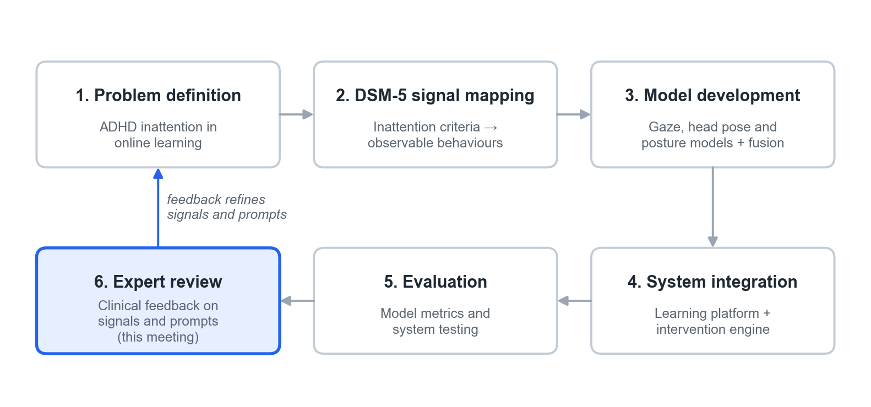
Figure 1. Research methodology. This meeting is step 6; its feedback feeds back into steps 1–4.
Step | What was done
1. Problem definition | Learners with ADHD often lose attention during self-paced online lessons, and nobody is present to notice. The aim is to notice drift early and offer gentle, supportive help.
2. DSM-5 signal mapping | The nine DSM-5 inattention criteria were reviewed and each was linked to a behaviour that can be seen in a classroom and measured by a learning platform (Section 3).
3. Model development | Because no public dataset of distracted learners exists, the webcam problem was split into three smaller models, each trained on a suitable public dataset: eye-gaze direction (MPIIGaze), head orientation (BIWI Kinect Head Pose), and upper-body posture (MediaPipe landmarks). A fourth, simple “fusion” model combines them into one decision; it was trained on webcam recordings made for this study. The behavioural signals use transparent rules over the learner's activity log.
4. System integration | The models and rules were built into a full web learning platform (lessons, quizzes, teacher and admin tools) with an intervention engine that chooses a prompt when a sign of inattention lasts or repeats.
5. Evaluation | Each model was tested on people it had not seen during training. The whole platform was tested with automated tests and scripted scenarios.
6. Expert review | Clinical review of the signals and prompts (this meeting), before any study with learners.

2.1 Privacy and consent built into the method
- Monitoring cannot start unless a guardian's consent is recorded. The learner is also asked for their own agreement during onboarding.
- One small, low-resolution webcam image is analysed every 2 seconds and then discarded. No video is stored; only the result (focused, distracted or unknown) and timings are saved.
- If a microphone is allowed, only a single loudness number is computed on the learner's own device. No audio is recorded or sent.
- The activity log stores events, not content: for example “answer submitted, incorrect, 4 s after the question appeared”. Keystroke contents are never recorded.
- An indicator is always visible when the camera is active. Detections lead only to supportive prompts, never to marks or penalties.

3. Identifying distraction: the DSM-5 symptom mapping

3.1 Why DSM-5, and how it is used
The DSM-5 (American Psychiatric Association, 2013; text revision 2022) lists nine symptoms of inattention, labelled (a) to (i). A diagnosis needs at least six of them (five from age 17), lasting at least six months, present in two or more settings, with several present before age 12, and clearly affecting functioning. Diagnosis is a clinical judgement.
Luma uses the criteria for a narrower purpose: to decide which observable behaviours are worth measuring during a lesson. Each criterion was linked to a behaviour a teacher could see in a classroom, then to a signal a learning platform can record, and finally to a simple threshold. A signal crossing its threshold is treated as a moment-to-moment sign of possible inattention, not as a symptom in the diagnostic sense. Luma never counts symptoms or labels a learner.
Two of the nine criteria were left out because a learning platform cannot observe them: (e) difficulty organising tasks and (g) losing things needed for tasks.

3.2 The mapping table
Seven criteria are mapped. The first four columns give the mapping; the last two describe how Luma captures and evaluates each signal and the research that supports the link.
DSM-5 inattention criterion | Classroom behaviour you can observe | System signal | Threshold | How Luma captures and evaluates it | Supporting references
(b) Difficulty sustaining attention in tasks | Long pauses mid-task | Idle time: no clicks, keys, touches or scrolling on a quiz or reading screen | Idle ≥ 15 s while the webcam does not show the learner looking at the screen (≥ 45 s if no camera) | Browser records the time of the last interaction; idle is not counted while a video is playing or while the learner is judged FOCUSED (reading or thinking) | APA (2013); Kofler et al. (2008); Kofler et al. (2013); Beck (2005)
(h) Easily distracted by extraneous stimuli | Looking away; reacting to noises | Gaze or head turned away from the screen (webcam). Separately: sustained room noise (microphone) | Continuous distraction episode ≥ 5 s. Noise: ≥ 12 dB above the room's starting level for ~8 s | Webcam image every 2 s scored by the detection model (Section 4). Loudness measured on the device; one noise notice per session | APA (2013); Kofler et al. (2008); Hutt et al. (2019); D'Mello et al. (2012); Söderlund et al. (2007)
(d) Does not follow through; fails to finish | Starts but does not complete quizzes or modules | Quiz running past its expected time; items opened and left unfinished | Quiz not submitted by 1.5× its expected time (e.g. 30 min for a 20-min quiz), or ≥ 2 items left unfinished within 10 min | Teacher sets each quiz's expected time; the server compares elapsed time and tracks opened-but-incomplete items | APA (2013); Loe & Feldman (2007); Frazier et al. (2007)
(a) Careless mistakes | Errors on material already known | Error streak on easy items | ≥ 3 wrong in a row on items marked easy or previously answered correctly | Each answer is graded on the server; the streak counter uses the item's difficulty and the learner's own history | APA (2013); Kofler et al. (2013); Frazier et al. (2007)
(c) Does not seem to listen when spoken to directly | Misses simple spoken or written instructions | Repeated hint or help requests, or reopening the instructions, on the same question | ≥ 2 hint requests or instruction re-opens on one question within 2 min | Hint and instruction buttons log an event with the question it belongs to | APA (2013); Martinussen et al. (2005); Kasper et al. (2012); Aleven et al. (2016)
(f) Avoids or dislikes sustained mental effort | Skips or scrolls rapidly through content | Rapid skipping or rapid guessing | > 3 screens or items skipped within 60 s, or an answer submitted < 3 s after the question appears | Navigation, video-seek and answer events are time-stamped; the server checks a rolling 60 s window | APA (2013); Sonuga-Barke (2003); Baker et al. (2004); Beck (2005)
(i) Forgetful in daily activities | Forgets routines and steps just learned | Missed daily study goal (streak broken) | Daily goal not met on a planned study day, or ≥ 2 missed days in a week | The daily streak and focus-goal record is checked when the learner next logs in | APA (2013); Gawrilow & Gollwitzer (2008); Martinussen et al. (2005)

About the thresholds
The thresholds are design values chosen for this project; no study we found gives validated numbers of seconds or errors for these behaviours in learners with ADHD. They are stored as settings, so a teacher or administrator can adjust them, and they are intended to be calibrated with pilot data and with your advice (for example, how they should differ by age).

3.3 How the signals are captured
The signals come from three sources (Figure 2). The webcam feeds the detection model described in Section 4. The microphone gives only a loudness number. Everything else comes from the learning activity log: a time-stamped record of what the learner does on the platform.
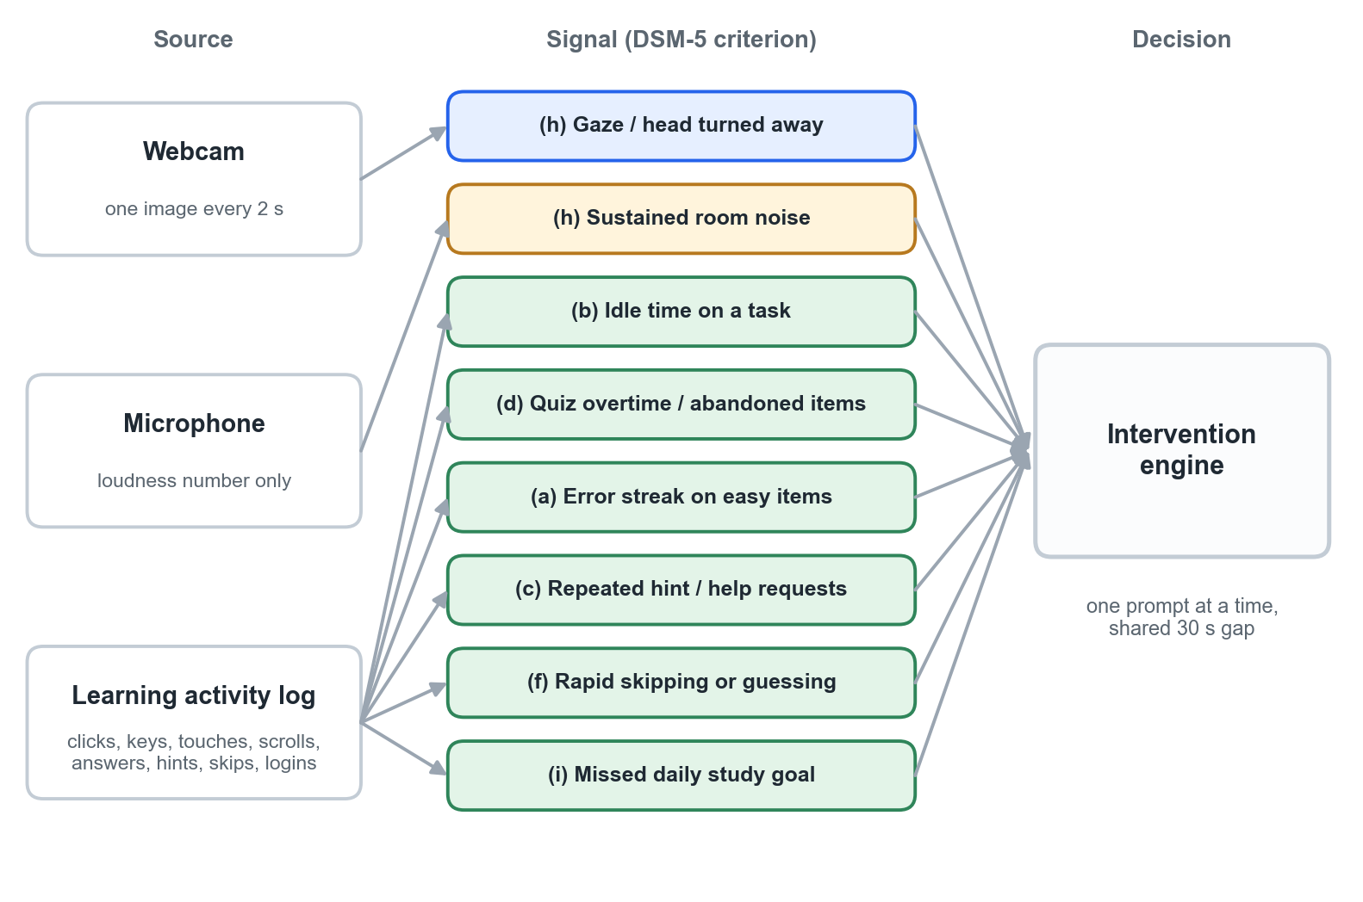
Figure 2. Sources and signals. All signals feed one intervention engine.
Three design rules keep the behavioural signals fair:
- Signals are checked against each other where it matters. Idle time does not count while the webcam shows the learner looking at the screen, because a learner may be reading or thinking without touching anything.
- Thresholds depend on the activity. Idle time is not measured during video playback; quiz overtime uses the time the teacher set for that quiz.
- Each signal names its likely cause. Unlike the webcam, which only shows that attention has moved, a behavioural signal points to a specific difficulty (stuck, rushing, overwhelmed, out of routine), so the prompt can be matched to it (Section 5.4).

3.4 Research behind each link
(b) Sustaining attention → idle time. In classroom observation studies, children with ADHD are off task noticeably more often than their peers (Kofler et al., 2008). Lab studies show more frequent brief lapses, seen as unusually slow responses scattered among normal ones (Kofler et al., 2013). In tutoring software, long gaps without any input are a standard sign of disengagement (Beck, 2005).
(h) Distracted by stimuli → gaze away, room noise. Looking away from the work is the most common off-task behaviour coded in ADHD classroom studies (Kofler et al., 2008). Eye-tracking systems can detect mind wandering in classrooms from gaze alone (Hutt et al., 2019), and gaze-reactive tutors use looking away as their trigger (D'Mello et al., 2012). For noise, the evidence is mixed: moderate white noise improved some cognitive performance in children with ADHD (Söderlund et al., 2007). This is one reason the noise notice offers choices rather than assuming noise is harmful.
(d) Fails to finish → quiz overtime and abandoned items. ADHD is consistently associated with lower academic achievement and poorer work completion (Loe & Feldman, 2007; Frazier et al., 2007). Comparing time spent with the time the teacher expects gives an objective, activity-specific measure of not following through.
(a) Careless mistakes → error streaks on easy items. Errors on material a learner already knows are more likely to reflect a lapse than a gap in knowledge; attention lapses are linked to performance errors (Kofler et al., 2013). Achievement studies document the academic cost (Frazier et al., 2007).
(c) Does not seem to listen → repeated hint or help requests. Working-memory difficulties are well documented in ADHD (Martinussen et al., 2005; Kasper et al., 2012), which makes instructions easy to lose part-way through a task. Asking for the same help repeatedly on one question is an established help-seeking signal in tutoring research (Aleven et al., 2016). DSM-5 (c) concerns being spoken to directly, so this is an on-screen analogue of the behaviour.
(f) Avoids sustained effort → rapid skipping or guessing. Delay aversion, a preference to escape tasks that demand waiting or sustained effort, is one of the main explanatory models of ADHD (Sonuga-Barke, 2003). In tutoring software, clicking through content or answering faster than the question could be read is a recognised disengaged behaviour (Baker et al., 2004; Beck, 2005).
(i) Forgetful in daily activities → missed daily study goal. DSM-5 (i) concerns everyday routines. A daily study goal is one such routine, and a broken streak is a direct record of it being missed. Forming a specific plan of when and where to act (an implementation intention) has improved self-regulation in children with ADHD (Gawrilow & Gollwitzer, 2008), which informs the response in Section 5.4. Working-memory research also explains why recently learned steps are easily lost (Martinussen et al., 2005).

4. How the system decides whether the learner is distracted
Luma uses two kinds of evidence: the webcam detection model, which judges every 2 seconds whether attention is on the screen, and the behavioural rules from Section 3, which check the learner's activity. This section explains both.

4.1 The webcam decision, step by step
While a monitored lesson is open, the learner's browser sends one webcam image to the server every 2 seconds. Each image goes through the steps in Figure 3 and produces one of three results: FOCUSED, DISTRACTED or UNKNOWN.
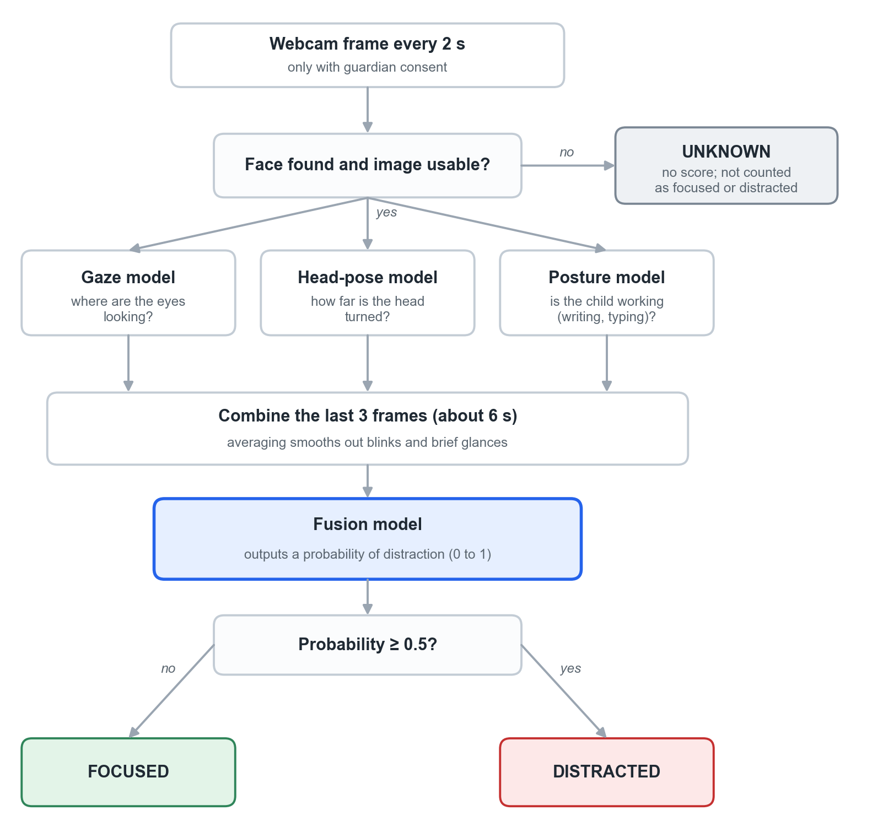
Figure 3. How one webcam image becomes a verdict.
- Is the image usable? If no face is found (the learner has left, or the camera is covered or badly lit), the result is UNKNOWN. UNKNOWN is never counted as distraction and never triggers a prompt. It simply means the system cannot tell.
- Three questions are asked of the image. The gaze model estimates whether the eyes point at the centre of the screen, left, right or down. The head-pose model estimates how far the head is turned or tilted. The posture model estimates whether the hands and upper body look like active work (writing or typing), so that looking down at a notebook is not automatically treated as distraction.
- Short-term smoothing. The answers from the last three images (about 6 seconds) are averaged, so a blink or a quick glance does not change the result.
- One combined decision. A small, transparent statistical model (logistic regression) turns these values into a probability of distraction between 0 and 1. If it is 0.5 or above, the result is DISTRACTED; otherwise FOCUSED. A personal baseline taken at the start accounts for differences in camera position and posture.
- From moments to episodes. Luma does not react to single results. A run of DISTRACTED results forms a distraction episode with a start time and a length. A FOCUSED result ends the episode (the learner is counted as having returned). An UNKNOWN result also ends it, but is not counted as a return. Webcam prompts depend on how long the current episode has lasted (Figure 4).
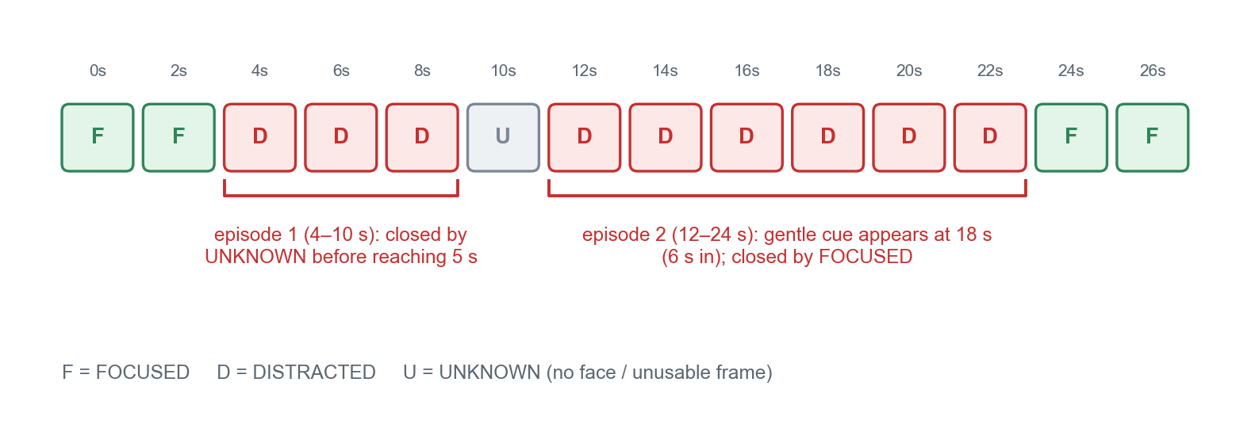
Figure 4. Example of how 2-second results form distraction episodes.

4.2 The behavioural rules
Every interaction (answer, hint request, page change, video seek, scroll) is sent to the server as a small time-stamped event together with the 2-second heartbeat. The server keeps a short rolling record for the session and checks each rule from Section 3.2 whenever a new event arrives, or once a second for time-based rules such as idle time and quiz overtime. The daily-goal rule is checked once, at login.
A rule that crosses its threshold produces a trigger that names the signal (for example, “error streak, 3 in a row”). Triggers go to the same intervention engine as the webcam, so the learner never sees two prompts at once (Section 5).

4.3 How reliable the decisions are
Current accuracy
The webcam model was trained on recordings of few participant in few setting. Tested on a recording it had not seen, it separated focused from distracted moments moderately well (ROC-AUC ≈ 0.77) but its overall correctness is modest (F1 ≈ 0.54). In practice this means some prompts will appear while the learner is actually attending, and some real drift will be missed. The webcam also cannot tell why attention moved: boredom, confusion, tiredness, taking notes, a noise, or a model error look the same. Retraining on recordings of more participants is planned.
The behavioural rules are exact counts and timings, so they do not misread what happened. Whether a given threshold reflects inattention, rather than, for example, a genuinely hard question, depends on calibration, which is why the thresholds are adjustable settings.

5. How the interventions happen, one by one
Every webcam verdict and every behavioural trigger goes to the same intervention engine, which makes the checks in Figure 5. The idea is to start with the gentlest prompt and only become more interruptive if the sign of inattention continues or repeats.
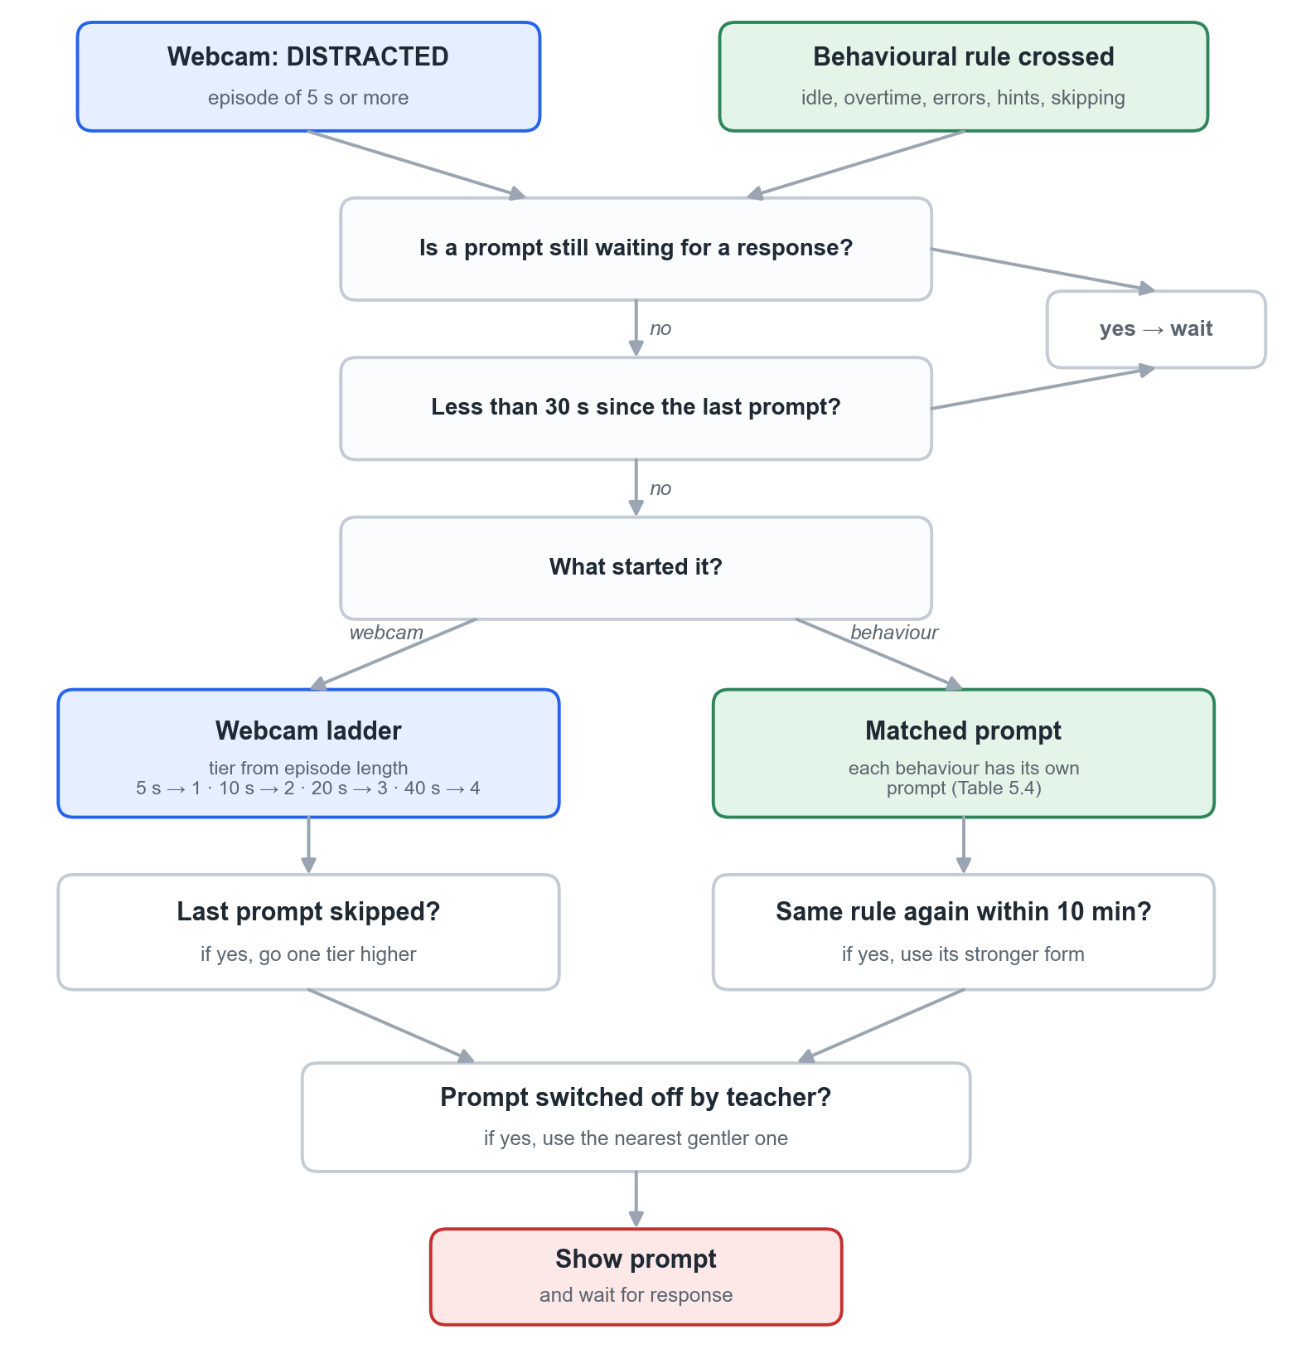
Figure 5. How the engine chooses a prompt.

5.1 The rules in plain words
- One prompt at a time, from any source. No new prompt appears while one is still waiting for a response.
- At least 30 seconds between prompts (an administrator can change this).
- Webcam prompts follow a ladder. Nothing happens until an episode has lasted 5 seconds. Then: 5 s → gentle cue, 10 s → pacing pause, 20 s → brief quiz (or a hint during a quiz), 40 s → slow-down, and on later occasions a suggested break. If the learner skips a prompt, the next is one level stronger. As soon as the learner is judged FOCUSED, the ladder starts again.
- Behavioural prompts are matched to the cause. Each behavioural signal has its own prompt (Section 5.4). If the same rule fires again within 10 minutes, its stronger form is used.
- Task problems come first. If a behavioural trigger and a webcam prompt are due at the same moment, the behavioural one is shown, because it names a specific difficulty.
- Teachers can switch prompts off for their subject; a switched-off prompt falls back to the nearest gentler one.
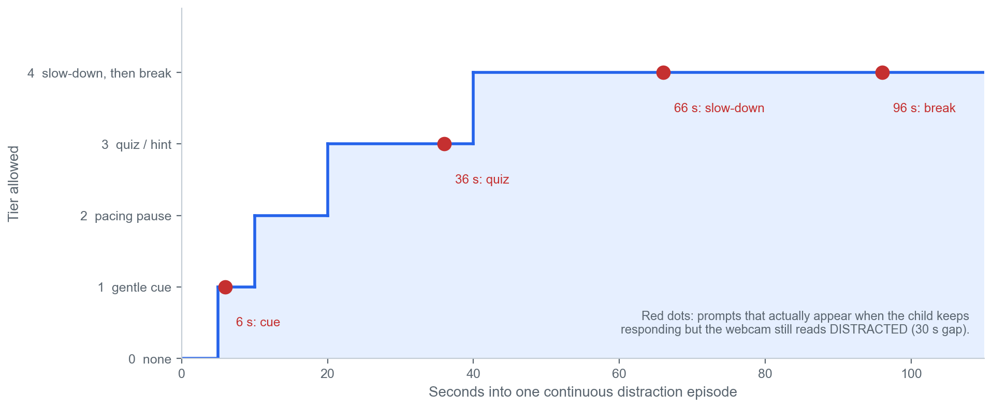
Figure 6. The webcam escalation ladder during one continuous distraction episode, and the prompts that actually appear.

5.2 What a learner experiences from the webcam ladder
Because of the 30-second gap, one long, unbroken webcam episode produces this sequence (red dots in Figure 6): gentle cue at about 6 s → brief quiz at about 36 s → slow-down at about 66 s → break at about 96 s. Three consequences matter for your review:
- The pacing pause is rarely reached, because by the time the second prompt is allowed the episode is already past 20 seconds.
- Escalation follows elapsed time, not the learner's response. Pressing “I'm here” does not prevent a stronger prompt if the webcam still reads distraction.
- A learner who never touches the first banner receives no further webcam prompts in that episode. The idle-time rule (Section 5.4) covers this case on quiz and reading screens.

5.3 Webcam-triggered interventions and their research basis
Intervention | What the learner sees | When it appears | Intended purpose | Related research | Where Luma differs from the research
Tier 1. Gentle cue | A small banner at the top: “Let's refocus together!” with an “I'm here” button. The video keeps playing. | Episode ≥ 5 s (≈ 6 s in practice) | Gives the learner a chance to notice that attention has drifted and return to the task (self-monitoring). | Rafferty et al. (2011); Wills & Mason (2014); Harris et al. (2005); Reid et al. (2005); D'Mello et al. (2012); Hutt et al. (2021) | The ADHD studies trained children to self-monitor and asked “Was I on task?” (yes/no) on a schedule. Luma only asks for an acknowledgement.
Tier 2. Pacing pause | Video pauses. “Quick check-in”, with three faces: 😀 Going well, 😐 Okay, 😩 Tough, and “Skip for now”. | Episode 10–20 s old when a prompt is allowed (rare in practice) | Gives time to catch up and choose when to continue. | Mayer & Chandler (2001); Rey et al. (2019); counter-evidence: Szpunar et al. (2013) | Studies split lessons at meaningful points; Luma pauses wherever drift is detected.
Tier 3. Brief quiz | Video pauses. One multiple-choice question from the teacher's checkpoint questions, optional hint, gentle feedback either way. | Episode ≥ 20 s (≈ 36 s in practice) | Restores active involvement with the lesson: retrieving an answer is an active task. | Szpunar et al. (2013); Roediger et al. (2011); Knouse et al. (2016); Hutt et al. (2021) | Best-supported prompt. Research used questions about the part just studied, so questions should be tied to the current section.
Tier 3 in a quiz. Hint | Panel on the quiz page: “A hint for this question… Skim the heading and first sentence of the current section.” | Same timing, during a quiz | Content support when understanding may have been disrupted. | Mills et al. (2021); Aleven et al. (2016) | Research hints were specific to the current step; Luma's webcam-triggered hint is general.
Tier 4 (first). Slow-down | Video pauses. “Let's slow down a little”; video continues at 75% speed. | Episode ≥ 40 s (≈ 66 s), once per session | More processing time. | No direct support found. Caution: Zentall (1975); Murphy et al. (2022) | Weakest-supported prompt; an optional speed choice would be easier to justify.
Tier 4 (later). Suggested break | “Stretch & breathe”: a 60-second breathing circle, then “Ready to continue”. | Next tier-4 moment (≈ 96 s) | A short rest to reset. | Pontifex et al. (2013); Mahar et al. (2006); Ariga & Lleras (2011) | Studies used 10–20 minutes of physical activity. A 60-second seated breathing break is untested.
Separate. Noise notice | Video pauses. “It's quite noisy around you”: headphones, move somewhere quieter, or continue anyway. | Room ≥ 12 dB louder than its starting level for ~8 s; once per session | Gives the learner control over the environment. | No direct study; see Söderlund et al. (2007) for why noise is not assumed harmful | Never escalates and never affects the webcam prompts.

5.4 Behaviour-triggered interventions
Each behavioural signal from Section 3 has a matched prompt. The first column of prompts is shown the first time the rule fires; the stronger form is used if the same rule fires again within 10 minutes.
Signal (DSM-5) | Prompt the learner sees | Stronger form (repeat within 10 min) | Intended purpose | Related research
(b) Idle time | Gentle cue: “Still with it? Tap to carry on.” | Check-in with choices: “I'm thinking” · “I'm stuck” · “I need a break”. Stuck opens a hint for the current question; break opens the break screen. | Notice the pause and say what is happening, so the next step fits the cause. | Rafferty et al. (2011); Harris et al. (2005); Beck (2005)
(d) Quiz overtime / abandoned items | Progress check: “You've been on this quiz for a while — 4 questions left.” Choices: keep going · take a 2-minute break · save and finish later. | For abandoned items: a short checklist of unfinished work, with the nearest one to completion suggested first. The teacher's dashboard shows unfinished items. | Make remaining work visible and break it into a manageable next step. | Loe & Feldman (2007); Rey et al. (2019); Reid et al. (2005)
(a) Error streak on easy items | “Let's slow down and check.” For the next 3 questions, a one-line self-check appears before submitting: “Read the question again — did you check every option?” | A hint for the current question and an offer to review the related lesson section. | Self-monitoring of accuracy, encouraging a careful check instead of a fast answer. | Harris et al. (2005); Reid et al. (2005); Kofler et al. (2013)
(c) Repeated hint / help requests | The instructions are shown again in short numbered steps, one at a time, with key words highlighted. | A worked example of a similar question, and a note on the teacher's dashboard that the learner may need help with this topic. | Reduce working-memory load and give help specific to the current step. | Martinussen et al. (2005); Kasper et al. (2012); Aleven et al. (2016)
(f) Rapid skipping / guessing | “Moving fast! Try one quick question on what you just skipped.” A single question from the skipped section. | A three-point summary of the skipped content (from the teacher-approved summary), then the option to continue. | Restore active involvement through retrieval rather than blocking navigation. | Szpunar et al. (2013); Baker et al. (2006); Beck (2005)
(i) Missed daily study goal | At the next login: “Welcome back! Here's where you left off,” with a one-question recap of the last lesson. The streak restarts without any loss message. | Plan for tomorrow: the learner picks a time (“When will you study tomorrow?”), receives a reminder then, and is offered a shorter daily goal (e.g. 10 minutes). | Rebuild the routine with a specific plan and a quick recap of what was forgotten. | Gawrilow & Gollwitzer (2008); Gollwitzer & Sheeran (2006); Roediger et al. (2011)

5.5 Overall position
Summary of the evidence
The research supports three general mechanisms: helping a learner notice a lapse (self-monitoring studies, including children with ADHD), restoring active involvement with content (retrieval practice), and giving relevant support when understanding may have been disrupted (attention-aware tutoring). Attention-aware tutors that detect drift and respond have worked in classrooms (Hutt et al., 2021; Mills et al., 2021).
These results do not automatically transfer to Luma's detection methods, age group or ADHD population. The specific timings (5/10/20/40 s, 30 s gap), the behavioural thresholds and the order of prompts are design choices to be calibrated; the closest classroom system used a 90-second minimum gap and about one prompt per session.

- Feedback
Methodology

System

References

- Aleven, V., Roll, I., McLaren, B. M., & Koedinger, K. R. (2016). Help helps, but only so much: Research on help seeking with intelligent tutoring systems. International Journal of Artificial Intelligence in Education, 26(1), 205–223. https://doi.org/10.1007/s40593-015-0089-1
- American Psychiatric Association. (2013). Diagnostic and statistical manual of mental disorders (5th ed.). https://doi.org/10.1176/appi.books.9780890425596
- American Psychiatric Association. (2022). Diagnostic and statistical manual of mental disorders (5th ed., text rev.). https://doi.org/10.1176/appi.books.9780890425787
- Ariga, A., & Lleras, A. (2011). Brief and rare mental “breaks” keep you focused: Deactivation and reactivation of task goals preempt vigilance decrements. Cognition, 118(3), 439–443. https://doi.org/10.1016/j.cognition.2010.12.007
- Baker, R. S., Corbett, A. T., Koedinger, K. R., & Wagner, A. Z. (2004). Off-task behavior in the cognitive tutor classroom: When students “game the system”. In Proceedings of the SIGCHI Conference on Human Factors in Computing Systems (pp. 383–390). https://doi.org/10.1145/985692.985741
- Baker, R. S. J. d., Corbett, A. T., Koedinger, K. R., Evenson, S., Roll, I., Wagner, A. Z., Naim, M., Raspat, J., Baker, D. J., & Beck, J. E. (2006). Adapting to when students game an intelligent tutoring system. In Intelligent Tutoring Systems: 8th International Conference, ITS 2006 (Lecture Notes in Computer Science, Vol. 4053, pp. 392–401). Springer. https://doi.org/10.1007/11774303_39
- Beck, J. E. (2005). Engagement tracing: Using response times to model student disengagement. In Proceedings of the 12th International Conference on Artificial Intelligence in Education (pp. 88–95). IOS Press.
- D'Mello, S., Olney, A., Williams, C., & Hays, P. (2012). Gaze tutor: A gaze-reactive intelligent tutoring system. International Journal of Human-Computer Studies, 70(5), 377–398. https://doi.org/10.1016/j.ijhcs.2012.01.004
- Frazier, T. W., Youngstrom, E. A., Glutting, J. J., & Watkins, M. W. (2007). ADHD and achievement: Meta-analysis of the child, adolescent, and adult literatures and a concomitant study with college students. Journal of Learning Disabilities, 40(1), 49–65. https://doi.org/10.1177/00222194070400010401
- Gawrilow, C., & Gollwitzer, P. M. (2008). Implementation intentions facilitate response inhibition in children with ADHD. Cognitive Therapy and Research, 32(2), 261–280. https://doi.org/10.1007/s10608-007-9150-1

- Gollwitzer, P. M., & Sheeran, P. (2006). Implementation intentions and goal achievement: A meta-analysis of effects and processes. Advances in Experimental Social Psychology, 38, 69–119. https://doi.org/10.1016/S0065-2601(06)38002-1
- Harris, K. R., Friedlander, B. D., Saddler, B., Frizzelle, R., & Graham, S. (2005). Self-monitoring of attention versus self-monitoring of academic performance: Effects among students with ADHD in the general education classroom. The Journal of Special Education, 39(3), 145–156. https://doi.org/10.1177/00224669050390030201
- Hutt, S., Krasich, K., Brockmole, J. R., & D'Mello, S. K. (2021). Breaking out of the lab: Mitigating mind wandering with gaze-based attention-aware technology in classrooms. In Proceedings of the 2021 CHI Conference on Human Factors in Computing Systems (Article 52). https://doi.org/10.1145/3411764.3445269
- Hutt, S., Krasich, K., Mills, C., Bosch, N., White, S., Brockmole, J. R., & D'Mello, S. K. (2019). Automated gaze-based mind wandering detection during computerized learning in classrooms. User Modeling and User-Adapted Interaction, 29(4), 821–867. https://doi.org/10.1007/s11257-019-09228-5
- Kasper, L. J., Alderson, R. M., & Hudec, K. L. (2012). Moderators of working memory deficits in children with attention-deficit/hyperactivity disorder (ADHD): A meta-analytic review. Clinical Psychology Review, 32(7), 605–617. https://doi.org/10.1016/j.cpr.2012.07.001
- Knouse, L. E., Rawson, K. A., Vaughn, K. E., & Dunlosky, J. (2016). Does testing improve learning for college students with attention-deficit/hyperactivity disorder? Clinical Psychological Science, 4(1), 136–143. https://doi.org/10.1177/2167702614565175
- Kofler, M. J., Rapport, M. D., & Alderson, R. M. (2008). Quantifying ADHD classroom inattentiveness, its moderators, and variability: A meta-analytic review. Journal of Child Psychology and Psychiatry, 49(1), 59–69. https://doi.org/10.1111/j.1469-7610.2007.01809.x
- Kofler, M. J., Rapport, M. D., Sarver, D. E., Raiker, J. S., Orban, S. A., Friedman, L. M., & Kolomeyer, E. G. (2013). Reaction time variability in ADHD: A meta-analytic review of 319 studies. Clinical Psychology Review, 33(6), 795–811. https://doi.org/10.1016/j.cpr.2013.06.001
- Loe, I. M., & Feldman, H. M. (2007). Academic and educational outcomes of children with ADHD. Journal of Pediatric Psychology, 32(6), 643–654. https://doi.org/10.1093/jpepsy/jsl054
- Mahar, M. T., Murphy, S. K., Rowe, D. A., Golden, J., Shields, A. T., & Raedeke, T. D. (2006). Effects of a classroom-based program on physical activity and on-task behavior. Medicine & Science in Sports & Exercise, 38(12), 2086–2094. https://doi.org/10.1249/01.mss.0000235359.16685.a3
- Martinussen, R., Hayden, J., Hogg-Johnson, S., & Tannock, R. (2005). A meta-analysis of working memory impairments in children with attention-deficit/hyperactivity disorder. Journal of the American Academy of Child & Adolescent Psychiatry, 44(4), 377–384. https://doi.org/10.1097/01.chi.0000153228.72591.73
- Mayer, R. E., & Chandler, P. (2001). When learning is just a click away: Does simple user interaction foster deeper understanding of multimedia messages? Journal of Educational Psychology, 93(2), 390–397. https://doi.org/10.1037/0022-0663.93.2.390
- Mills, C., Gregg, J., Bixler, R., & D'Mello, S. K. (2021). Eye-Mind reader: An intelligent reading interface that promotes long-term comprehension by detecting and responding to mind wandering. Human–Computer Interaction, 36(4), 306–332. https://doi.org/10.1080/07370024.2020.1716762
- Murphy, D. H., Hoover, K. M., Agadzhanyan, K., Kuehn, J. C., & Castel, A. D. (2022). Learning in double time: The effect of lecture video speed on immediate and delayed comprehension. Applied Cognitive Psychology, 36(1), 69–82. https://doi.org/10.1002/acp.3899
- Pontifex, M. B., Saliba, B. J., Raine, L. B., Picchietti, D. L., & Hillman, C. H. (2013). Exercise improves behavioral, neurocognitive, and scholastic performance in children with attention-deficit/hyperactivity disorder. The Journal of Pediatrics, 162(3), 543–551. https://doi.org/10.1016/j.jpeds.2012.08.036
- Rafferty, L. A., Arroyo, J., Ginnane, S., & Wilczynski, K. (2011). Self-monitoring during spelling practice: Effects on spelling accuracy and on-task behavior of three students diagnosed with attention deficit hyperactivity disorder. Behavior Analysis in Practice, 4(1), 37–45. https://doi.org/10.1007/BF03391773
- Reid, R., Trout, A. L., & Schartz, M. (2005). Self-regulation interventions for children with attention deficit/hyperactivity disorder. Exceptional Children, 71(4), 361–377.
- Rey, G. D., Beege, M., Nebel, S., Wirzberger, M., Schmitt, T. H., & Schneider, S. (2019). A meta-analysis of the segmenting effect. Educational Psychology Review, 31(2), 389–419. https://doi.org/10.1007/s10648-018-9456-4
- Roediger, H. L., III, Agarwal, P. K., McDaniel, M. A., & McDermott, K. B. (2011). Test-enhanced learning in the classroom: Long-term improvements from quizzing. Journal of Experimental Psychology: Applied, 17(4), 382–395. https://doi.org/10.1037/a0026252
- Söderlund, G., Sikström, S., & Smart, A. (2007). Listen to the noise: Noise is beneficial for cognitive performance in ADHD. Journal of Child Psychology and Psychiatry, 48(8), 840–847. https://doi.org/10.1111/j.1469-7610.2007.01749.x
- Sonuga-Barke, E. J. S. (2003). The dual pathway model of AD/HD: An elaboration of neuro-developmental characteristics. Neuroscience & Biobehavioral Reviews, 27(7), 593–604. https://doi.org/10.1016/j.neubiorev.2003.08.005
- Szpunar, K. K., Khan, N. Y., & Schacter, D. L. (2013). Interpolated memory tests reduce mind wandering and improve learning of online lectures. Proceedings of the National Academy of Sciences, 110(16), 6313–6317. https://doi.org/10.1073/pnas.1221764110
- Wills, H. P., & Mason, B. A. (2014). Implementation of a self-monitoring application to improve on-task behavior: A high-school pilot study. Journal of Behavioral Education, 23(4), 421–434. https://doi.org/10.1007/s10864-014-9214-8
- Zentall, S. (1975). Optimal stimulation as theoretical basis of hyperactivity. American Journal of Orthopsychiatry, 45(4), 549–563. https://doi.org/10.1111/j.1939-0025.1975.tb01185.x

