**Use Case: ETL Code conversion using LangGraph**

1. **LangGraph ETL flow**

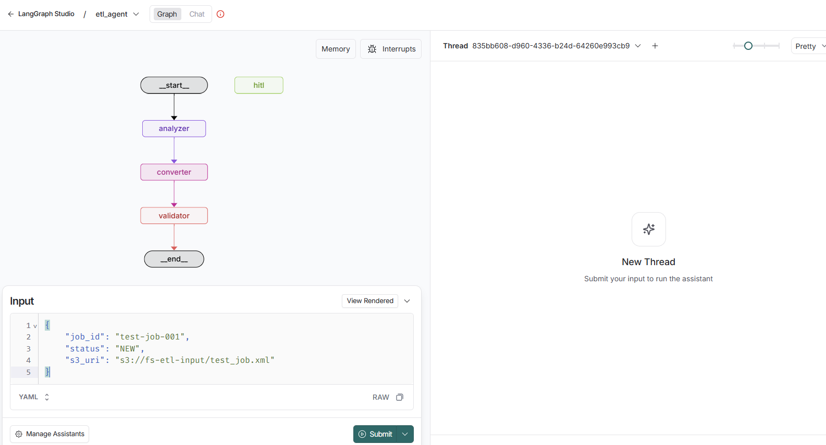

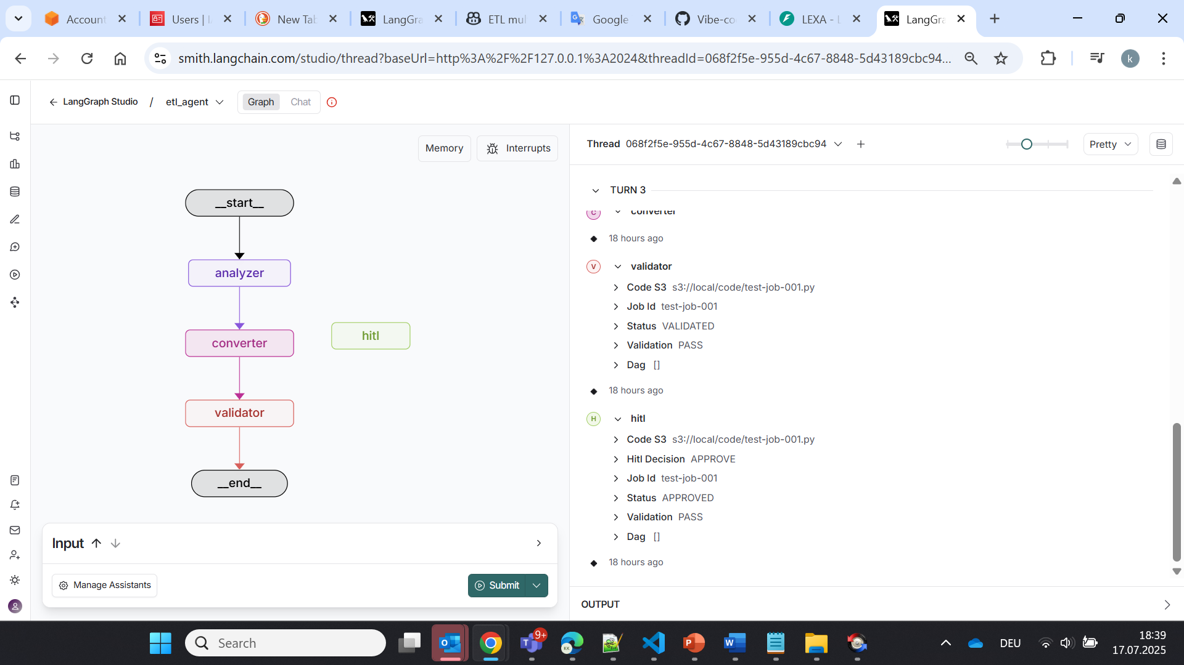

1. **Sample Input XML:**

1. High-level output:

**test-job-001.py** (generated output code: Pyspark code that parses, filters, and saves to s3)

