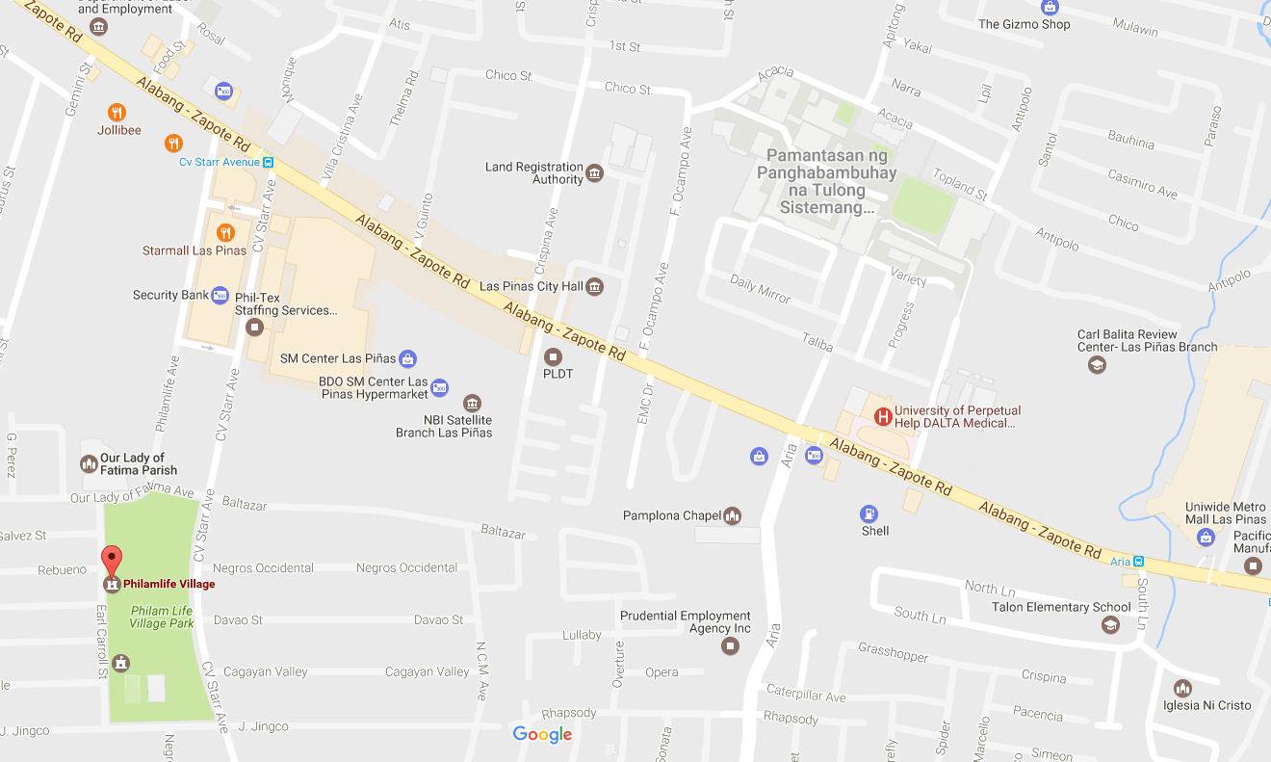

**SM Center**

**Las Piñas**

**Starmall**

**Las Piñas**

**To Philamlife Village**

**Las Piñas**

**City Hall**

**University of Perpetual Help**

**To Alabang**

**To Zapote**

**Reception Venue**

**Church**