Kalicia Nesbeth

11/7/17

Screenshot of how to convert strings from lower to upper case and upper to lowercase:

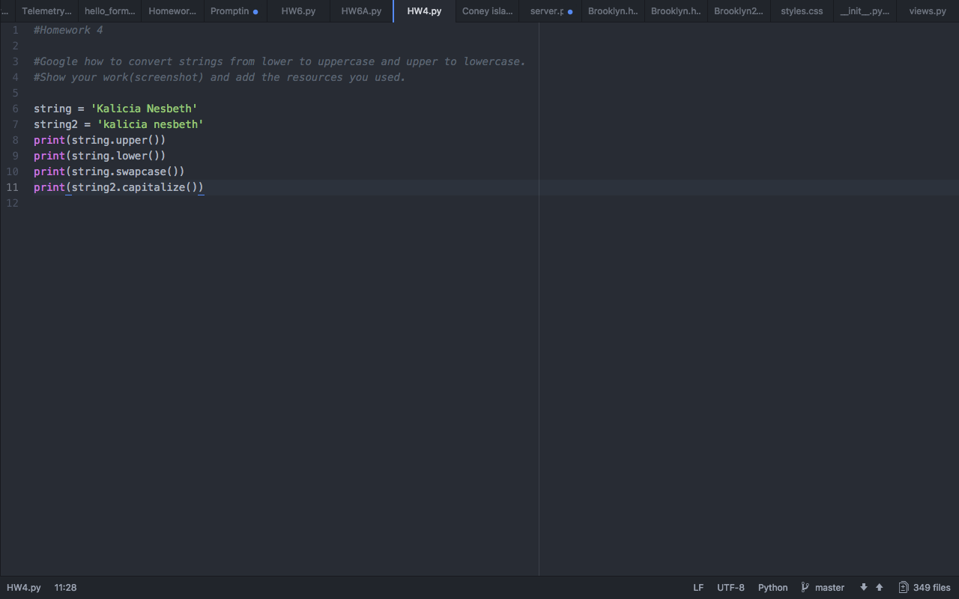

**Resource used to find the answer**

Youtube Tutorial:

<https://www.youtube.com/watch?v=mi7eX5o-mCw>