Tutorial for Manual Drive

OSMO Tester

MBT tool

v2.2

Teemu Kanstrén

Table of Contents

Introduction 3

Creating specific tests manually 3

Guiding the test generator 9

Conclusions 14

References 14

# Introduction

This tutorial describes the data modeling concepts of OSMO Tester using simple examples. It skips the background, the theoretical descriptions and just shows some examples. Check the OSMO manual for more lengthy descriptions. The reader should be familiar with the information presented in the OSMO Tester basic tutorial and data modeling tutorial.

The reader is expected to have basic knowledge of Java programming and ability to use their own favourite IDE such as Eclipse, IntelliJ, or Netbeans. The code shown in this tutorial is available in the OSMO Tester examples package.

# Creating specific tests manually

Previously in the data tutorial we created a model that prints “HELLO” and “WORLD” and uses ValueSet and ValueRange data model objects. In this tutorial we use the model program from the data tutorial as a basis and show how to manually create specific test cases from this model. As a reminder, Listing 1 shows the model program that was developed.

public class HelloModel {

private int helloCount = 0;

private int worldCount = 0;

private ValueSet<String> names = new ValueSet<String>("teemu", "bob");

private ValueSet<String> worlds =

new ValueSet<String>("mars", "venus");

private ValueSet<Integer> sizes = new ValueSet<Integer>(1,2,6);

private ValueRange<Double> ranges = new ValueRange<Double>(0.1d, 5.2d);

@BeforeSuite

public void init() {

names.setStrategy(DataGenerationStrategy.BALANCING);

}

@BeforeTest

public void startTest() {

helloCount = 0;

worldCount = 0;

System.out.println("TEST START");

}

@AfterTest

public void endTest() {

System.out.println("TEST END");

}

@Guard("hello")

public boolean thisNameReallyIsIrrelevant() {

return helloCount == worldCount;

}

@TestStep("hello")

public void sayHello() {

System.out.println("HELLO "+names.next()+" ("+sizes.next()+")");

helloCount++;

}

@Guard("world")

public boolean thisNameIsIrrelevant() {

return helloCount > worldCount;

}

@TestStep("world")

public void sayWorld() {

System.out.println("WORLD "+worlds.next()+" ("+ranges.next()+")");

worldCount++;

}

}

Listing 1. The model program from the basic tutorial.

Similarly, Listing 2 shows the configuration we set up to run the model program.

public class Main {

public static void main(String[] args) {

OSMOTester tester = new OSMOTester(new HelloModel());

tester.setSeed(345);

tester.addTestEndCondition(new Length(5));

tester.addSuiteEndCondition(new Length(3));

tester.generate();

}

}

Listing 2. Running the model program.

And as a final reminder, the output from running this model program is shown in Figure 1.

TEST START

HELLO bob (1)

WORLD mars (3.1562892313483015)

HELLO teemu (2)

WORLD mars (1.4289575493440612)

HELLO bob (2)

TEST END

TEST START

HELLO teemu (1)

WORLD venus (3.279034197651822)

HELLO teemu (2)

WORLD mars (2.814722267683214)

HELLO bob (1)

TEST END

TEST START

HELLO teemu (1)

WORLD mars (1.96781339845851)

HELLO bob (6)

WORLD venus (2.7852251942158026)

HELLO bob (1)

TEST END

generated 3 tests.

Figure 1. Example output.

So far the models have been used as a basis by the OSMO Tester for automatically generating test cases based on the defined test algorithm configurations. This is commonly what model-based testing (MBT) is defined as. However, considering overall management of automated test cases, it is useful from the test creation and maintenance viewpoint also to be able to automate more of the test generation in all aspect based on the test model. This way, there is less test script to write manually and the test model is used to cover more testing needs. More cost-effective that is. But let’s get to the point already.

How do we get the manual drive to use? Simply replace the test generation algorithm with the ManualDrive algorithms. This is shown in Listing 3.

public class ManualMain {

public static void main(String[] args) {

OSMOTester tester = new OSMOTester(new HelloModel());

tester.setSeed(345);

tester.addTestEndCondition(new Length(5));

tester.addSuiteEndCondition(new Length(3));

**tester.setAlgorithm(new ManualAlgorithm());**

tester.generate();

}

Listing 3. Running the model program.

Now, when you run this you will see the GUI pictured in Figure 2. Upper left corner shows the log of the test steps and data values you have chosen. In the bottom left corner you see the list of available test steps at this time. The only thing on this list is “hello” since “world” is only allowed after “hello”. Thus the GUI will always reflect what is legal for generation according to your model. Practically, it executes your model program one step at a time as you choose.

So click on “hello” in the lower left corner. What you will see is the GUI shown in Figure 3. This is asking you to specify a value for the “names” variable in the model program as the “hello” test step starts by asking a value to be generated for the “names” variable. With manual drive the user becomes the generator and all the OSMO modeling objects will ask the user for the input. Note that this only works with the ValueSet, ValueRange, ValueRangeSet, and ReadableWords objects included with OSMOTester. This should not be a major constraint since most data can be modeled in this way assuming some modeling skills.

Now the GUI for ValueSet shown in Figure 3 contains the options defined for the “names” variable. That would be “teemu” and “bob”. In this case, we choose “teemu” and press “OK”. The other choices are “Skip” and “Auto”. Using these causes the algorithm to generate automatically values in the same way that would be done if not manual drive is used. Skip causes one value to be generated for the variable. Auto causes this and all future instances of the variable to be automatically generated.

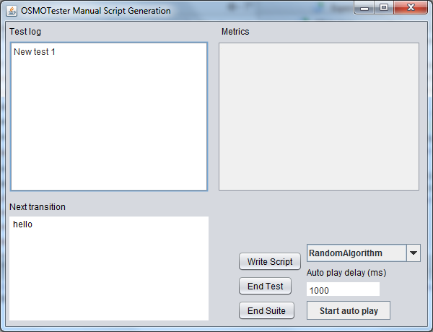

Figure 2. Manual drive GUI.

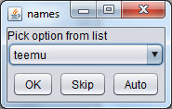

Figure 3. ValueSet GUI.

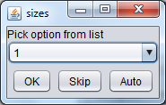

Figure 4. ValueSet GUI for “sizes”.

Now that we chose the value “teemu” and pressed OK, we should see the next value requested. Since the “hello” step also generates a value for this, it is also requested. As it is also a ValueSet, a similar GUI is shown to choose the value. This time we click “Skip”.

Now the manual drive GUI looks like Figure 5.

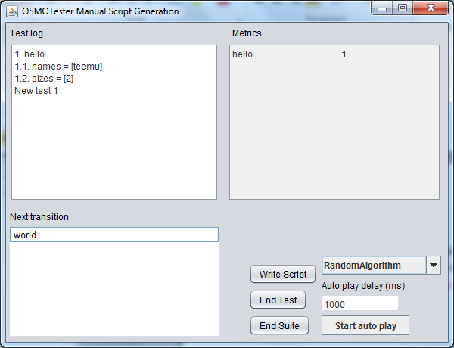

Figure 5. GUI after the first steps.

The log now shows that we have started the first test and chosen the first step, which is “hello”. For this step we have given the variable “names” value “teemu” and the second variable “sizes” got the value “2” from the automated algorithm choice. The metrics show that we have overall one step in our test cases and that is “hello”. The list of possible steps is now updated to show only “world” since that is the only enabled step once “hello” is taken once. Now we click on “world” to execute that step.

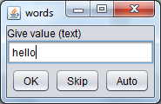

Figure 6. ReadableWords GUI.

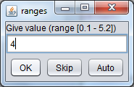

Figure 7. ValueRange GUI.

The “world” step requires values for variables “words” and “ranges”. These are shown in Figure 6 and Figure 7. After these choices, the overall GUI should now look like Figure 8.

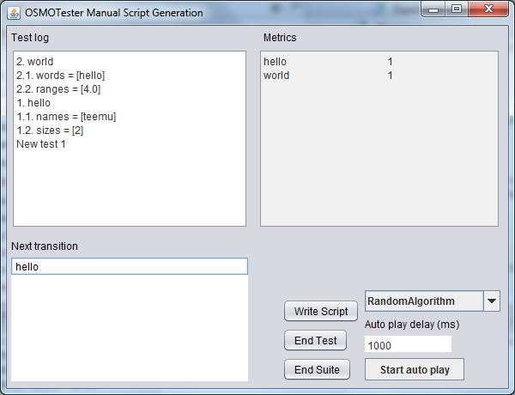

Figure 8. Yet another GUI screenshot.

From these, “end test” and “end suite” do what the title says, mainly noting that they cause associated model elements to be executed (after, aftersuite, before). It is also possible to start autoplay, which will choose steps according to the algorithm chosen in the algorithm box. The delay can be modified while running the autoplay to change how fast the steps are taken.

Typically the script is generated (offline) or test is executed (online) while the model program is executed. Additionally, a script in OSMO Tester format can also be written to disk using “write script”. The result is written to a text file called “osmo-tests.txt” in your working directory. In this case the output should look like that in Figure 9. Later, this file can be used to re-execute the manually created test script from the test model.

action, name, value

new test,,

step,hello,

variable,names,teemu

variable,sizes,2

step,world,

variable,words,hello

variable,ranges,4.0

Figure 9. Written script.

A similar script can also be written manually as a text file or the GUI generated file can be modified manually. To execute the text file, we need some special OSMO magic as shown in Listing 3.

public class ManualMain {

public static void main(String[] args) throws Exception {

AsciiParser parser = new AsciiParser();

List<TestScript> scripts = parser.loadAndParse("osmo-tests.txt");

ScripterMain main = new ScripterMain();

main.setSeed(345);

Collection<Object> models = new ArrayList<Object>();

models.add(new HelloModel());

main.run(models, scripts);

}

}

Listing 4. Running the manual script.

Here, we cannot define the end conditions or the algorithms since everything will simply be executed according to the script, which should contain all the required elements. Of course, if something is not there the results are unpredictable.. In this case, executing this with the previously generated script gives the output shown in Figure 10.

TEST START

HELLO teemu (2)

WORLD hello (4.0)

TEST END

generated 1 tests.

Figure 10. Example output.

# Guiding the test generator

In the above, we manually crafted some very specific scripts. Besides this, it is commonly interesting to be able to generate several tests that “slice” the general model according to some more specific rule without going to the level of detail required for specific single test cases.

In OSMO Tester terminology this is called domain-specific modeling (DSM) (scripting) as the names given to the test steps are seen to form a domain specific language for test modeling.

Using the same model programs as before as input, we can initiate a DSM GUI with the code shown in Listing 5.

public class DSMMain {

public static void main(String[] args) {

OSMOTester tester = new OSMOTester(new HelloModel());

tester.setSeed(345);

tester.addTestEndCondition(new Length(5));

tester.addSuiteEndCondition(new Length(3));

FSM fsm = tester.getFsm();

DSMGUI g = new DSMGUI(fsm);

g.setVisible(true);

}

}

Listing 5. Initializing the DSM GUI.

This GUI is shown in Figure 11.

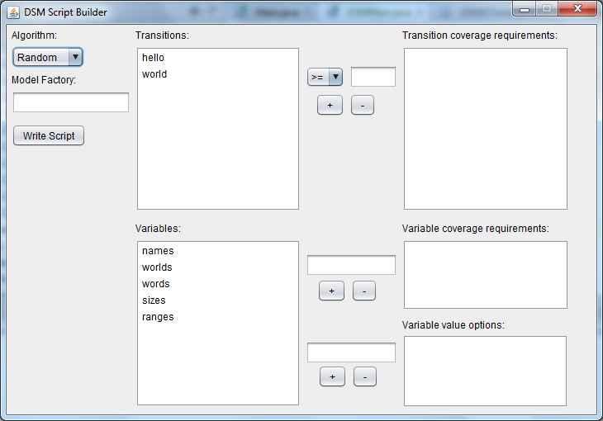

Figure 11. DSM GUI with the hello world example.

In the upper part, we see the available test steps in the model (“hello” and “world” here). In the below part, we see the data variables used in the given model. We can now select a test step and define bounds for how many times we want to see it included in each generated test case. This can be a maximum number (<= operator), minimum number (>= operator) or exact equals number (== operator). Simply choose the test step of interest from the list, pick an operator from the combobox, and enter the constraint number in the small text box next to the combobox. Then click on “+” to add the defined constraint.

For this example, let’s say we want at least three “hello”’s in each test.

For variables we can define coverage requirements in a similar way. First, choose a variable from the list at the bottom part. Second, write either a requirement in the upper text box next to the variable list or an option in the lower text box. Finally, press “+” to add your new stuff to the list on the right just as for the test steps.

A variable coverage requirement states that each of the generated test cases must cover at least the defined set of values. A variable value option defines what values the test generator can give to that variable when it is encountered in test generation. For example, we pick “names” and give it options “john” and “bob”. Then we add a coverage requirement for “names” for “john”. This means that the name in test generation can be either “john” or “bob” and each test that is generated will go on until at least one “john” is included.

Note that the sensibility of the definitions is not checked by the GUI at this point. It is assumed that the user has enough sense to figure their own model out themselves. Of course, contributions for improvement are welcome.

Figure 12 shows a GUI with these example values filled in.

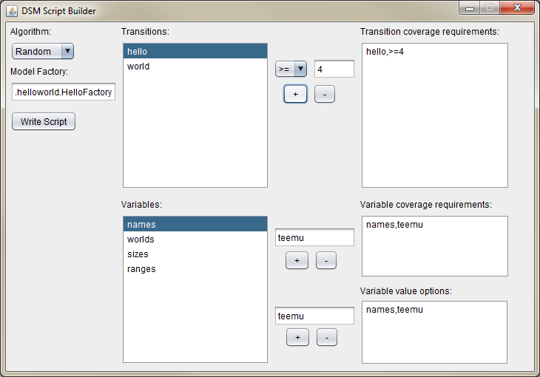

Figure 12. The GUI with example values filled in.

The output from “write script” for this configuration is show in Figure 10.

setting, value

algorithm, Random

model factory, osmo.tester.examples.helloworld.HelloFactory

step, times

hello,>=3

variable, coverage

names,teemu

variable, value

names, teemu

Figure 13. Example output.

On the left hand side we see the remaining options needed to configure the DSM test generator. This is the algorithm for traversing the test steps in the model, and the model factory. The algorithm should be quite clear. The model factory needs to be a fully qualified Java class name that is accessible to the test generator and is responsible for creating the model objects. This is to allow for different model compositions as is illustrated in the model composition tutorial, as well as for custom logic required in setting up the model objects.

To run the DSM script from a file we use Listing 6.

public class DSMLoaderMain {

public static void main(String[] args) throws Exception {

AsciiParser parser = new AsciiParser();

DSMConfiguration config = parser.loadAndParse("osmo-dsm.txt");

osmo.tester.scripting.dsm.DSMMain.execute(config);

}

}

Listing 6. Running the DSM script.

The model factory we use here is shown in Listing 7.

public class HelloFactory implements ModelObjectFactory {

@Override

public Collection<Object> createModelObjects() {

Object model = new HelloModel();

Collection<Object> objects = new ArrayList<Object>();

objects.add(model);

return objects;

}

@Override

public Collection<EndCondition> createTestEndConditions() {

Collection<EndCondition> end = new ArrayList<EndCondition>();

end.add(new Length(5));

return end;

}

@Override

public Collection<EndCondition> createSuiteEndConditions() {

Collection<EndCondition> end = new ArrayList<EndCondition>();

end.add(new Length(3));

return end;

}

}

Listing 7. Model factory.

Once we are happy with what we have defined, we can “Write Script” just as with the manual driver GUI. In a similar way, this results in a text file being written to the disk. This is shown in . Again, one can modify this manually and re-run the test generator as much as they like. As with manual GUI, reloading the saved script to the GUI is currently not supported, but contributions are welcome.

setting, value

algorithm, Random

model factory, osmo.tester.examples.helloworld.HelloFactory

step, times

hello,>=4

variable, coverage

names,teemu

variable, values

names,teemu

Figure 14. Generated domain specific script definition.

Once we run our example with this, we get the output shown in Figure 15.

TEST START

HELLO teemu (2)

WORLD venus (3.013874187456732)

HELLO teemu (2)

WORLD venus (1.652371396482848)

HELLO teemu (6)

WORLD mars (2.065167276123717)

HELLO teemu (2)

TEST END

TEST START

HELLO teemu (1)

WORLD mars (2.5756822843541602)

HELLO teemu (2)

WORLD mars (5.0710623426002)

HELLO teemu (1)

WORLD mars (1.225625736688)

HELLO teemu (1)

TEST END

TEST START

HELLO teemu (6)

WORLD mars (4.983682361795929)

HELLO teemu (6)

WORLD mars (2.437715334869641)

HELLO teemu (2)

WORLD venus (4.864473501745214)

HELLO teemu (6)

TEST END

generated 3 tests.

Figure 15. Example output.

Notice how each generated test case now has at least one “teemu” in it, at least four “hello” steps, and only “teemu” as names. Sweeeet dude…

# Conclusions

This tutorial showed the how to use the manual modeling mechanisms to guide test generation with OSMO Tester. Some useful functionality that is still missing is the ability to load previously recorded scripts for editing in the GUI (although the text file can be manually edited) and the ability to verify possible errors in the scripts, such as one chosen option precluding another. This type of validation is currently up to the domain expert..

# References

OSMOTester home page, discussion forums & source code: <http://code.google.com/p/osmo/>