# C:\Users\pc\Desktop\log.jpg

# **KOMBOLCHA INSTITUTE OF TECHNOLOGY**

# **COLLEGE OF INFORMATICS**

# 

**Acknowledgement**

First of all thank for the almighty GOD keep our safe, staying power and energy starting from up to the day we have finished this project successfully.

Lastly, we would also like to thank our friends who helped us a lot in finishing this first phase of industrial project within the limited time next.

**Thanks To All Again.**

**Our Group Members**

**Abstract**

This project document deals all about Trade License management system for Kombolcha Trade and Industry Office. It has five chapters: introduction, analysis, design phase, implementation and coding and conclusion and recommendation. The introduction part deals with the background for the project area and office, statement of the problem, scope, methodology and feasibility study of the project in terms of economic, technical and time feasibility. It also includes project time schedule and organization of the project.

The second chapter shows the detail analysis of the existing and the new system. This chapter deeply deals with discussions of the new proposed system using a UML (Unified Modeling Language) diagrams. A detailed description of system functionalities and use case documentation, Sequence diagram for the interaction between the actor and system, activity diagrams, and class diagram are also part of this new proposed system.

The second third of this documentation is the design phase. The computer based solutions to the problems of the system which is Trade License management system are included in this part. It starts with objectives and goals of the design. Next the proposed architecture of the solution including subsystem decomposition, component diagram, deployment diagram and ER diagram for relational database, persistence model for tables mapping followed with the access control are included in this part.

The fourth chapter shows the implementation of the project. The last chapter of this project is conclusions and recommendation of our project.

Contents

List of tables VI

List of figure VII

Chapter one 1

Introduction 1

1.1 Background of the project 1

1.2 Statement of the problem 2

1.3 Objective of the project 2

1.3.1 General objective 2

1.3.2 Specific objective 2

1.4 Methodology 3

1.4.1 Requirement gathering methods 3

1.4.2 Requirement modeling methods 4

1.5 system development tools 4

1.5.1 Software tools 4

1.5.2 Hardware tools 5

1.6 Feasibility study 5

1.6.1 Economical Feasibility 5

1.6.2 Technical Feasibility 6

1.6.3 Operational feasibility 6

1.6.4 Time Feasibility 7

1.7 Project Scope and limitation 9

1.7.1 Scope 9

1.7.2 Limitation 9

1.8 Significance of the project 9

1.8.1 Significant for customers 10

1.8.2 Significance for the organization 10

1.8.3 Significance for the team members/students 10

1.9 Organization of the project 10

1.10 Task breakdown 10

1.11 communication plan 11

Chapter 2: Analysis 12

Introduction 12

2.1 Existing system descriptions 12

2.1.1 Customer’s application and license giving 12

2.1.2 Renewal of license 13

2.1.3 Update license 13

2.1.4 Cancel trade license 13

2.2 Business rules 13

2.3 constraints 14

2.4 Proposed system Overview 14

2.5 Requirements of the system 15

2.5.1 Functional requirement 15

2.5 .2 Nonfunctional requirements 15

2.6 Use case diagram 16

2.7 CRC Diagram 33

2.8 Sequence diagram 36

Sequence diagram for Give license 39

2.9 Activity Diagram 47

2.10 Conceptual model: Class diagram 57

2.11 identifying change case 59

2.12 User interface prototype 59

Chapter Three 61

3.0 System design 61

3.1 Purpose and Goals of Design 61

3.1.1 Purpose of System design 61

3.1.2 Design Goals 61

3.2 Class modeling diagram 62

3.3 current System Architecture 64

3.4 Proposed system architecture 64

3.4.1 Subsystem Decomposition 65

3.4.2 Component Diagram 66

3.4.3 Deployment Diagram 67

3.4.4 Persistence Modeling for Object Oriented Database 68

3.4.5 Access Control and security 72

3.4.6 Boundary condition and Exception handling 73

3.4.6.1 Boundary condition 73

3.4.6.2 Exception handling 74

3.5 user interface designing 74

Admin Homepage 76

Chapter 4 77

4.1 Implementation 77

4.2 test approach 77

4.2.1 Unit testing 78

4.2.1 Integration testing 79

4.2.3 System testing 79

4.2.4 Acceptance Testing 79

4.3 coding 80

4.3.1 Sample code 80

4.3.1.1 Loginn code 80

4.3.1.2 Coding index 84

Chapter 5 86

Conclusion and Recommendation 86

5.1 Conclusion 86

5.2 Recommendation 86

Reference 87

# List of tables

Table 1time feasibility 8

Table 2task break down 11

Table 3 communication plan 11

Table 4use case description for login 23

Table 5use case description for logout 24

Table 6use case description for create account 25

Table 7 use case description for apply registration 26

Table 8use case description for give license 27

Table 9use case description for renewal license 28

Table 10use case description for update license 29

Table 11use case description for cancel license 30

Table 12use case description for generate report 31

Table 13use case description for view report 32

Table 14use case description for search information 33

Table 15CRC diagram 36

Table 16applicant persistance 69

Table 17account persistance 70

Table 18licens persistance 71

Table 19Employeepersistence 71

Table 20Renew persistence 72

Table 22Renew_ request persistence 72

Table 23Access control and security 73

Table 24test for login 78

# List of figure

Figure 1 Essential use case diagram 19

Figure 2 System use case diagram 21

Figure 3sequence Diagram for Apply Registration 37

Figure 4sequence diagram for create account 38

Figure 5Sequence Diagram for Login 39

Figure 6 Sequence Diagram for Give license 40

Figure 7 Sequence Diagram for Renew license 41

Figure 8sequence diagram for logout 42

Figure 9Sequence Diagram for Cancel license 43

Figure 10Sequence Diagram for Generate Report 44

Figure 11Sequence Diagram for View Report 45

Figure 12sequence diagram for search customer information 46

Figure 13Activity Diagram for Apply Registration 48

Figure 14Activity Diagram for Login 49

Figure 15activity diagram for log out 50

Figure 16Activity diagram view report 51

Figure 17activity diagram for create account 52

Figure 18Activity Diagram for Give License 53

Figure 19Activity Diagram for Renew License 54

Figure 20Activity Diagram for Cancel License 55

Figure 21Activity Diagram for Generate Report 56

Figure 22class diagram 58

Figure 23User interface flow diagram 60

Figure 24class modeling diagram 63

Figure 25software architecture for kombolcha Trade and industry Office 65

Figure 26Component Diagram for Trade License Management System 67

Figure 27Deployment Diagram 68

# Chapter one

# Introduction

# 1.1 Background of the project

All trade and industry offices have a wide range of long term registration of new coming Customers and licensing system as well as payments for the services and annual tax. The registration may be for getting TIN (Tax Identification Number) number or for getting trade license. The licenses system incorporates giving, renewal and cancelation of the license. Application for registration for license and TIN number reduces paper work, the need of many manpower and costs. The proposed registration for trade license and the payment system for the services will eliminate all the manual invention and increase the speed of whole process of licensing and payment system. In this work we are going to design and implement the registration system for trade license and the payment system for the services used for kombolcha Trade and industry Office.

**Mission:**The organization is mainly aimed to make sure that the pepole are benefited by providing modern and fast trading system with trade legality and fast market.

**Vision**

Civilizing information system of kombolcha trade and industry office and improve the lives for the peoples with in the town to stand them on behalf of medium income countries.

**Goal**

Improve the legal managment of all activities done by the organization.

# 1.2 Statement of the problem

The office of kombolcha trade and industry does its work in manual system. All the activities of license giving, renewal and updating license, cancelling license and others are done through manual process.

* Customers have to come to the office for every service such as
* Registering Customers
* Giving license
* Renewal the license
* Cancelling license
* Need of many employees.
* Time loss to give information about trade codes for each Customer.
* Searching information is difficult

# 1.3 Objective of the project

The project team has identified the objectives of the project as general and specific in regard to the vision and mission of kombolcha trade and industry office.

## 1.3.1 General objective

The overall purpose of this project as a final output is to develop web based application for taking trade license for kombolcha trade and industry office.

# 

## 1.3.2 Specific objective

These are subsequent objectives that go with the develpment of web basedapplication for the trade and industry office.

* To identifying problem of the current system
* To analyze of the existing system
* To design different web page based on privilege
* To design different artifacts of the new system
* Prepare documentation
* System analysis and Object design
* Implement and test the system until the organization needs is fulfill.

# 1.4 Methodology

The methods that facilitate us to capture information about requested system is called Methodology Starting from proposed system we gathered information and data through different mechanisms.

While in doing our project, we used the following methods of data collection or fact finding techniques to gather information regarding the problems of the existing and requirements of the proposed system.

## 1.4.1 Requirement gathering methods

**Observation:** The project team has conduct observation around the office of kombolcha trade and industryto know the overall activities performed and studied the working environment and also we have observed how the Customer document or file is stored.

**Iinterview:** The team has prepared interviwe to gather information for the overall functionalities, activities, and processes of the trading system.

**Document analysis:** We have analysed documents like the regestration form which helps to build the contents of the registration form.

1.4.2 Requirement modeling methods:

The method we have been chosen to develop the system is object oriented system analysis and design methodology because of the following reasons.

* It will implement the concept of classes and objects.
* It minimizes development time because of using unified modeling language (UML).
* It treats both data and process simultaneously.

For the purpose of modeling the new system, we use different diagrams such as use case diagram, activity diagram, sequence diagram and class diagram. And also we use other diagrams for designing purposes which are deployment diagram, component diagram, state diagram, class diagram (detail) and collaboration diagram.

# 1.5 system development tools

## 1.5.1 Software tools

* Microsoft word for the documentation.
* Enterprise architect (UML diagrams for the drawing of different diagrams for example for sequence diagram, activity diagram class diagram…).
* Microsoft internet explorer, Google, and Mozilla Firefox for browsing.
* MySQL for the database.
* Notepad.

## 1.5.2 Hardware tools

* Computer
* Flash disk
* CD

# 1.6 Feasibility study

Feasibility: is used to assess the strengths and weaknesses of a proposed project and present directions of activities which will improve a project and achieve the desired results. From broad idea of what solutions are provided to solve the current system problems the best solution should be selected. The best solution selected is focused on the system acceptance in different areas which have to be examined in terms of feasibility study of proposed system. To get user acceptance and making the system easily understandable and accessible the new system considers:

## 1.6.1 Economical Feasibility

When the system is web based it does not be require much more cost beyond the capacity of the organization. This is one advantage of solving problems with kombolcha trade and industry office. Is process of identifying the financial benefits and associated with development of the proposed system (project). This feasibility is the resource saving ability specially cost-benefit analysis. The newly developed system will provide many benefits to the society and the customers. The newly being developed system will improve the time gap, access of property and saves resource Benefit estimation

**A. Tangible benefit:** - are those our project benefit that can convert into monetary values.

***B.* Intangible benefits*:*** are those our project benefit that cannot convert into monetary values**.**

## 1.6.2 Technical Feasibility

The technical feasibility assessment is focused on gaining an understanding of the present technical resources of the organization and their applicability to the expected needs of the proposed system. It is an evaluation of the hardware and software and how it meets the need of the proposed system.

This type of feasibility study refers to the technical requirements of the proposed system to satisfy the great compatibility of the Trade License Management System. The project is technically feasible because of it deeply investigates the requirements of the system based on the problems of the existing system and tries to solve those huge problems.

## 1.6.3 Operational feasibility

Operational feasibility is a measure of how well a proposed system solves the problems, and takes advantage of the opportunities identified during scope definition and how it satisfies the requirements identified in the requirements analysis phase of system development.

It shows the success and achievement of the objectives of the proposed system to the organization.

The proposed system will minimize the time and the manpower required to give service for the office as well as the students.

The system is accepted and supported by the office workers and site viewers.

## 1.6.4 Time Feasibility

This means estimating how long the system will take to develop. It is a measure of how reasonable the project timetable is.

It indicates the time assigned to perform each project phases and the proper management of time sequencing. Our group members have produced the progress, reports and other activities of the project development based on the schedule shown below.

## 

# 

# 1.7 Project Scope and limitation

## 1.7.1 Scope

The scope of the project is about tasks that will be performed throughout the system. Our main goal in doing this system is making the existing manual into web based system, more efficient, less time consuming and overall a better working system and customers can access the information by using web based system.

Our project aims to develop a web based registration for trade license to help the functionalities of kombolcha trade and industry office.

The scope of the project is:

* Registering Customers for license
* Give the license for those who fulfill the requirements
* Update the license annually
* Cancel the license
* Announce information to customer by sent notification

## 1.7.2 Limitation

The limitation of our system is: -

* The annual tax payment system is not included.
* The payment system for each service is not included.
* The process how to get TIN (tax identification number) is not include.

# 1.8 Significance of the project

The system being implemented facilitates new coming Customers registration for trade license and they have a chance for applying web based registration for trade license from anywhere at any time. The office can manage customer records easily and can retrieve and use for quick and on time decision making. The system can give better services for Customers and can have a great role in trade legality and modernity of the country by contributing the effort to attain missions of the office.

## 1.8.1 Significant for customers

Allow customers to get informatoion where they are and can be easily awarded.

Increase profit by decreasing the distance barrier that Customers were affected by, when they are taking, updating, and cancelling the license.

## 1.8.2 Significance for the organization

Kombolcha trade and industry office will be benefited after the completion of the projectin many ways including:

* To be competitive, profitable, and manage all Customers affairs easily.
* The access to information will be easier, faster, safer, and also in a neat and well organized way.
* Employee cost will be reduced with respect to both time and money.

# 

# Chapter 2: Analysis

# Introduction

In this chapter we will investigate the overview of the existing system, overview of the proposed system and problems that are found in it. Studying the existing system has a great importance for understanding of the problems and to put the appropriate solution for those problems. This helps us for the success of our next works in the design and implementation phases. It requires a careful understanding of the system and if any error occurs in this phase, it leads to improper implementation. Therefore, it is the basic and the one which is given special care for the success of the proposed system.

In this section we, the project development team, are expressed what the current system looks like, what players/participants are involved in the system, modeling of the current system and describing the functionalities of the system and boundaries of the system using Use-case diagram, showing the behavior of the system and the communication among objects using sequence diagram, describing the structure of the system using class diagram ,Basic course of action and alternative course of actions, practices that are preserved from the current system i.e. their weakness and strength, what are the Business rule of the system, our constraints and the Alternative solution to the whole system, the functional and non-functional requirements of the new system in order to save resources.

# 2.3 constraints

There is a different constraint that limits us to perform required activities.

* Due to limited development time we cannot perform activities with related organizations Because of environmental constraints in our system
* Due to less experience of the organization it makes us less informed about how the system does.

Technical problems: Our knowledge and experience towards project work is not that much sufficient and we kill more time on studying and understanding some references and supportive courses about project work

# 2.4 Proposed system Overview

Our proposed system will overcome the problems faced in the manual management system and the newly proposed system is web based system. The proposed system is intended to perform all activities through accessing the website of the organization. The Customer applies the registration by filling all personal information and a clearance from the kebele administrator to and the Tax identification number (TIN) taken from the revenues authority. While doing this the customer has to submit the selected trade code he/she wants to have the license over it.

The system performs registering Customers who wants to participate in the trade for:-

* Trade license
* Gives the license
* Update license
* Renewal license and cancel license along with collecting the service fee. System do the above listed functions after the account system send a confirmation number to it to show that the customer have license to be performed or he/she has requested. The System has also notification for Customers when time reaches to renewal license or to perform payments through mail system. The user must login to the website of the kombolcha trade and industry office to view the services of the organization, trade codes and his/her profile or data.

# 2.5 Requirements of the system

Requirements of the system can be seen as functional and nonfunctional as follows.

## 2.5.1 Functional requirement

The functional requirement is the services that are provided by the system. It also describes the interactions between the system and the user, and any other external system. It describes user tasks that the system needs to support.

Functional requirement is a description of activities and services that a system must provide. It is clear that the new system have to perform all the tasks done by the current system without changing the rules and in cost effective way. The following are the functional requirements that must be fulfilled by our system. Describe the processing (i.e. function to be supported) by the new system

* Registering Customers for trade license,
* Give license
* Renewal of the license,
* Update the license,
* Cancel the license,
* Generate reports

## 2.5 .2 Nonfunctional requirements

Nonfunctional requirement describes user invisible aspects of the system that are not designed to the functional behavior of the system. Some of the nonfunctional requirements are:

**Integrity/security**: only the Clerk(employee)and Admin has a privilege to access the database but every user cannot perform any change on the database.

**Response Time:** This is the time that needed to get any required service from the website after applying a request. The system should be able to serve as quickly as possible.

**User Interface:** The application should have a user interface which is simple to use and negotiable through each page. The system is user friendly. When we say user interface we use GUI standards, lay out buttons and other interactive to the users

**Efficiency:** The system must respond to Customer’s request as fast as possible and should be fully on the working day.

**Performance:** The system should have a quick response time for a single request made. For the purpose of this project, this would be defined as less than 40 seconds. It is expected that the software would perform functionally all the requirements that are specified by the organization.

**Ease of use:** The general and organizational views should be easy to use and essential. Web based help out and certification should be provided.

**Reliability:** The system should encompass little or almost no downtime and should be able to hold multiple parallel users.

**Error handling**: When the user makes some mistakes the system responds that error is occurred using easily understandable messages and allows the user to recover from the error. In developing our project we use JavaScript for validating data, and hence errors handled and only correct data will be accepted.

# 2.6 Use case diagram

Use case diagram is a UML diagram that is used for describing user scenarios and capturing user needs. It is used during the analysis phase to represent the external behaviors (actors, the boundary and use cases including the association in between them).

Use Case Diagrams describe what a system does from the viewpoint of an external observer. The emphasis is on what a system does rather than how. A use case describes a function provided by the system that yields a visible result for an actor. An actor describes any entity that interacts with the system (e.g., a user, another system, the system’s physical environment). Use Case Diagrams are closely connected to scenarios. A scenario is an example of what happens when someone interacts with the system.

**Actors**

Admin: -The admin can do such activities: - Manage account (view account, delete account, update), change password and check the license and send confirmation.

Clerk (employee): - The clerk(employee) (officer) can use the system for give license, update license, generate report, view report, search customer information renew license and cancel license.

Customer: -The customer can use the system by apply registration, pay service fee and take license.

Essential Use Case Diagram

Essential use case modeling is a simplified abstract, generalized use case that captures the intentions of the user in a technology and implementation independent manner. It identifies use case and actors of the proposed system.



Figure 1 Essential use case diagram

System use case diagram

The use case represents system goals or system functions. A uses case is an abstraction of a system response to external inputs, and accomplishes a task that is important from user’s point of view. Essential Use Case Model is one of the Unified Modeling Language artifacts which is intended to capture the essence of problems through technology-free, idealized and abstract descriptions. It also highlights what its users are trying to accomplish. The purposes of use case diagrams can be as follows:

* Used to gather requirements of a system.
* Used to get an outside view of a system.
* Identify external and internal factors influencing the system.
* Show the interacting among the requirements are actors.

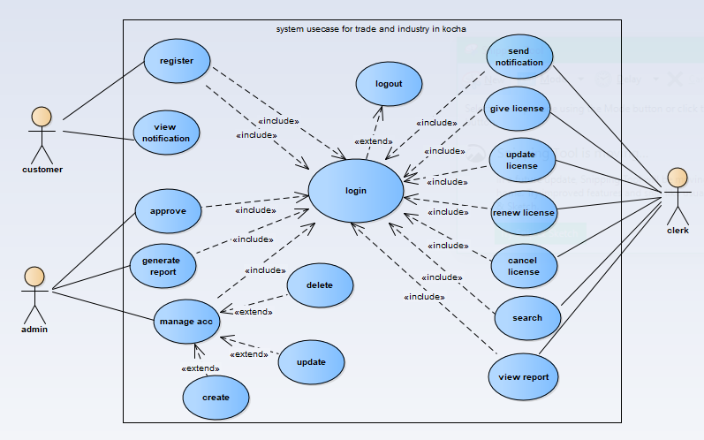

Figure 2 System use case diagram

|  |  |
| --- | --- |
| **Use case description for Create account** | |
| **Use case Name** | Create account |
| **Use case ID** | UC-04 |
| **Actor** | Clerk(employee) |
| **Description** | The admin create account for customers. |
| **Goal** | Admin wants to create account |
| **Precondition** | The admin must be login |
| **Post condition** | The user account is created on the database. |
| **Basic Course of Action** | The admin clicks on the create account button.  The system displays user registration form with the username, password and user type fields.  The admin adds an account and click submit button.  The system displays the acknowledgement message.[AC]  Use case ends |
| **Alternative course 4**. | . The system displays an error message.  The system let the user to enter again.  End of case. |

Table 6use case description for create account

|  |  |
| --- | --- |
| **Use case description for apply registration** | |
| **Use case Name** | **apply registration** |
| **Use case ID** | UC-02 |
| **Actor** | Customer |
| **Description** | Customer wants to be a trader for this he/she has to have a registration. |
| **Goal** | Customer wants to register. |
| **Precondition** | Customer wants to have license. |
| **Post condition** | Customer can have license. |
| **Basic Course of Action** | Customer browses the website of kombolcha trade and industry office.[AC]  Customer select register menu.  System displays the registration form.  Customer fills all detail information.  Customer click on register button.  System display conformation message.  Use case end. |
| **Alternative course 1**. |  |

# 2.7 CRC Diagram

Class Responsibility Collaboration diagram is a collection of standard index cards that have been divided in to sections those are class, responsibility, and collaborator. Class incorporates a collection of similar objects, which are the building blocks of the application. Responsibilities are attributes what a class have or information about the class and what a class does. Collaborator is a class whose services are needed to fulfill one responsibility.

|  |  |
| --- | --- |
| Customer | |
| Name  TIN  Age  Sex  Address  Keble ID | Clerk(employee) |
| Apply registration  Pay service fee  Take license |

|  |  |
| --- | --- |
| Admin | |
| Name  Age  Sex  Responsibility | Clerk(employee) |
| Check license  Create account  View report |

|  |  |
| --- | --- |
| Clerk(employee) | |
| Name  Age  Sex  Generate report  Give license  Renew license  Cancel license | Customer  Admin |

|  |  |
| --- | --- |
| Account | |
| Username  account ID  holder name  password | Admin  Clerk(employee) |
| validate ()  authenticate()  change password() |

|  |  |
| --- | --- |
| License | |
| Code  name | Customer  Clerk(employee) |
| GetGiveDate()  GetRenewalDate()  GetCancelDate( ) |

Table 15CRC diagram

# 2.8 Sequence diagram

A sequence diagram in unified modeling languages (UML) is a kind of interaction diagram that shows how processes operate with one another and in what order. It is a construct of message sequence chart. A sequence diagram shows object interaction arranged in time sequence.

We draw the sequence diagram from the use case description especially from Basic course of action and alternative course of actions.

Sequence diagram for registering Customers

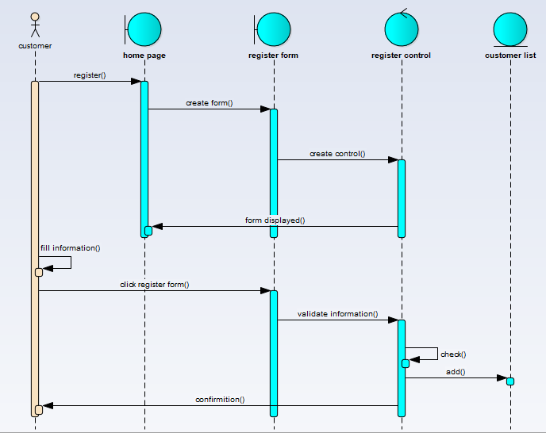

Figure 3sequence Diagram for Apply Registration

Sequence diagram for create account

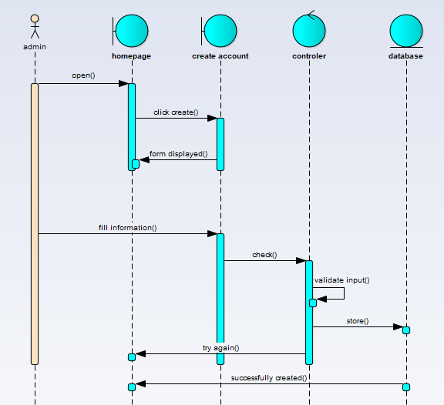

Figure 4sequence diagram for create account

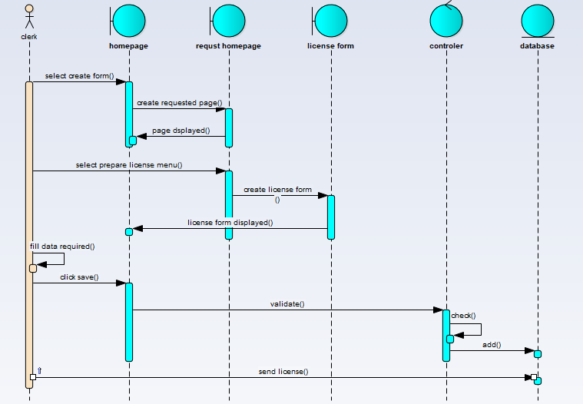

Sequence diagram for Give license

# 2.9 Activity Diagram

Activity diagrams are graphical representations of workflows of stepwise activities and actions with support for choice, iteration and concurrency. In the unified modeling language, activity diagrams can be used to describe the business and operational step-by-step workflows of components in a system. An activity diagram shows in overall flow of control. In its basic form an activity diagram is a simple and intuitive illustration of what happens in a workflow, what activities can be done in parallel, and whether there are alternative paths through the workflow. Activity diagram is basically a flow chart to represent the flow form one activity to another activity. And also UML activity diagram shows the business and functional step by step workflows of components in a system. It shows the overall flow of control. These diagrams are typically used for business process modeling, for modeling the logic captured by a single use case or usage scenario**.**

**Activity Diagram for Apply Registration**

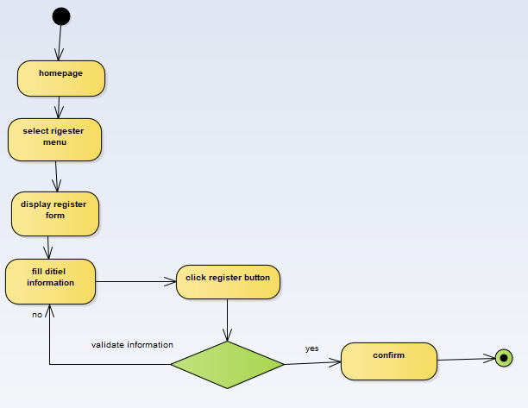

Figure 13Activity Diagram for Apply Registration

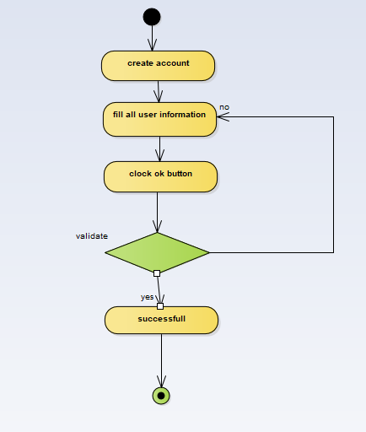

Figure 17activity diagram for create account

# 2.10 Conceptual model: Class diagram

Class diagram is a type of static structure diagram that describes the structure of a system by showing the system’s classes (name), their attributes, operations (or methods), and the relationships among the classes. The class diagram with its corresponding objects will present in the diagram.

Class diagram is the building block of the system that we develop. It shows all the objects and tells us how they are interrelated. Class diagrams are the most popular UML diagrams used by the object oriented community. It describes the objects in a system and their relationships. Class diagram consists of attributes and functions.

A single class diagram describes a specific aspect of the system and the collection of class diagrams represents the whole system. Basically the class diagram represents the static view of a system.

Class diagrams are the only UML diagrams which can be mapped directly with object oriented languages. So it is widely used by the developer community.

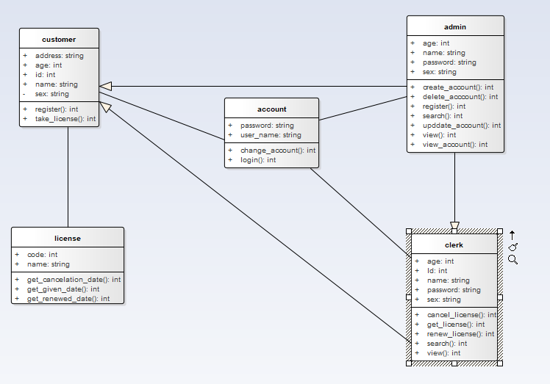

Figure 22class diagram

# Chapter Three

# 3.0 System design

The purpose of designing is to show the direction how the system is built and to obtain clear and enough information needed to drive the real implementation of the system. The goal of the design is to model the system with high quality. Design is the reference frame for the implementation of the system with reasonable changes. If the system is design effectively, any change is easy and clear.

Systems design is the process of defining the architecture, components, modules, interfaces, and data for a system to satisfy specified requirements. Systems design could be seen as the application of system theory to product development. System design is the transformation of the analysis model into a system design model. Until we have determined functional and non-functional requirements of the system by using various requirement elicitation and analysis tools. In the system design we have identified design goals, which are inferred from the non –functional requirements identified during the first phase. Then system decomposition is applied to reduce the complexity of the system. Following architecture of the system is decided to meet the design goals of the system. Hardware software mapping/deployment is also done to identify the technology and platforms going to be implemented. We will identify persistent objects on which the system will have web around and data management system is defined for those object. Finally we have designed interfaces and dialogues to satisfy the needs of the customer.

# 3.1 Purpose and Goals of Design

## 3.1.1 Purpose of System design

The purpose of system analysis and system design are for a business to increase their efficiency, because when we look at a current system we will see flows that need fixed answer within the new system that we design we will take these into consideration. A new system will make the business more profitable. Since we make each step and procedure with design, it will be simple to implement in practice. This means system design is used to indicate how each function is performed. The purpose of our system is to make all users of the system can access easier and faster to the system

## 3.1.2 Design Goals

Design goals are qualities that one system should focus on and are from non functional requirements or from the application domain.

The design goals are derived from the non-functional requirements of the system, which were stated in chapter two of this document. They describe what the system should focus on. This includes:

**Performance:** this is the measures of the system’s operation under load. Criteria’s for performance are the response-time, throughput and space for file storage.

**Availability:** The system needs to be on work for 24 hours in a day and 7 days in a week.

**Security:** system provides security controls through authentication, authorization and data protection. The authentication is by confirming a user. The authorization is by verifying the authenticated user has permission to access a particular resource.

**Reliability:** The reliability criteria determine how much effort should be expanded in minimizing the system crashes and their consequences.

**End user:** End user criteria’s are qualities that are desirable from user’s point of view like usability, maintainability and utility.

The project is purposeful on meeting those design goals. For example:

* Speeding up the response time when a customer comes with request to get service.
* Minimizing the storage space and time to find for files.
* Decreasing the expenses a customer faces while coming to the office to have a license, to renew or update a license.

# 3.3 current System Architecture

Existing system of trade and industry office is manual system and hence there is no current software architecture that will be considered. As a result, we only describe the software architecture of the newly proposed system.

# 3.4 Proposed system architecture

The software system architecture is a high level structure of software system, the discipline of creating such structures, and the documentation of these structures. There are many recognized architectural patterns and styles. Among them are:

The proposed system is expected to replace the existing manual system by an web based system which is all aspects of trade license management system. The architecture used for the system is a three tier Client/Server Architecture where a client can use Internet browsers to access the provided by the system using the Internet or LAN.

Three tier architectures consist of three components distributed in three layers: client (requester of services), data handler and server (provider of services). The three components are

User System Interface (such as session, text input, dialog, and display management services)

Processing Management (such as process development, process enactment, process monitoring, and process resource services)

Database Management (such as data and file services)

The three tier design allocates the user system interface exclusively to the client. It places the application logic on the second layer and places database management on the third layer. Why we choose 3-tier architecture is:

The system works on homogeneous environments with processing rules (business rules) that do not change very often.

Separation of business logic from application logic minimizes the work load of server and enhances the security of data.



Figure 25software architecture for kombolcha Trade and industry Office

## 3.4.1 Subsystem Decomposition

Subsystem decomposition is the process of dividing the system in to manageable subsystems from the analysis model of the proposed system. The goal of the system decomposition is to reduce the complexity of design model and to distribute the class of the system in to large scale and cohesive components.

A subsystem is a collection of classes, operations, events and constraints that are interrelated to provide a set of services to a system. These are a grouping of model elements that represent a behavioral unit in a physical system. We used subsystem decomposition diagrams to express how our system is decomposed to smaller parts or set of related operations that share a common purpose. Subsystem decomposition results into a set of loosely dependent parts which make up of the system.

Subsystem diagram shows the service it provides or it accepts from other subsystems, and the coupling and the coherence between them.

* Create account subsystem
* Registration subsystem
* Notification subsystem
* Give license subsystem
* Update license subsystem
* Renew license subsystem
* Search customer subsystem
* Approve subsystem
* Send message subsystem
* View message subsystem
* Search request subsystem
* Manage account subsystem
* Generate report subsystem

## 3.4.2 Component Diagram

Systems may be built from components in component based architecture. Component diagram shows how objects (classes) in the system will grouped together and form components. The components interact with each other either in giving service to other components or requesting service from other component.

Component diagram is used to model the physical aspects of the system. These physical aspects are the elements in the system like executables, libraries, documents, files, forms, etc. which resides in the nodes, so that we used component diagrams to visualize the organization and relationships among components in our system.



Figure 26Component Diagram for Trade License Management System

## 3.4.3 Deployment Diagram

Deployment modeling is used to show the hardware of the system, the software that is installed in the hardware and also shows how the software and the hardware components work together.

Deployment diagram is a UML diagram that used for describing how the hardware components are deployed. We used to visualize the topology of the physical components of our system where the mentioned software component diagrams are deployed.

Deployment diagram depicts a static view of the run-time configuration of processing nodes and the components that run on those nodes. In other words, deployment diagrams show the component of the software will installed on which the hardware machine and how they interact with each other. That is hardware and software part of the system work together efficiently. We want to create a deployment diagram for applications that are deployed to several machines.

It is representing the allocation of components to different nodes and the dependencies among components. The proposed system has layers: presentation layer web server and the database server. For example, the first layer is presentation layer which is used to clients that enable them to communicate with the web server. It is shown as a client application which is found under the client machine. Web server contains a number of functionality supported by the system. For example, the web Server as shown in the deployment diagram incorporates those components. The database is developed using MYSQL. It stores the data persistently. The presentation layer communicates with the web server using http connection that makes it to invoke methods remote.



Figure 27Deployment Diagram

## 

**Chapter four**

**Implementation**

**Coding**

**for admin**

public class admin extends customer clerk {

public int age;

public string name;

public string password;

public string sex;

public account m_account;

public admin(){

}

public void finalize() throws Throwable {

super.finalize();

}

public int create_account(){

return 0;

}

public int delete_acccount(){

return 0;

}

public int register(){

return 0;

}

public int search(){

return 0;

}

public int upddate_account(){

return 0;

}

public int view(){

return 0;

}

public int view_account(){

return 0;

}

}//end admin

**For customer**

public class customer {

public string address;

public int age;

public int id;

public string name;

private string sex;

public account m_account;

public license m_license;

public customer(){

}

public void finalize() throws Throwable {

}

public int register(){

return 0;

}

public int take_license(){

return 0;

}

}//end customer

# Chapter 5

# Conclusion and Recommendation

# 5.1 Conclusion

In analyzing of the existing manual system, we found that services in “trade and industry office” are not enough to serve and a lot of problem. This manual system is highly time consuming. So that the existing system creates a lot of work load on employee. These lead to service delay, job and service dissatisfaction and inefficient, and user need to find resources from the office.

So, after we have completed this project we are sure that the existing problems would answer. The” WEB BASED TRADE LICENSE MANAGEMENT SYSTEM” minimizes the problem in the office.

In this project we try to gather different information about kombolcha trade license management how to work their management activities. Such kinds of data gathering procedures help us to web based trade license management system from scratch by using all software development life cycle like requirement gathering, requirement specification, system design, implementation, and configuration of the system.

The proposed system made computerized to reduce human errors and to increase the efficiency. The main focus of this project is to lessen human efforts. The maintenance of the records is made efficient, as all the records are stored in the database, and also data can be retrieved easily. The editing is also made simpler.

Our main aim of the project is:

* Reduce the number of employee
* Minimize the time required to perform task
* Minimize the work load of employees
* Provide sufficient security
* Increase employee satisfaction

# 5.2 Recommendation

According to scope of our project the team develops web based application. Because of the time constraint we may have limitation which should be consideration in, but in the feature the team believes that this system should be fully operationally by adding some functionality that are not included in the proposed system.

We recommend to working the following functionality in the future:

* Web based payment system for the applications such as give licens,update license, renew license and cancel license required by the system

Finally the team would recommend that further work should done on the system in order to make the system perform better for organization who like to use web based trade license management system.