Homework 2 – Exercise 2A
Improving Weak Prompts

Weak Prompt a) Explain regression
a) Improved prompt: explain regression to a beginner in two paragraph in the most common understandable way with example
b) Screenshot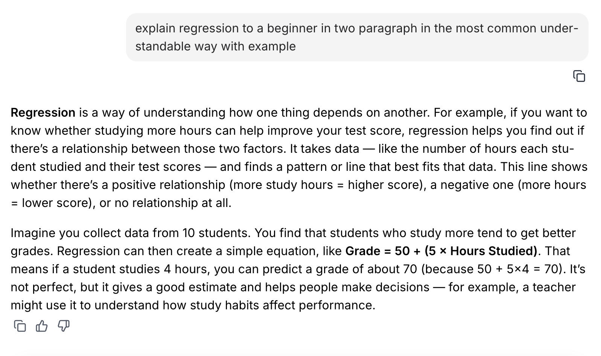

Weak Prompt b) Help me understand SQL
a) Improved prompt.explain the basics of SQL to a beginner and two good sentences with examples and stating how helpful it is
b) Screenshot.
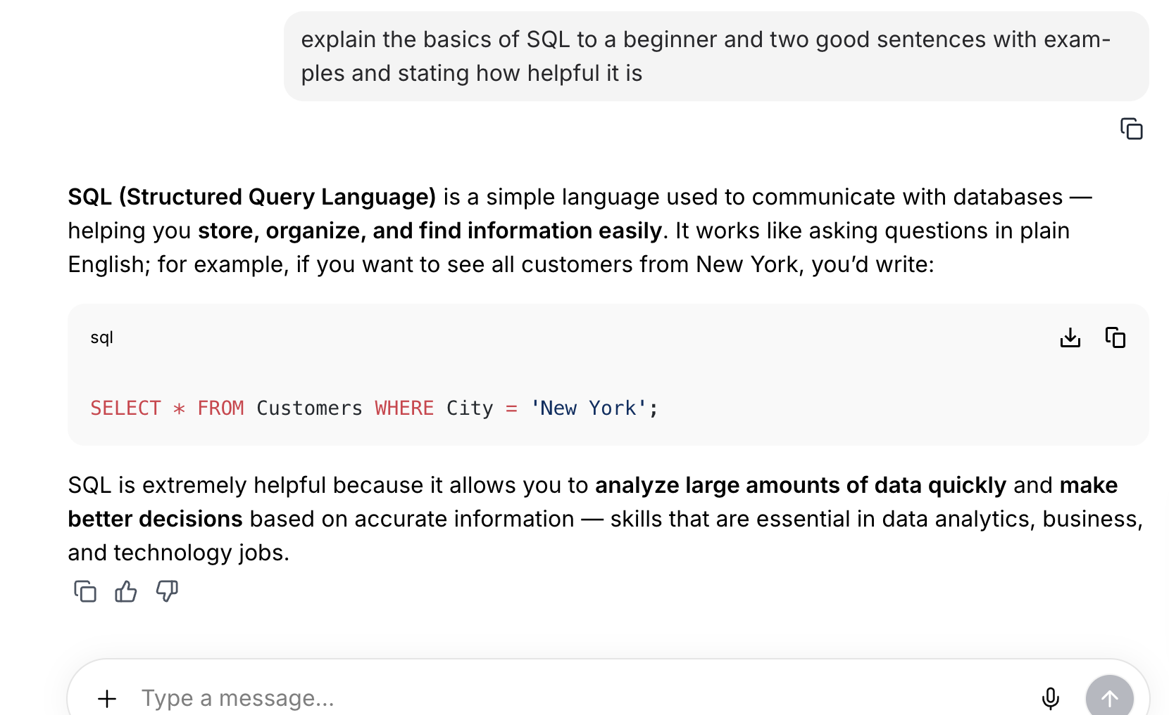
Weak Prompt c) Create a dataset
a) Improved prompt: Create a data set of 5 year UP United student showing their grades in data pre-work communication and a workplace applied learning Wilmington and CDIR courses.
b) Screenshot
