Arabic Morocco CO
Linguistic Groups
HTML5

Directions: Click and drag the flags identifying language regions to the appropriate locations on the map. Once a flag is selected, the window will display a hint. If a selected flag is dropped in the correct location, it will change color and remain in place. Information about the ethnic group will be displayed. This information can also be accessed by clicking a flag already placed on the map.

Moroccan
Hint: Moroccan speakers are found primarily along the Atlantic coast.
Moroccan Arabic is a spoken dialect that has been influenced by Tamazight, French, and Spanish.
[Note: Identified as orange on the map.]

Tarifit
Hint: Tarifit speakers are found primarily in northern Morocco.
Tarifit is one of the Tamazight languages of northern Morocco. It is spoken by people living in the Rif region.
[Note: Identified as light gray on the map.]

Tamazight
Hint: Tamazight speakers are found primarily in central Morocco.
Tamazight has been a written language for over 2,000 years. The name Tamazight is also used to refer to other non-Arabic languages in Morocco.
[Note: Identified as dark gray on the map.]

Tachelhit
Hint: Tachelhit speakers are found primarily in southwestern Morocco.
Tachelhit speakers are primarily indigenous non-Arabs, mostly Sunni Muslims, who live in the southwest of Morocco.
[Note: Identified as green on the map.]

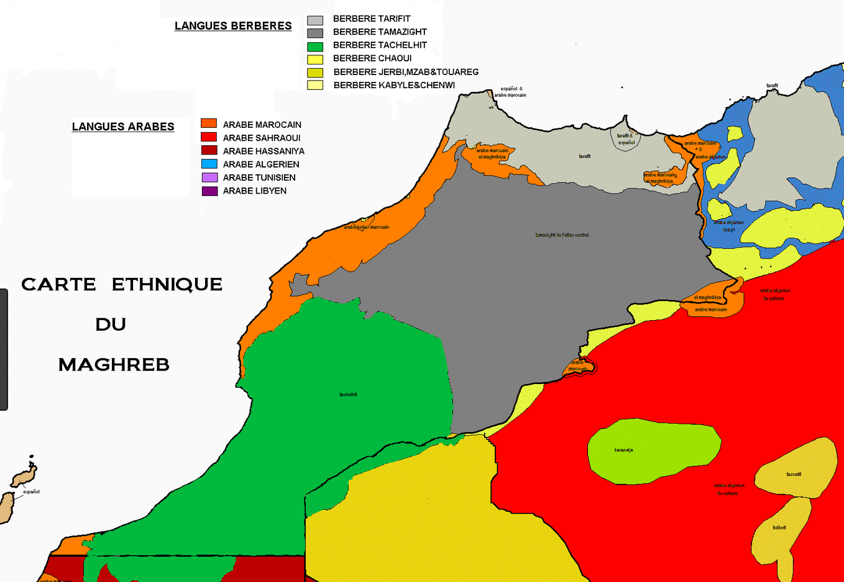

https://www.google.com/search?biw=1536&bih=750&tbm=isch&sa=1&ei=X_-5XJjIHab_0gLzkbmICA&q=morocco+dialect+map&oq=morocco+dialect+map&gs_l=img.3...56300.59287..59486...0.0..0.155.1521.8j7......1....1..gws-wiz-img.......0i7i30j0i8i7i30j35i39j0.bZ-ZyVuuaw8#imgrc=k0QuqbehesJxjM:

