Complete genome sequence of the cyprodinil-degrading Acinetobacter johnsonii LXL_C1
Weijun Wang,¹ Xiaoxin Chen,² Hai Yan¹, Jiye Hu¹ and Xiaolu Liu¹*

¹Institute of Chemistry and Biological Engineering, Department of Biological Technology, University of Science and Technology Beijing, Beijing 100083, People’s Republic of China;

²College of Chemistry and Environmental Science, Hebei University, Baoding City, Hebei Province, 071002, P.R.C China

*Corresponding author: Xiaolu Liu, e-mail:xiaoluliu@ustb.edu.cn, Tel.: +86 13717911089
Weijun Wang and Xiaoxin Chen contributed equally to this work.

Abstract
Acinetobacter johnsonii LXL_C1, degrader of cyprodinil, was isolated and purified from cyprodinil-contaminated agricultural soil. Here, we elaborated the complete genome sequence of LXL_C1, the genome contained one circular chromosome of 3,398,706 bp with 41.2% G + C content and one plasmid of 44,866 bp. Based on COG and KEGG database, the annotation indicated that the strain contained genes encoding cytochrome P450 monooxygenase and hydrolase, which could degrade cyprodinil effectively. Complete genome sequence of LXL_C1 can provided genetic information for constructing recombinant degrader using genetic engineering technology.
Key words
Acinetobacter johnsonii LXL_C1; Complete genome sequence; Cyprodinil; Microbial degradation

Introduction
Cyprodinil, 4-cyclopropyl-6-methyl-N-phenylpyrimidin-2-amine, is a broad-spectrum anilinopyrimidine fungicide by Syngenta and has widely used worldwide in agriculture to protect wheat, vegetables, fruit plants and other crops from various pathogens such as Venturia inaequalis, Tapesia yallundae, Botrytis spp., Alternaria spp., and Rhynchospium secalis^{[1]}. Anilinopyrimidines fungicide could inhibit germ-tube elongation and initial mycelial growth^{[2]}. In addition, cyprodinil was also discovered for it’s a bility as to secretion inhibition of extracellular proteins that include fungal hydrolases associated with pathogenesis^{[2]}. The fungicide enough to kill target pathogens, but affect native ecosystem in the same time^{[3]}. Up to now, cyprodinil has generally been reported to cause slight acute toxicity and groundwater contamination ^{[4]}.Recently, Wang Y have reported that cyprodinil has multiplex effects on zebrafish growth^{[5]}. As we all know, the use of microorganisms has been considered as a crucial way for the biodegradation of fungicides. It was reviewed that 90.6% of the toxic substances were biodegraded by bacteria and 9.4% were only done by fungi and algae, respectively^{[6]}. Multiple microorganisms, known to contain the enzyme cytochrome P-450 monooxygenase or other degradative enzymes, can metabolize cyprodinil fungicide, such as C. echinulata var. echinulata ATCC 9244, A. pseudocylindraspora ATCC 24169^{[7]}. It has been reported that these strains could convert cyprodinil to monohydroxylated and dihydroxylated metabolites, as well as 4-cyclopr- opyl-6-methyl-2-pyrimidamine^{[7]}. Additionly, cytochrome P450 enzymes have been known to transform chlorpyrifos through oxidation and hydrolytic reactions^{[8]}.
Acinetobacter johnsonii LXL_C1 was a Gram-negative bacterium which was isolated and purified from cyprodinil-contaminated agricultural soil in China^{[9]}. Phylogenetic analysis of 16S rRNA gene sequences revealed that the strain was classified as Acinetobacter, and it was most closely related to Acinetobacter junii strain ATCC 17908 with 99% sequence similarity^{[9]}.They played an important role in mineralization of aromatic compounds. Here, we reported the complete genome sequence of Acinetobacter johnsonii LXL_C1 ,which contained the cytochrome P450 monooxygenase.
Genomic DNA from an Acinetobacter johnsonii LXL_C1 was extracted (这里好像using引导了一个省略了连接词的条件状语从句，但没有这种用法，可以用with代替，或when using) using （by）DNA Extraction Kit (E.Z.N.A® xxx DNA kit, OMEGA). The genomic sequencing of this strain was performed using Illumina Hiseq combined with third-generation sequencing technology. Illumina PE libraries (300-500bp) and PacBio libraries (15-20kb) were generated with Illumina TruSeqTM Nano DNA Sample Prep Kit and G-tubes, respectively. The genome of Acinetobacter johnsonii LXL_C1 was sequenced on the single molecule real-time (SMRT) DNA sequencing platform by a PacBioRS sequencer. PacBio SMRTbell libraries were loaded to SMRT cells for sequencing. After the filtration of low quality reads, a total of 17,611 reads and 146,540,043 bp were generated with an average read length of 8321 bp. Illumina sequencing data was initially assembled with ABySS version 2.0.2 software, resulting in one circular chromosome of 3,398,706 bp and one plasmid of 44,866 bp. The coding sequences were predicted by RAST （http://rast.nmpdr.org/）. rRNA and tRNA in the genome were predicted by RNAmmer version 1.2 and tRNAscan-SE version 1.3.1 software. To obtain the annotation information of the predicted gene, the protein sequence of the predicted genes was compared with the eggNOG database by blastp (BLAST 2.2.28+). The BLAST algorithm (BLAST+ 2.7.1) was used to compare the predicted genes with the KEGG gene database(http://www.genome.jp/kegg/), and the corresponding biological pathways involved in the genes were obtained based on the obtained KO numbers. The GO (Gene Ontology, http://www.geneontology.org/) annotation of the blast results were analyzed by blast2go software. The genomic circle map was constructed by Circos v0.64 (http://circos.ca/) software.
The genome of Acinetobacter johnsonii LXL_C1 consisted（不及物） a circular chromosome 3,398,706 bp in size (Fig. 1A) and a 44,866 bp plasmid (Fig. 1B). A total of 3258 and 48 coding DNA sequences were predicted in circular chromosome and plasmid, respectively. The plasmid encode a number of genes dedicated to bacterial secretion system such as virB, lvhB, virD4 and lvhD. Based on the annotation, 9 genes were described to be involved in secretion system of the strain. It's commonly known that the type IV secretion system consists of 11 virB proteins and 1 virD4 protein, which has been shown to play key roles in DNA and proteins transfer^{[16-19]}. Furthermore, We also identified 2 genes on the plasmid, virB11 and lvhB11, which may be related to the epithelial cell signaling in helicobacter pylori infection, based on KEGG database. Moreover, one genes related to legionellosis are located in the plasmid, namely, lvhB2, could improve the efficiency of Legionellosis pneumophila infection of mammalian cells^{[20]}. Additionaly, five genes related to legionellosis pathway were also found in the genome of LXL_C1 chromosome, including sdhA, frdA , lepA, groEL and HSPD1.
In addition, 87 tRNA and 21 rRNA were predicted in the complete genome of Acinetobacter johnsonii LXL_C1(Table.1). The chromosome had an average GC-content of 41.2% (Table.1 and Fig. 1A). Genome features of Acinetobacter johnsonii LXL_C1 were summarized in Table 1. Circular genome map was visualized in Fig.1. Furthermore, there were 2063 predicted genes assigned to the COG database (Table 2 ).
Table 1
Genome features of Acinetobacter johnsonii Strain LXL_C1
features | values
 | Chromosome | Plasmid
Genome size (bp) | 3,398,706 | 44,866
G +C content (%) | 41.2 | --
tRNA | 87 | --
rRNA | 21 | --
Gene number | 3258 | 48

Table 2
COG categories of Acinetobacter johnsonii Strain LXL_C1
COG class | Functional categories | Count
A | RNA processing and modification | 1
B | Chromatin structure and dynamics | 0
C | Energy production and conversion | 147
D | Cell cycle control, cell division, chromosome partitioning | 24
E | Amino acid transport and metabolism | 183
F | Nucleotide transport and metabolism | 62
G | Carbohydrate transport and metabolism | 56
H | Coenzyme transport and metabolism | 88
I | Lipid transport and metabolism | 104
J | Translation, ribosomal structure and biogenesis | 161
K | Transcription | 73
L | Replication, recombination and repair | 167
M | Cellwall/membrane/envelope biogenesis | 143
N | Cell motility | 10
O | Posttranslational modification, protein turnover, chaperones | 90
P | Inorganic ion transport and metabolism | 156
Q | Secondary metabolites biosynthesis, transport and catabolism | 42
R | General function prediction only | 197
S | Function unknown | 225
T | Signal transduction mechanisms | 60
U | Intracellular trafficking, secretion, and vesicular transport | 46
V | Defense mechanisms | 27
W | Extracellular structures | 1
Y | Nuclear structure | 0
Z | Cytoskeleton | 0

Fig.1
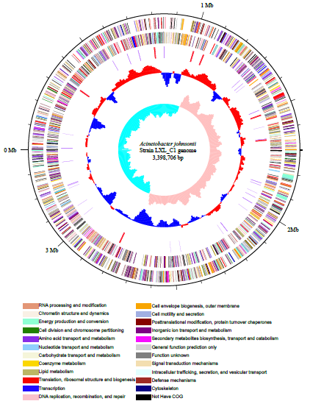
(A)
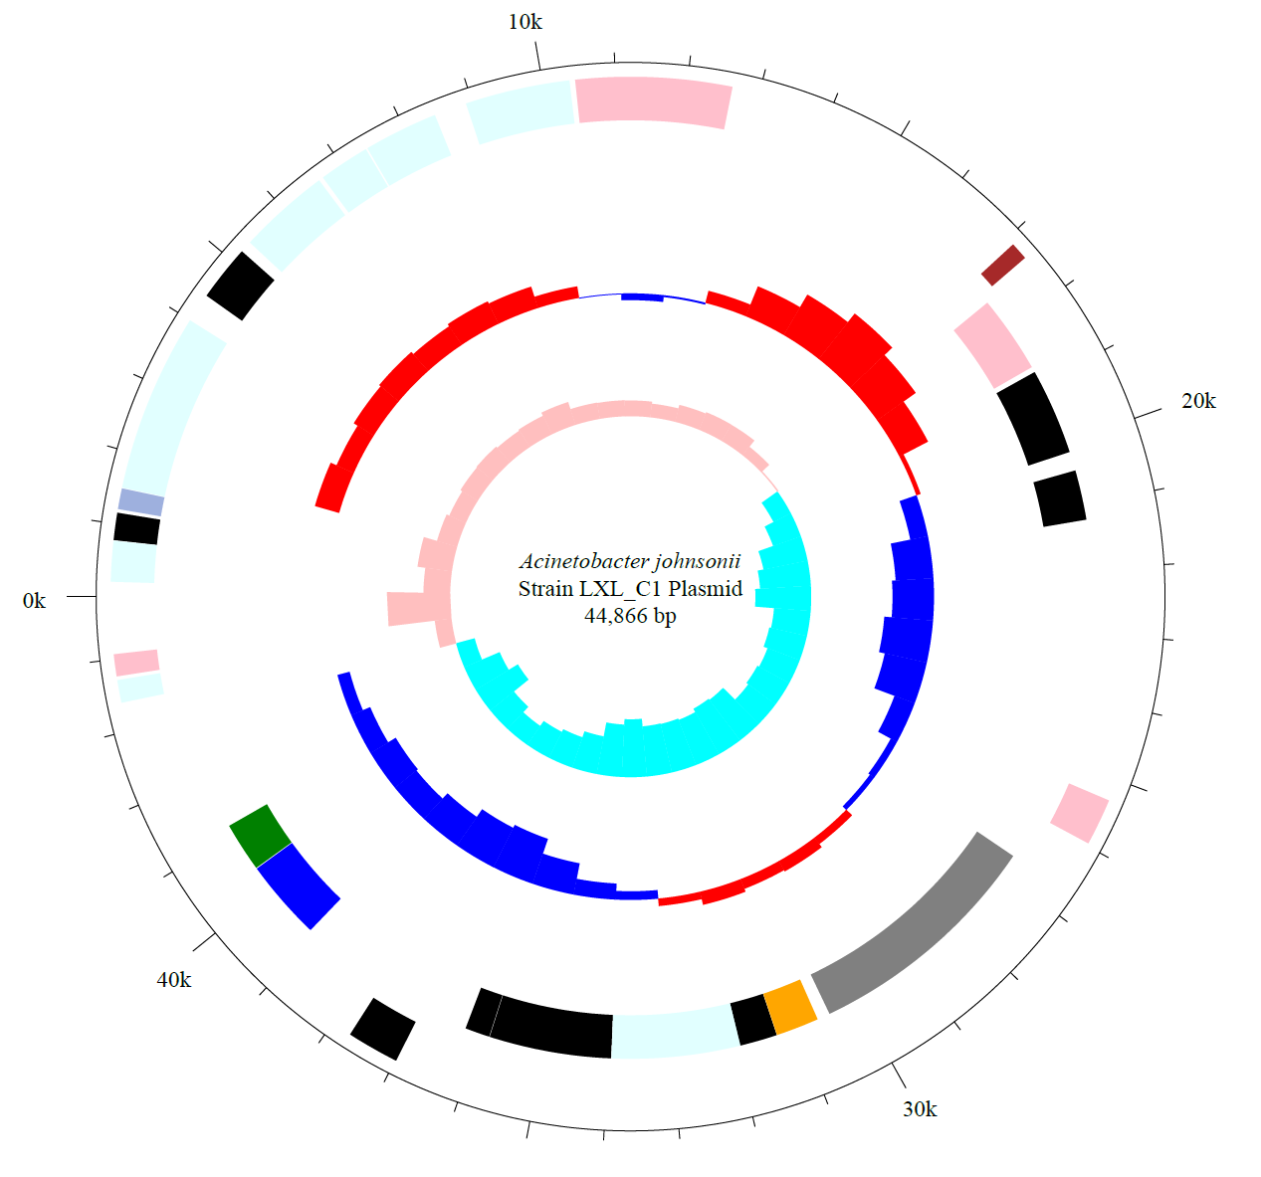
(B)
Based on the identification of metabolites using HPLC-QTOF-MS/MS technique, the metabolic pathway of Acinetobacter johnsonii LXL_C1 to cyprodinil was elucidated. In the metabolic pathway, cyprodinil was transformed into 4-cyclopropyl-6-methyl-2-pyrimidamine and parahydroxylate-substituted (4-cyclopropyl-6-methyl-N-phenol-2-pyrimidinamine) metabolite^{[9]}. The finding suggested that Acinetobacter johnsonii LXL_C1 strain retained genes encoding enzymes including in the hydroxylase and amine hydrolase^{[9]}. As is well known, cytochrome P450 is a class of monooxygenase that can catalyze aromatic hydrocarbons and alkanes^{[10]}. Furthermore, CYP genes could be identified as the killer of chemical insecticidesin Diptera, Hemiptera and Coleoptera^{[11]}. The enzyme has the ability to cause aliphatic and aromatic hydroxylations as well as N-, S-, and O-dealkylations with a wide range of xenobiotic substrates^{[7]}. Previously, it has been extensively reported that cytochrome P450 were capable of eliminating the toxic effects of pesticides through hydroxylation，such as mepanipyrim, cyprodinil.[12-15]. The above literatures (above表示副词时意思是a above b，这里应该是the literatures above（this line）) illustrated that cytochrome P450 played a paramount role in the degradation of cyprodinil. According to the annotation of KEGG database, some genes located on the genome of Acinetobacter johnsonii LXL_C1, were predicted to be involved in degradation of cyprodinil. The frmA, ADH5, and adhC genes encoded metabolic pathways of xenobiotics and drugs by cytochrome P450, which can hydroxylate the aromatic rings of cyprodinil. There were hydrolase genes in the genome that could catalyze the amino hydrolysis of cyprodinil, which removed the phenyl ring from the cyprodinil molecule.
Summarized, the genomic features of LXL_C1 demonstrate that it has the potential to transform anilinopyrimidine fungicide. Our complete genome sequence of Acinetobacter johnsonii LXL_C1 provided a better understanding of the mechanisms as to degradation of cyprodinil at the gene level and theoretical support for the practical application of biodegradation of cyprodinil.
Conflicts of interest
The authors declare no competing financial interest and human conflicts.
Acknowledgments
This work was supported by financial support from National Natural Science Foundation of China (Project NO. 31500034) and Fundamental Research Funds for the Central Universities (Project NO. FRF-BR-17-002B).

References
[1] Esteveturrillas F A, Agulló C, Abadfuentes A, et al. Immunoreagent Generation and Competitive Assay Development for Cyprodinil Analysis[J]. Journal of Agricultural & Food Chemistry, 2012, 60(19):4803.
[2] KnaufBeiter, G, Dahmen, H, Heye, U, et al. Activity of cyprodinil: optimal treatment timing and site of action.[J]. Plant Disease, 1995, 119(1):280-292.
[3] Rangasamy K, Athiappan M, Devarajan N, et al. Emergence of multi drug resistance among soil bacteria exposing to insecticides[J]. Microbial Pathogenesis, 2017, 105:153-165.
[4] Fang C C, Chen F Y, Chen C R, et al. Cyprodinil as an activator of aryl hydrocarbon receptor[J]. Toxicology, 2013, 304(1):32-40.
[5] Wang Y, Dai D, Yu Y, et al. Evaluation of joint effects of cyprodinil and kresoxim-methyl on zebrafish, Danio rerio[J]. Hazard Mater. 2018;352:80-91.
[6] Awasthi G, Kumari A, Pant A B, et al. In silico identification and construction of microbial gene clusters associated with biodegradation of xenobiotic compounds[J]. Microbial Pathogenesis, 2018, 114:340-343.
[7] Schocken M J, Mao J, Schabacker D J. Microbial transformations of the fungicide cyprodinil (CGA-219417).[J]. Journal of Agricultural & Food Chemistry, 1997, 45(9):3647-3651.
[8] Rangasamy K, Athiappan M, Devarajan N, et al. Pesticide degrading natural multidrug resistance bacterial flora.[J]. Microbial Pathogenesis, 2017, 114:304.
[9] Chen X, He S, Liu X, et al. Biobegradation and metabolic mechanism of cyprodinil by strain Acinetobacter sp. from a contaminated-agricultural soil in China[J]. Ecotoxicology and environmental safety, 2018, 159:190.
[10] Bernhardt R. Cytochromes P450 as versatile biocatalysts[J]. Journal of Biotechnology, 2006, 124(1):128-145.
[11] Dulbecco AB, Moriconi DE, Calderón-Fernández GM, et al. Integument CYP genes of the largest genome-wide cytochrome P450 expansions in triatomines participate in detoxification in deltamethrin-resistant Triatoma infestans[J]. Sci Rep. 2018;8(1):10177.
[12] Mary A. Schuler. Plant Cytochrome P450 Monooxygenases[J]. Critical Reviews in Plant Sciences, 1996, 15(3):235-284.
[13] Christopher J T, Preston C, Powles S B. Malathion Antagonizes Metabolism-Based Chlorsulfuron Resistance in Lolium rigidum[J]. Pesticide Biochemistry & Physiology, 1994, 49(3):172-182.
[14] Topal A, Adams N, Dauterman W C, et al. Purification and herbicide metabolism studies on tulip (Tulipa gesneriana) cytochrome P450[J]. Pest Management Science, 2010, 38(1):9-15.
[15] Zhu Y Z, Keum Y S, Lin Y, et al. Metabolism of a Fungicide Mepanipyrim by Soil Fungus Cunninghamella elegans ATCC36112[J]. Journal of Agricultural & Food Chemistry, 2010, 58(23):12379-12384.
[16] Das A. Delineation of polar localization domains of Agrobacterium tumefaciens type IV secretion apparatus proteins VirB4 and VirB11[J]. Microbiologyopen. 2014 ;3(5):793-802.
[17] Kerr JE, Christie PJ. Evidence for VirB4-mediated dislocation of membrane-integrated VirB2 pilin during biogenesis of the Agrobacterium VirB/VirD4 type IV secretion system[J]. Bacteriol. 2010 ;192(19):4923-34.
[18] Tsai Y L, Wang M H, Gao C, et al. Small heat-shock protein HspL is induced by VirB protein(s) and promotes VirB/D4-mediated DNA transfer in Agrobacterium tumefaciens[J]. Microbiology, 2009, 155(10):3270-3280.
[19] Redzej A, Ukleja M, Connery S, et al. Structure of a VirD4 coupling protein bound to a VirB type IV secretion machinery.[J]. Embo Journal, 2017, 36(20):3080-3095.
[20] Dennis A. Ridenour, Suat L. G. Cirillo, Sheng Feng, et al. Identification of a Gene That Affects the Efficiency of Host Cell Infection by Legionella pneumophila in a Temperature-Dependent Fashion[J]. Infect Immun. 2003 ; 71(11): 6256–6263.

Figure and Table captions
Fig.1 Circular genome map of Acinetobacter johnsonii LXL_C1.fig.1A and fig.1B represent genome map of chromosome and plasmid, respectively. From the outermost circle to the innermost circle, circle (1) represents the size of the Genome, each scale is 0.5 Mb; circle (2) and circle (3) represent the coding DNA sequence (CDS) on the positive and negative chain, respectively; circle (4) represents rRNA and tRNA; circle (5) and circle (6) represents GC content and GC skew, respectively.
Table.1 Genome features of Acinetobacter johnsonii Strain LXL_C1
Table.2 COG categories of Acinetobacter johnsonii Strain LXL_C1

