Resources For Data Science and Machine Learning

**Try this :** [**Guided Machine Learning**](https://elephantscale.github.io/guided-machine-learning/) **by Sujee Maniyam :-)**

# Learning Python

* [A Byte of Python](https://python.swaroopch.com/) - (FREE online book) - a very good online book introducing Python
* [Dive into Python](https://diveintopython3.problemsolving.io/) - (FREE online book)
* [Learn Python the Hard Way](https://learnpythonthehardway.org/python3/) - (FREE online book)
* [Google Python Class](https://developers.google.com/edu/python/?csw=1) - FREE online class
* [Python Cookbook](https://github.com/ActiveState/code) - Recipes in Python
* [Python tutorials and exercises](https://www.w3resource.com/python-exercises/) - For your practice

# Python Data Science

* <https://scipy-lectures.org/>
* [Best Python data science books](http://bigdata-madesimple.com/8-best-python-data-science-books/)
* Book - [Python for Data Analysis](https://www.oreilly.com/library/view/python-for-data/9781491957653/)
* Book - [Natural Language Processing with Python](http://www.nltk.org/book/)

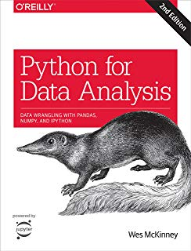 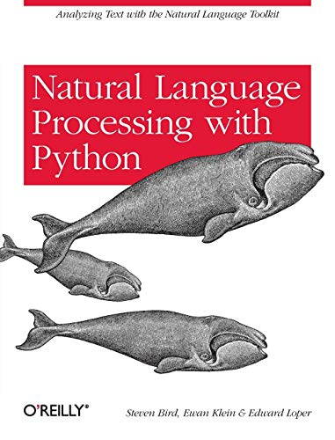

# Machine Learning Basics / Foundations

* Book - [Think Stats](https://greenteapress.com/wp/think-stats-2e/)
* Book - [Practical Statistics for Data Scientists](http://shop.oreilly.com/product/0636920048992.do)
* [Basic Stats](https://statpages.info/)
* [Fantastic video series on Stats by Brandon Foltz](https://www.youtube.com/playlist?list=PLyuzqMwtJuvKwadONz4R9H2JFrOi8LFWt)

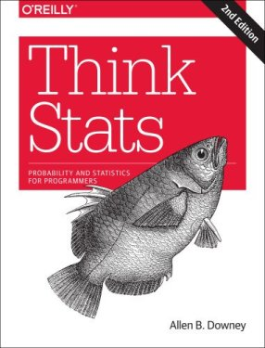 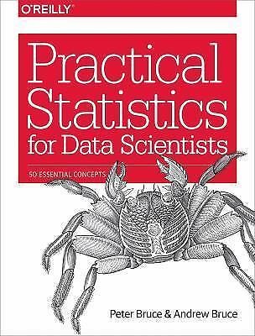

# Machine Learning Meta Links

* [Awesome Machine Learning](https://github.com/josephmisiti/awesome-machine-learning)
* [Machine Learning for Software Engineers](https://github.com/ZuzooVn/machine-learning-for-software-engineers)

# Machine Learning

* [Machine Learning Mastery](https://machinelearningmastery.com/) - Good collection of books and blog posts
* Book - [Real-World Machine Learning](https://www.manning.com/books/real-world-machine-learning)
* Book - [An Introduction to Statistical Learning](http://faculty.marshall.usc.edu/gareth-james/) - A gentle introduction to ML theory
* Book - [Elements of Statistical Learning](https://web.stanford.edu/~hastie/ElemStatLearn/) - more rigorous math treatment than above

