

Employee Advisor

TEAM PROJECT OF IT SYSTEM

**Version [1.0]**

**Authors:**

Marko Andrushchenko  
Alexandr Shevchenko  
Viktor Surzhko

Lublin 2020

Table of Contents

General subject info 4

1 Project description 5

2 Time schedule for project implementation 7

3 Description of processes that take place in the planned IT system 8

3.1 Business model 8

3.1.1 Market Analysis 8

3.1.2 Marketing Plan 8

3.2 Processes 8

3.2.1 Process number 1 – [Employee registration and supervision] 8

3.2.2 Process number 2 – [Collecting data] 10

3.2.3 Process number 3 – [Calculation and preparation of data] 12

3.2.4 Process number 4 – [Recommendation generation and visualization] 13

4 Objective, scope, context and Implementation Stages of the IT system 15

4.1 Objective 15

4.2 Scope 15

4.3 Context 15

4.4 Project Implementation Stages 15

5 Examples of documents used in the designed IT system 16

6 Requirements description 18

6.1 Main requirements 18

6.1.1 Functional requirements 18

6.1.2 Non-functional requirements 18

6.2 Extra requirements 20

6.2.1 Functional requirements 20

7 Identification of possible system events 21

8 Design of the functional structure of the system 22

8.1 System diagram (DFD0) 22

8.2 Use Case diagram 22

9 Hierarchical function model 23

10 User interface design 23

10.1 Login Interface 23

10.2 Administrator interface 25

10.3 User Interface 28

10.4 Project Manager 29

10.5 Company Director 31

11 Documents generated by the System 31

12 Technical and spatial structure of the designed IT system 31

12.1 Frontend technologies 31

12.2 Backend technologies 31

13 Basic test cases 33

13.1 Test Case №1: Login 33

13.2 Test case №2: Registration 33

13.3 Test case №3: View statistics 33

13.4 Test Case №4: Manage groups 33

14 List of figures 35

15 List of tables 35

# General subject info

**Subject:**

TEAM PROJECT OF IT SYSTEM

**Description:**

The aim of this course is the team preparation of IT system technical document by students.

It should be a summary and practical verification of programming knowledge acquired by students.

**Project requirements:**

1. Students should go through the entire software development cycle - from requirement specifications to testing.
2. It is recommended that students learn the new technologies needed to complete the project while working on the project.
3. The specification acquisition phase should be as close as possible to the reality - students should create requirements on the basis of conversations with the course leader - who then acts as a client.

# Project description

The goal of our project is to analyze employees’ performance and create special recommendations and statistics. Our project implies that the office will be fitted with video cameras, which will be used to supervise employees. Every employee must complete a mandatory registration where he\she will be asked to scan his\her face in order to be recognized by our face recognition system. Our implemented system will also collect data about whether employees had completed their assigned tasks. Additionally, we may collect information about employee’s whereabouts (within the office), their food or drink preferences (in case they order their meals using IoT vending machines). The recommendations for employees will provide them with information about their productivity rating and how can they improve it. On the other hand, the company directors will be able to see statistics regarding all employees with ability to filter it. This information can be used in order to help out employees in trouble or reward productive employees.

In order to ease the company supervision, our project suggests such office control structure:

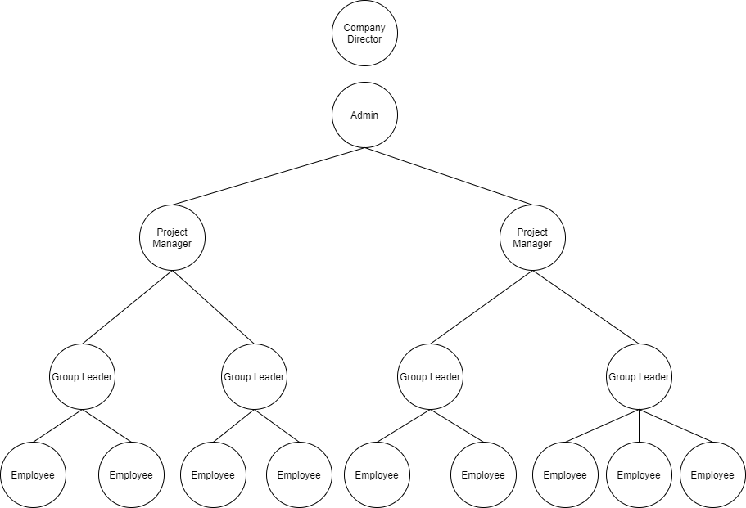

Figure 1 Company Control Structure Example

Source: Own work

The Administrators assign initial Project Managers, the Project Managers assign and control Group Leaders, the Group Leaders can add users to their group. Additionally, the Administrators will be able to assign any roles if there is such a need.

We see that many companies have the need to automate supervision of their employees and to register any outliers. The bigger offices that have a big number of employees are especially hard to supervise without any automatization.

Our project is intended to catalogue and analyze employee data. This data will then be used to build graphs and recommendations. It will ease the task of accounting and checking on the employees.

We chose this project because we would like to develop a system that solves the problem with employee supervision. We see that many companies have a problem with personnel management, and we would like to develop a solution for that.

The users will be able to login to our application and see their productivity rating as well as receive recommendations regarding their activities. Only employees without roles and group leaders will receive personal recommendations. The company director will be able to see a list of employees and their average rating with ability to filter this list.

# Time schedule for project implementation

Table 1 Schedule of Project Implementation

Source: Own Work

|  |  |  |  |
| --- | --- | --- | --- |
|  | *Deadline* | *Task* | *Executed* |
| *1* | *02/12/2019* | *Prepare a project description* | *01/12/2019* |
| *2* | *09/12/2019* | *Prepare a Project Time Schedule* | *05/12/2019* |
| *3* | *09/12/2019* | *Prepare description of processes that take place in the planned IT system without BPMN* | 08/12/2019 |
| *4* | *16/12/2019* | *Add BPMN diagrams to planned IT System* | 13/13/2019 |
| *5* | *7/01/2020* | *Prepare Objective, scope and context of the IT system* | 5/01/2020 |
| *6* | 14/01/2020 | *Prepare Examples of documents used in the designed IT system* | 12/01/2020 |
| *7* | 14/01/2020 | *Prepare Functional Requirements description*  *Prepare Nonfunctional Requirements description* | 12/01/2020 |
| *8* | 21/01/2020 | *Identify possible system events* | 19/01/2020 |
| *9* | 21/01/2020 | *Design the foundation of the functional structure of the system* | 19/01/2020 |
| *10* | 21/01/2020 | *System diagram (DFD0)*  *Use Case diagram* | 19/01/2020 |
| *11* | 27/01/2020 | *User interface design* | 24/01/2020 |
| *12* | 27/01/2020 | *Documents generated by the System* | 24/01/2020 |
| *13* | 27/01/2020 | *Technical and spatial structure of the designed IT system* | 26/01/2020 |
| *14* | 27/01/2020 | *Prepare a hierarchical function model.* | 30/01/2020 |
| *15* | 03/02/2020 | *Prepare basic test cases* | 30/01/2020 |

# Description of processes that take place in the planned IT system

## Business model

### Market Analysis

Following the market analysis, we have concluded that larger the company is, the more difficult it is to manage it. This supports the main idea of our project since the success of any project depends on the quality of personnel management. Even the most ingenious project cannot be implemented without the right leadership. The timely finding of a weak chain link will keep the project management informed about the possible risks associated with certain employees. Our program is to be offered to IT companies with a large or medium number of employees who are faced with personnel management problems. Specifically, companies where due to the large number of employees, it became difficult to track the productivity of each individual employee.

### Marketing Plan

Our system will have 3 deployment plans. These plans imply one-time installation and configuration payment.

Basic package – such system will support up to 2 offices and 200 employees total.

Pro package – such system will support up to 4 offices and 600 employees total.

If the need arises, there is one more available package:

Premium package – such system will support requested number of offices and employees. The costs associated with installation will be calculated according to requests.

## Processes

1. Employee registration and supervision in the office.
2. Collecting data to the database.
3. Calculating and preparing data for users.
4. Recommendation generation and visualization.

### Process number 1 – [Employee registration and supervision]

Each employee will have to complete a mandatory registration process in order to work with our system. The office cameras will be used in order to monitor the registered employees. The system will be able to recognize employees’ faces, which room they are in and how much time do they spend there.

#### Task List

1. A new employee invitation is sent.
2. The new employee’s personal information is received.
3. The new employee’s personal information is saved on server.
4. The new employee’s face is scanned.
5. Camera neural network is trained in order to recognize a new employee’s face.
6. The neural network training results are saved on server.
7. The cameras send video feed to the server.
8. The server gets camera video feed.
9. The server processes the video feed and recognizes employees’ faces and their whereabouts.
10. The daily data about employees is locally cached on server

#### BPMN diagram

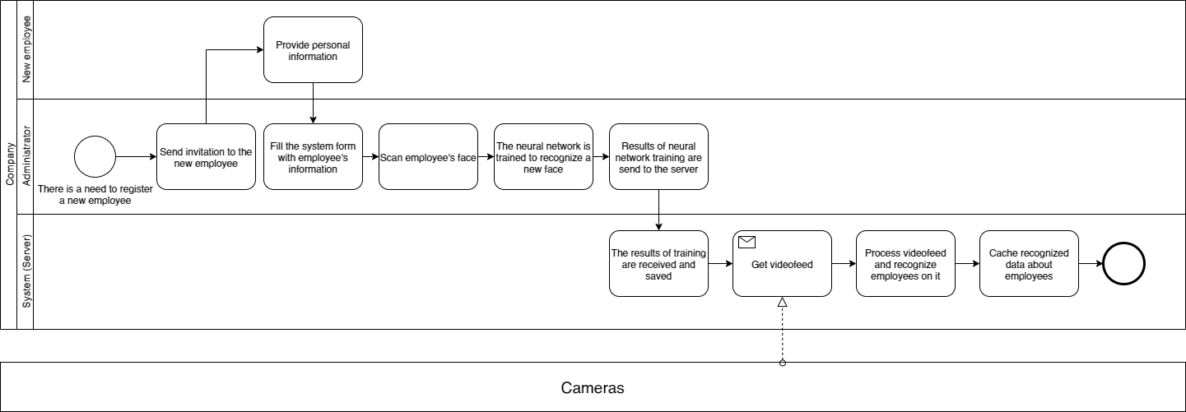

Figure 2 BPMN Diagram of Supervising Employees Process

Source: Own Work

### Process number 2 – [Collecting data]

The system will collect data about employees, namely employee’s personal data and how much time each employee spends in different facilities. It may also collect the data about buying coffee or food in IoT enabled machines, if such machines are installed in the office. In addition, the system will receive information about whether an employee has completed his assigned task. The data will then be saved to database and later used in the calculating process.

#### Task list

1. A database is created if it does not exist.
2. A database is filled with tables.
3. An empty cache file is created if it does not exist.
4. Server starts data collection.
5. The information about employee’s presence in different facilities is written to cache.
6. The information about time when the employee enters and exits a facility is written to cache.
7. The information about orders collected from IoT machines if an employee has used any is written to cache.
8. The information about employee’s task completion is written to cache.
9. By the end of the day the collected data is processed in [Calculating process].
10. The final results of calculations are written to the database.
11. The cache file is cleared.

#### BPMN diagram

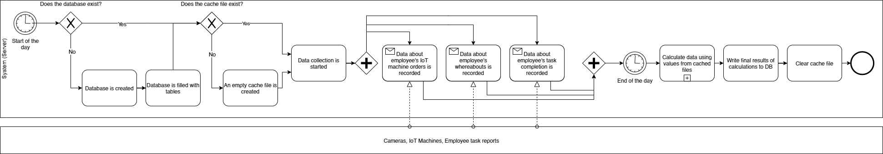

Figure 3 BPMN Diagram of Data Collection Process

Source: Own Work

### Process number 3 – [Calculation and preparation of data]

By the end of the day, the data from the cache is taken and compiled together. The summing calculations are performed to unify and optimize collected data (For example, if an employee has visited one facility many times, such data shall be summed and compiled together into one timeframe). This data is then written to the database in order to be used for further calculations. The following data will be used in productivity rating calculation. The system will then form a daily/weekly/monthly rating scores if enough data is gathered (One day is usually 8 working hours, one week is 5 working days, one month is ≈ 20 days). The results of such calculations will be written down to the database.

#### Task list

1. Data from cache is read[1].
2. Data from cache is optimized[2].
3. The optimized cache values are written to the database.
4. The updated values are read from database.
5. Employee’s rating is calculated.
6. Daily/weekly/monthly rating scores are generated by the system.
7. The information about employee’s visits to different facilities is analyzed.
8. The information about employee’s orders in IoT machines is analyzed.
9. The parallels between rating scores and employee’s activities are made[3].
10. Results of such calculations are written to the database by the system.

#### BPMN diagram

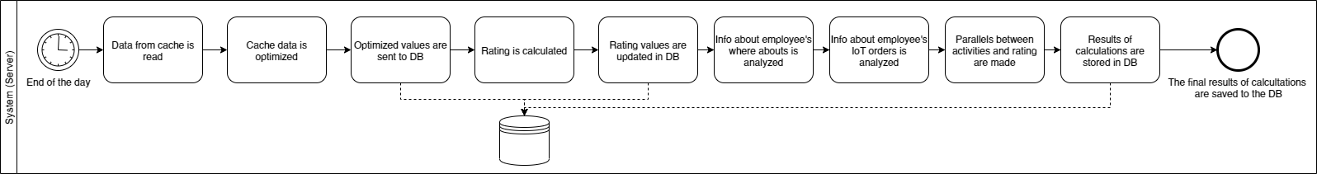

Figure 4 BPMN Diagram of Data Collection and Calculation Process

Source: Own Work

### Process number 4 – [Recommendation generation and visualization]

The system will be able to generate recommendations and visualize rating data.

The system will generate separate recommendations for employees. These recommendations are made in order to improve working potential. The regular users will be able to see the statistics and recommendations for themselves. The Group Leaders will be able to see statistics for their group and themselves. The Project Managers will be able to see statistics for their groups. The Company Director will be able to see statistics regarding all employees in the office.

The employees or the company directors do not have to strictly follow these recommendations.

#### Task list

1. The login screen is displayed.
2. The employee logs into an application.
3. The system checks user role.
4. The application downloads data regarding associated user’s role.
5. The application opens a main user menu.
6. The rating graphical representation is built using downloaded values.
7. The recommendations are displayed using the premade calculations[4].
8. The employee logs out of an application.

#### BPMN diagram

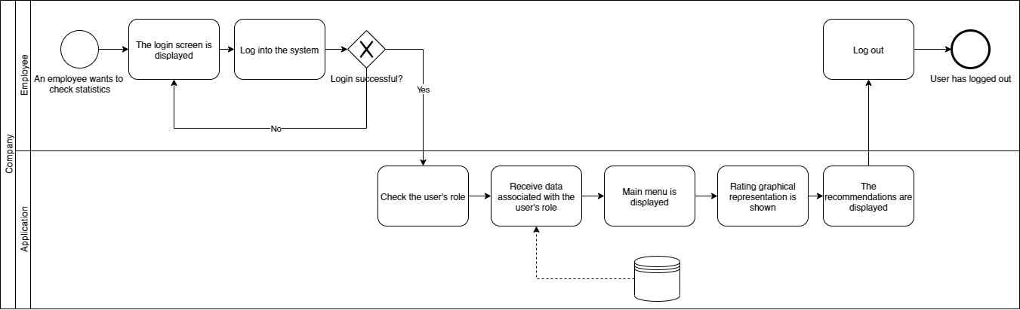

Figure 5 BPMN Diagram of Recommendation Generation and Visualization Process

Source: Own Work

# Objective, scope, context and Implementation Stages of the IT system

## Objective

The objective of our project is to develop a solution to help the company directors oversee their employees in a more efficient way. The system will also monitor the employees and generate suggestions to improve their performance.

## Scope

The scope of our project consists out of user registration system, monitoring people by cameras, face and place recognition system, user group forming system, collection of data from IoT machines, employee productivity rating calculation, graph and statistics generation, generation of possible recommendations for the employees in order to increase their productivity.

## Context

Our project is an administration system for offices. It represents an ability to efficiently manage people, organize them in teams and oversee their productivity.

## Project Implementation Stages

The project will be implemented in 3 stages:

1. The main functionality of administrative system must be implemented[5]. Such system must be deployed as a PC application.
2. The recommendation generation module as well as extra functionalities must be implemented.
3. The mobile application must be developed and deployed. The mobile application will only include regular user[6] functionalities.

# Examples of documents used in the designed IT system

1. Employee Application Form



Figure 6 Employee Application Form, Page 1

Source: Own Work



Figure 7 Employee Application Form, Page 2

Source: Own Work

# Requirements description

## Main requirements

### Functional requirements

1. The system must register new users on demand
2. The system must create and edit groups of users on demand
3. The system must edit or remove user’s credentials on demand
4. The system must remove users from the system on demand
5. The system must assign roles to the users on demand
6. The system must recognize employee’s faces and their whereabouts
7. The system must collect data about how much time each employee spends in different facilities
8. The system must collect information about whether an employee has completed his assigned task
9. The system must periodically optimize collected data[7]
10. The system must write final optimized data to database[8]
11. The system must calculate employee’s rating
12. The system must save calculated rating to the database
13. The system must generate graphs and statistics
14. The system must collect the employee task completion statistics
15. The system must show employee graphs and statistics on demand

### Non-functional requirements

#### Efficiency

1. The system must be available at least 98% of working time.
2. At least 15 percent of the processor capacity and storage space available to the system must be unused at peak load seasonal periods.
3. The system must not be shut down for maintenance more than once in a 24‐hour period.
4. A new installation of the system must be available for first‐time use within 24 hours of the start of the install.
5. No piece of text that can be displayed to a user shall reside in source code. That is, every piece of text that a user might see must be modifiable without changing source code.

#### Security

1. The system must have a default administrator account with a default password[9] for initial configuration.
2. The Administrator must be able to view and edit the collected data used in employee rating calculation.
3. In case the administrator edits the collected data, it must be marked as edited by administrator.
4. Any user roles can be changed by the system administrator if needed.
5. The Project Manager can assign or remove “Group Leader” roles to users.
6. The Group Leader can add or remove users from his group.
7. The user must enter his preferred password during the registration process.
8. The password must be at least 6 symbols long, contain at least 1 Uppercase and 1 Lowercase letter, at least 1 number and at least 1 symbol.
9. Passwords must never be viewable at the point of entry or at any other time.
10. The password can only be changed by admin at the request of the user.
11. Users without special roles cannot access other user’s data.
12. The users with special roles can view data of other users which are located lower than them in the hierarchy tree[10].
13. The password must be stored in encrypted hash form using the SHA-256 encryption.

#### Technologies

1. The office must be equipped with high definition cameras, streaming video in at least HD 720p.

#### Accessibility

1. The common language used in the system must be English to increase communication effectiveness and reduce processing errors.
2. The system must present user a notification informing that the system is not available, in case of maintenance.

#### Employee Registration

1. The photos of employee’s face must be taken against a light (white or off-white), plain background on which no shadows may be seen.
2. The head should be completely visible and needs to be centered
3. The employee cannot wear any glasses or headwear (unless for religious reasons) during the registration process.
4. The hair should not cover the employee’s face during the registration process.
5. There must be at least 40 photos made from different angles.

## Extra requirements

### Functional requirements

1. The system must collect data about employee’s orders from IoT machines
2. The system must generate recommendations for employees based on analysis of collected information regarding their task completion percentages and time spent in different facilities.
3. The system must save the latest recommendation for each user to the database.

# Identification of possible system events

Table 2 Possible System Events

Source: Own Work

| Name | Actors | Description |
| --- | --- | --- |
| Registration event | Administrator, new employee, System | The administrator prepares a new user account using the new employee’s credentials. This account is then added to the system. |
| Login event | Employee, System | The employee logs into the system using his provided credentials. The system checks the validity of the provided credentials and authorizes the request. |
| Statistics build request | Employee, System | The system builds the statistics and graphs using the data from database and displays it on the screen of the requester. The built statistics will vary depending on the role of the user. |
| Data optimization event | System | Once every defined period (default is one day), the system will take collected cached data, compile it together and update the values in the DB for the usage in further calculations. |
| Recommendation Generation event | System | After one week of employee data collection, the system will generate basic recommendations. In the following weeks, the fluctuations in employee’s rating will be used in order to correct recommendations. |

# Design of the functional structure of the system

## System diagram (DFD0)

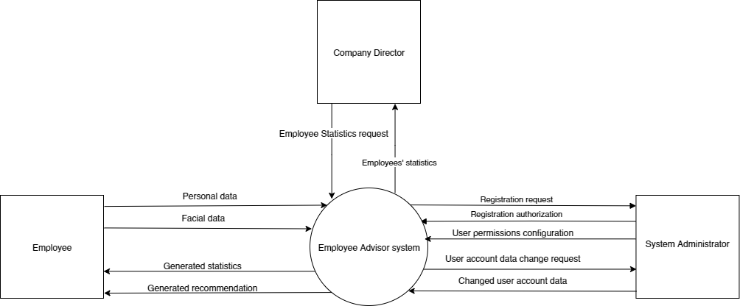

Figure 8 DFD0 Diagram

Source: Own Work

## Use Case diagram

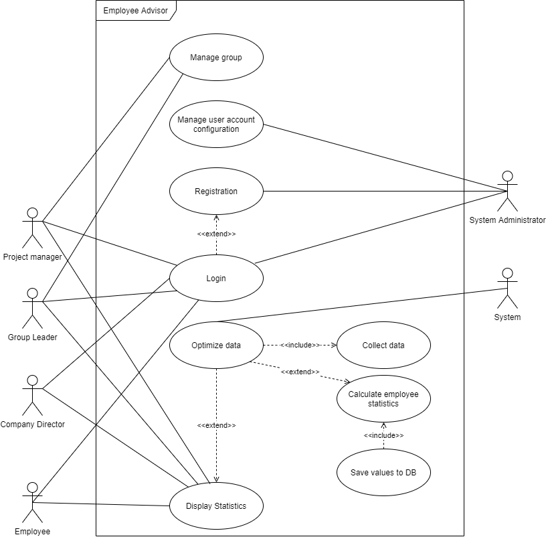

Figure 9 Use Case Diagram

Source: Own Work

# Hierarchical function model

1. OptimizeData()
   1. CollectData()
   2. GetDataFromCache()
   3. SummarizeData()
   4. WriteDataDB()
   5. ClearCache()

# User interface design

## Login Interface

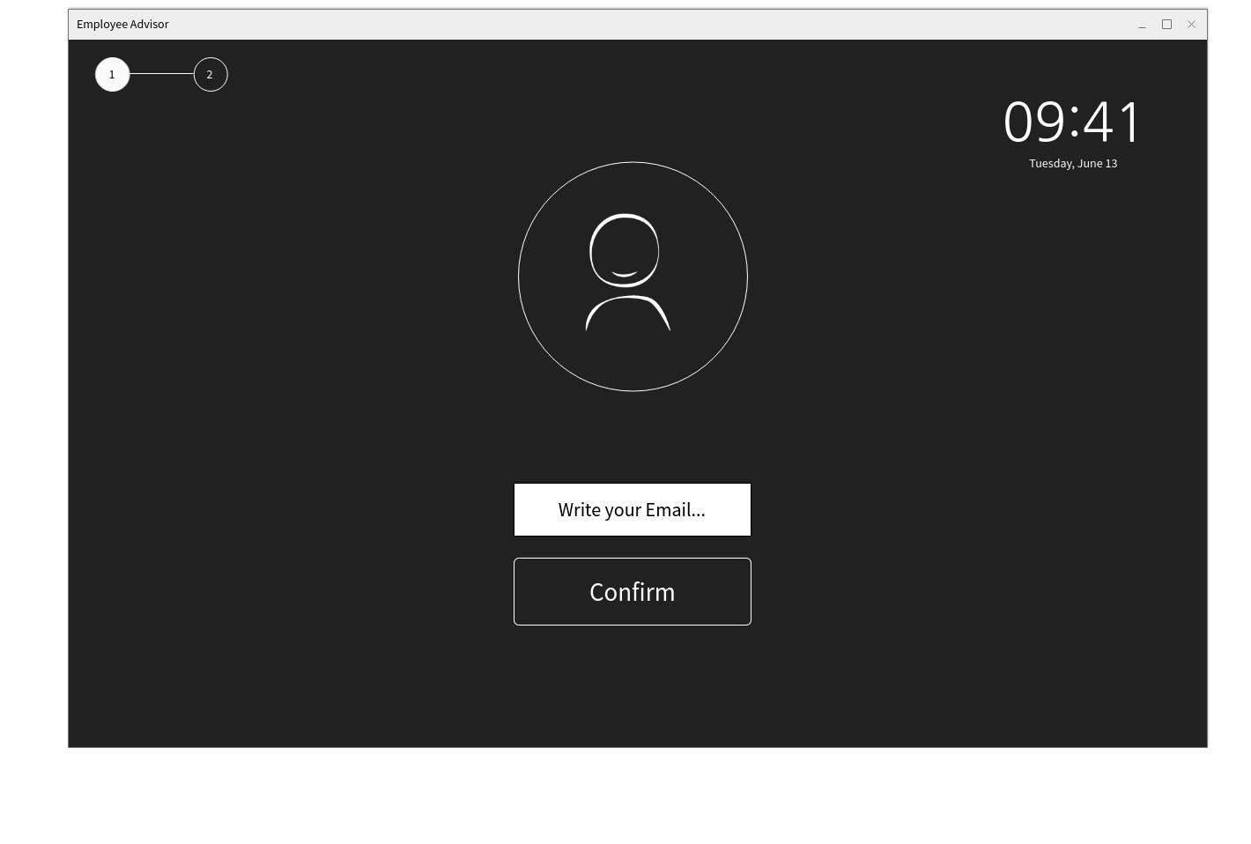

Figure 10 First step of login

Source: Own Work

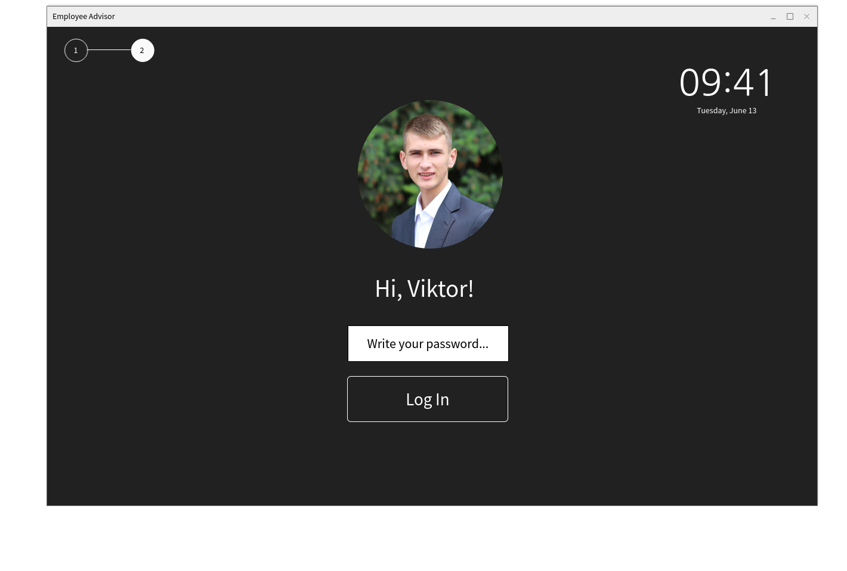

Figure 11 Second step of login

Source: Own Work

## Administrator interface

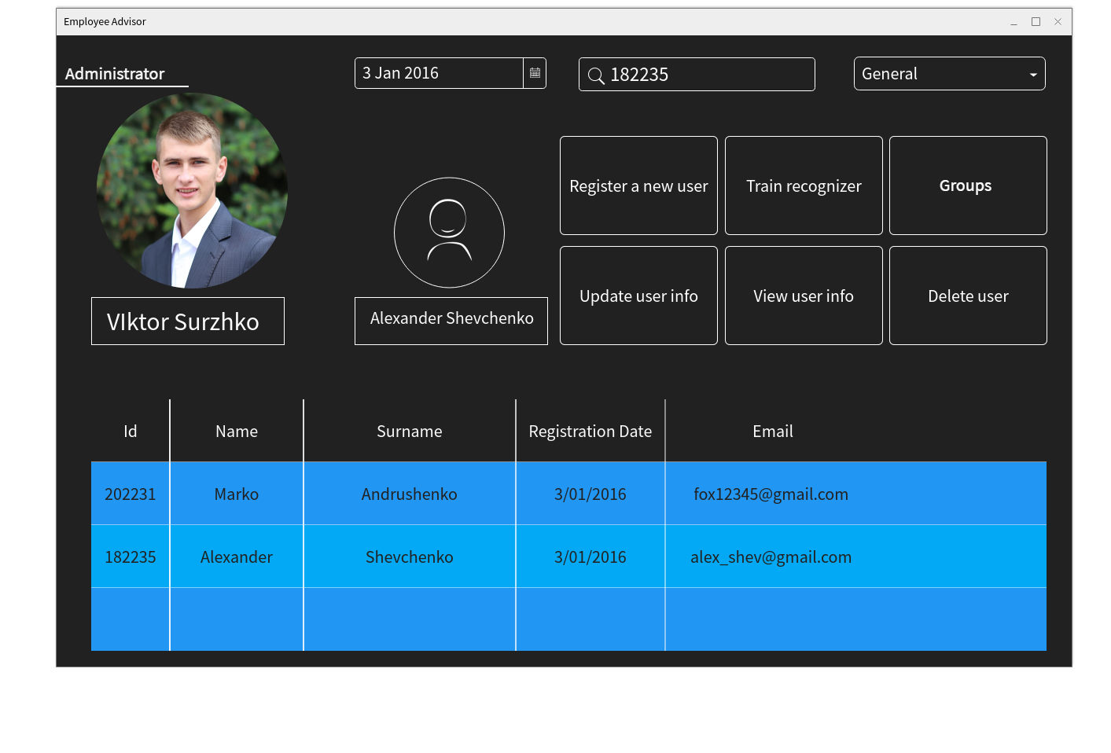

Figure 12 Administrators` general tab

Source: Own Work

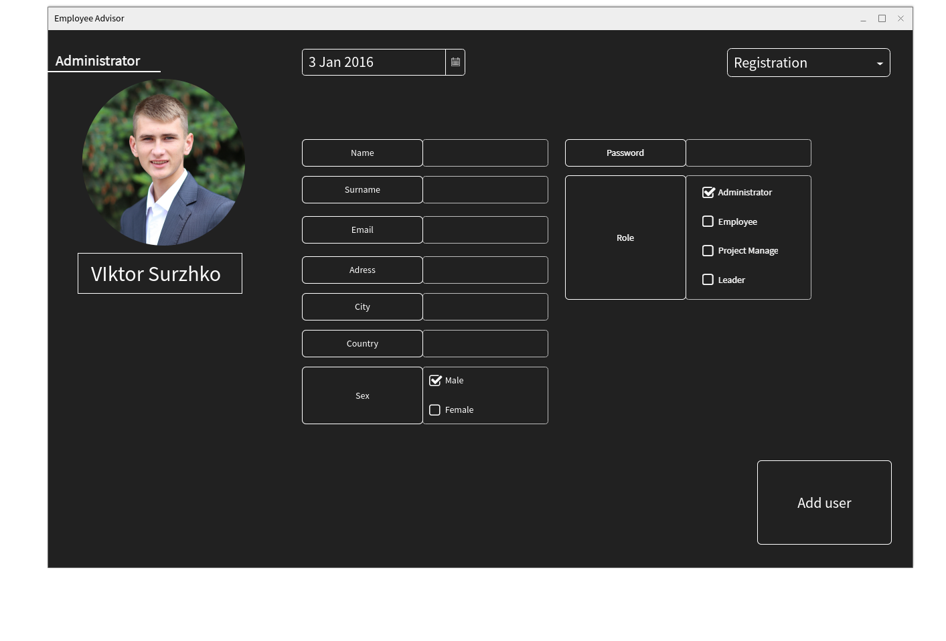

Figure 13 Administrators` new employee registration tab

Source: Own Work

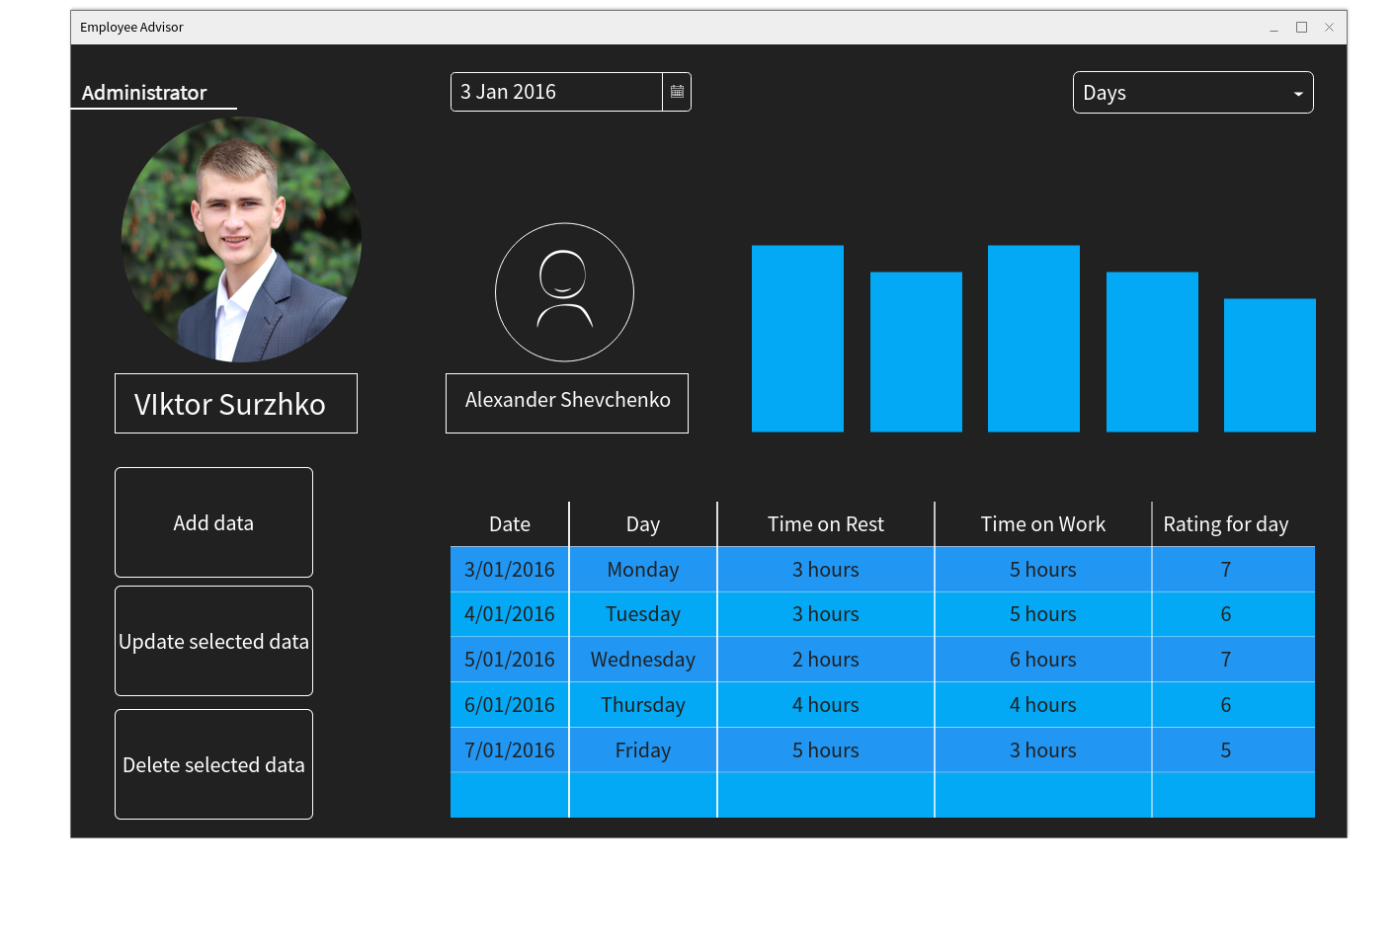

Figure 14 Selected users` statistic for days

Source: Own Work

## User Interface

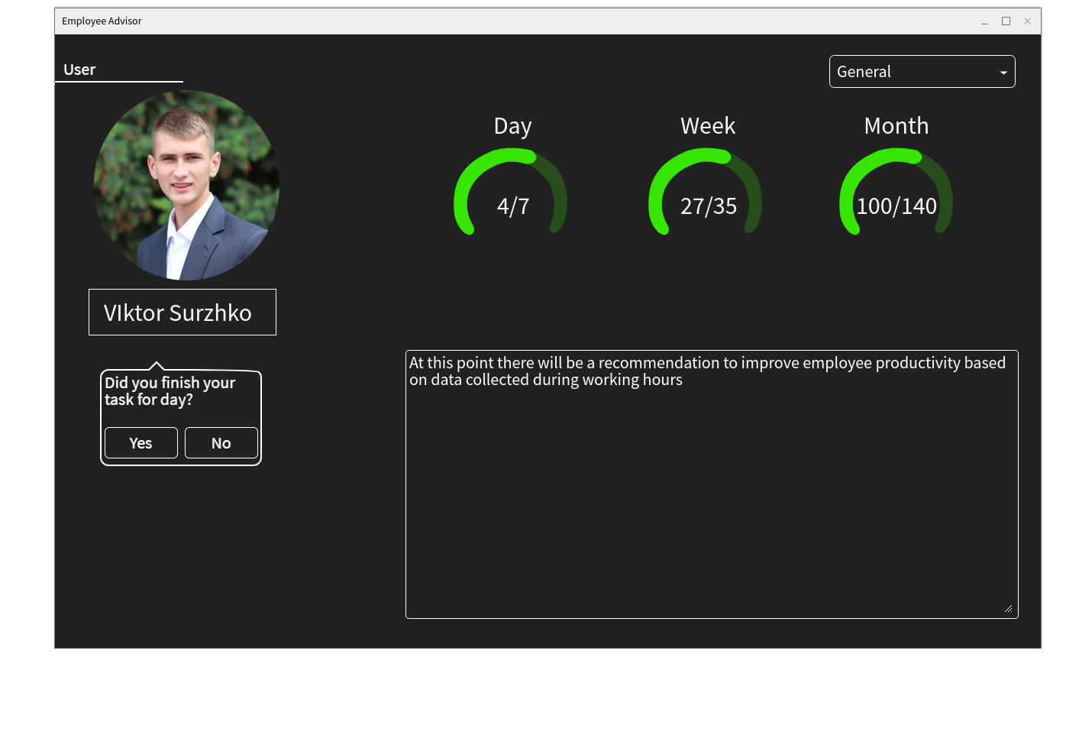

Figure 15 Users` General Tab

Source: Own Work

## Project Manager

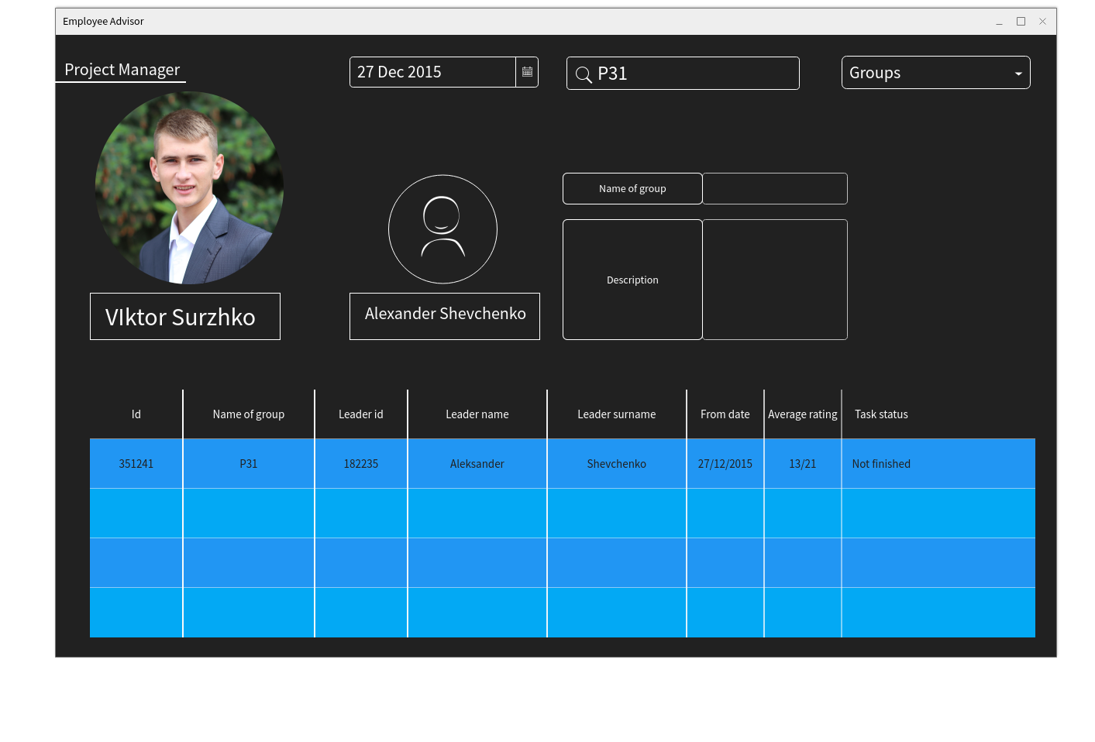

Figure 16 Project Managers` Groups tab

Source: Own Work

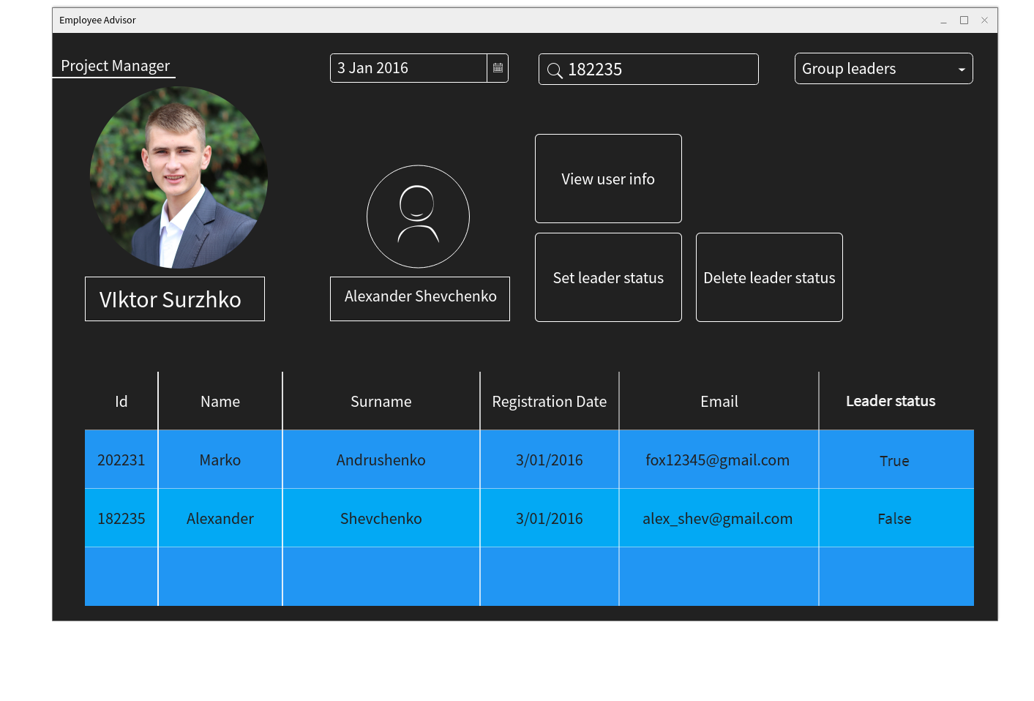

Figure 17 Project Managers` Group leaders tab

Source: Own Work

## Company Director

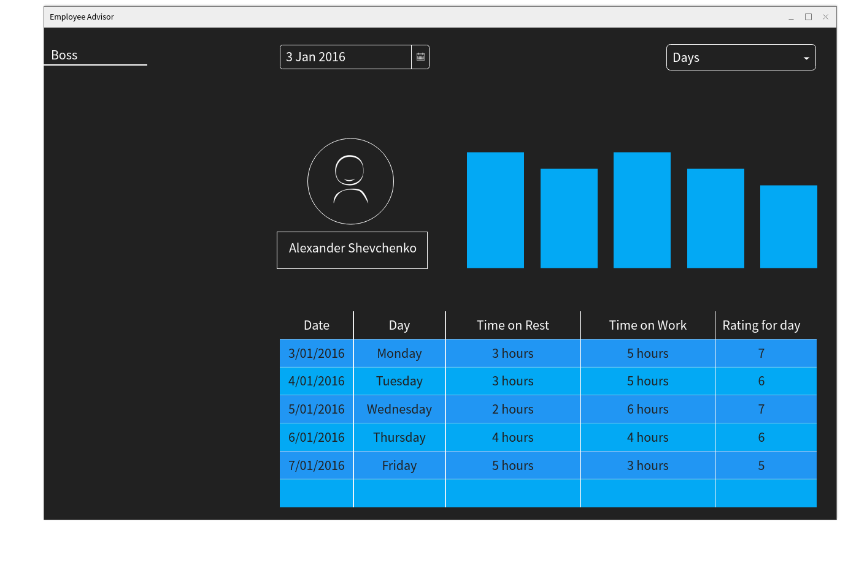

Figure 18 Company Directors` Days tab

Source: Own Work

# Documents generated by the System

The system will not generate any printed documents. This is the result of the fact that the project represents an automated supervising system that stores all its calculations internally in the database. Additionally, any generated graphs, statistics or recommendations are displayed locally on user’s PC.

# Technical and spatial structure of the designed IT system

## Frontend technologies

1. Python 3.7 distribution.
2. Kiwi 1.11.1 stable release for GUI.
3. Matplotlib for graphics drawing.

## Backend technologies

1. Oracle SQL Database version 18c.
2. OpenCV 4.1.1 for face recognition.
3. Java Spring Server Framework 5.0

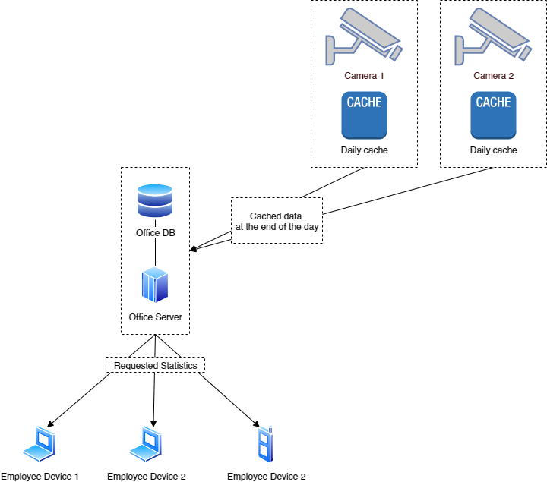

Figure 19 System Logic Architecture

The logical architecture is as follows:

The central office server performs all calculations. Each camera will have a cache file associated with it. The server then reads the cache file, summarizes the data and performs calculations described before. The final results of calculations are stored in the database.

Cameras require cache files in order to minimize the number of requests to the database. Every recognized person’s info will be written to the cache.

The employee’s devices will download values from the server and use these values locally in order to build graphics and statistics.

# Basic test cases

## Test Case №1: Login

**Condition: None**

1. The user opens the application.
2. The user enters his email account and click on confirmation button.
3. The users then enters his password on the next screen and clicks the confirmation button.

**Result: The user has logged in and can access the program interface**

## Test case №2: Registration

**Condition: Administrator has logged in and is using his admin account**

1. Administrator clicks on the “register new user” button.
2. Administrator fills the required fields in the registration form.
3. Administrator clicks on the “register” button.
4. Administrator takes photos of the new employee’s face.
5. Administrator trains the neural network in order to recognize the new employee’s face.

**Result: The new information regarding the employee is added to the database.**

## Test case №3: View statistics

**Condition: The user has logged in**

1. The user clicks on tabs to check his daily\weekly ratings.
2. The user can view different graphics presented by the system.
3. The user clicks “log out” button.

**Result: The user *can* *see* the built graphics and statistics. The user can successfully log out of application without raising any errors.**

## Test Case №4: Manage groups

**Condition: The user must be logged in. The user must have a role which allows such behavior.**

1. The user enters the group creation menu
2. The user clicks on the “manage group” button.
3. The application presents a user the group management interface.
4. The user can add or remove his team group members using the associated buttons.
5. The user clicks “manage group” button again.
6. The system closes the group management interface.
7. The user can now see all active members of his current group.

**Result: A new group is formed. The information regarding the group can be seen in the database, as well as on the user’s interface.**

# List of figures

Figure 1 Company Control Structure Example 5

Figure 2 BPMN Diagram of Supervising Employees Process 10

Figure 3 BPMN Diagram of Data Collection Process 11

Figure 4 BPMN Diagram of Data Collection and Calculation Process 13

Figure 5 BPMN Diagram of Recommendation Generation and Visualization Process 14

Figure 6 Employee Application Form, Page 1 16

Figure 7 Employee Application Form, Page 2 17

Figure 8 DFD0 Diagram 22

Figure 9 Use Case Diagram 22

Figure 10 First step of login 23

Figure 11 Second step of login 24

Figure 12 Administrators` general tab 25

Figure 13 Administrators` new employee registration tab 26

Figure 14 Selected users` statistic for days 27

Figure 15 Users` General Tab 28

Figure 16 Project Managers` Groups tab 29

Figure 17 Project Managers` Group leaders tab 30

Figure 18 Company Directors` Days tab 31

Figure 19 System Logic Architecture 32

# List of tables

Table 1 Schedule of Project Implementation 7

Table 2 Possible System Events 21

1. The process does not start until the end of the day.
2. The cached data is unified and merged.
3. The system must find how does a certain activity affect employee’s productivity.
4. Calculations are performed in process №3.
5. See the main functionalities in functional requirements section.
6. The user that has no special roles.
7. For the description of data optimization process, see Process №3, page 13.
8. After each data optimization cycle, the system must save the final result.
9. Login is “Admin”, Password is “Admin”.
10. See project description.