Supplementary Information
Revision status as of 31 October 2026. This revision retains the original WorldMoE ablation tables and twelve figure images, and adds S29–S30. The source admissions, nine original historical policy/completion books and current exact hindsight witness are now supplied. Earlier public-only evidence-gap statements in S19–S26 describe the previous inspection scope; S29–S30 provide the current admission, service and settlement status. The conservative opportunity bounds in S27 remain the main numerical certificate.
Contract rights and the economic value of data centre flexibility
Xiang Yi^{1,*}, Yuyang Chen^{2,†}, Shengye Guan^{2,†}
1 Northwest Minzu University, Lanzhou, Gansu, China
2 School of Management, Lanzhou University, 222 Tianshui South Road, Lanzhou 730000, Gansu, China
†Yuyang Chen and Shengye Guan contributed equally as joint second authors.
*Correspondence: Xiang Yi (mohamwdkali@gmail.com).
Author emails: Yuyang Chen (chenych2024@lzu.edu.cn); Shengye Guan (guanshy2024@lzu.edu.cn).

Scope and terminology
This supplement provides the original service accounts, model specification and evaluations. Parameter fitting, model selection and market evaluation use 2021–2023, 2024 and 2025. Tables 1–31 retain the original evidence, with Frontier deadlines reconciled in Table 15. Sections S19–S24 give exact deadline definitions, feasible repair, monetary allowances and the original-programme audit. Sections S25–S26 separate information and net contract value and reproduce matched contract increments. Section S27 supplies new admission-envelope certificates. Section S28 retains moved technical equations and all six original main-paper figures. Original WorldMoE ablation values in Tables 9, 10, 28 and 29 and all six original supplementary figure images are unchanged.
The implementation identifiers W0 and W1 denote successive pretraining stages of one 59,156,961-parameter sparse mixture-of-experts backbone; R2 denotes the probabilistic price module with anchored price-identity coupling (APIC). These names identify archived assets and figure labels. DA and RT denote day-ahead and real-time prices; DART is their difference. PV denotes photovoltaic generation and PUE denotes power usage effectiveness. The three decision refinements share an already trained 227,527-parameter initialization and fixed upstream features. Seeds vary batch order and auxiliary target sampling. The selected archive epochs are 6, 2 and 0 for seeds 20260920, 20260921 and 20260922; all parameters remain fixed during 2025 evaluation. Table 27 preserves the separate author display labels and immutable archive identities.
Eagle supplies one historical workload. Requested-node counts from time-stamped job submissions are aggregated into divisible service cohorts, normalized using a training-prefix transformation and divided equally among four simultaneous simulated sites. A job may request several nodes; a cohort is not a single-node job. Each site has one work unit of capacity per quarter-hour, an independent queue and physical balance, and its regional prices. Portfolio costs sum the four executions. Historical source-job CPU efficiency is reported separately in Table 30.
The ordered source library contains 1,086 complete UTC days from 15 November 2018 to 14 November 2021. For target UTC date d, the source index is its calendar-day offset from 1 January 2022 modulo 1,086, using zero-based indexing. Every selected day contributes all 96 release bins. The 2025 local-year evaluation, including UTC boundary portions, selects source days spanning 25 November 2018–28 November 2019. This circular mapping retains within-day order, burst sizes and quarter-hour spacing, including source-calendar gaps and wraparound. Service obligations persist across target days.
Normalization is fitted once to the first 60% of the chronological raw panel: 118,085 intervals ending at 21:15 UTC on 28 March 2022. The first and ninety-ninth percentiles are 0 and 2,248 requested nodes. Multiplication of nonnegative excess above the first percentile by 4/2,248 gives aggregate work units; values above the upper quantile remain uncapped. The mapping and scale are unchanged in 2024 selection and 2025 evaluation. Historical source days are deliberately reused, so market-year generalization is distinct from generalization to unseen workload years. Same-weekday matching applies to physical priors, not realized arrivals.

Service outcomes and financial uncertainty
Supplementary Table 1. Selected refinements and complete-year service outcomes.
Seed | Epochs  run | Display epoch | 2024 saving  US$ | 2025 saving  US$ | Ceiling  % | Late IT  MWh | Closing IT  MWh
20260920 | 12 | 6 | 52,842.39 | 105,565.67 | 79.61 | 7.4e-10 | 0.000
20260921 | 6 | 2 | 52,797.36 | 105,003.52 | 79.18 | 1.77e-09 | 0.000
20260922 | 6 | 2 | 52,768.03 | 105,244.00 | 79.37 | 1.35e-09 | 0.000

The three annual savings are US$105,565.67, US$105,003.52 and US$105,244.00, a range of US$562.15 (approximately 0.53% of their mean). This measures refinement variability conditional on a shared trained initialization. For seed 20260922, the author display epoch is 2 but the retained artifact is epoch00; the display correction does not change its tensors or imply an untrained decision module.
Supplementary Table 2. Paired seven-day-block financial intervals. The 2,000 resamples use seed-mean daily differences and random seed 20260928. These intervals describe the original native-system accounts and do not apply to the common-executor aggregates in Table 28.
Contrast | Annual difference  US$ | Lower 95%  US$ | Upper 95%  US$
WorldMoE vs earliest service | 105,271.06 | 78,261.97 | 137,854.63
WorldMoE vs RASC-ME | 42,908.97 | 28,683.08 | 63,147.88
WorldMoE vs Seasonal-ME | 38,284.05 | 25,669.85 | 58,049.79

Certified opportunity and service windows
The opportunity programme minimises cost over an outer feasible set with perfect information, independently of trained forecasts, checkpoint selection and current-action search. Its terminal rule retains a priced residual obligation while relaxing a required beyond-year execution plan. Exact box minimisation supplies a valid dual lower bound when the outer-set and objective-dominance conditions hold. Sections S21–S22 distinguish the archived floating-point implementation from the complete exact evaluation required for a mathematical certificate. A relaxed cost floor need not correspond to an executable schedule.
Supplementary Table 3. Reported Eagle cost-bound summaries for six year–contract combinations. Cost lower bounds retain their recorded precision and savings ceilings are rounded upward to cents from the unrounded summaries. These aggregate identities do not replace the original per-site verification records.
Year | Trace | Window  h | Reference cost | Cost lower bound | Savings ceiling
2024 | Eagle | 12 | 315,704.12 | 266,532.69 | 49,171.44
2024 | Eagle | 16 | 315,704.12 | 257,981.69 | 57,722.44
2024 | Eagle | 24 | 315,704.12 | 249,108.69 | 66,595.44
2025 | Eagle | 12 | 555,168.21 | 457,365.78 | 97,802.43
2025 | Eagle | 16 | 555,168.21 | 441,857.78 | 113,310.43
2025 | Eagle | 24 | 555,168.21 | 422,562.78 | 132,605.43

The 12, 16 and 24 h evaluations use the same selected checkpoints. Each capture ratio divides executed savings by the corresponding contract-specific upper bound. Fixed-parameter decision-signal interventions do not identify the effect of independently retrained neural components.
Supplementary Table 4. Out-of-sample 2025 WorldMoE performance under 12, 16 and 24 h contracts.
Window h | Seed | Saving US$ | Saving % | Ceiling US$ | Ceiling fraction | Late IT MWh | Closing IT MWh
12 | 20260920 | 72,361.65 | 13.03 | 97,802.43 | 73.99% | <10⁻⁸ | 0.00
12 | 20260921 | 72,099.98 | 12.99 | 97,802.43 | 73.72% | <10⁻⁸ | 0.00
12 | 20260922 | 72,201.28 | 13.01 | 97,802.43 | 73.82% | <10⁻⁸ | 0.00
16 | 20260920 | 86,257.34 | 15.54 | 113,310.43 | 76.12% | <10⁻⁸ | 0.00
16 | 20260921 | 85,833.93 | 15.46 | 113,310.43 | 75.75% | <10⁻⁸ | 0.00
16 | 20260922 | 86,024.40 | 15.50 | 113,310.43 | 75.92% | <10⁻⁸ | 0.00
24 | 20260920 | 105,565.67 | 19.02 | 132,605.43 | 79.61% | <10⁻⁸ | 0.00
24 | 20260921 | 105,003.52 | 18.91 | 132,605.43 | 79.18% | <10⁻⁸ | 0.00
24 | 20260922 | 105,244.00 | 18.96 | 132,605.43 | 79.37% | <10⁻⁸ | 0.00

Heterogeneous deadlines
Each release is divided deterministically into 4, 12 and 24 h classes with shares of 25%, 50% and 25%. The archived H0 identifier denotes the homogeneous 24 h request stream assessed under this mixed contract. H1 denotes actions recomputed from the mixed deadline prefixes. H0 electricity savings must be read alongside its overdue work; it does not deliver the mixed contract.
Supplementary Table 5. Economic and service outcomes under heterogeneous deadlines.
Pathway | Seed | Saving US$ | Late IT MWh | Closing IT MWh | P95 delay h
H0 FIFO | 20260920 | 105,565.67 | 1,567.69 | 0.00 | 23.50
H0 EDF | 20260920 | 105,565.67 | 1,753.21 | 0.00 | 28.50
H1 mixed aware | 20260920 | 79,410.73 | <10⁻⁸ | 0.00 | 22.50
H0 FIFO | 20260921 | 105,003.52 | 1,556.28 | 0.00 | 23.50
H0 EDF | 20260921 | 105,003.52 | 1,751.33 | 0.00 | 28.50
H1 mixed aware | 20260921 | 79,053.02 | <10⁻⁸ | 0.00 | 22.75
H0 FIFO | 20260922 | 105,244.00 | 1,590.61 | 0.00 | 23.50
H0 EDF | 20260922 | 105,244.00 | 1,789.16 | 0.00 | 28.75
H1 mixed aware | 20260922 | 79,081.93 | <10⁻⁸ | 0.00 | 22.75

Electrical delivery and service debt
The declared commitment-time executor receives a fixed request stream and arrived service obligations. It computes current service capacity from the zero-PV, maximum-PUE envelope and, when applicable, the previous completed import plus the upward-ramp allowance. Deadline protection advances work when conservative future capacity would otherwise be insufficient. Tables 6–7 retain the reported stress outputs. Section S23 distinguishes this declared rule from the inspected public projection, which reads same-interval realised PV/PUE; linking the reported replacement results to the declared rule requires their matching corrected programme and trajectories.
The archive labels cap75 and cap50 identify the moderate and tighter import-cap tests. The labels ramp25 and ramp125 identify upward-ramp limits of 0.537556 and 0.268778 MW per quarter-hour; cap75_ramp25 combines the moderate cap and the first ramp limit. These identifiers link the reported cases to the released results.
Supplementary Table 6. Reported economic outcomes under electrical constraints. Each row averages three fixed request streams. The programme-to-output information-boundary reconciliation is described in Section S23.
Execution | Condition | Saving US$ | Policy cost US$ | Reference cost US$ | Nominal value retained %
Projection | cap75 | 104,226.17 | 450,607.50 | 554,833.67 | 99.01
Guarded | cap75 | 104,116.68 | 450,716.99 | 554,833.67 | 98.90
Projection | cap50 | 97,454.94 | 452,305.57 | 549,760.51 | 92.58
Guarded | cap50 | 95,833.44 | 453,927.07 | 549,760.51 | 91.03
Projection | ramp25 | 73,974.46 | 488,320.15 | 562,294.61 | 70.27
Guarded | ramp25 | 64,955.36 | 497,339.25 | 562,294.61 | 61.70
Projection | ramp125 | 3,160.60 | 605,091.24 | 608,251.84 | 3.00
Guarded | ramp125 | 1,162.85 | 607,089.00 | 608,251.84 | 1.10
Projection | cap75_ramp25 | 72,059.54 | 488,400.88 | 560,460.42 | 68.45
Guarded | cap75_ramp25 | 63,539.62 | 496,920.80 | 560,460.42 | 60.36

Supplementary Table 7. Reported electrical and service outcomes for the projection and deadline-guard experiments. Maxima span three request streams; numerical residuals are retained. Section S23 states the implementation evidence.
Execution | Condition | Max late IT MWh | Max closing IT MWh | Upward ramp MW / 15 min | Cap excess MW | Ramp excess MW
Projection | cap75 | 22.24 | 0.208740 | 1.432112 | 0 | 0
Guarded | cap75 | 8.665e-12 | 0.208740 | 1.432112 | 0 | 0
Projection | cap50 | 126.6 | 0.700580 | 0.894687 | 0 | 0
Guarded | cap50 | 1.533e-11 | 0.700580 | 0.989778 | 0 | 0
Projection | ramp25 | 109.7 | 0.317801 | 0.537556 | 0 | 4.4e-16
Guarded | ramp25 | 1.174e-11 | 0.317801 | 0.537556 | 0 | 3.3e-16
Projection | ramp125 | 764.6 | 0.852438 | 0.268778 | 0 | 5.6e-16
Guarded | ramp125 | 0 | 0.149557 | 0.268778 | 0 | 5.6e-16
Projection | cap75_ramp25 | 141.1 | 0.465710 | 0.537556 | 0 | 4.4e-16
Guarded | cap75_ramp25 | 1.174e-11 | 0.465710 | 0.537556 | 0 | 3.3e-16
The retained stress tables report zero deadline lateness for the five references, guarded lateness below 10⁻⁸ IT MWh, zero static-cap violations and upward-ramp residuals below 10⁻⁸ MW. The reported replacement-projector checks give maximum numerical lateness 1.54 × 10⁻¹¹ IT MWh and nominal service change 7.28 × 10⁻¹² work units. These remain reported outputs. The inspected public projector responds to current realised physical forcing, so its source alone does not establish the claimed unrevealed-physics invariance of the declared commitment-time rule; the matching replacement-run evidence is specified in Sections S23–S24.

Photovoltaic sensitivity
Supplementary Table 8. Photovoltaic sensitivity against condition-matched references.
PV fraction | Saving US$ | Saving % | Late IT MWh | Closing IT MWh
0% | 69,183.79 | 8.86 | <10⁻⁸ | 0.00
50% | 77,470.71 | 12.40 | <10⁻⁸ | 0.00
100% | 105,565.67 | 19.02 | <10⁻⁸ | 0.00

Decision-output diagnostics and price consistency
Supplementary Table 9. Decision-output zeroing diagnostics with the pretrained backbone held fixed under the 24 h contract.
Variant | Seed | Saving US$ | Saving % | CVaR95 US$ | Late IT MWh
full | 20260920 | 105,565.67 | 19.02 | 306.85 | <10⁻⁸
no_opportunity | 20260920 | 105,455.09 | 19.00 | 314.41 | <10⁻⁸
no_cost_bias | 20260920 | 105,163.18 | 18.94 | 303.82 | <10⁻⁸
Combined output zeroing | 20260920 | 105,290.87 | 18.97 | 304.38 | <10⁻⁸
full | 20260921 | 105,003.52 | 18.91 | 317.22 | <10⁻⁸
no_opportunity | 20260921 | 104,986.24 | 18.91 | 322.79 | <10⁻⁸
no_cost_bias | 20260921 | 104,606.06 | 18.84 | 303.39 | <10⁻⁸
Combined output zeroing | 20260921 | 104,765.52 | 18.87 | 303.07 | <10⁻⁸
full | 20260922 | 105,244.00 | 18.96 | 316.06 | <10⁻⁸
no_opportunity | 20260922 | 105,211.82 | 18.95 | 322.09 | <10⁻⁸
no_cost_bias | 20260922 | 104,933.63 | 18.90 | 306.90 | <10⁻⁸
Combined output zeroing | 20260922 | 104,922.82 | 18.90 | 310.96 | <10⁻⁸
The combined zeroing diagnostic removes the opportunity score, task-conditioned cost bias and price–PV cross-moment contribution. It retains the pretrained backbone, APIC price module, queue inputs, analytical physical-cost decoder, constrained executor and final market shift. Its archived key, price_only, identifies this output intervention and differs from the independently trained historical price-only baselines in Table 29. The intervention neither removes decision-focused training nor retrains a substitute physical-cost interface.
Market pretraining enforces DART = DA − RT in targets and joint paths. The probabilistic module retains DA and spread quantiles and derives post-publication RT quantiles through the complementary-quantile identity. Both terminal-shift settings preserve this upstream system; their comparison does not remove APIC.
Supplementary Table 10. Primary-refinement forecast and placement diagnostics for the final market shift.
Final shift | RT pinball | Coverage 90% | Ordering violations | Saving US$ | Changed actions | Reassigned IT MWh
on | 5.595 | 89.398 | 0 | 105,565.665 | 2737 | 35.682
off | 5.588 | 89.655 | 0 | 105,647.983 | 2737 | 35.682

Supplementary Table 11. Numerical check of the post-publication DA–spread–RT quantile identity.
Stage | Zone-hours | Quantiles | Maximum residual | Mean residual
Post-publication price module | 35040 | 7 | 4.39e-05 | 1.90e-06

Event definitions and financial influence
The supplementary NYISO event analysis uses daily across-zone spread range, maximum absolute spread and maximum RT price, with thresholds estimated from 2024. The cross-market screen uses each market’s own 2025 percentile and is descriptive. Positive aggregate performance on extreme dates need not imply an advantage on most such dates or a causal response to grid scarcity. Financial exclusions remove observed contributions while retaining the original physical schedules.
Supplementary Table 12. Sensitivity to event definitions and thresholds. Monetary amounts are US dollars; confidence intervals use seven-day blocks.
Contrast | Definition | q (%) | Extreme  dates | Extreme  US$ | Ordinary  US$ | Lower 95% | Upper 95%
vs RASC-ME | spread_range | 90.0 | 59 | 19,932.4 | 22,976.6 | 7,436.1 | 38,659.6
vs RASC-ME | spread_range | 95.0 | 35 | 15,190.2 | 27,718.7 | 3,914.0 | 33,608.6
vs RASC-ME | spread_range | 97.5 | 16 | 10,677.4 | 32,231.6 | 884.6 | 28,071.6
vs RASC-ME | max_abs_spread | 90.0 | 52 | 18,785.6 | 24,123.4 | 6,500.7 | 37,246.7
vs RASC-ME | max_abs_spread | 95.0 | 28 | 13,176.5 | 29,732.5 | 2,530.9 | 31,298.3
vs RASC-ME | max_abs_spread | 97.5 | 16 | 10,677.4 | 32,231.6 | 884.6 | 28,071.6
vs RASC-ME | max_rt | 90.0 | 78 | 21,819.1 | 21,089.8 | 8,019.4 | 41,846.4
vs RASC-ME | max_rt | 95.0 | 33 | 15,241.2 | 27,667.8 | 3,807.9 | 33,961.0
vs RASC-ME | max_rt | 97.5 | 17 | 11,298.2 | 31,610.7 | 1,356.8 | 28,679.9

Supplementary Table 13. Block-length sensitivity of the aggregate extreme-date increment.
Contrast | Block  days | Extreme increment  US$ | Lower 95%  US$ | Upper 95%  US$
vs RASC-ME | 3 | 15,190.24 | 4,662.60 | 32,895.39
vs RASC-ME | 7 | 15,190.24 | 3,913.95 | 33,608.56
vs RASC-ME | 14 | 15,190.24 | 3,015.21 | 34,566.31
vs RASC-ME | 28 | 15,190.24 | 2,446.32 | 33,733.91

Supplementary Table 14. Outcome-selected financial exclusions for WorldMoE relative to RASC-ME. Dispatch remains unchanged.
Contrast | Excluded local dates | Retained total  US$ | Retained extreme  US$
vs RASC-ME | None | 42,908.97 | 15,190.24
vs RASC-ME | 2025-07-25 | 35,393.04 | 7,674.32
vs RASC-ME | 2025-07-25 to 2025-07-31 | 33,797.38 | See source rows

Nonpreemptive Frontier jobs
The node-power mapping is fitted using the retained 2024 development trace, and all 977,884 jobs in the 2025 trace are retained. Each nonpreemptive job occupies consecutive capacity at its fixed site for its full rounded runtime. The model’s 24 h slot-score horizon guides feasible starts; later starts use the predefined earliest-feasible fallback. Separate available slots cannot replace a sufficiently long contiguous placement.
The inspected archived summaries report 1,764, 27 and zero overdue jobs under 24, 30 and 48 h rights, respectively. The longer contracts each retain 519 year-end unfinished jobs, compared with 501 at 24 h. A job unfinished at year end can remain within its original deadline; timely completion and an empty reporting-boundary queue are different conditions. Table 15 reconciles the earlier author-supplied 30 h zero with the retained executable source and summary. The 48 h case provides the reported feasible nonpreemptive extension.
Supplementary Table 15. Frontier job-level service outcomes reconciled to the retained 24/30/48 h summary JSON files. The archived 30 h result is 27 overdue jobs, superseding the earlier author-supplied zero for which no matching replacement run was supplied.
Contract window (h) | Jobs | Overdue jobs | Year-end unfinished jobs
24 | 977884 | 1764 | 501
30 | 977884 | 27 | 519
48 | 977884 | 0 | 519

Architecture and forecast scores
Supplementary Table 16. Decision-module architecture.
Component | Dimensions | Function or constraint
Pretrained backbone | Two pretraining stages; 59,156,961 parameters | No gradient updates
Cached market features | 128 market dimensions | Shared across refinement seeds
Market adapter | 128 → 64 → 128 | 0.1 tanh residual; market-only price shift
Market / physics encoders | 135 → 64; 13 → 64 | Separate input streams
Cross attention | 4 heads; 24 hourly tokens | Bidirectional market–physics fusion
Temporal processing | 2 layers; 64 width; 128 feed-forward | Dropout 0
Work query | 9 → 64; 96 query slots | Query includes local market/physical context
Quarter-hour refinement | 192 → 64 → 128 | 0.2 tanh residual
State decoder | 22 → 64; pooled 327 → 96 → 64 → 5 | PV cost representation; task bias; opportunity
Cross-moment head | 157 → 64 → 1 | 0.95 tanh output
Refinement total | 227,527 trainable parameters | Shared decision-trained initialization
Differentiable allocation | τ = 2; 16-cohort rollout | Capacity, equality and active-set derivatives

The decision module receives a 128-dimensional pretrained market representation and seven price quantiles. Bidirectional four-head attention connects market and physical states, and 96 work-to-time queries represent candidate service slots. Five effective physical and task quantities, assembled from the decoder and a separate cross-moment head, enter analytical import valuation. Nine uniform capacity nodes and seven PV-derived nodes define up to 15 intervening segments; these 16 candidate boundaries are distinct from the 16 arriving cohorts unrolled during training.
Supplementary Table 17. Queue-independent post-publication RT forecast scores. Task-specific cost and opportunity adjustments are excluded.
Seed | Pinball  US$/MWh | Median MAE  US$/MWh | 90% coverage  % | Interval width  US$/MWh
20260920 | 5.5948 | 16.7277 | 89.40 | 75.469
20260921 | 5.5932 | 16.7213 | 89.45 | 75.469
20260922 | 5.5949 | 16.7292 | 89.47 | 75.469

Training refinements and model selection
Supplementary Table 18. Training settings, economic early stopping and retained neural-model histories.
Setting | Value
Parameter-fitting years | 2021–2023
Physical-label years | 2022–2023
Selection / evaluation | 2024 / 2025
Training episodes | 2,349 retained of 2,376; 27 conservative feasibility exclusions
Validation snapshots | 320; no optimizer updates
Training batch | 32
Optimizer | AdamW; learning rate 0.0001; weight decay 0.0001
Gradient clipping | L2 norm 1
Auxiliary loss weights | PV pinball 2; marginal-cost Huber 0.2
Regularization | 0.002 mean opportunity squared; 0.005 mean cross-moment coefficient squared; 0.1 mean price-shift squared / 100
Quantile grid | 0.05, 0.10, 0.25, 0.50, 0.75, 0.90, 0.95
Cost quadrature weights | 0.075, 0.10, 0.20, 0.25, 0.20, 0.10, 0.075
Precision | BF16 training; precision-controlled physical costs and evaluation
Epoch budget | WorldMoE ceiling 12; minimum 6 before early stopping; Non-MoE retained search completes 6
Economic selection | Common rule on eligible retained histories: full-2024 economic value; restore maximum actual saving, including registered initialization
Patience | Three evaluations without an eligible gain exceeding US$50; threshold controls stopping only
Price-score guard | At most 1.02 times the fixed model-specific reference: WorldMoE 0.4193302095; Non-MoE 0.4118362963
Feasibility guard | Late and closing work below 1e-8 IT MWh
Replication scope | Three refinements sharing a trained initialization and fixed upstream features; display epochs 6, 2 and 2
Deployment | Current action only; 0.025 action grid plus physical/reference knots
Future service capacity | 0.9 safety fraction; expected continuation cost
Price / cost separation | Queue-independent price shift; task-specific bias and opportunity values are not price forecasts
WorldMoE actual histories | Completed 12 / 6 / 6 epochs; selected archive epochs 6 / 2 / 0; author display mapping unchanged
Non-MoE retained history | Candidates 0 / 2 / 4 / 6; common stopping condition at 6; selected 0
Application of common rule | Retained-history selection; no new optimizer updates or 2025-based checkpoint choice

The conditional-price slope approximates the price–PV cross moment and is bounded during learning. Uncertainty in completed physical observations attenuates its current-quarter contribution. Future costs use clipped-Gaussian partial moments; training evaluates midpoint segment costs, whereas deployment integrates endpoint costs. These related numerical representations are assessed by actual annual execution and settlement when selecting the 2024 checkpoint.
Task-cost bias, opportunity value and price–PV dependence have no standalone labels for their optimal decision values. The episode-cost loss supplies intertemporal gradients through the 16-cohort allocator; marginal-cost regression and regularization provide additional gradients. Removing the allocator would remove the decision-alignment path, not necessarily all learning signals. Deployment uses analytical endpoint integration and a 0.025-work-unit current-action grid, with deadline protection in the specified electrical cases.
Training begins from reservations generated by a causal behavior policy and unrolls arriving cohorts in order. Existing claims persist, allocations retain their original deadlines and residual capacity carries forward. The same conservative feasibility screen excludes 27 training episodes for every seed; all 2025 arrivals and calendar intervals remain in evaluation. Future outcomes are training targets only within fitting years. Operating-time feature gates are distinct from the historical archive-version limitation discussed below.
AdamW uses learning rate and weight decay of 10⁻⁴, batches of 32 and gradient-norm clipping at 1. The maximum refinement budget is 12 epochs, with full-year economic evaluation every two epochs and at initialization when registered. Eligibility requires late and closing work below 10⁻⁸ IT MWh and a normalized price score no greater than 1.02 times the fixed model reference (0.4193302095 for WorldMoE). Let ℰ denote the evaluated eligible candidates; selection maximizes actual 2024 savings:
$e^{*}={argmax}_{e∈ℰ}[C_{2024}(0)−C_{2024}(π_{e})].$
Early stopping is permitted after six epochs when three successive economic evaluations fail to improve the stopping anchor by more than US$50. This threshold governs stopping only: the highest eligible saving among all evaluated candidates determines deployment, including gains below US$50. The three WorldMoE histories select archive epochs 6, 2 and 0. All fitting and selection exclude 2025 outcomes. Experiments use Python 3.13, PyTorch 2.9 and an NVIDIA RTX 3080, with refinements run sequentially.
Supplementary Table 19. Original checkpoint SHA-256 digests and author display epochs. Table 27 gives exact archive identities; exported inference hashes are recorded separately in the release manifest.
Seed | Display epoch | SHA-256
20260920 | 6 | 0cf04e11318184a2f064a1cf571cffe25cb3a78b77f2dc95bb30b01fceba14ab
20260921 | 2 | 2f281002e8ccafb859c197c7745c366e945e1b9ce8568e5ccd514ebdebf78448
20260922 | 2 | e6e031bbd9757baee3fbaed4fbad587652fe84d0a27394ac05965f3a096f9e17

Release v1.4.1 provides the complete inference chain, fitted preprocessing, physical observers and executable service-accounting code at https://github.com/kalimustafa/executable-service-commitments-worldmoe/releases/tag/v1.4.1. A deterministic synthetic example loads every selected refinement and checks one constrained action. Annual replay and retraining additionally require the provider archives and full feature calendars. Version v1.3.0 remains unchanged. Table 20 reports cached scheduling runtime, measured after input preparation, model loading and tracing.
Scheduling runtime covers the annual action loop after data/model loading, feature preparation and TorchScript tracing; independent settlement and export follow afterward. Dividing by 35,040 gives amortized time per portfolio quarter-hour, including inactive intervals. The nominal 0.025 grid requires 228.14 s, or 6.51 ms per calendar step; 0.05 and 0.0125 grids require 308.34 and 320.16 s. These single cached-loop measurements exclude upstream inference and do not estimate a p95 latency or establish a general speed ordering.
Released source data retain all selected refinements, constrained cases, event sensitivities and daily differences underlying the reported figures and tables. No unfavorable seed, date or restriction is excluded from annual totals. Financial exclusions are influence diagnostics. MANIFEST.json records file hashes; source_data/current_provenance.json identifies checkpoint roles; figure builders identify input tables. Historical local paths are provenance identifiers rather than download links.

Current-action grid convergence
Supplementary Table 20. Sensitivity to current-action grid resolution.
Grid | Saving US$ | Δ from finest US$ | Runtime s | Late IT MWh
0.05 | 105,570.47 | -2.85 | 308.34 | <10⁻⁸
0.025 | 105,565.67 | -7.66 | 228.14 | <10⁻⁸
0.0125 | 105,573.32 | 0.00 | 320.16 | <10⁻⁸

Electrical parameter consistency and binding counts
At full service and zero PV, maximum site demand is 1.0929484367370605 × (1.639059066772461 + 0.23069976270198822) = 2.0435499897494154 MW. The nominal interconnection cap of 2.1502225399017334 MW provides 5.21996% headroom. The rounded display calculation gives 2.0383 MW and is not used to recompute results.
Supplementary Table 21. Nominal cap occupancy and constraint binding. Stress-case counts identify requests exceeding commitment-time admissible capacity by more than 10⁻⁹ work units after the selected guard rule; ranges span three request streams. Binding differs from a realized electrical violation.
Execution | Condition | Minimum count | Maximum count
Nominal | 20260920 | 0 | 0
Nominal | 20260921 | 0 | 0
Nominal | 20260922 | 0 | 0
Projection | cap75 | 3153 | 3188
Guarded | cap75 | 2786 | 2882
Projection | cap50 | 6343 | 6412
Guarded | cap50 | 5109 | 5359
Projection | ramp25 | 19040 | 19192
Guarded | ramp25 | 16548 | 16882
Projection | ramp125 | 50097 | 50215
Guarded | ramp125 | 43151 | 43300
Projection | cap75_ramp25 | 19639 | 19775
Guarded | cap75_ramp25 | 16953 | 17275

Price archive vintages and historical availability
NYISO forecasts and settlement use gate_hourly_2025_with_context.parquet and its matching forcing manifest. The retained DA retrieval batch is dated 9 August 2026 UTC; the RT archive-loading batch is dated 17 September 2026 UTC and may reuse cached monthly ZIPs. URLs and hashes identify retained files, not their first-release availability. The source_vintage label is an archive description, not a file-by-file revision audit. The evidence establishes neither that all prices were revised nor that none were.
ISO-NE settlement and lagged RT/spread features use rt_lmp_final_usd_mwh from the final hourly archive. This product can differ from preliminary prices and can be republished. The retained report for 1 January 2025 states “Report generated: 01/02/2025 14:26:45 EST”, later than the 2 January 04:55 gate and the 12:27:14.240 EST DA notice for 3 January delivery. This timestamp does not establish availability of that retained report at those gates, although it does not prove that an earlier numerical value differed.
Completed intervals, forecast issue times and DA-completion notices identify operational timing; historical price-file versions identify publication provenance. Final prices are the ex-post settlement reference. Table 22 distinguishes the evidence for each input, including modeled physical observations and priors.
Market features use same-local-hour lags of 2, 3, 7, 14 and 28 days, shifted rolling summaries, a pre-DA cutoff and the published target-day DA anchor. The two-day minimum is nominally 48 h relative to the target hour, not a guaranteed 48 h buffer before the decision gate; daylight-saving changes also affect elapsed time. NYISO uses preceding-day 04:55 and 11:00 gates, while ISO-NE uses its actual DA-completion notice. Physical observations are at least one quarter-hour old. This is chronological replay with out-of-sample parameter independence; first-release price vintages are not fully reconstructed.
The declared information chronology admits released work, outstanding service, forecasts whose issue gates have passed and physical observations through t−1. Under the robust commitment-time rule, registered physical bounds and the previous completed import determine capacity before current PV/PUE is revealed. Realised interval-average forcing then closes the physical and settlement ledger. The public historical stress projector uses current realised forcing instead; Section S23 separates that implementation from the declared rule. No subinterval sensor record is assumed.

Registered information and execution chronology
The information audit contains 77,742 feature/date or physical-decision records. Unknown historical publication timestamps remain unfilled. The 35,040 quarter-hours cover all 365 local dates, including 92 intervals on 9 March and 100 on 2 November. Physical priors are present for 362 dates; missing context on 27–28 May and 12 November uses the predefined fallback without dropping execution dates.
Supplementary Table 22. Input-specific information gates and historical-version evidence.
Input | Operational gate | Retained evidence | Historical availability
NYISO historical market features | 04:55 preceding local day; completed-interval cutoff | 2/3/7/14/28-day lags and shifted summaries | Timing rule retained; original price versions unresolved
NYISO target DA prices | Nominal preceding-day 11:00 local | Archived target-day DA panel | Daily actual release and first-release version unresolved
ISO-NE target DA prices | Actual DA-completion notice | 365 dated official notices used by runtime | Release-time gate supported; file version separate
ISO-NE historical RT | Completed-interval cutoff | Features derived from final RT archive | Retrospective final values, not proven original availability
Issued PV/PUE priors | Registered issue mask | Fixed pre-2025 same-weekday templates | Modeled priors, not contemporary forecast archives
Completed PV/PUE observations | Previous completed quarter-hour | NASA-reconstructed PV and fixed physical model | Modeled observation proxy
Physical projection | Declared commitment-time rule; archived implementation differs | Robust bounds specified in manuscript; public projector reads current PV/PUE | Matching corrected programme and trajectory required; see S23
Physical realization | After current service commitment | Interval-average realized PV/PUE proxy | Closes physical balance; next interval may observe it
2025 settlement | After execution | Final DA/RT prices and complete service ledger | Appropriate ex-post economic account

NYISO identifies corrected historical RT prices and archive updates; ISO-NE publishes preliminary and final RT products separately. These source conventions require publication-version evidence in addition to numerical lagging. Sources: https://mis.nyiso.com/public/P-4Alist.htm and https://www.iso-ne.com/participate/support/web-services-data.

NYC commercial-tariff sensitivity
The NYC import trajectories are re-priced under Con Edison’s 2025 SC-9 Rate II non-standby terms for 13.2 kV high tension and 120/208 V low tension. Eligibility is assumed: actual voltage, PV interconnection status and the customer contract are unavailable. The approximate 2.044 MW site peak is simulated. These alternative single-site contracts define specified tariff charges (Account B); adding the existing model adjustments gives Account C. Neither replaces or augments the separate four-site wholesale account (Account A).
Rider M energy equals Zone J hourly DA price multiplied by imported energy and the 1.071 loss factor. It replaces DA/RT wholesale energy settlement in the retail calculation. Included charges are the US$500 per-30-day customer charge, US$0.0079/kWh delivery rate, applicable demand windows, and the verified MAC, SBC, RDM, SDR, DLM, AMP and EVS adjustments.
$E_{retail}=\sum_{t}{1.071p_{t}^{DA}g_{t}Δt}$
Billing demand is the maximum mean of adjacent 15-minute imports wholly within each applicable window. Overlapping summer weekday 08:00–18:00 and 08:00–22:00 demand charges are added; low tension also includes an all-hours component. Calendar months define billing periods, and fixed/per-kW charges are prorated by days/30. Charges are calculated separately for each refinement before averaging. Base revenue exceeds the conservative 18-month minimum-bill bound at the unchanged 2,150.22 kW physical cap, so the ratchet is inactive.
Supplementary Table 23. Annual NYC specified tariff charges and model adjustments, averaged across three refinements. The calculation is a specified-charge subtotal, not a complete invoice.
Annual quantity / US$ | High tension | Low tension
Wholesale energy saving, separate account | 30,981.97 | 30,981.97
Rider M retail-energy saving | 28,967.61 | 28,967.61
Demand-charge adjustment | 41,068.72 | 36,304.20
2025 capacity adjustment at equal inherited tags | 0.00 | 0.00
Identified tariff-charge subtotal saving | 74,960.80 | 70,196.27
Net economic saving after existing fees/PV valuation | 74,433.58 | 69,669.05
Immediate subtotal excluding unknown capacity | 757,151.54 | 1,016,063.98
WorldMoE subtotal excluding unknown capacity | 682,190.74 | 945,867.70
Fixed customer charges, each policy | 6,083.33 | 6,083.33
Complete customer bill / saving rate | Not established | Not established

Identical pre-2025 customer histories give the two policies the same inherited ICAP tag, so capacity charges change the denominator but contribute no within-year saving. A constant tag T kW adds US$131.738 × T annually. The illustrative 1,500 kW tag adds US$197,607 to both policies and produces specified-subtotal saving rates of 7.8513% and 5.7838% for high and low tension, respectively. These are not actual total-bill percentages.
Supplementary Table 24. Monthly demand-charge adjustments and specified-charge savings. Negative values denote increased charges.
Month | High tension demand US$ | High tension subtotal US$ | Low tension demand US$ | Low tension subtotal US$
1 | 9,088.56 | 15,128.42 | 9,088.56 | 15,128.42
2 | -1,753.96 | 1,219.22 | -2,689.04 | 284.15
3 | 4,067.93 | 6,438.13 | 4,136.38 | 6,506.58
4 | 3,019.09 | 4,358.55 | 2,389.34 | 3,728.80
5 | 7,257.36 | 8,393.06 | 7,001.36 | 8,137.06
6 | 4,590.49 | 7,139.64 | 4,590.49 | 7,139.64
7 | 1,193.42 | 7,016.43 | 1,188.00 | 7,011.01
8 | 6,031.23 | 8,399.88 | 6,025.82 | 8,394.47
9 | 25,709.38 | 27,534.92 | 25,433.20 | 27,258.74
10 | -7,123.61 | -5,147.97 | -6,004.98 | -4,029.34
11 | -12,290.85 | -10,961.97 | -16,069.19 | -14,740.30
12 | 1,279.68 | 5,442.49 | 1,214.25 | 5,377.06

Demand charges increase in February, October and November. Unresolved charges include ancillary/NTAC and transmission adders, Merchant Function Charge, CES supply, VDER recovery, the MAC adjustment factor, taxes, payment processing and export compensation; reactive-demand records are also unavailable. Some depend on imports or demand and cannot be assumed to cancel. Complete-bill fields remain empty. Sources: Con Edison January 2025 tariff, leaves 84–85, 330–330.1, 447 and 449, and monthly capacity/adjustment statements: https://www.coned.com/-/media/files/coned/documents/rates/electric/historical/psc-10/tariff/sc-202501.pdf; https://www.coned.com/en/rates-tariffs/rates/electric-rates-schedule/electric-psc-10.

Boundary-matched finite-window opportunity certification
Seven- and thirty-day subproblems cover fixed routine dates, high-volatility and workload-burst windows selected using 2024 covariates, and the year-end boundary. The annual schedule outside each window, initial FIFO obligations and terminal cumulative service are common. Consequently, work shifted beyond a truncated reporting boundary cannot create artificial savings. Only the primary refinement is used; no forecasting or scheduling parameter is selected on 2025 outcomes.
The reported perfect-information search improves service transfers using the existing action grid, physical/reference knots, FIFO prefix constraints and original piecewise-linear cost. Future realised inputs guide the search. An exactly feasible, fully re-settled schedule supplies a lower opportunity bound; the independent Lagrangian supplies a cost floor and savings ceiling. The search is not asserted globally optimal. Section S20 specifies how a numerical candidate is converted into an exact feasible witness.
Supplementary Table 25. Online value A, feasible perfect-information value B and independent opportunity ceiling C under common window boundaries. Values and gaps are US dollars.
Window | A | B | C | C − B | B / C % | Time s
routine  7 d | 762.62 | 1,260.64 | 1,267.66 | 7.02 | 99.45 | 1.72
volatile  7 d | 8,343.81 | 11,761.48 | 11,767.80 | 6.32 | 99.95 | 0.77
burst  7 d | 666.19 | 842.66 | 848.62 | 5.97 | 99.30 | 0.83
year end  7 d | 363.40 | 1,173.11 | 1,191.09 | 17.98 | 98.49 | 0.79
routine  30 d | 3,284.86 | 4,220.46 | 4,229.89 | 9.43 | 99.78 | 3.47
volatile  30 d | 18,638.19 | 23,874.58 | 23,914.56 | 39.98 | 99.83 | 3.41
burst  30 d | 3,935.11 | 4,775.49 | 4,785.96 | 10.47 | 99.78 | 3.69
year end  30 d | 10,121.74 | 15,384.32 | 15,457.76 | 73.44 | 99.52 | 3.74

The reported local values attain 98.49–99.95% of their window ceilings. They characterise finite-window tightness and do not replace an annual certificate. Recorded computation times include subproblem verification, not end-to-end forecasting latency. The exact original-cost and witness-validation records required to promote these numerical diagnostics to certified bounds are specified in Sections S20–S24.
A calendar-only rule is reported to embed three nonoverlapping 30-day perfect-information schedules into the primary annual schedule, preserving outside intervals and boundary service totals. Its reported annual saving is US$117,000.2387599464, approximately US$11,434.57 above the primary online result. The supplied summary reports overdue work of 6.12308×10⁻¹⁰ IT MWh and zero closing work. These tolerance diagnostics identify a numerical candidate; they are not an exact feasibility proof. The named source records are certificate_annual_hindsight_bridge.csv, certificate_annual_hindsight_complete_book.npz and certificate_annual_bridge/. The complete annual candidate assignment was not present in the inspected release. Section S20 provides an exact repair, its monetary correction and the acceptance budget needed before using the saving as a rigorous lower endpoint.

Validity with negative prices and numerical tolerances
Let service and residual obligations satisfy the original balance and finite boxes. The full Lagrangian includes common charges, all slot costs and the terminal backlog price. Write φₜ for the global minimum of the original slot cost minus its service multiplier and ψₜ for the bounded backlog minimum including the terminal coefficient. Arbitrary equality multipliers give the following cost lower bound; Section S21 states each term explicitly.
Lλ=Ccommon+t​λtbt+ϕtλt+ψt.
$$L\left(λ\right)≤C^{⋆}, H^{cert}≤S^{⋆}≤C_{0}−L\left(λ\right).$$
For every feasible original balance, equality multiplier terms cancel. Each independent box minimum is no greater than that schedule’s corresponding cost. The original cost is affine between its physical and reference-import breakpoints, so testing all breakpoints and both endpoints gives the global scalar minimum even at negative prices. The exact reevaluation in Section S21 does not depend on solver optimality or floating-point hull geometry. A candidate schedule supplies a separate lower savings endpoint only after exact feasibility and its full cost correction have been established.
The inspected annual source constructs its hull and dual objective in floating point and reports floor(dual)−1 per site. That reserve is not, by itself, a proved numerical error allowance. The new reference evaluator forms each scalar summand exactly from declared rational inputs, rounds the complete term downward to a fixed dollar quantum and accumulates integers. This gives a stated arithmetic-loss bound. It has passed the small-contract tests in Table 37; the original annual multipliers and witness arrays are still needed to apply it to the reported annual bounds. Any outward box expansion must retain the original domain and be recorded with the terminal convention.

Public inference and reproducibility
Release v1.4.1 includes the pretrained market backbone, APIC price distributions, decision module and constrained execution code. The final W1 state contains the backbone after both pretraining stages. Assets include tokenization, fitted multiscale normalization, calibration, physical observers, fallbacks and all three selected decision refinements. Inference exports remove optimizer/RNG and unused legacy state while preserving trained inference tensors.
The release includes the model card, environment, feature definitions, timing rules, fallbacks and checkpoint lineage. Synthetic examples exercise inference and service-accounting interfaces. Full annual reconstruction additionally requires original admissions, full feature calendars and recovery records. A corrected commitment-time projector was described separately from the unchanged model release; its matching replacement source and trajectories are not established by the inspected archive. Sections S23–S24 distinguish the public implementation, reproduced settlement and remaining annual verification records.
Supplementary Table 26. Four levels of reproduction supported by release v1.4.1.
Level | Public capability | Evidence boundary
1 Complete model inference | All three refinements run through the complete chain on a deterministic synthetic fixture | Interface execution, not an annual economic experiment
2 Executor and ledger | Original current-action kernel, physical/deadline handling and service-debt conservation check | One-decision example; annual accounting source retained
3 Published annual statistics | Existing public annual/daily derived outputs and reproduction tools | Recalculation from retained outputs is distinct from new replay
4 Retraining and annual replay | Model definitions, code and fitted assets supplied | Provider raw archives and full feature calendars still required

The public 228,062,293-byte inference archive was downloaded without authentication and matched the manifest SHA-256: 911b94f110ccb0996bc857e68a1b2b762240ccf19f4e2f64f222b8a57183e2ac. Release URL: https://github.com/kalimustafa/executable-service-commitments-worldmoe/releases/tag/v1.4.1. Version v1.3.0 is unchanged; v1.4.0 remains a superseded prerelease following the portable multiscale adapter correction. Packaging did not rerun or select annual results.
The portable CPU example uses FP32 with FP16 bridge quantization; historical feature extraction used CUDA BF16/FP16. Exact annual numerical reproduction requires the original precision and complete input pipeline. Model-parameter identity does not eliminate this numerical compatibility boundary.
Supplementary Table 27. Author display epochs and immutable source artifacts. Hashes identify original checkpoints; exported-file hashes are recorded in model_manifest.json.
Seed | Display epoch | Exact archive identifier | Source SHA-256
20260920 | 6 | CdfR2_seed20260920_epoch06.pt | 0cf04e11318184a2f064a1cf571cffe2  5cb3a78b77f2dc95bb30b01fceba14ab
20260921 | 2 | CdfR2_seed20260921_epoch02.pt | 2f281002e8ccafb859c197c7745c366e  945e1b9ce8568e5ccd514ebdebf78448
20260922 | 2 | CdfR2_seed20260922_epoch00.pt | e6e031bbd9757baee3fbaed4fbad5876  52fe84d0a27394ac05965f3a096f9e17

The third display epoch remains 2 on author authority, while the unchanged checkpoint is epoch00. Frontier Table 15 instead follows the executable archive’s 30 h count of 27 because no matching replacement run supports the earlier zero. The stated sealing of the 2025 evaluation calendar remains an author-corrected chronology rather than an independently reconstructed historical access log. None of these records alone establishes first-release input availability.

Common-executor comparison
Table 28 contains retained annual common-executor aggregates, rounded to US dollars. It introduces no new daily reconciliation or statistical inference. Historical risk measures and paired intervals remain tied to their original native-system accounts.
The shared early-stopping and economic-selection rule is applied to the completed neural-model candidate histories. WorldMoE runs completed 12, 6 and 6 epochs. Non-MoE completed six, with candidates at 0, 2, 4 and 6; its highest-value eligible candidate is the initialization, which already contains a trained dense market encoder. Selection from these retained histories performs no new optimization updates. The selected interfaces remain fixed in 2025; archived systems retain their fitted states and, for native-system comparisons, their original controllers.
Supplementary Table 28. Annual savings of complete model interfaces under the common executor.
Model | Annual saving US$ | Value provenance
Full WorldMoE | 105,271 | Retained three-refinement mean, rounded
Regime-calibrated LightGBM | 83,983 | Revised aggregate summary
Previous WorldMoE | 84,420 | Revised aggregate summary
Non-MoE neural decision model | 85,684 | Revised aggregate summary

The confidence intervals and risk statistics reported for native systems cannot be transferred to Table 28. Native-system comparisons preserve each historical model’s calibration and controller and therefore answer a separate complete-system question.

Historical complete-system benchmarks
Supplementary Table 29. Twenty-six historical model–controller combinations, with immediate execution and current WorldMoE as references. Numerical values are unchanged.
Each row is a complete historical model–controller combination under the stated workload, calendar, service and accounting conditions. P, I, ME and other abbreviated labels are retained archive identifiers, not new concepts introduced in this study. Risk and service fields remain specific to the original native-system accounts, separate from Table 28.
Pipeline / policy | Saving / US$k | Saving / % | Shifted IT / MWh | CVaR95 / US$ | Late IT / MWh | Closing IT / MWh
Immediate execution | 0.00 | 0.00 | 0.0 | 0.00 | 0.000 | 0.000
WorldMoE (3 refinements) | 105.27 | 18.96 | 2,097.1 | 313.38 | 0.000 | 0.000
Previous WorldMoE / P | 78.17 | 14.08 | 2,160.3 | 424.58 | 0.000 | 7.772
LightGBM recent / P | 75.55 | 13.61 | 2,157.3 | 434.67 | 0.000 | 7.677
LightGBM no-state / P | 75.15 | 13.54 | 2,160.1 | 439.34 | 0.000 | 7.712
RASC-ME / P | 75.02 | 13.51 | 2,144.0 | 425.75 | 0.000 | 7.718
Seasonal-ME / P | 75.00 | 13.51 | 2,175.1 | 446.08 | 0.000 | 7.770
Global calibration / P | 74.92 | 13.50 | 2,154.1 | 428.62 | 0.000 | 7.714
LightGBM full / P | 74.77 | 13.47 | 2,157.3 | 437.42 | 0.000 | 7.720
Ridge-ME / P | 74.59 | 13.44 | 2,169.0 | 417.96 | 0.000 | 7.815
Previous WorldMoE / I | 71.97 | 12.96 | 1,607.8 | 264.67 | 0.000 | 0.000
Seasonal-ME / I | 66.99 | 12.07 | 1,536.0 | 307.34 | 0.000 | 0.000
Ridge-ME / I | 66.28 | 11.94 | 1,479.2 | 318.39 | 0.000 | 0.000
LightGBM recent / I | 65.87 | 11.86 | 1,515.9 | 277.59 | 0.000 | 0.000
LightGBM no-state / I | 63.59 | 11.45 | 1,434.9 | 296.18 | 0.000 | 0.000
LightGBM full / I | 62.42 | 11.24 | 1,424.7 | 263.06 | 0.000 | 0.000
Global calibration / I | 62.41 | 11.24 | 1,419.6 | 262.42 | 0.000 | 0.000
RASC-ME / I | 62.36 | 11.23 | 1,429.1 | 263.14 | 0.000 | 0.000
Price-only head / P | 47.03 | 8.47 | 2,470.2 | 530.28 | 0.000 | 8.633
Previous price head / P | 46.24 | 8.33 | 2,462.9 | 522.80 | 0.000 | 8.633
Published DA myopic / P | 44.23 | 7.97 | 2,568.1 | 567.59 | 0.000 | 8.633
Price-only head / I | 43.40 | 7.82 | 1,244.8 | 414.11 | 0.000 | 0.000
RASC-direct / P | 43.04 | 7.75 | 2,424.9 | 553.20 | 0.000 | 8.633
Previous price head / I | 42.72 | 7.69 | 1,319.5 | 376.17 | 0.000 | 0.000
Published DA persistent / P | 42.40 | 7.64 | 2,511.0 | 582.09 | 0.000 | 8.633
RASC-direct / I | 36.79 | 6.63 | 1,074.5 | 344.41 | 0.000 | 0.000
Lagged RT / P | 27.51 | 4.96 | 2,435.7 | 822.25 | 0.000 | 8.534
DAC / direct | 0.40 | 0.07 | 14.5 | 2.64 | 0.000 | 0.000
Source: the historical benchmark table retained in the 16 October 2026 manuscript. All 26 comparison rows and both references are preserved; source manuscripts and release v1.3.0 remain unchanged.

Source job CPU efficiency
CPU efficiency describes the historical Eagle source jobs, independently of replayed service feasibility and economic performance. It is computed once for the common population supplying all four workload partitions. Source: Clark, Selensky and Menear, NLR HPC Eagle Jobs Data and Additional Energy Metrics (2025), https://doi.org/10.7799/3023273.
Selected jobs have UTC submission dates within the 366 source days used in the 2025 replay, spanning 25 November 2018–28 November 2019. Each retains its full recorded runtime. The source fields cpu_eff, processors_used and wallclock_used supply efficiency, allocated processors and elapsed hours, respectively.
For source job $j$, denote these values by $e_{j}$, $p_{j}$ and $h_{j}$, respectively. The set $J$ contains records with positive allocated CPUs and elapsed time and finite $e_{j}$ in the closed interval from zero to one. The same rule is applied to all valid executed states and to the normally completed subset:
$$U_{CPU,alloc}=\frac{\sum_{j∈J}{e_{j}p_{j}h_{j}}}{\sum_{j∈J}{p_{j}h_{j}}}×100\%$$
Supplementary Table 30. Allocation-time-weighted CPU efficiency of Eagle source jobs selected by the replay mapping.
Population | Valid jobs | Allocated CPU time (CPU h) | Efficiency-weighted CPU time (CPU h) | CPU efficiency (%)
All valid executed states | 1,175,631 | 452,152,366.56 | 315,542,015.80 | 69.7867
Normally completed subset | 935,994 | 200,047,405.19 | 148,150,377.40 | 74.0576
CPU h denotes processor-hours. Efficiency-weighted time sums source-reported efficiency multiplied by allocated processor-hours. Displayed CPU hours are rounded to two decimals; percentages are calculated before rounding. Normally completed jobs form a subset of all executed states, so rows are not additive.
The selected source days contain 1,304,753 unique jobs without duplicate identifiers. Of these, 1,175,943 have positive allocated processors and elapsed time. Excluding 312 records with missing or out-of-range efficiency leaves 1,175,631 valid records, including 60,821 with zero efficiency. Valid records cover 99.4318% of allocated CPU time in the executed population. Efficiency uses the archive’s cpu_eff field; cpu_used is not substituted.

Additional methods and supporting results

Probabilistic price representation and publication conditioning
Sequential market pretraining fits one 59,156,961-parameter sparse mixture-of-experts backbone. Its fixed representation feeds the probabilistic price module and integrated decision learning. In the price parameterization, an issue-derived DA anchor $a^{DA}$ and training-fitted zonal envelope $c_{z}$ define a bounded DA residual. A direct spread head completes the coupled system:
$\hat{A}=a^{DA}+c_{z}tanh(r^{DA}), \hat{Δp}=h_{Δp}(H), \hat{r}=\hat{A}−\hat{Δp}.$
Here $H$ is the gate-indexed market representation, $r^{DA}$ is dimensionless, and the remaining terms have price units. The forward calculation recomputes spread as predicted DA minus predicted RT at the numerical precision used for execution. Pretraining checks target consistency and the pathwise price identity; the probabilistic module expresses the resulting market state through ordered marginals and the publication-conditioned transformation below.
Before publication, the probabilistic module represents ordered DA and DART quantiles on seven levels. A learned bounded dependence coefficient couples Gaussian ranks; inverse marginal quantile functions generate joint paths (Schefzik et al., 2013, https://doi.org/10.1214/13-STS443; Owen, 1997, https://doi.org/10.1214/aos/1031594731). For each path $j$,
$A^{(j)}=Q_{A}(U_{j}), Δp^{(j)}=Q_{Δp}(V_{j}), r^{(j)}=A^{(j)}−Δp^{(j)}.$
The probabilistic module uses scrambled Sobol draws to generate 64 paired Gaussian samples, with dependence coefficient bounded by $0.95tanh(·)$. Piecewise-linear inverse marginals and linear tail continuation produce joint paths satisfying DART = DA − RT before publication. Thus dependence and price identity are maintained together, rather than inferred from separately sorted uncertain marginals.
After publication, $A$ is known. Reflection of the spread distribution gives the complementary-quantile identity
$q_{RT}(τ|A)=A−q_{DART}(1−τ|A).$
At fixed DA, upper RT quantiles correspond to lower spread quantiles, which explains the reversed index and preserves ordering. Across 35,040 zone-hour rows and seven quantiles, the retained post-publication forecasts satisfy the complementary-quantile identity with maximum residual $4.39×10^{−5}$ US$/MWh and mean residual $1.90×10^{−6}$ US$/MWh (Table 11). This quantifies numerical price consistency; forecast calibration is assessed separately.
The final 227,527-parameter decision module includes a market-only residual adapter. For fixed pretrained market state $h$, it forms $h′=h+0.1tanh(f_{adapt}(h))$ and a shared price shift $δ=8tanh(f_{δ}(h′))$ US$/MWh. Computed before queue-conditioned attention, this shift translates all RT quantiles together and preserves their order (Chernozhukov et al., 2010, https://doi.org/10.3982/ECTA7880). Its APIC-consistent counterpart is
$r′=r+δ, Δp′=Δp−δ, A′=A, A′−Δp′=r′.$
APIC couples market representation to the common economic objective throughout fitting, selection and execution: its conditional price distributions determine the costs faced by both the training allocator and the runtime executor. DA, DART and RT scores accompany the service-cost objective, giving the market residual both predictive and economic supervision. In each 2024 evaluation, the APIC-conditioned distributions feed executable scheduling and annual settlement. A price-score guard limits predictive degradation, while eligible annual savings select the complete policy. The selected parameters then remain fixed in 2025 and ISO-NE transfer.

Analytical physical-cost decoder
The executable value interface contains five effective quantities: PV location and scale, task-cost bias, a time-centred opportunity score and price–PV dependence. Of the five raw decoder outputs, two adjust PV location, one controls dispersion, and one each controls opportunity and cost bias; a separate cross-moment head supplies dependence. These quantities combine with APIC quantiles and PUE to determine the physical breakpoints and analytical import costs used in scheduling.
PV location $μ$ and scale $σ$ are measured in MW: location is clipped at zero, and scale is positive with a bounded multiplicative adjustment to the issued prior. The dimensionless coefficient $ρ$ lies between −0.95 and 0.95. Task-cost bias is bounded by ±5 US$/MWh. The opportunity head is bounded by ±5 US$/MWh before centring across 96 slots, yielding zero temporal mean and a per-slot absolute bound of 10 US$/MWh. The interface therefore retains explicit physical units and controlled valuation ranges.
For service $x$, facility demand is $L=PUE(P_{idle}+kx)$. PV follows $P=max(0,μ+σZ)$, with $Z$ standard normal, and grid imports are $g=(L−P)_{+}$. This clipped Gaussian includes a zero-output atom. Define $z_{L}=(L−μ)/σ$ and $z_{0}=−μ/σ$, with standard-normal distribution and density $Φ$ and $φ$. Its first partial moment on positive output below demand is
$m_{1}(L)=μ[Φ(z_{L})−Φ(z_{0})]+σ[φ(z_{0})−φ(z_{L})].$
The analytical Gaussian partial-moment cost decoder evaluates expected imports directly:
$𝔼[(L−P)_{+}]=LΦ(z_{L})−m_{1}(L).$
For clarity, the second partial moment and the associated price–PV cost term are
$m_{2}(L)=(μ^{2}+σ^{2})[Φ(z_{L})−Φ(z_{0})]+2μσ[φ(z_{0})−φ(z_{L})]+σ^{2}[z_{0}φ(z_{0})−z_{L}φ(z_{L})],$
$𝔼[P(L−P)_{+}]=Lm_{1}(L)−m_{2}(L).$
Under the affine conditional-price approximation $𝔼[r|P]=α+βP$, the expected import-cost term is $α𝔼[(L−P)_{+}]+β𝔼[P(L−P)_{+}]$. A separate $0.95tanh$ output bounds price–PV dependence. The decoder consequently evaluates the relevant cross moment and explicitly integrates the clipped Gaussian’s zero-output atom. Realized execution and settlement provide the economic evaluation of this analytical approximation.

Decision-focused objective and regularization
The allocation trajectory unrolls 16 consecutively arriving cohorts over 111 quarter-hours. Work assigned to one cohort occupies capacity required by later cohorts, while original deadlines remain attached to every obligation. The shared objective therefore transmits the opportunity cost of future service capacity into model training.
The hybrid objective aligns the coupled market representation, physical valuation and service allocation through price scoring, realized episode cost, physical learning and regularization:
$ℒ=ℒ_{price}+𝔼[D/Z]+2ℒ_{PV}+0.2ℒ_{cost}+ℛ.$
$D$ is the realized episode dollar difference from earliest service. The training-only normalizer $Z$ is released-work reference electricity energy multiplied by US$50/MWh, with a numerical floor. After training-only scale normalization, the DA, DART and RT pinball terms receive weights 0.5, 1 and 0.5 (Gneiting and Raftery, 2007, https://doi.org/10.1198/016214506000001437; Koenker and Bassett, 1978, https://doi.org/10.2307/1913643). PV loss uses seven quantiles, and marginal-cost regression uses Huber loss. Regularization weights the mean squared opportunity by 0.002, the mean squared cross-moment coefficient by 0.005 and the mean squared price shift divided by 100 by 0.1. Future realized outcomes supply training targets only within the fitting years.

Grid-response metrics and recovery accounting
Fleet imports sum the four site balances. Hourly means combine four consecutive physical quarter-hours, and hours are ranked by the arithmetic mean of the four zonal RT prices, with chronological tie-breaking. The highest 10%, 5% and 1% of 8,760 hours have thresholds of US$120.8525, US$151.85 and US$246.7325/MWh. Fleet ramps are adjacent 15 min import differences. Maximum upward site ramps, annual hourly fleet peaks and monthly 30 min site billing demands are separate metrics.
WorldMoE avoids 235.6 MWh of imports in the 876 highest-price hours, a 23.82% reduction and a mean fleet-import reduction of 0.269 MW. The historical LightGBM recent / P system avoids 196.9 MWh. The 95th percentile of absolute fleet ramps falls from 1.2432 to 0.7607 MW per 15 min (38.8%), but annual maximum hourly imports remain 8.1737 and 8.1742 MW for immediate execution and WorldMoE. Maximum upward/downward fleet ramps increase from 6.8748/6.9351 to 7.1030/7.4347 MW. Supplementary Fig. 1 shows the retained physical trajectories. Routine smoothing therefore does not establish an extreme-ramp or peak-delivery guarantee.
Gross avoided imports are 2,181.36 MWh, valued at US$172,510.11; gross recovery imports are 1,167.40 MWh, costing US$64,971.82. Identical variable-IT service yields 67.57 MWh more facility energy because execution moves across PUE conditions, but 1,081.53 MWh less PV curtailment reduces net imports by 1,013.96 MWh. Recovery is a gross intertemporal import movement, not an annual energy increase. The US$1,081.53 curtailment benefit, US$3,348.76 import-deviation charge and zero terminal difference produce the net US$105,271.06 saving in Table 31. Price-ranked hours describe market exposure; physical scarcity or congestion would require corresponding grid observations.

Native-system risk and concentration of annual savings
Daily financial differences in native-system comparisons include changes in marked outstanding-service value. Daily loss is negative saving relative to immediate execution. CVaR95 averages the largest 5% of losses with fractional boundary-day weighting (Rockafellar and Uryasev, Optimization of conditional value-at-risk, 2000, https://doi.org/10.21314/JOR.2000.038). Paired intervals use 2,000 circular seven-day block resamples of refinement-mean daily differences with random seed 20260928 (Künsch, The jackknife and the bootstrap for general stationary observations, 1989, https://doi.org/10.1214/aos/1176347265). Resampling retains the original schedules and describes variation within the observed year; it does not supply inference for the common-executor aggregates.
The strongest historical non-WorldMoE system, LightGBM recent / P, saves US$75.55k; previous WorldMoE / P saves US$78.17k. Their respective 7.677 and 7.772 IT MWh closing obligations remain valued. Current WorldMoE improves annual savings by US$29,720 and US$27,100 and closes its nominal account. Its CVaR95 is US$313.38, compared with US$434.67 and US$424.58; the historical paired LightGBM difference has a seven-day-block interval of US$22,446–38,505. Published-DA myopic, the stronger historical price-only neural system and RASC-ME / P save US$44.23k, US$47.03k and US$75.02k. These are complete-system contrasts with the original horizons, calibration and controllers (Table 29; Supplementary Fig. 2).
The cross-market event screen uses the daily range of zonal DA-minus-RT spreads across four NYISO or eight ISO-NE zones. Market-specific 2025 95th percentiles are US$395.710/MWh and US$193.046/MWh, selecting 19 dates per market. Daily savings first average the three refinements. Selected dates contribute 28.85%, 13.08% and 12.07% of annual savings in NYISO, ISO-NE SOUTH and NORTH; the remaining dates contribute 71.15%, 86.92% and 87.93%. Monthly totals retain every date (Supplementary Fig. 5).
Removing the largest contributing day leaves US$97,368, US$86,006 and US$85,102 in the same three portfolios. Removing the largest contiguous seven-day contribution leaves US$93,352, US$83,600 and US$82,703. These financial exclusions remove observed contributions without rescheduling work. Tables 12–14 retain the separate NYISO analysis using 2024 thresholds and 3-, 7-, 14- and 28-day blocks. Evaluated-calendar percentiles and outcome-selected exclusions characterize concentration rather than predictive event rules.

Reconciliation of wholesale and specified retail accounts
The wholesale account prices physical import deviations at RT while holding the DA procurement position common. The NYC retail account instead applies the specified SC-9 charges and DA-indexed, loss-adjusted energy rate from the official Con Edison tariff sources cited above. For month m, the retail subtotal combines Rider M energy, time-of-day and applicable all-hours demand, fixed customer charges, other included delivery adjustments and inherited capacity charges:
$B_{π}^{spec}(T)=∑_{m}[E_{m,π}^{RM}+D_{m,π}^{TOD}+D_{m,π}^{all}+F_{m}+N_{m,π}+r_{m}^{CAP}T_{m}]$ (S1)
Table 31 uses the illustrative common 1,500 kW capacity tag. The NYC reference and policy stated-account costs are Account B; their net modeled saving is Account C after the listed import-deviation, PV-curtailment and terminal adjustments. High and low tension are alternatives for one site, so they are not added to one another or to the four-site total. Common fixed and capacity charges affect denominators, not marginal savings. Supplier pass-through and tariff eligibility are required for customer-facing interpretation, and unknown account-specific charges remain outside the subtotal.
Supplementary Table 31. Economic reconciliation of the four-site wholesale/service account and the NYC specified-tariff alternatives. Values are US dollars, averaged across three refinements and calculated before rounding.
Account item | NYISO four-site wholesale/service | NYC high tension, 1,500 kW tag | NYC low tension, 1,500 kW tag
Reference stated-account cost | 555,168.21 | 954,758.54 | 1,213,670.98
WorldMoE stated-account cost | 449,897.14 | 879,797.74 | 1,143,474.70
Reduction in stated account | 105,271.06 | 74,960.80 | 70,196.27
Gross avoided energy cost (benefit) | 172,510.11 | 45,660.81 | 45,660.81
Gross recovery-import energy cost | 64,971.82 | 16,693.20 | 16,693.20
Net energy-cost reduction (subtotal) | 107,538.29 | 28,967.61 | 28,967.61
Net demand-charge reduction | Not modeled | 41,068.72 | 36,304.20
Other volumetric delivery reduction | Not modeled | 4,924.47 | 4,924.47
PV-curtailment valuation benefit | 1,081.53 | 287.38 | 287.38
Model execution-change charge (cost) | 3,348.76 | 814.61 | 814.61
Terminal-obligation cost difference | 0.00 | 0.00 | 0.00
Net modeled economic saving | 105,271.06 | 74,433.58 | 69,669.05
Common DA component in both accounts | 2,409.78 | Not applicable | Not applicable
Annual fixed customer charge in both | Not modeled | 6,083.33 | 6,083.33
Common inherited capacity charge in both | Not modeled | 197,607.00 | 197,607.00
Account A is the four-site wholesale/service account. Account B is the NYC specified-charge subtotal. Account C adds the existing model adjustments to Account B. NYC trajectories are re-priced without tariff-aware reoptimization; the calculation does not reconstruct a complete customer invoice.

Supplementary figures
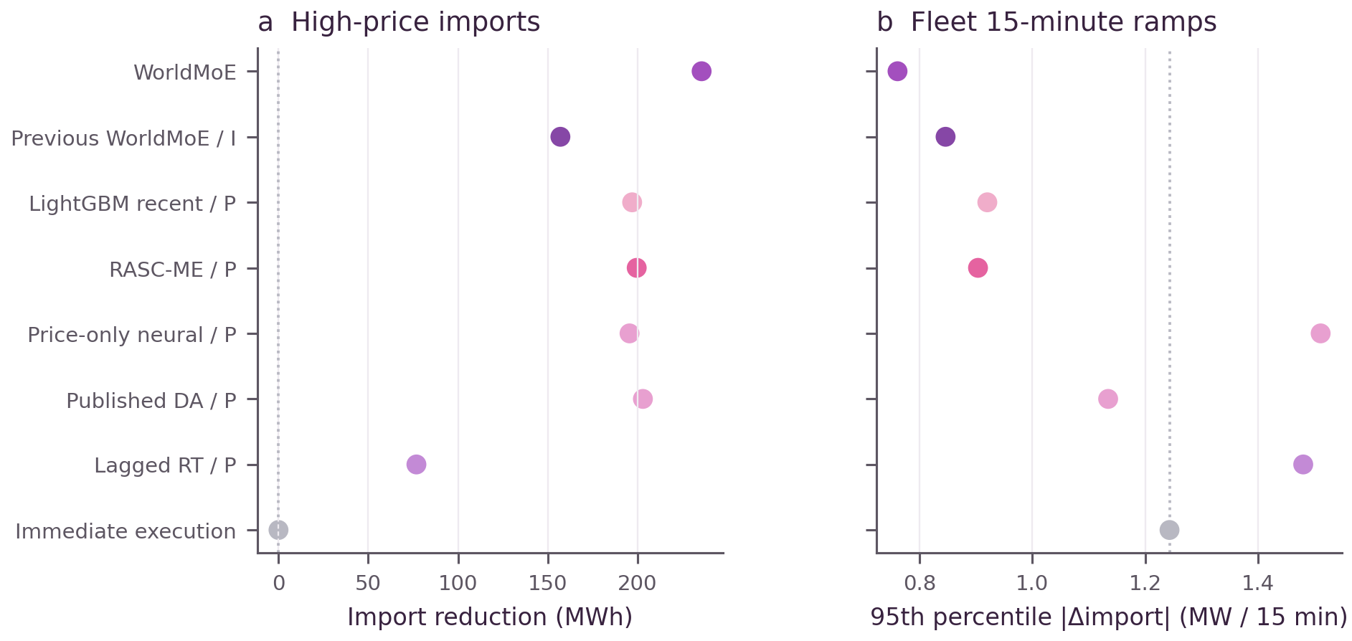
Supplementary Fig. 1. High-price import displacement and routine fleet ramps. (a) Net imports avoided during the highest-price 10% of fleet hours (MWh). (b) The 95th percentile of absolute adjacent 15 min fleet-import changes (MW per 15 min). Seven historical model–controller systems and immediate execution use the original nominal trajectories; dotted lines identify the immediate-execution reference. Archive abbreviations identify historical systems. Site ramp constraints and monthly billing demand are assessed separately.
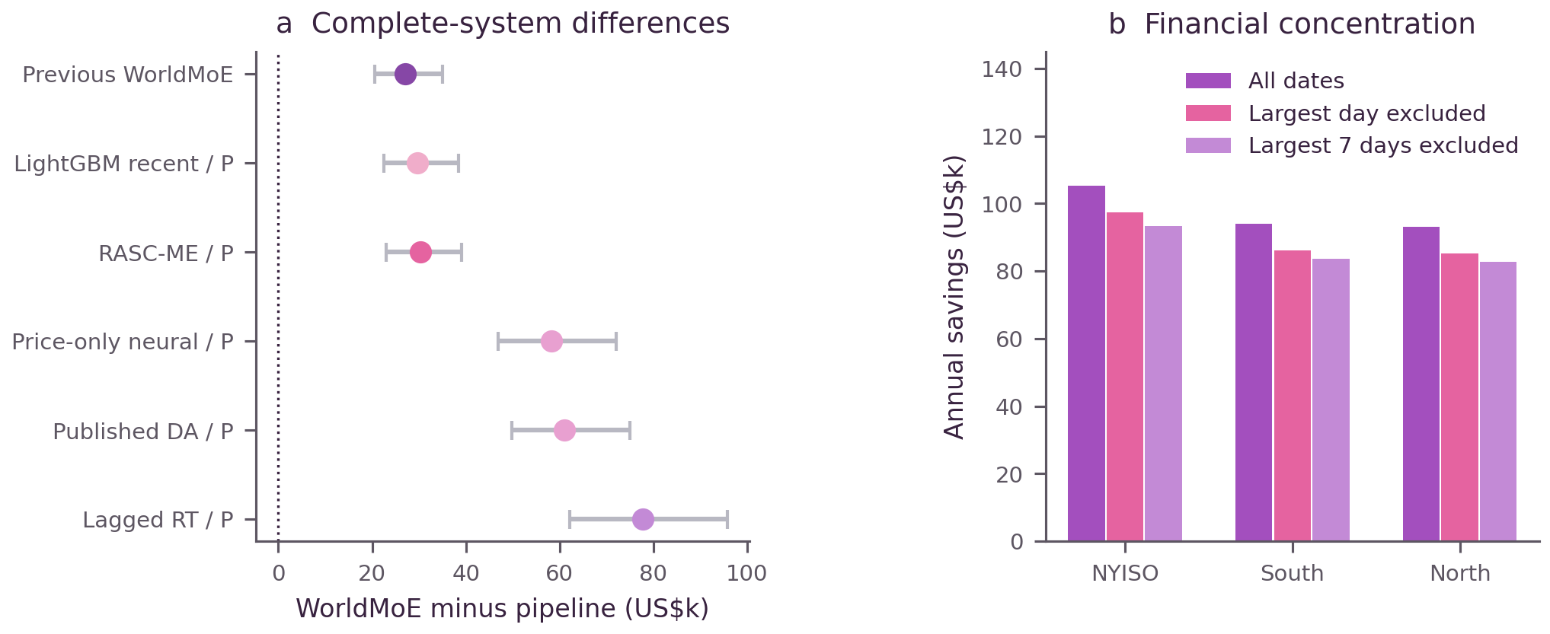
Supplementary Fig. 2. Native-system financial differences and concentration of annual savings. (a) WorldMoE savings relative to six historical systems, with paired 95% intervals from seven-day block resampling. Labels retain original archive identifiers. (b) Savings remaining after removal of the largest daily or contiguous seven-day contribution, without rescheduling. Table 29 contains the full historical comparison; Table 28 separately reports common-executor annual aggregates.
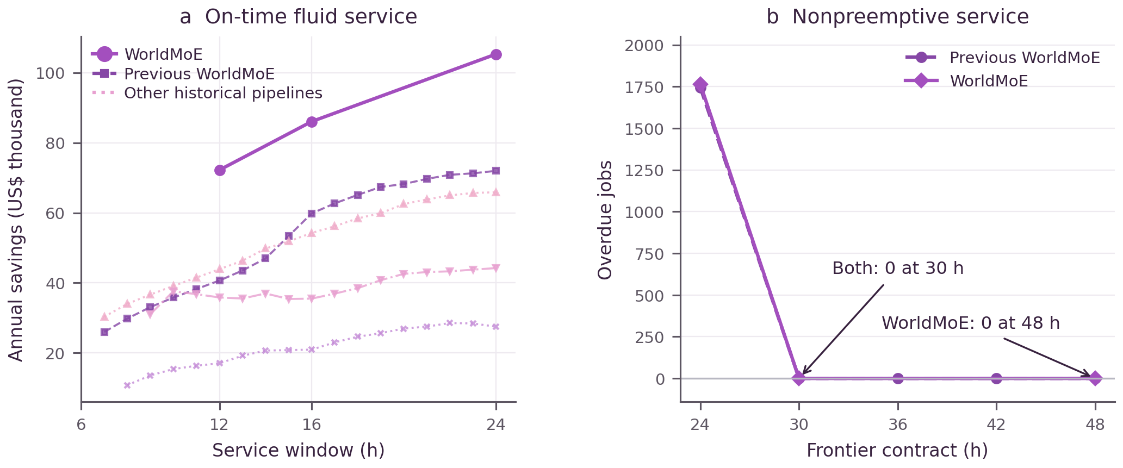
Supplementary Fig. 3. Retained historical rendering of service-window sensitivity and nonpreemptive job outcomes. (a) Eagle fluid-work savings under different service windows, with original means, ranges and historical native-system curves. (b) The graphic retains the earlier 30 h zero display. The source-reconciled current-WorldMoE count is 27 in Table 15 and Section S23; that corrected table governs the deadline interpretation. No figure pixels or ablation values were changed.
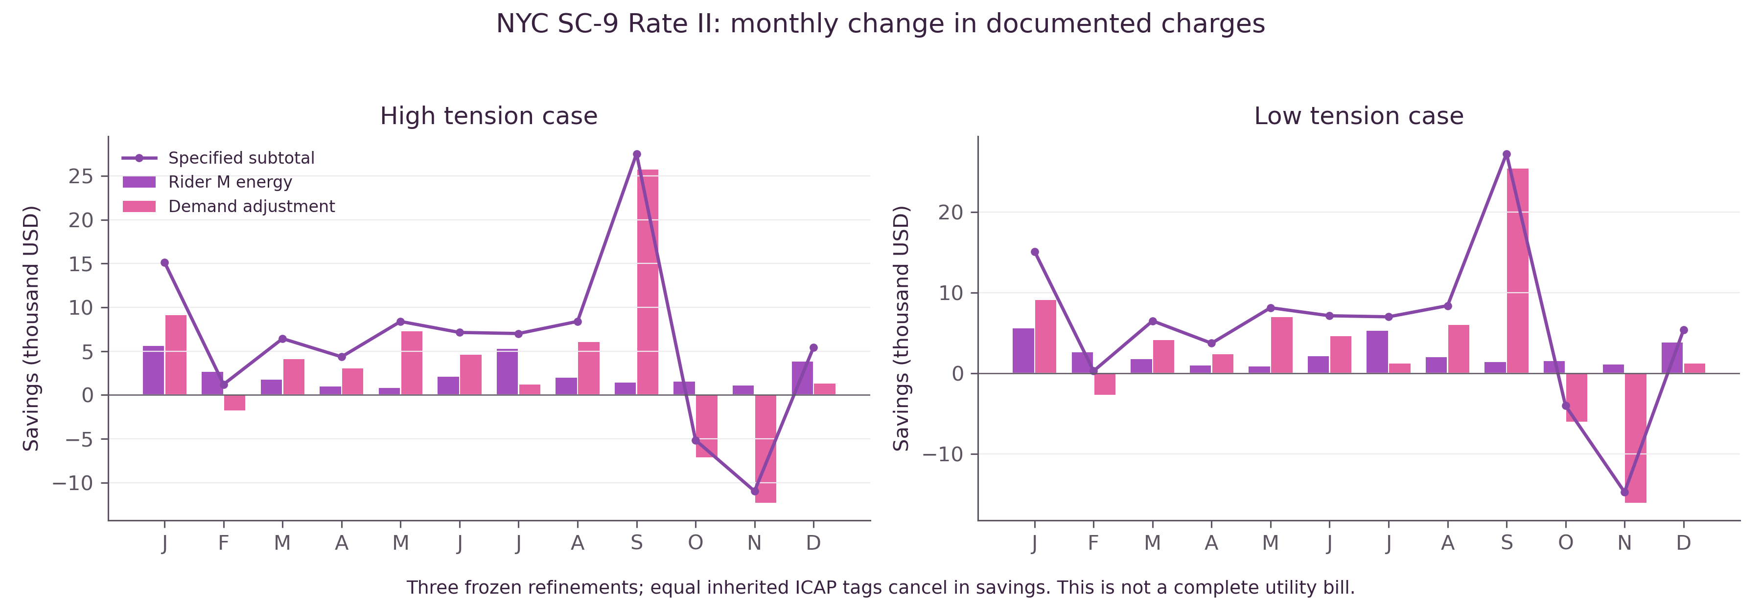
Supplementary Fig. 4. Monthly savings in specified NYC SC-9 Rate II charges. Billing demand uses adjacent 15 min observations to form 30 min windows, evaluated separately for each refinement before averaging. High- and low-tension cases retain fixed customer charges and equal inherited capacity tags. Increased demand charges in February, October and November coexist with positive annual subtotal savings. Tables 23, 24 and 31 define the included charges and model adjustments.
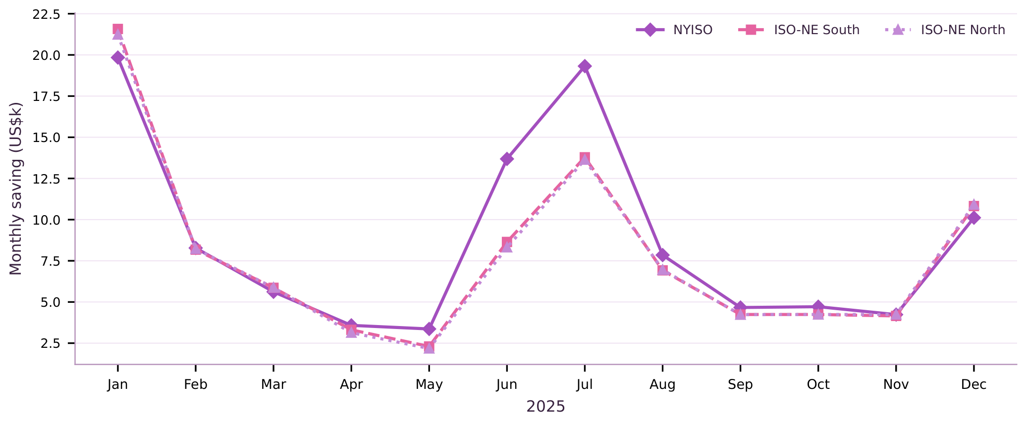
Supplementary Fig. 5. Monthly service-adjusted savings for NYISO and the two ISO-NE price portfolios. Each monthly value averages three refinements relative to its matched immediate-execution reference and includes every calendar date. ISO-NE changes regional prices while retaining the facility and workload structure; transfer involves no retraining or recalibration.

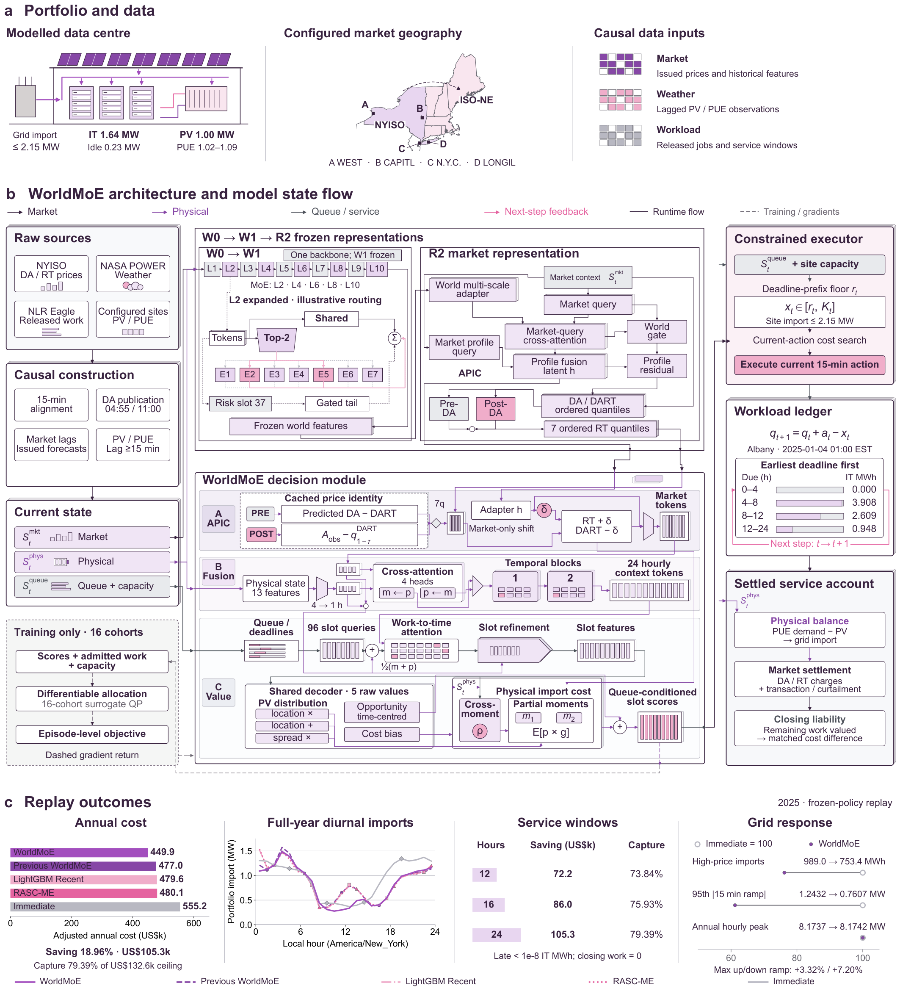
Supplementary Fig. 6. Detailed implementation of WorldMoE. (a) The Eagle release stream is divided among four simulated sites with independent service and physical constraints. (b) W0/W1 denote successive pretraining stages of one backbone; R2 is the probabilistic price module and APIC couples DA, RT and spread prices. Dashed paths show the training surrogate and gradients; solid paths show execution and settlement. The diagram represents the declared commitment-time architecture; Section S23 distinguishes it from the archived contemporaneous-physics stress projection. (c) Historical native-system outcomes retain their original controllers and closing obligations. The image and all original model results are preserved.

S19 Contract intervals and service feasibility

Admission and deadline conventions
A service right specifies a release slot and the first slot in which execution is no longer permitted. With quarter-hour intervals, a cohort admitted at the beginning of slot $r_{j}$ under a $W_{j}$-hour right has $D_{j}=4W_{j}$ eligible slots. The exclusive deadline and execution set are
$$D_{j}=4W_{j}, d_{j}=r_{j}+D_{j}, I_{j}=\{r_{j},…,d_{j}−1\}. \text{(S19.1)}$$
The admission slot is included. A cohort with a 24 h right may use 96 slots; including slot $r_{j}+96$ would grant 97. These definitions restore main-text Eq. (1b). They apply unchanged when a deadline falls beyond the reporting year. Initial unfinished cohorts retain their original releases, remaining work and deadlines.
Let $v_{jt}$ be work from cohort $j$ executed in slot $t$, $a_{j}$ its admitted amount and $c_{t}$ shared service capacity. The complete divisible-service representation is
vjt≥0, vjt=0 t∉Ij, t∈Ij​vjt=aj, xt=j​vjt≤ct. (S19.2)
Every physical and accounting constraint applies to the resulting execution, not separately to overlapping cohort reservations. The finite horizon must either include the complete recovery assignment or specify the surviving cohort obligations and terminal valuation. Extending a cohort’s deadline while preserving all other constraints gives a nested feasible set. Comparing heterogeneous menus requires checking that extension separately for every cohort.

Exact homogeneous deadline prefixes
For the cumulative representation, number slots from 1 and set $A_{t}=\sum_{s=1}^{t}{a_{s}}$, $X_{t}=\sum_{s=1}^{t}{x_{s}}$, with $A_{s}=0$ for $s≤0$. For an initially empty, homogeneous $D$-slot service system,
$$A_{t−D+1}≤X_{t}≤A_{t}, 0≤x_{t}≤c_{t}. \text{(S19.3)}$$
Necessity follows because no service can precede admission and all cohorts released by $t−D+1$ are due by the end of slot $t$. For sufficiency, assign aggregate service to the oldest outstanding cohort. The upper prefix prevents execution before release. At cohort $r$’s last eligible slot $r+D−1$, the lower prefix gives $X_{r+D−1}≥A_{r}$, so FIFO assignment has completed that cohort and every earlier one. The slot-capacity constraint is unchanged. This establishes the equivalence used in main-text Eq. (1d), including exact completion boundaries. Initial cohorts enter the prefix requirements through their retained deadlines.
The same two total prefixes are not sufficient for arbitrary mixed deadlines. Consider unit cohorts released in slots 1 and 5, with last eligible slots 10 and 5. Executing one unit in slot 1 and another in slot 10 satisfies aggregate release and due totals but misses the second cohort. Cohort-to-slot flow in Eq. (S19.2), or an equivalent complete interval-demand formulation, resolves this ambiguity. The mixed 4/12/24 h audit therefore retains each class’s release and deadline and assigns execution by EDF.
For an inclusive last-eligible slot $u$, let $B_{t}\left(u\right)$ be currently outstanding admitted work due by the end of $u$. A conservative future capacity path gives the current requirement
$$r_{t}=\max_{u≥t}max\{0,B_{t}\left(u\right)−\sum_{s=t+1}^{u}{c_{s}^{−}}\}. \text{(S19.4)}$$
There are $u−t$ future slots after the current action. With an exclusive boundary $d=u+1$, the same sum ends at $d−1$. The capacities must be jointly achievable under the declared electrical constraints. If the required service exceeds current capacity, the instance is infeasible under those admissions and that declared capacity path; a conservative envelope alone need not imply infeasibility under a larger realised capacity path. Clipping the action does not establish deadline feasibility.

S20 Exact repair and the monetary value of a feasible witness

Exact cumulative repair
A numerical candidate becomes a feasible witness after its original constraints are checked exactly. Interpret stored binary64 inputs as exact binary rationals, or use a declared exact decimal representation consistently. For one homogeneous contract, let $L_{t},U_{t}$ be nondecreasing cumulative deadline and release boundaries, with $L_{0}=U_{0}=X_{0}=0$, $c_{t}≥0$ and $C_{t}=\sum_{s=1}^{t}{c_{s}}$. A fixed final service total is encoded by $L_{N}=U_{N}$. The initial cohort ledger determines the earliest obligations; no initial work is discarded.
Assume the candidate increments already satisfy $0≤{\hat{x}}_{t}≤c_{t}$ exactly. Propagate the corridor through the capacity limits and clamp the candidate cumulative path:
$$ℓ_{t}=\max_{s≥t}\{L_{s}−\left(C_{s}−C_{t}\right)\}, u_{t}=\min_{s≤t}\{U_{s}+\left(C_{t}−C_{s}\right)\}. \text{(S20.1)}$$
$${\tilde{X}}_{t}=min\{u_{t},max\left(ℓ_{t},{\hat{X}}_{t}\right)\}, {\tilde{x}}_{t}={\tilde{X}}_{t}−{\tilde{X}}_{t−1}. \text{(S20.2)}$$
The propagated corridor is feasible only if $ℓ_{t}≤u_{t}$ for every boundary. Both envelopes are nondecreasing, with each increment bounded by the corresponding capacity. Pointwise minimum and maximum preserve these properties, so the repaired path satisfies all original prefixes, nonnegativity, fixed service capacities and specified endpoints. The envelopes require one backward and one forward pass. The accompanying exact verifier rejects an infeasible corridor or a raw increment outside its capacity box.
Suppose exact prefix evaluation establishes $L_{t}−{\hat{X}}_{t}≤ε_{d}$ and ${\hat{X}}_{t}−U_{t}≤ε_{r}$. For $s≥t$, the raw capacity bound implies ${\hat{X}}_{s}−{\hat{X}}_{t}≤C_{s}−C_{t}$, giving $ℓ_{t}≤{\hat{X}}_{t}+ε_{d}$. The corresponding argument for $s≤t$ gives $u_{t}≥{\hat{X}}_{t}−ε_{r}$. Thus
$$−ε_{r}≤{\tilde{X}}_{t}−{\hat{X}}_{t}≤ε_{d}, \sum_{t=1}^{N}{|{\tilde{x}}_{t}−{\hat{x}}_{t}|}≤N\left(ε_{r}+ε_{d}\right). \text{(S20.3)}$$
The second inequality follows by differencing the prefix perturbation, whose range has width $ε_{r}+ε_{d}$. This proves main-text Eq. (5c). Prefix errors must include any imposed terminal endpoint. Rounded diagnostic maxima alone do not establish these exact hypotheses.
This repair applies to homogeneous divisible service and fixed capacity bounds. Mixed deadlines require the cohort flow. Electrical ramp coupling or nonpreemptive execution requires the original coupled constraints. A general repair can minimise weighted absolute execution changes over that original feasible set, reconstruct a rational solution and verify it independently. The exact import graph must be retained: allowing imports merely to exceed net demand can create artificial receipts at negative prices.

Original-account monetary correction
For fixed realised physics, define grid imports $G_{t}\left(x\right)={[{PUE}_{t}\left(P^{idle}+kx\right)−P_{t}^{PV}]}_{+}$ and curtailment $V_{t}\left(x\right)={[P_{t}^{PV}−{PUE}_{t}\left(P^{idle}+kx\right)]}_{+}$. The released wholesale ledger charges RT energy, US$1/MWh of curtailment and US$1/MWh of absolute import deviation from the reference. Let $ΔG$ and $ΔV$ denote repaired minus candidate values and $δΨ$ the repair-induced terminal-cost change. A safe increase in the original cost is
BR=z,t​Δt[|pztRT|+1|ΔGzt|+|ΔVzt|]+|δΨ|. (S20.4)
The positive-part map is 1-Lipschitz, so both $|ΔG|$ and $|ΔV|$ are bounded by $k PUE |Δx|$. The reverse triangle inequality also bounds the change in the absolute import-deviation fee by $|ΔG|$. Therefore
BR≤z,t​Δt kzPUEzt|pztRT|+2|Δxzt|+|δΨ|. (S20.5)
This proof covers negative prices. For a linear terminal liability, |δΨ|≤z​|τz| |Δqzend|; it is zero when the terminal state is fixed. A completed recovery path and the same completed work must not both be charged as terminal obligations. The original account uses a frozen historical-price terminal valuation, so replacing it with actual tail RT settlement would change the account and require new matched bounds.
Let $ε_{H}$ bound numerical error in both the reference and candidate settled costs when forming their saving difference. Since $C\left(\tilde{x}\right)−C\left(\hat{x}\right)≤B_{R}$, the exact feasible witness satisfies
$$Δ_{B}=B_{R}+ε_{H}, H_{B}^{cert}=H_{B}^{raw}−Δ_{B}≤C_{0}−C\left(\tilde{x}\right)≤S_{B}^{⋆}. \text{(S20.6)}$$
This is the correction used in main-text Eqs. (5d)–(5e). A feasible repair need not be optimal. Its verified cost, or a proved upper bound on its cost increase, is sufficient for the exclusion theorem.

Conditional numerical budget
The released annual physical/electricity array has 35,040 intervals at four sites. Its displayed binary64 extrema are $max|p^{RT}|=4522.13$, $maxPUE=1.0929484367370605$ and $maxk=1.639059066772461$. Rational evaluation of those stored values gives a coefficient below 2026.139589 US$/work; the outward value $M=2026.14$ is sufficient. If the reported prefix maxima $ε_{r}=3.006750×{10}^{−12}$ and $ε_{d}=6.381505×{10}^{−12}$ are independently confirmed as exact bounds, including endpoints, then
z,t​|Δxzt|≤435040εr+εd=1.3158578208×10−6. (S20.7)
$$B_{R}^{electricity}≤2026.14\left(1.3158578208×{10}^{−6}\right)<0.002667 US dollars. \text{(S20.8)}$$
This evaluates the theorem’s conditional budget; it does not report a reconstructed annual witness. Changed terminal liabilities and numerical cost evaluation require separate allowances. The available annual array contains policy and reference execution, physics and prices, but not the original admissions or the US$117,000.2387599464 hindsight assignment.
For the manuscript-reported raw witness and larger 12 h ceiling, the nominal difference is US$19,197.8179185550. Its claimed downward-cent floor of US$19,197.81 survives only when the total additional correction is at most US$0.0079185550. The same threshold applies to the reported 16→24 h floor. These are acceptance conditions for a repaired witness, not substitutes for the missing verification record.

S21 Original cost Lagrangian verification

Full cost and terminal terms
The first released certificate programme uses incremental segments of a lower convex cost envelope and end-of-slot backlog. It is already a convex-hull relaxation. The original realised slot cost, including the reference-dependent fee, is
$$f_{t}\left(x\right)=Δt\{p_{t}^{RT}G_{t}\left(x\right)+V_{t}\left(x\right)+|G_{t}\left(x\right)−G_{t}^{0}|\}. \text{(S21.1)}$$
For zero initial backlog and homogeneous duration $D$, its balance and backlog box are
$$x_{t}+q_{t}−q_{t−1}=a_{t}, 0≤q_{t}≤Q_{t}=A_{t}−A_{t−D+1}. \text{(S21.2)}$$
These equations use the inclusive end-slot convention of Eq. (S19.3). Initial backlog is incorporated into the first balance and its original deadline prefixes. Let $N$ be the last modelled slot, set $λ_{N+1}=0$, and let $τ$ be the common work-unit terminal price. With arbitrary equality multipliers,
$$ϕ_{t}\left(λ_{t}\right)=\min_{0≤x≤c_{t}}\{f_{t}\left(x\right)−λ_{t}x\}, ψ_{t}=Q_{t}min\{0,λ_{t+1}−λ_{t}+τ1_{\{t=N\}}\}. \text{(S21.3)}$$
$$L^{Lag}\left(λ\right)=C_{common}+\sum_{t=1}^{N}{\left(λ_{t}a_{t}+ϕ_{t}\left(λ_{t}\right)+ψ_{t}\right)}. \text{(S21.4)}$$
An initial nonzero queue adds its fixed multiplier contribution. For a feasible balance, multiplier terms cancel. Independent minimisation over the service and backlog boxes can only reduce the Lagrangian, proving a cost lower bound. The terminal term must appear in the final backlog coefficient; omitting it changes the cost account.
The cost is continuous and affine between physical breakpoints. Its global scalar minimum is obtained by testing both box endpoints, the zero-import breakpoint, and every reference-import breakpoint within the box. Subtracting $λ_{t}x$ introduces no new breakpoints. This argument holds at negative prices and does not require the original slot cost to be convex. The supplied evaluator recomputes these minima from original physical inputs rather than trusting a floating-point hull.

General finite box certificate
For an outer programme with objective $c_{0}+c^{⊤}y$, equalities $Ay=b$, inequalities $My≤h$ and finite bounds $l≤y≤u$, take unrestricted $λ$ and $μ≥0$. Define
r=c−A⊤λ+M⊤μ, L=c0+λ⊤b−μ⊤h+i​minliri,uiri. (S21.5)
The equality term is $λ^{⊤}\left(b−Ay\right)$ and the inequality term is $μ^{⊤}\left(My−h\right)≤0$ on the feasible set. Minimising that Lagrangian over its finite box proves Eq. (S21.5), corresponding to main-text Eqs. (4b)–(4c). Small stationarity errors are priced through the actual variable bounds. If inequality multipliers are clipped to their allowed sign, recompute the full expression; the old dual objective cannot be retained.
Transfer to the original contract additionally requires an embedding of every original feasible schedule and a relaxed objective nowhere above its original cost. Any proved coefficient, input or modelling allowance is subtracted from the cost bound. A minimisation subproblem’s feasible incumbent is an upper cost value and cannot replace a global lower bound.

Arithmetic and rounding
The released annual programme constructs the hull and evaluates its dual in floating point, then uses $⌊L_{z}⌋−1$ per site. The one-dollar reserve is an archived numerical convention; by itself it does not prove a bound on hull, coefficient or arithmetic error. The exact reference evaluator instead forms each scalar summand as a rational, rounds that complete term downward to a declared dollar quantum, and accumulates the resulting integers. For $m$ terms and quantum $δ$, the downward loss is less than $mδ$.
At 35,040 intervals with three scalar terms per interval and $δ={10}^{−12}$ dollars, the arithmetic loss is below US$0.00000010512 per site, before separate input or modelling allowances. This procedure avoids applying one-direction rounding indiscriminately to signed intermediate operations. It has been verified on small contracts; the unavailable original annual multiplier vectors prevent an annual application here.
Cost floors and witness floors round downward; savings ceilings round upward. Table 32 applies that presentation rule to the unrounded values reported in the manuscript. The full corrected bound and its evidence status must accompany each displayed amount.
Supplementary Table 32. Manuscript-reported 2025 savings ceilings displayed with conservative upward cent rounding. The independent assembly records and annual exact re-evaluations remain requirements in Table 36.
Right | Allocation Lagrangian US$ | Independent epigraph US$ | Combined ceiling US$
12 h | 97,802.43 | 97,796.43 | 97,796.43
16 h | 113,310.43 | 113,305.22 | 113,305.22
24 h | 132,605.43 | 132,598.68 | 132,598.68

S22 Independent cumulative epigraph certificate
The second implementation is assembled directly from the same immutable admissions, physical inputs and settlement specification. Its variables may comprise execution, cumulative service or backlog, and slot-cost epigraphs. It must reconstruct the release and deadline rows from the interval convention in S19, retain the shared capacity and use the identical terminal rule. Import or ramp constraints may be relaxed only by a stated outer-set construction.
For each slot, construct every supporting facet of the lower convex envelope on the declared service interval:
$$η_{t}≥α_{tj}x_{t}+β_{tj} \text{for every facet }j, {\underline{f}}_{t}\left(x\right)=\max_{j}\left(α_{tj}x+β_{tj}\right). \text{(S22.1)}$$
Check each facet below the original $f_{t}$ at every original breakpoint and both domain endpoints. On an interval between consecutive breakpoints, the difference between a facet and the original cost is affine, so endpoint dominance proves dominance throughout that interval. This establishes ${\underline{f}}_{t}\left(x\right)≤f_{t}\left(x\right)$ over the whole domain, including all negative-price cases. Selected grid points are insufficient.
Finite epigraph bounds must preserve the embedding of every original feasible execution; excessively restrictive bounds can invalidate the certificate. An original schedule embeds by taking $η_{t}=f_{t}\left(x_{t}\right)$ when those bounds permit it. With all rows and bounds recorded, sign-corrected multipliers are evaluated by Eq. (S21.5). Primal residuals, stationarity residuals and solver termination are retained as diagnostics; exact finite-box evaluation supplies the bound.
Incremental segments and supporting facets of the same complete lower convex envelope describe the same convex relaxation. Independent reconstruction is an implementation check. It does not, without a proved domain or envelope difference, establish a second unrelated mathematical relaxation. Differences in the reported corrected ceilings may reflect outward domain allowances, multiplier quality and rounding. All such differences must be reconciled against a common original contract and cost.
For independent site accounts, sum corrected site cost bounds and include common procurement charges once. Network-coupled sites require a joint construction or a proved relaxation of the coupling. Combining two valid cost floors gives
$$U_{A}^{comb}=C_{0}−max\{L_{A}^{Lag},L_{A}^{cut}\}=min\{U_{A}^{Lag},U_{A}^{cut}\}. \text{(S22.2)}$$
An exactly feasible broader-rights witness exceeding this minimum proves exclusion using the tighter method. To claim that it exceeds both independently evaluated ceilings, require $H_{B}^{cert}>max\left(U_{A}^{Lag},U_{A}^{cut}\right)$. Neither test turns a hindsight witness into an information-adapted policy. A retrospective outer set can bound all realised nonanticipative trajectories while the witness remains a perfect-information construction.

S23 Programme audit and independently reproduced accounts

Contract implementations and boundary reconciliation
The source audit fixes repository commit 323c2084e7ee668ba512fb1e33dd56b8394b32d4 of executable-service-commitments-worldmoe. It distinguishes the historical implementation, newly specified exact verifiers, and reproduced scalar accounts. Table 33 identifies the contract-relevant checks; full paths and hashes accompany the verification package.
Supplementary Table 33. Original programme behaviour and the corresponding interpretation.
Programme | Observed implementation | Required interpretation
run_service_window.py | Uses 4W−1 queue offsets and tightens dispatch deadlines at year end | Early-service heuristic; full-W rights remain the certifier’s domain
run_g4_window.py | Preserves 8/48 h queue windows and a 96-slot valuation horizon | Contract duration and forecast horizon are separate
run_mixed_deadlines.py and audit_hetero_book.py | Fixed 25/50/25 classes with EDF attribution through the extended book | Mixed-contract feasibility requires the class-specific audit
context.py and reservation.py | Complete FIFO audit checks extended deadlines; legacy late counter censors some tail misses | Use full deadlines, per-site conservation and retained initial cohorts
controllers.py project_grid | Archived current projection reads same-interval realised PV/PUE | Distinguish this experiment from an unrevealed-physics robust executor
run_frontier_jobs.py | Earliest feasible fallback can finish after the requested deadline | Classify the outcome by its actual completion time
The old year-end clamp restricts the controller’s choices, so it can still produce a feasible schedule under the broader original right. It must not silently restrict the feasible set used for a contract-wide savings ceiling. The legacy reservation counter increments lateness only for deadlines inside the year; the independent full-deadline check detects tail misses. The exact verifier also checks conservation separately at each site, preventing cross-site cancellation.
The archived electrical projection reads current physical forcing before computing capacity, whereas the commitment-time rule in Eqs. (S28.6)–(S28.7) uses registered physical bounds and the previous completed import. The original supplementary stress values are retained as reported, but they do not by themselves verify the newly specified information boundary. Their corrected-run linkage requires the matching programme, inputs and trajectories. Idle-load infeasibility must be recorded even when computed service capacity is clipped to zero.
For Frontier, the archived 24/30/48 h summaries contain 1,764/27/0 late jobs and 41.051989/0.794196/0 IT MWh, respectively. The 24 h immediate reference itself has 1,744 late jobs and 38.052365 IT MWh. The 48 h nonpreemptive case saves US$60,673.0370 with no reported late jobs. Table 15 now uses these archived counts; the earlier author-supplied 30 h zero has no matching replacement run in the inspected source. The retained figure is a historical rendering and its 30 h zero does not override the reconciled table.

Independent re-settlement of released annual trajectories
The released grid_metrics_inputs_2025.npz contains the full 35,040×4 annual price, physical, reference and three policy arrays. Independently reconstructing imports and the original energy, curtailment and deviation-fee ledger gives Table 34. The file’s SHA-256 is 5be123c40f01b111cf6503b07882e703a4c2cc29a03dde3cfb7aa4321ce2cf72. These checks reproduce observed-year settlement before any terminal-cost difference; the source reports zero terminal differences for the nominal policies.
Supplementary Table 34. Independent observed-year wholesale re-settlement from released arrays. Values are US dollars; the common reference cost is 555,168.205055697.
Seed | Avoided energy value | Recovery energy cost | Net saving before terminal difference
20260920 | 172,496.174057 | 64,667.755556 | 105,565.665462
20260921 | 172,557.408233 | 65,271.835060 | 105,003.517378
20260922 | 172,476.740375 | 64,975.857243 | 105,244.002685
Mean | 172,510.107555 | 64,971.815953 | 105,271.061842
The mean deviation fee is US$3,348.756768 and the mean curtailment benefit is US$1,081.527007. Their inclusion reproduces the US$105,271.06 reported saving. Import reduction of 1,013.960857 MWh equals curtailment reduction of 1,081.527007 MWh minus increased facility demand of 67.566150 MWh. The largest reconstructed-import discrepancy is below $3.24×{10}^{−16}$ MW. This is independent re-settlement of supplied trajectories, not training replay, a reconstructed admission/deadline audit or verification of the missing hindsight witness.

Published certificate scalar checks
The public certificate CSVs contain 48 site rows grouped into twelve four-site cases across two years, two traces and three rights. Every recorded site floor equals the archived rule floor(dual)−1. Reaggregating site values matches the published raw totals within $6.5×{10}^{−11}$ US dollars; subtracting group cost floors from reference costs matches reported ceilings within $1×{10}^{−11}$ US dollars. The common 2025 DA charge is US$2,409.7842143056 and is included once per four-site account.
These 48 summary rows must not be confused with the twelve 2025 Eagle site-contract certificates required for the independently assembled second formulation. Scalar consistency does not reconstruct their matrices, hull facets, multipliers or exact input-error allowances. The archived primal diagnostics accept nonzero residuals; the smallest reported original-cost-minus-relaxed-primal value is −US$0.00000287457. Exact original-cost evaluation and domain dominance, rather than that tolerance check, establish a rigorous lower bound.

S24 Verification materials and reproduction scope
The verification package provides the exact homogeneous repair, original-cost Lagrangian evaluator, generic finite-box verifier, scalar reaggregation, source boundary tests and independent observed-year settlement. The accompanying manifest identifies the annual materials required for the twelve site-contract instances. Blank entries remain unresolved evidence fields, not successful checks.
Supplementary Table 35. Required 2025 Eagle site-contract instances. Each instance needs its own original-cost and independently assembled epigraph records.
Contract | Sites | Instances | Common matched account
12 h, 48 slots | WEST, CAPITL, N.Y.C., LONGIL | 4 | Identical admissions, physics, reference and terminal rule
16 h, 64 slots | WEST, CAPITL, N.Y.C., LONGIL | 4 | Identical admissions, physics, reference and terminal rule
24 h, 96 slots | WEST, CAPITL, N.Y.C., LONGIL | 4 | Identical admissions, physics, reference and terminal rule
Supplementary Table 36. Minimum records for a complete annual certificate and witness audit.
Material | Minimum contents | Evidence status
Original contract inputs | Admissions, initial cohorts, capacities, physical data, reference, terminal rates, units and hashes | Annual physical/policy arrays available; original admissions and full recovery books absent
First formulation | Source hash, all multipliers, exact breakpoint minima and correction ledger | Source and scalar summaries available; annual multiplier records absent
Independent epigraph formulation | Separately assembled sparse rows, finite bounds, every facet and all dual multipliers | Manuscript reports summaries; twelve original NPZ certificates absent
Feasible broader-rights witness | Complete cohort assignment, recovery boundaries, exact residuals and original re-settlement | Raw saving and diagnostic maxima reported; original annual assignment absent
Exact reference verifiers | Arithmetic representation, test fixtures, outputs and error allowances | Supplied and tested on stated fixtures
Decision-time information | Immutable first releases, receipt and processing times, checkpoint and action hashes | Timing rules and fixed assets available; complete first-release replay not established
The finite-box input schema records objective coefficients, equality and inequality matrices, right-hand sides, all finite variable bounds, and equality/inequality multipliers. The original-cost schema additionally records arrivals, capacity, RT prices, PV, PUE, idle load, work conversion, reference imports, terminal price and common charges. The repair schema accepts candidate execution, admissions, capacities, duration, initial cohort deadlines and the exact closing rule. Binary floats and decimal strings have explicitly different exact interpretations; the chosen interpretation is recorded with input hashes.
Supplementary Table 37. Verification procedures delivered with this revision and their scope.
Procedure | Completed checks | What the result establishes
reference_verifier.py | 12 regression tests | Signs, finite boxes, facets, rounding and arithmetic identities
annual_dual_revaluation.py | 5 small-contract tests | Original-cost breakpoint minima and terminal Lagrangian terms
exact_witness_repair.py | 13 checks including 729 rational paths | Exact homogeneous prefix repair and its perturbation bound
source_contract_checks.py | 16 original-function boundary fixtures | Recorded deadline, tail and physical-projection behaviour
independent_settlement_check.py | Three full-year policy arrays | Reproduction of the observed-year wholesale account
published_bound_scalar_audit.json | 48 site rows, twelve groups | Internal consistency of supplied certificate summaries
The annual_dual_revaluation evaluator uses complete exact scalar terms and a declared downward quantum. The repair verifier supplies an exactly feasible output only when its own original-domain guards pass. A sample four-slot input is an algorithm fixture and contributes no empirical WorldMoE result. The new tests leave Tables 9, 10 and 29, all original ablation values and all six figure images unchanged.
An annual verification closes only after the required original arrays, recovered witness and both formulations’ records are bound to a common manifest and all exact checks pass. Nonanticipativity is a separate record-level test: each numerical input must have been available after receipt and processing before the committed action. Re-settlement under realised prices, fixed pre-evaluation parameters and an admissible information rule establish different parts of that argument and are reported separately.

S25 Information and net contract value

S25.1 A common account and three value objects
Fix admissions, physical equipment, site assignments, the reference execution and the original electricity/service account. The cost $C\left(x,ω\right)$ includes energy, the existing import-deviation and curtailment charges, and the declared terminal treatment. The realised path $ω$ contains prices, physical forcing and other uncertain inputs. It has a probability law $P$ and decision-time filtration $F={\left(F_{t}\right)}_{t}$. The expectation below can be conditional on information available at contract signing. It must use the same law and reference for every contract.
For right $W$, let $X_{W}\left(ω\right)$ be the complete pathwise service-feasible set and $Π_{W}^{F}$ the class of policies whose committed actions are adapted to $F$ and satisfy those constraints almost surely. Each policy must preserve the original deadline, electrical and terminal definitions. For a selected policy and a realised path, the historical operating saving is
$$S_{W}^{π}\left(ω\right)=C_{0}\left(ω\right)−C\left(π,ω\right). \text{(S25.1)}$$
The perfect-information opportunity and the optimal nonanticipative expected value are different objects:
$$\begin{matrix}V_{W}^{PI}\left(ω\right) & =\sup_{x∈X_{W}\left(ω\right)}\left(C_{0}\left(ω\right)−C\left(x,ω\right)\right), \\ V_{W}^{F} & =\sup_{π∈Π_{W}^{F}}E[S_{W}^{π}].\end{matrix} \text{(S25.2)}$$
The first optimiser may inspect the entire realised path. The second selects a policy whose actions use only available information. Assume the relevant value functions are measurable, finite and integrable. Every feasible adapted policy produces a pathwise feasible schedule, giving
$$E[S_{W}^{π}]≤V_{W}^{F}≤E[V_{W}^{PI}]. \text{(S25.3)}$$
The proof first applies $S_{W}^{π}\left(ω\right)≤V_{W}^{PI}\left(ω\right)$ almost surely, takes expectations, and then takes the supremum over admissible policies. It does not interchange a supremum and an expectation. A single historical value of Eq. (S25.1) does not identify either expectation. Re-settlement establishes an account for supplied actions; the actual input vintages establish their information admissibility. A nonanticipative rule does not by itself supply a probability law or an expected-value guarantee.

S25.2 Information gaps and nested-rights increments
Suppose the expansion $A⊆B$ preserves all common inputs and constraints and allows every $A$ policy under $B$. Then both the pathwise perfect-information optimum and the optimal adapted expected value are nondecreasing. Define the information gap
$$I_{W}=E[V_{W}^{PI}]−V_{W}^{F}≥0. \text{(S25.4)}$$
Subtracting the two definitions gives the exact decomposition
$$V_{B}^{F}−V_{A}^{F}=E[V_{B}^{PI}−V_{A}^{PI}]−\left(I_{B}−I_{A}\right). \text{(S25.5)}$$
Although each information gap is nonnegative, their difference need not have a fixed sign. Therefore an expected perfect-information upgrade is not generally an upper or lower bound on the adapted expected upgrade. Table 38 supplies two exact counterexamples. Each has two equiprobable states and an action selected before the state is observed. The actions have abstract payoff pairs; they are not claimed to arise from the paper’s deadline-only expansion.
Supplementary Table 38. Abstract nested-action examples separating the two incremental values. Values are illustrative utility units, not market observations. In each row, B retains every A action.
Example | A action payoffs | Additional B action payoffs | Expected PI increment | Adapted expected increment
Information becomes more useful | (0, 0) | (1, −1), (−1, 1) | 1 | 0
New action removes information dependence | (2, 0), (0, 2) | (2, 2) | 0 | 1
In the first row, every available action has expected payoff zero, but hindsight selects the positive-payoff action in either state. Thus $I_{A}=0$ and $I_{B}=1$. In the second row, A’s best ex-ante action yields one and its statewise maximum yields two; B’s new action yields two in both states. Thus $I_{A}=1$ and $I_{B}=0$. These calculations verify Eq. (S25.5) and both possible orderings.
There is a corresponding historical-policy decomposition. For an exactly feasible policy, define $r_{W}^{π}\left(ω\right)=V_{W}^{PI}\left(ω\right)−S_{W}^{π}\left(ω\right)≥0$. Then
$$S_{B}^{π_{B}}−S_{A}^{π_{A}}=V_{B}^{PI}−V_{A}^{PI}−\left(r_{B}^{π_{B}}−r_{A}^{π_{A}}\right). \text{(S25.6)}$$
A same-controller historical upgrade therefore combines the change in optimal opportunity with the change in that controller’s unused opportunity. The paired values in S26 are operating comparisons; they do not independently identify the optimal rights premium.

S25.3 Incremental bounds under a stated criterion
Let $H_{A},H_{B}$ be exactly feasible savings, including their monetary correction, and let $U_{A},U_{B}$ be valid savings ceilings for the same realised path and account. The corrected incremental interval is
$$max\left(0,H_{B}−U_{A}\right)≤V_{B}^{PI}−V_{A}^{PI}≤U_{B}−H_{A}. \text{(S25.7)}$$
The lower difference follows from $V_{B}^{PI}≥H_{B}$ and $V_{A}^{PI}≤U_{A}$; nesting adds zero as a lower bound. The opposite pair gives the upper difference. Subtracting two ceilings or two witnesses does not establish this interval. For example, A and B value intervals [50, 100] and [80, 120] permit nested true values (99, 100) or (50, 120). The corresponding increments are 1 and 70, while the difference of witness endpoints is 30 and the difference of ceiling endpoints is 20. The valid general increment interval is [0, 70].
Using $H_{B}=H_{B}^{raw}−δ_{B}$ and $H_{A}=H_{A}^{raw}−δ_{A}$ makes the lower endpoint $max\left(0,H_{B}^{raw}−δ_{B}−U_{A}\right)$ and the upper endpoint $U_{B}−H_{A}^{raw}+δ_{A}$. A’s repair allowance must therefore be retained when reporting an upper incremental bound. Any additional ceiling allowance enters in its adverse direction. Independent implementations combine through the smaller valid savings ceiling; exceeding both separately requires comparison with the larger ceiling. These statements apply to any original or newly constructed certificate once its domain, objective dominance and verification conditions have been established.
For the ex-ante criterion, a constructive test uses an admissible B policy $π_{B}$ and a validated lower bound $h_{B}^{F}$ on its expected saving. If $u_{A}^{F}$ upper-bounds $V_{A}^{F}$, then
$$V_{B}^{F}−V_{A}^{F}≥h_{B}^{F}−u_{A}^{F}. \text{(S25.8)}$$
An integrable pathwise ceiling gives $V_{A}^{F}≤E[U_{A}]$, so a valid upper bound on that expectation can supply $u_{A}^{F}$. The B lower bound must come from an implementable policy under the same law; a hindsight witness cannot replace it. Scenario-specific hindsight choices are not a nonanticipative policy unless their decisions agree whenever the available histories agree. If either endpoint is statistically estimated, the claimed coverage of their difference must hold jointly. The original annual hindsight scalar and one observed policy year do not establish Eq. (S25.8) numerically.

S25.4 Net operator value and bilateral participation
Let $g$ denote an explicitly identified incremental operating-value criterion: a historical policy contrast, a pathwise PI difference, or the adapted expected difference. Let $F$ be an incremental tenant transfer and $K_{o}$ the operator’s incremental implementation, contracting and verification cost, all relative to retaining A. If these charges are fixed and independent of dispatch, the operator net increment is
$$N_{o}=g−F−K_{o}. \text{(S25.9)}$$
The ex-ante version uses $g=V_{B}^{F}−V_{A}^{F}$; the historical sensitivity in S26 uses the selected policy’s realised difference. These substitutions must not be mixed. If the chosen criterion has a valid interval $g∈[g_{L},g_{U}]$ and the additional charges satisfy $F∈[F_{L},F_{U}]$ and $K_{o}∈[K_{L},K_{U}]$, a safe enclosure is
$$g_{L}−F_{U}−K_{U}≤N_{o}≤g_{U}−F_{L}−K_{L}. \text{(S25.10)}$$
A positive lower endpoint proves a positive margin under that criterion, and a negative upper endpoint rules one out. An interval containing zero does not identify strict profitability. Correlation among uncertain costs may make the enclosure loose; simultaneous bounds remain sufficient. Costs already charged in the original operating ledger are not deducted again. Dispatch-dependent compensation must enter the optimisation and the corresponding certificate directly.
For fixed-calendar monetary amounts or common risk-neutral expectations, let $D$ be the tenant’s incremental delay/disruption cost and $K_{t}$ its incremental implementation cost. Its net benefit is $F−D−K_{t}$. Binary bilateral weak participation requires
$$D+K_{t}≤F≤g−K_{o}, N_{joint}=g−D−K_{o}−K_{t}. \text{(S25.11)}$$
The transfer cancels from joint surplus. Strict improvement on both sides requires strict inequalities and $g>D+K_{o}+K_{t}$. This participation interval does not establish incentive compatibility for a menu of private types. The original IC conditions require their own type-dependent costs and incentive comparisons; no such empirical distribution is inferred here.
Risk adjustments also require a consistent monetary unit. The objective $E[L]+ρ{CVaR}_{α}\left(L\right)$ changes by $\left(1+ρ\right)F$ when a deterministic fee $F$ is added inside the loss, because both components are cash-additive. Deducting only $F$ from that objective would be inconsistent. One cash-normalized alternative is $\left(1−γ\right)E[L]+γ{CVaR}_{α}\left(L\right)$ with $0≤γ≤1$. Another convention places deterministic fees outside an explicitly defined risk premium on operating uncertainty. In either convention, the risk functional and its parameter must be declared before comparing contracts. The difference between two CVaRs does not generally equal the CVaR of their paired loss difference.

S26 Matched contract increments and fee sensitivity

S26.1 Retained paired annual evidence
The released file source_data/current/fig3_service_windows.csv contains nine observations: each of the three frozen WorldMoE checkpoints appears under 12, 16 and 24 h rights. Within a seed, the full checkpoint SHA-256 is unchanged across rights. All nine rows use the common reference cost US$555,168.2050556969. The annual saving fields satisfy reference cost minus adjusted cost to within US$4×10⁻¹¹ of their printed decimal representations. The aggregate means independently match source_data/current/0927_adapted_window_contrasts.csv.
The archived controller verifies the selected configuration and checkpoint before the 2025 run, constructs the contract-specific queue and uses the common measurement function. Its year-end dispatch tightening is retained as the implemented heuristic described in S23. The pairing holds the trained model fixed while changing the service right and its resulting queue state. Table 39 presents every paired observation and their arithmetic mean. The values retain the original operating charges and terminal convention; no tenant payment has been added.
Supplementary Table 39. Full historical same-checkpoint contract pairing, annual four-site US dollars. Differences are calculated from unrounded source values before display rounding. The mean and refinement spread describe one calendar.
Seed | 12 h saving | 16 h saving | 24 h saving | 12→16 increment | 16→24 increment | 12→24 increment
20260920 | 72,361.65 | 86,257.34 | 105,565.67 | 13,895.69 | 19,308.33 | 33,204.02
20260921 | 72,099.98 | 85,833.93 | 105,003.52 | 13,733.95 | 19,169.59 | 32,903.54
20260922 | 72,201.28 | 86,024.40 | 105,244.00 | 13,823.11 | 19,219.61 | 33,042.72
Mean | 72,220.97 | 86,038.55 | 105,271.06 | 13,817.58 | 19,232.51 | 33,050.09
The paired ranges are US$13,733.95–13,895.69, US$19,169.59–19,308.33 and US$32,903.54–33,204.02, respectively. They describe variation across three refinements with a shared pretrained backbone and the same market calendar. They are not confidence intervals over future years. Existing paired intervals for different models at 24 h do not become deadline-upgrade intervals by relabelling them.
All 24 h observations are independently re-settled from the released grid_metrics_inputs_2025.npz, which contains 35,040 intervals at four sites. Reconstructing grid imports and the original energy, curtailment and import-deviation ledger gives mean saving US$105,271.06184163212695 before terminal-cost difference. The largest discrepancy from a published seed saving is US$5.88×10⁻¹²; the largest exported-grid reconstruction difference is below 3.24×10⁻¹⁶ MW. The source reports zero nominal terminal differences. The 12 and 16 h full trajectories, original admissions and complete recovery assignments are not in the inspected release, so those components remain summary-supported. This calculation does not turn their reported numerical service residuals into exact feasible witnesses.

S26.2 Historical fee sensitivity and break-even budgets
For the fixed historical policy pair, Eq. (S25.9) gives a one-dollar reduction in operator net value for each additional dollar of dispatch-independent compensation or implementation expense. Table 40 applies illustrative annual budgets $q=F+K_{o}$ to the observed mean paired differences. The grid is an analytical sensitivity choice; the repository contains no observed contract fees or tenant reservation-price sample. In particular, $q=0$ is a stated scenario, not an estimate that additional contracting costs vanish.
Supplementary Table 40. Mean historical net increments under assumed additional annual four-site costs. All values are US dollars. The first column is an analytical input; the remaining columns are paired operating increments minus that input.
Assumed additional $F+K_{o}$ | 12→16 h net | 16→24 h net | 12→24 h net
0 | 13,817.58 | 19,232.51 | 33,050.09
5,000 | 8,817.58 | 14,232.51 | 28,050.09
10,000 | 3,817.58 | 9,232.51 | 23,050.09
15,000 | −1,182.42 | 4,232.51 | 18,050.09
20,000 | −6,182.42 | −767.49 | 13,050.09
30,000 | −16,182.42 | −10,767.49 | 3,050.09
35,000 | −21,182.42 | −15,767.49 | −1,949.91
The exact mean historical break-even budgets from the printed source decimals are US$13,817.584760550363, US$19,232.507466893387 and US$33,050.092227443750. Positive mean net value requires a strictly smaller added budget. Positivity for every one of the three observed refinements instead requires $q$ below US$13,733.95372379268, US$19,169.58506638567 and US$32,903.53879017835. Neither condition guarantees future-year profitability. Extra printed digits document arithmetic and do not claim equivalent physical precision.
The reference arrays imply 2,981.6073925153343935 MWh of annual variable-IT execution. Dividing the three mean budgets by that same denominator gives 4.63427, 6.45038 and 11.08466 US dollars per reference IT MWh. This optional normalization is neither a price per shifted MWh nor a capacity-market rate; the principal result remains the annual four-site budget. No incremental cost already present in the original ledger is deducted again.

S26.3 Conditional transfer intervals
Table 41 quantifies the operator-side endpoint of Eq. (S25.11) for three illustrative implementation budgets. The tenant-side endpoint remains $D+K_{t}$ because those costs are unobserved. A positive operator endpoint alone does not establish a mutually acceptable transaction.
Supplementary Table 41. Mean historical upper transfer endpoints $g−K_{o}$ under assumed operator implementation expenses. The lower endpoint in every cell is the unobserved $D+K_{t}$. These are conditional retrospective participation intervals, not observed payments or ex-ante procurement prices.
Assumed $K_{o}$, US$ | 12→16 h upper $F$, US$ | 16→24 h upper $F$, US$ | 12→24 h upper $F$, US$
0 | 13,817.58 | 19,232.51 | 33,050.09
5,000 | 8,817.58 | 14,232.51 | 28,050.09
10,000 | 3,817.58 | 9,232.51 | 23,050.09
For example, the mean historical 12→24 h pairing with $K_{o}=US\$ 5,000$ gives the interval $D+K_{t}≤F≤US\$ 28,050.09222744375$. It exists only if the unknown tenant-side cost does not exceed that endpoint. For an actual ex-ante agreement, replace the historical $g$ with a validated expected or consistently risk-adjusted operating increment and value the tenant’s disruption under the same criterion. The source data do not identify those replacements.

S26.4 Reproduction records and provenance
The supplied economic_value_analysis.py reads the nine annual rows, pairs by seed, checks identical checkpoint hashes and the common reference, recomputes each mean and difference, independently re-settles the available 24 h arrays, and generates the fee and transfer tables. It also evaluates Table 38 with exact rational arithmetic. The outputs are paired_upgrades.csv, upgrade_summary.csv, historical_fee_scenarios.csv, conditional_transfer_frontiers.csv and economic_value_results.json. Published decimal strings are interpreted exactly for descriptive arithmetic; the independent physical re-settlement uses extended numerical precision.
The source commit is 323c2084e7ee668ba512fb1e33dd56b8394b32d4. The NPZ SHA-256 is 5be123c40f01b111cf6503b07882e703a4c2cc29a03dde3cfb7aa4321ce2cf72. Complete hashes for the paired CSV, published aggregate means, checkpoint provenance, original certificate summaries and separate manuscript-reported scalars are recorded in economic_value_results.json. The original same-seed checkpoint hashes are checked against source_data/current/current_provenance.json rather than inferred from display epoch labels.
The original annual witness and second-formulation files remain distinct from these historical account checks. Any independently constructed replacement certificate must record its admissions domain, constraints, terminal account and relationship to the original contract before its bound is used in Eq. (S25.7). The economic definitions and interval proofs apply to a valid replacement without implying recovery of an absent original file. None of the new calculations changes the WorldMoE ablations, the original benchmark table or the workload evidence.

S27 Verified conservative certificates from the released annual reference

Evidence and the quantity being certified
This section reports a new conservative verification using the complete released 2025 arrays. It does not reconstruct the unpublished 29 October certificate files or the previously reported US$117,000.2387599464 hindsight assignment. The retained input is source_data/grid_metrics_inputs_2025.npz, SHA-256 5be123c40f01b111cf6503b07882e703a4c2cc29a03dde3cfb7aa4321ce2cf72, at public repository commit 323c2084e7ee668ba512fb1e33dd56b8394b32d4. It supplies 35,040 quarter-hour intervals at four sites, including prices, realised physical inputs, reference execution and three policy executions. The original public array file does not contain admissions. The source admissions have now been recovered from the local forcing archive and are supplied and matched in S29–S30.
The certificate concerns the original nominal, divisible, homogeneous-rights account with zero initial queue, unit service capacity, static import limits and fixed realised PV/PUE. The archived nominal constraints contain no ramp limit. Dropping additional physical restrictions would preserve an outer savings bound but would not by itself validate a witness for those additional restrictions. The reference provenance premise is the archived reservation.reference recurrence: nonnegative finite binary64 arrivals are added to a queue, immediate service is its minimum with unit capacity, and the remainder is carried forward. The nominal cost and terminal rule are those in economic_core.record. The separate terminal-rate audit verifies positivity of the historical coefficients from the published MTM ledger and the documented accounting lineage; their positivity and conservative upper bounds are used below.
Reference execution cannot simply be relabelled as admissions. Each site’s reference contains 639 capacity-saturated intervals in 158 busy blocks. The longest saturated run is 35 intervals. As an explicit inference counterexample, moving half of the next positive reference amount into a preceding saturated interval yields a distinct nonnegative arrival vector with exactly the same complete reference output when the original function is executed. Neither constructed vector is asserted to be the original admissions. The new method instead bounds every admission vector compatible with the reference recurrence.
The published reference is retained as the source’s fixed settlement ledger and absolute-deviation fee anchor. Its expense $C_{0}$ is a fixed benchmark; the stored floating reference is not promoted to an exactly feasible witness for the unknown admissions. Exact feasibility claims below concern the repaired candidate schedules. Replacing the reference or fee anchor would define a different account and is unnecessary for the stated savings bounds or nested-rights increments.

A proved admission envelope from floating queue bookkeeping
Let $b_{t}$ be stored reference service, $R_{t}=\sum_{s=1}^{t}{b_{s}}$ its exact rational prefix, $A_{t}=\sum_{s=1}^{t}{a_{s}}$ the unknown exact admission prefix and $q_{t}$ the stored reference queue. Set $A_{0}=R_{0}=q_{0}=0$. At an unsaturated interval, $b_{t}<1$ and the stored queue clears exactly. Define $e\left(t\right)$ as the first unsaturated interval at or after $t$, with $e\left(0\right)=0$. Every observed final block closes inside the supplied year.
Under round-to-nearest binary64 arithmetic, put $u=2^{−53}$ and $β=2u+u^{2}$. Combining the source addition and subtraction gives
$$q_{t}=q_{t−1}+a_{t}−b_{t}+ϵ_{t}, |ϵ_{t}|≤β\left(q_{t−1}+a_{t}\right). \text{(S27.1)}$$
If two successive reference intervals are unsaturated, the starting queue is zero and the update is exact: $fl\left(0+a_{t}\right)=a_{t}$ and $fl\left(a_{t}−a_{t}\right)=0$. Thus only saturated blocks and their clearing intervals contribute to the bound. Consider $m$ saturated intervals followed by a clearing interval. Backwards iteration of $q_{t}≥\left(1−β\right)\left(q_{t−1}+a_{t}\right)−b_{t}$, using $b_{t}≤1$, bounds its cumulative update error by
$$E_{m}=\frac{\left(m+1\right)\left(m+2\right)β}{1−\left(m+2\right)β}. \text{(S27.2)}$$
The denominator is checked positive. The bound uses ${\left(1−β\right)}^{j}≥1−jβ$ and deliberately permits a larger remaining-service count than necessary. Binary64 addition/subtraction yielding a subnormal result is exact on the common representable-number lattice; the stated finite-input, finite-recurrence premise excludes overflow. Summing Eq. (S27.2) over all 158 blocks and rounding upward to ${10}^{−15}$ work units gives, independently at every site,
$$E=2.412×{10}^{−12}, |A_{t}−R_{t}−q_{t}|≤E. \text{(S27.3)}$$
Since $q_{t}≥0$, and $q_{e\left(t\right)}=0$ while admissions are nondecreasing, the exact original admissions satisfy
$$A_{t}^{−}:=max\left(0,R_{t}−E\right)≤A_{t}≤R_{e\left(t\right)}+E=:A_{t}^{+}, A_{0}^{−}=A_{0}^{+}=0. \text{(S27.4)}$$
This is a source-derived outward envelope. Its error is independent of the printed residuals associated with the missing old hindsight witness.

Two independently assembled annual outer formulations
For $D=4W$ eligible slots, every original feasible cumulative service path $X_{t}$ satisfies
$$\begin{matrix}L_{t}:=A_{max\left(0,t−D+1\right)}^{−} & ≤X_{t}≤A_{t}^{+}=:U_{t}, \\ X_{t}−X_{t−1} & =x_{t}, 0≤x_{t}≤c_{t}.\end{matrix} \text{(S27.5)}$$
The original physical calculation gives $c_{t}=1$ exactly throughout these public nominal inputs; this is checked against every static import limit, including idle load. Enlarging admission prefixes to Eq. (S27.5) can only enlarge the feasible execution set. The outer programmes do not impose $X_{N}=A_{N}$ or invent a feasible tail. They allow closing work. The source’s fixed-reference MTM terminal term is $τ_{z}\left(R_{zN}−X_{zN}\right)$, which differs from true unfinished-work liability $τ_{z}\left(A_{zN}−X_{zN}\right)$ by the small fixed offset $τ_{z}\left(R_{zN}−A_{zN}\right)$. The terminal audit proves $0<τ_{z}<21$ dollars per work unit. Since every original feasible schedule has $X_{zN}≤A_{zN}$, the source term is bounded below by $−21E$. We therefore subtract δT=z​21E=2.02608×10−10 dollars from each aggregated slot-cost floor; the signed offset is not silently omitted. The common fixed DA charge $K=2409.7842143056$ dollars is added once after summing site cost bounds and once to the matched reference cost.
The first programme uses incremental service segments and cumulative states. The floating LP is used only to propose equality multipliers. With $λ_{N+1}=0$, exact original-cost minimisation and finite-box weak duality give
LW1=K−δT+z,t​ϕzt+ψzt,ϕzt=min0≤x≤cztfztx−λztx,ψzt=minλzt−λz,t+1Lzt,λzt−λz,t+1Uzt. (S27.6)
To verify the sign, subtract $λ_{t}\left(x_{t}+X_{t−1}−X_{t}\right)$ from the objective. The service coefficient becomes $f_{t}\left(x_{t}\right)−λ_{t}x_{t}$ and the cumulative-state coefficient becomes $λ_{t}−λ_{t+1}$. These multiplier terms cancel on every feasible equality. Minimising each remaining term over its original finite box proves the bound for any multiplier values. Every service minimum is evaluated at both physical endpoints, the zero-import breakpoint and the reference-import breakpoint. This proves global minima of the original continuous piecewise-linear cost, including negative-price intervals, without trusting a floating convex hull.
The second programme independently assembles variables $\left(x_{t},X_{t},η_{t}\right)$, the cumulative balance rows and all exact lower-envelope facets $α_{tj}x_{t}−η_{t}≤−β_{tj}$. The finite epigraph box is the minimum and maximum of the original cost over its complete breakpoint set. Consequently every original execution embeds as $η_{t}=f_{t}\left(x_{t}\right)$. Every facet is checked beneath the original cost at every original breakpoint and endpoint. Affinity between consecutive original breakpoints establishes dominance throughout the interval.
For inequality multipliers $μ_{tj}≥0$, the exact finite-box residuals and constant are
rtx=−λt+j​μtjαtj, rtX=λt−λt+1,rtη=1−j​μtj, kt=j​μtjβtj. (S27.7)
The cost floor sums $k_{t}$ and the minimum of each residual times both corresponding finite endpoints, adds $K$ once and subtracts the same $δ_{T}$. This is Eq. (S21.5) applied to the independently assembled epigraph model with the proved terminal-cost allowance. HiGHS’ nonpositive sensitivity for a minimisation problem’s upper inequality row is negated to obtain this $μ$ convention. Any negative $μ$ is clipped to zero and the entire expression is recomputed. No clipping was needed in the retained annual records. All 2,095,170 retained facet–breakpoint comparisons pass exactly. Nonzero stationarity or primal residuals remain diagnostics; the full finite-box arithmetic supplies the rigorous bound.
These two programmes represent the same complete convex outer relaxation. Their independent matrices and exact verifiers check implementation agreement. They are not presented as two different economic mechanisms or two unrelated mathematical relaxations.
Each stored input and multiplier is interpreted as an exact binary rational. Complete scalar lower-bound terms are rounded downward at ${10}^{−12}$ dollars before integer accumulation. The first method uses two terms per interval, giving a loss below $2N×{10}^{−12}$ dollars per site; the second uses four terms per interval, giving a loss below $4N×{10}^{−12}$. The reference expense is enclosed from below and above using the same complete-term rule. Thus all monetary differences use the correct opposing enclosure directions.

A constructive feasible-value guarantee without recovering the unknown arrivals
For 24-hour rights, construct an exact surrogate schedule in the stricter corridor
$$R_{e\left(max\left(0,t−D+1\right)\right)}≤{\overline{X}}_{t}≤R_{t}, {\overline{X}}_{N}=R_{N}, D=96. \text{(S27.8)}$$
A separate LP proposes service increments. They are explicitly clipped into their physical boxes and then repaired by the exact propagated-corridor construction of S20. The resulting four complete rational schedules pass all 35,040 service boxes, all corridor prefixes and the closing equality, and are re-settled using the original nonconvex slot costs. The public reference itself establishes nonemptiness of Eq. (S27.8), because its longest busy block clears within 36 slots.
For clarity, the exact original admission-dependent corridor is also nonempty. Let $Q_{t}=max\left(Q_{t−1}+a_{t}−1,0\right)$ be the exact earliest-service queue on the actual admissions. Its update map is 1-Lipschitz. Comparing it with the floating recurrence and summing Eq. (S27.1) gives $|Q_{t}−q_{t}|≤E$. At every stored clearing interval $c$, the exact pre-service queue is at most $b_{c}+E$. The smallest recorded clearing-capacity margin is $1−b_{c}=0.04137009475380182…$, strictly exceeding $E$. Hence the exact queue clears at the same interval. Every actual cohort completes within a block of at most 36 intervals, satisfying all displayed 48/64/96-slot contracts. The final source interval is unsaturated, so exact earliest service completes the actual total $A_{N}$ within the year.
For any actual admission vector compatible with the source reference, Eq. (S27.4) implies that the surrogate schedule violates each true release/deadline prefix by at most $E$, including its final endpoint. Apply the exact S20 repair to that actual corridor, imposing ${\tilde{X}}_{N}=A_{N}$. It constructs a feasible original schedule and proves
$$\sum_{t=1}^{N}{|{\tilde{x}}_{t}−{\overline{x}}_{t}|}≤2NE. \text{(S27.9)}$$
The repaired schedule completes all actual work inside the year, so its true terminal backlog is zero. Its source MTM terminal term is nevertheless $τ_{z}\left(R_{zN}−A_{zN}\right)$, a possible signed bookkeeping offset bounded in magnitude by $21E$. The surrogate schedule ends at $R_{N}$ and has zero source MTM terminal term. For each site, let $M_{z}=\max_{t}Δt k_{z}{PUE}_{zt}\left(|p_{zt}^{RT}|+2\right)$. The original import, curtailment, absolute-deviation and source-terminal account therefore gives
Jx−Jx≤z​Mz2NE+δT<0.000837 US dollars. (S27.10)
The retained exact total, including the signed-terminal allowance, is less than $0.000836658044037$ dollars. This calculation uses proved reference-bookkeeping bounds, not unverified residuals of the old witness. It yields a uniform constructive existence and value guarantee for every compatible actual admission vector. The four explicit surrogate schedules are supplied. S29 now materialises the original-admission assignment from the recovered source input. All four supplied schedules already satisfy that exact corridor, so their additional repair is zero. No first-release or information-adapted policy performance is inferred from this hindsight construction.
Supplementary Table 42. New conservative annual results on the public-reference admission envelope. Savings ceilings are rounded upward and the feasible-value floor downward. The common matched account and terminal sign proof apply to both formulations. Premiums use exact unrounded enclosures before cent rounding.
Right | Original-cost ceiling US$ | Independent epigraph ceiling US$ | Uniform 24 h value floor US$ | 24 h premium above both ceilings US$
12 h | 100,625.48 | 100,625.48 | 130,931.31 | 30,305.84
16 h | 115,735.23 | 115,735.23 | 130,931.31 | 15,196.08
24 h | 134,437.85 | 134,437.85 | 130,931.31 | Not an exclusion comparison
The largest unrounded difference between the two formulations’ annual ceilings is below $0.000000138$ dollars. The new 24-hour perfect-information opportunity is enclosed by US$130,931.31 and US$134,437.85 on this conservative verification. The remaining bound-to-witness-value gap is at most US$3,506.54. This gap is an upper bound on remaining optimisation opportunity, not an assertion of the exact unknown optimum.

Terminal-rate sign and the reference-anchored liability
The outer bound must retain a possible negative constant in the original terminal account. This subsection establishes both the required coefficient sign and that constant’s allowance. The evidence is the released daily mark-to-market file source_data/current/worldmoe_daily_by_seed.csv, the same three annual policy arrays and the documented per-zone branch of economic_core.record, with no migration or fee/grid override. The source aggregate is produced by summarize_worldmoe_final.py. The inference conditions on that matched-account lineage, binary64 round-to-nearest arithmetic, shortest round-trip decimal exports and the one intervening default Pandas precise_xstrtod parse. It does not infer a historical package version from the CSV or recover the original training-price file.
Reproduce the source’s binary64 cash-value array $v_{t}$ and cumulative work-energy differences $w_{t,z}=fl\left(Δtcumsum{\left(\left(b−x\right)k_{z}\right)}_{t,z}\right)$. These floating outputs are known constants of the remaining inverse problem, rather than approximations that are silently substituted for an exact cumulative sum. Let $ρ_{z}={PUE}^{max} p_{z}^{hist}$ be the unknown frozen terminal coefficient and Dt=z​wt,zρz. The source computes its debt through two multiplications and a four-term reduction, subtracts successive debts from cash value, and sums the result within each local calendar day.
For a day spanning indices $s$ through $e$, let $y_{d}$ be the binary64 value round-tripped from its final CSV field. Define the exact matrix row and right-hand side by
$$\begin{matrix}M_{dz} & =w_{e,z}−w_{s−1,z}, d_{d}=\sum_{t=s}^{e}{v_{t}}−y_{d}, \\ |d_{d}−M_{d}ρ| & ≤a_{d}+b_{d}∥ρ∥_{∞}.\end{matrix} \text{(S27.11)}$$
Here $w_{0,z}=0$ at the initial boundary, with the corresponding zero value used before the first day. Every known binary64 value is converted to its exact rational representation. Put $u=2^{−53}$, $γ_{n}=nu/\left(1−nu\right)$, Λt=z​|wt,z|, $V_{d}=\sum_{t=s}^{e}{|v_{t}|}$, $J_{d}=\sum_{t=s}^{e}{\left(Λ_{t}+Λ_{t−1}\right)}$ and $m=e−s+1$. The verified error coefficients are
$$a_{d}=\left(u+γ_{m}\left(1+u\right)\right)V_{d}+ϵ_{CSV,d}+{10}^{−100}, \text{(S27.12a)}$$
$$b_{d}=γ_{6}\left(Λ_{e}+Λ_{s−1}\right)+\left(u\left(2+u\right)\left(1+γ_{6}\right)+γ_{m}{\left(1+u\right)}^{2}\left(1+γ_{6}\right)\right)J_{d}. \text{(S27.12b)}$$
To obtain this enclosure, the debt computation contributes at most $γ_{6}Λ_{t}∥ρ∥_{∞}$ per interval. Summed exact debt differences telescope, leaving only the two endpoint debt errors. The remaining subtraction errors contribute the $u$ and $u\left(2+u\right)$ factors, and the daily reduction contributes $γ_{m}$. The positive ${10}^{−100}$ reserve covers subnormal effects in these finite nominal calculations; the declared maximum PUE is an order-one positive number.
The intermediate CSV parse is explicitly included. The retained official parser source uses at most 17 digits, at most 34 positive Horner operations, cached decimal powers and at most two divisions. A $γ_{40}$ relative allowance covers these operations. Shortest round-trip rendering contributes a conservative $γ_{2}$ relative allowance. Counting the leading zero against the parser’s digit limit can additionally discard less than ${10}^{−16}$ in fixed notation below one. Thus
$$\begin{matrix}η & =\left(1+γ_{2}\right)\left(1+γ_{40}\right)−1, δ=\left(1+γ_{40}\right){10}^{−16}+{10}^{−300}, \\ ϵ_{CSV,d} & =\frac{η|y_{d}|+δ}{1−η}.\end{matrix} \text{(S27.13)}$$
Indeed, if $y_{d}^{0}$ is the unknown original daily sum, then $|y_{d}−y_{d}^{0}|≤η|y_{d}^{0}|+δ$. Applying $|y_{d}^{0}|≤|y_{d}|+|y_{d}−y_{d}^{0}|$ yields the displayed computable bound. The largest selected-row CSV allowance is below US$3.686×10⁻¹¹. Default parsing is therefore not assumed correctly rounded.
Four rows are selected by pivoted QR only as a discovery step. They are seed 20260922 on 25 July, 6 January and 27 June 2025, and seed 20260921 on 18 August 2025. The matrix, right-hand side and inverse are then reconstructed and checked exactly. Let $\hat{ρ}=M^{−1}d$, $κ=∥M^{−1}∥_{∞}$, $a=\max_{d}a_{d}$ and $b=\max_{d}b_{d}$. Since the exact calculation verifies $κb<1$, every compatible coefficient vector satisfies
$$\begin{matrix}∥ρ∥_{∞} & ≤T:=\frac{∥\hat{ρ}∥_{∞}+κa}{1−κb}, \\ ∥ρ−\hat{ρ}∥_{∞} & ≤κ\left(a+bT\right).\end{matrix} \text{(S27.14)}$$
This self-bound follows from $ρ=\hat{ρ}−M^{−1}\left(d−Mρ\right)$ and does not assume a prior sign or magnitude for the historical prices. The retained exact inverse infinity norm is approximately 0.748489, $a<1.411×{10}^{−10}$ and $b<4.314×{10}^{−11}$. The verified radius is less than $1.728×{10}^{−9}$. The four coefficient lower endpoints exceed 31.0069471485, 44.8218153888, 44.3299885923 and 50.2319101507. Hence every compatible coefficient is strictly positive. Dividing the central estimates by the published maximum PUE gives 28.37, 41.01, 40.56 and 45.96 US dollars/MWh, which are descriptive centres rather than recovered training records. The complete 1,095-row residual check is also retained; the exact four-row enclosure, rather than that descriptive fit, proves the sign.
Define the dollar coefficient per work unit as $τ_{z}=Δt k_{z}ρ_{z}$. The verified upper endpoints are below 12.7055544656, 18.3664007270, 18.1648674345 and 20.5832669449, so the common rational bound $0<τ_{z}<21$ is valid. The source terminal account is reference-anchored: it charges $τ_{z}\left(R_{N,z}−X_{N,z}\right)$. Exact original service feasibility gives $X_{N,z}≤A_{N,z}$, and the reference envelope gives $|R_{N,z}−A_{N,z}|≤E$. Consequently
δT:=214E=0.000000000202608 US dollars, z​τzRN,z−XN,z≥−δT. (S27.15)
Each outer cost floor is therefore reduced by $δ_{T}$ before forming its saving ceiling. For the actual-admission repaired witness, $X_{N,z}=A_{N,z}$, so the true physical backlog is zero while the reference-anchored terminal charge may be signed. Its magnitude is at most $δ_{T}$; the witness cost upper bound includes $+δ_{T}$. A lower bound on an upgraded contract’s opportunity minus a narrower-rights ceiling retains both adverse allowances. The original reference account and deviation-fee anchor remain fixed. The result neither changes those accounts nor treats the tiny constant as negligible merely because it is smaller than a cent.
The executable proof is terminal_rate_audit.py; its exact matrix, inverse, error coefficients, parser assumptions, input hashes and rational coefficient enclosures are retained in terminal_rate_audit.json, with the full derivation in terminal_rate_audit.txt and the official parser provenance files. The terminal and reference-envelope assumptions are shared by both annual certificate formulations.

Retained materials and reproducibility boundary
The new verification directory contains 12 original-cost multiplier NPZs, 12 independently assembled epigraph multiplier NPZs, complete exact breakpoint/facet files, finite-bound files, four complete rational surrogate schedules and their original-account costs. A separate replay verifies the retained files and hashes without invoking an LP solver. Seven small regression tests check the new formulas, signs, negative-price facets, exact repair, admission non-identification and outward signed monetary rendering; those fixtures are distinct from the full-year certificate replay.
The original 29 October certificate and US$117,000.2387599464 hindsight assignment were outside the earlier public-only verification. They are not the numerical basis of the current conservative replacement. The source admissions and original policy books have now been recovered; S29 materialises the current exact witness and S30 provides complete historical policy fulfilment and settlement evidence. The current proofs and results use S27–S30. All original WorldMoE ablation data and figure images remain unchanged. Historical first-release-vintage validation and prospective performance remain separate evidence questions.

S28 Operating equations and retained main-paper figures

S28.1 WorldMoE’s role in the economic comparison
WorldMoE supplies the recorded operating trajectories under a common executor. Its W0/W1 market backbone and APIC price representation feed R2’s physical and queue-dependent valuation; the allocator reserves capacity across obligations and the executor commits one current action. An exactly feasible, fully settled schedule from any method can supply a lower endpoint for perfect-information opportunity. The independent opportunity bound does not depend on this architecture. Tables 16–22 and the retained model-method sections give the full dimensions, losses, chronology and public-inference specification. This section retains the equations moved from the main paper and identifies their economic function.

S28.2 Price identity and physical marginal cost
Before DA publication, the price representation forms joint DA/spread paths; after publication, the released DA value anchors complementary RT quantiles:
$$\begin{matrix}A^{\left(j\right)} & =Q_{A}\left(U_{j}\right), Δp^{\left(j\right)}=Q_{Δp}\left(V_{j}\right), r^{\left(j\right)}=A^{\left(j\right)}−Δp^{\left(j\right)}, \\ q_{RT}\left(τ∣A\right) & =A−q_{DART}\left(1−τ∣A\right).\end{matrix} \text{(S28.1)}$$
This construction preserves the stated price identity. Workload states affect service valuation rather than overwriting the exogenous price-scoring targets. The identity is an algebraic property; receipt-time input availability is verified separately.
For service $x$, facility load is $L=PUE\left(P^{idle}+kx\right)$. With clipped-Gaussian PV $P=max\left(0,μ+σZ\right)$, $σ>0$, define $z_{L}=\left(L−μ\right)/σ$ and $z_{0}=−μ/σ$. The standard-normal CDF and density are $Φ$ and $ϕ$. The first partial moment and expected imports are
$$\begin{matrix}m_{1}\left(L\right) & =μ\left(Φ\left(z_{L}\right)−Φ\left(z_{0}\right)\right)+σ\left(ϕ\left(z_{0}\right)−ϕ\left(z_{L}\right)\right), \\ E[{\left(L−P\right)}_{+}] & =LΦ\left(z_{L}\right)−m_{1}\left(L\right).\end{matrix} \text{(S28.2)}$$
Under the conditional-price approximation $E[r∣P]=α+βP$, with PUE and the conditional distribution fixed, the marginal imported-energy surrogate cost is
$$g′\left(x\right)=Δt k PUE\left(αΦ\left(z_{L}\right)+βm_{1}\left(L\right)\right)=Δt k PUE E[r 1_{\{P<L\}}]. \text{(S28.3)}$$
The derivative follows by differentiating the positive-part import cost away from its probability-zero continuous kink; the zero-PV atom is included in the import region for positive load. This formula describes imported-energy valuation under the declared approximation. The original curtailment, import-deviation and terminal charges remain in execution and settlement. The full second partial moment and price–PV cross moment are retained in the analytical decoder section above.

S28.3 Allocation and the shadow cost of capacity
For a cohort of size $a$, segment allocation $z$, widths $u$, segment costs $c$ and total slot execution $x_{s}$, the differentiable allocator solves
minz c⊤z+τ2s​xs2, 0≤z≤u, 1⊤z=a, τ=2. (S28.4)
Sequential cohort reservations share capacity, so a cheaper slot can be valuable to an obligation with fewer alternatives. Let $ℓ\left(x\right)$ be direct cost, $U$ available capacity and $F\left(U−x\right)$ continuation cost. Within a differentiable active set, write $m_{s}=∂ℓ/∂x_{s}$ and $κ_{s}=−∂F/∂U′_{s}$ at $U′=U−x$. A feasible marginal transfer from slot $t$ to slot $s$ gives
$$J\left(x,U\right)=ℓ\left(x\right)+F\left(U−x\right), D_{t→s}J=m_{s}−m_{t}+κ_{s}−κ_{t}. \text{(S28.5)}$$
Delay reduces local cost when $m_{t}−m_{s}>κ_{s}−κ_{t}$. The comparison includes the capacity released at the earlier slot. For a concrete illustration, two unit cohorts can use slots 1–2 and 2–3, respectively, with unit slot capacities and $c_{2}<c_{1}<c_{3}$. Moving the first cohort from 1 to 2 saves $c_{1}−c_{2}$ directly but displaces the second cohort from 2 to 3 at cost $c_{3}−c_{2}$. Serving the first cohort earlier saves $c_{3}−c_{1}$ overall while completing the same work. This is a deterministic operating illustration, separate from the abstract information examples in Table 38.

S28.4 Commitment-time executor
Let $B_{t}\left(d\right)$ be known outstanding admitted work whose exclusive deadline is no later than $d$, and let $K_{s}^{−}$ be a jointly achievable conservative future capacity path. The required current service is
$$r_{t}=max\left(0,\max_{d≥t+1}\left(B_{t}\left(d\right)−\sum_{s=t+1}^{d−1}{K_{s}^{−}}\right)\right). \text{(S28.6)}$$
For constant future capacity, the subtraction is $\left(d−t−1\right)K^{min}$. The equivalent inclusive last-eligible slot $u=d−1$ gives $\left(u−t\right)K^{min}$. The registered physical envelope uses zero PV, maximum PUE and the previous completed import:
$$\begin{matrix}G_{z,t}^{allow} & =min\left(G_{z}^{max},G_{z,t−1}+R_{z}^{up}\right), \\ K_{z,t}^{now} & =min\left(C_{z},max\left(0,\left(G_{z,t}^{allow}/{PUE}_{z}^{max}−P_{z}^{idle}\right)/k_{z}\right)\right).\end{matrix} \text{(S28.7)}$$
Serving the larger of the economic request and $r_{t}$, subject to current capacity and admissions, preserves a continuation for known obligations when the declared envelope is feasible. A failed prefix or idle-load check requires an explicit infeasibility record or admission control; clipping work capacity to zero does not repair an infeasible idle import. These are the commitment-time equations. S23 documents that the historical electrical-stress projector reads same-interval realised PV/PUE and therefore requires separate linkage to any replacement robust implementation. No information claim follows merely from retaining the equations or diagram.

S28.5 Original ablation interpretation
The completed ablations sharpen the interpretation of WorldMoE’s advantage. Common-executor replacement establishes a US$19,587 system difference, whereas suppressing the opportunity, task-cost and cross-moment outputs jointly reduces mean saving by US$278. The retained fitted system still saves US$104,993, approximately US$19,309 above the dense comparator. The large advantage therefore survives suppression of these residual outputs at inference. The small joint effect and the US$82 improvement from disabling the final shift show that nominal component count is not a measure of economic contribution. These interventions identify the use of particular outputs after training; the common-executor comparison tests the broader fitted representation pathway. Isolating sparse routing from pretraining, capacity or optimization history requires corresponding matched replacements. APIC’s algebraic price consistency remains established independently, since both shift settings preserve it.
The rounded interpretation above and all original values in Tables 9, 10, 28 and 29 are retained. The figures below are the six original main-paper images moved into this supplement without pixel changes. Historical certificate annotations and nearest-cent labels remain visible for source continuity; their captions state the relevant conditional or superseding interpretation. They are not new certificate computations.

S28.6 Retained figures
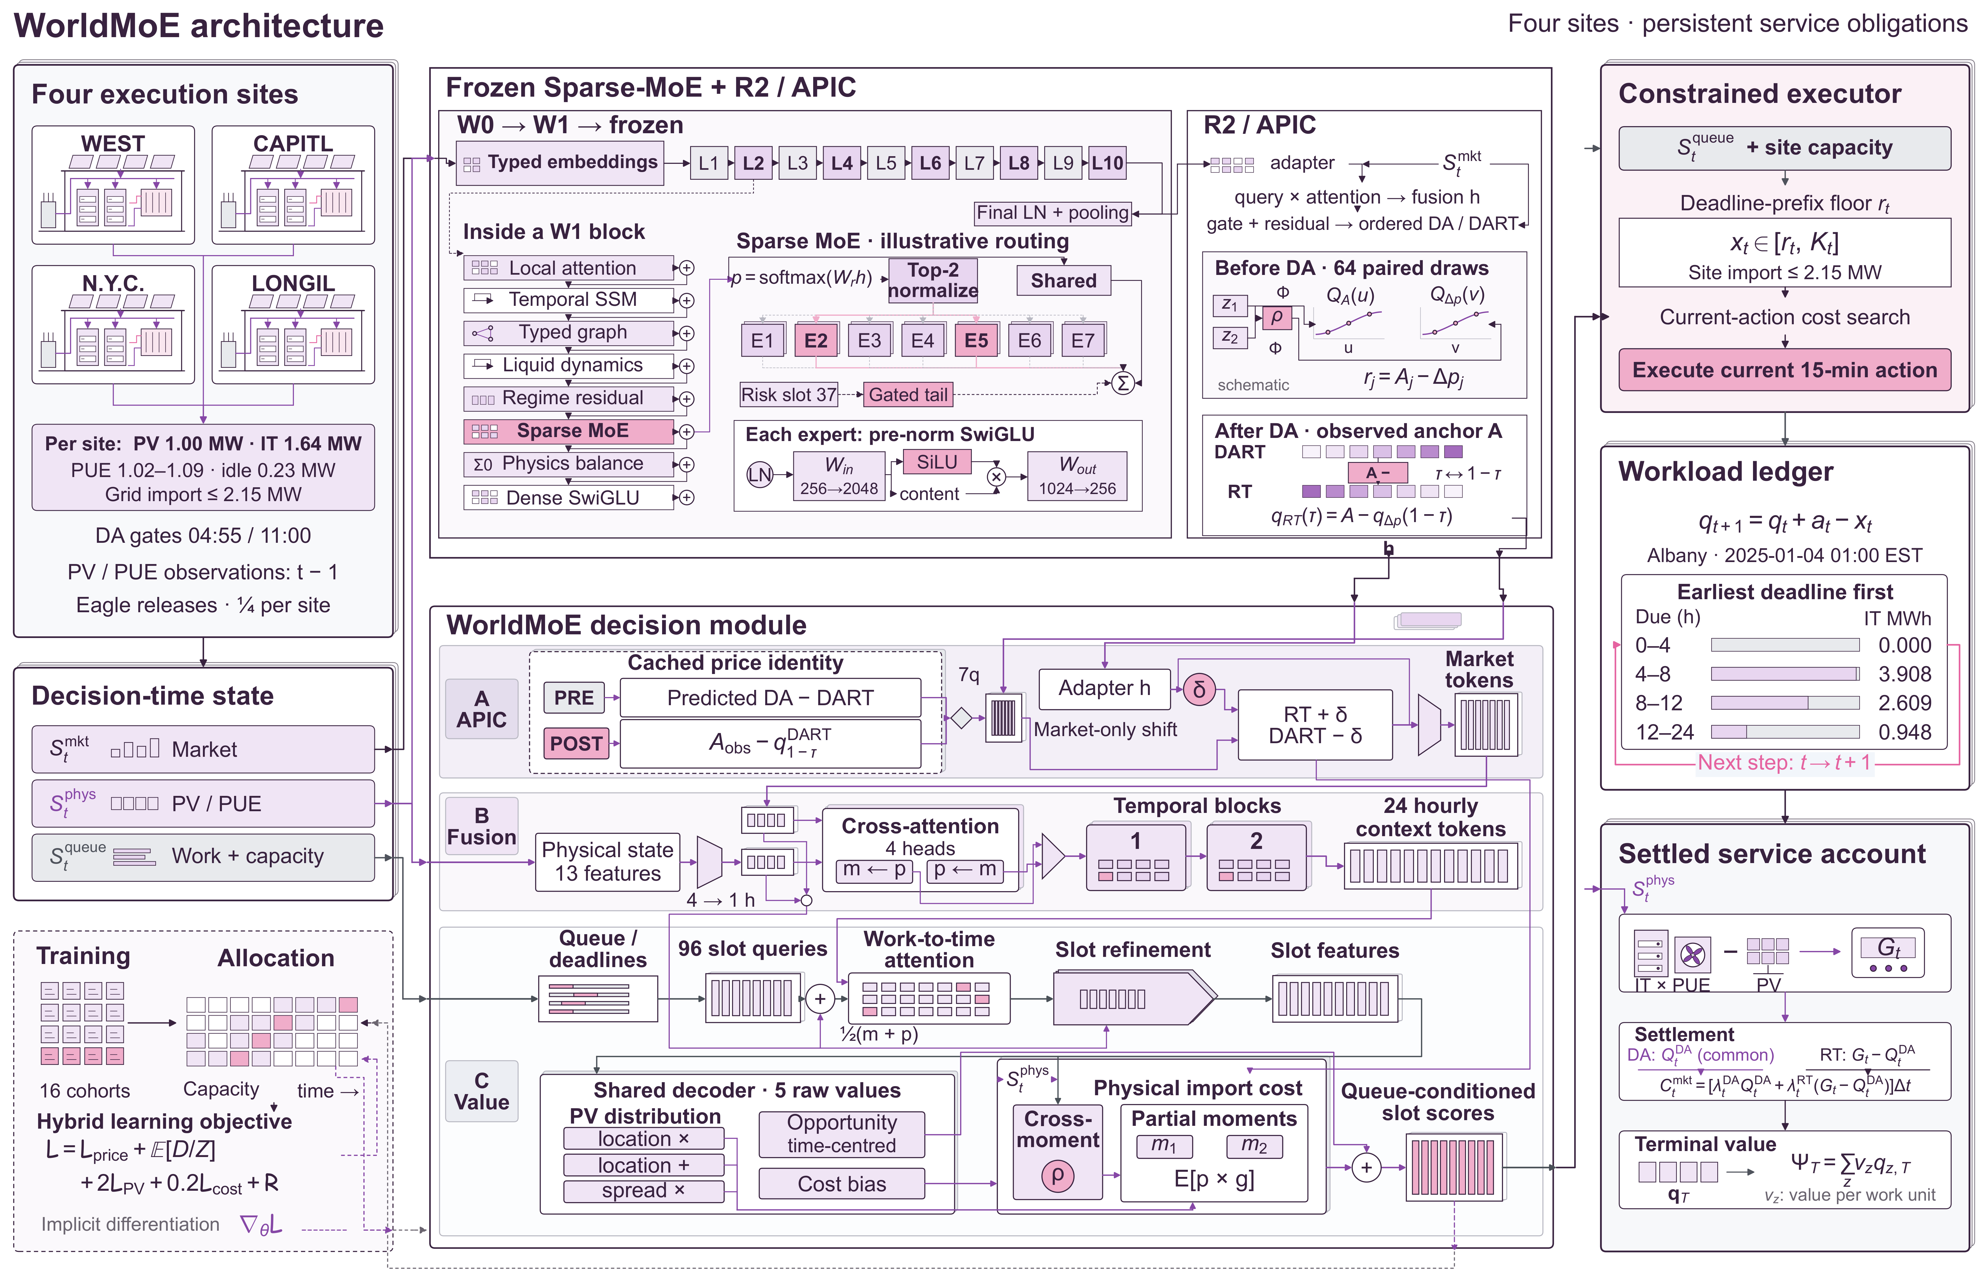
Supplementary Fig. 7 (original main Fig. 1). WorldMoE dispatch and independent rights certification. W0/W1 are successive market-pretraining stages; the probabilistic R2 module begins from the common R2 initialization. APIC price coupling, physical valuation, capacity reservation and the deadline executor produce operating requests and commitments. The certifier supplies a separate opportunity bound. Router probabilities are schematic. The image is retained unchanged; S23 distinguishes the declared information boundary from the inspected historical stress projector.

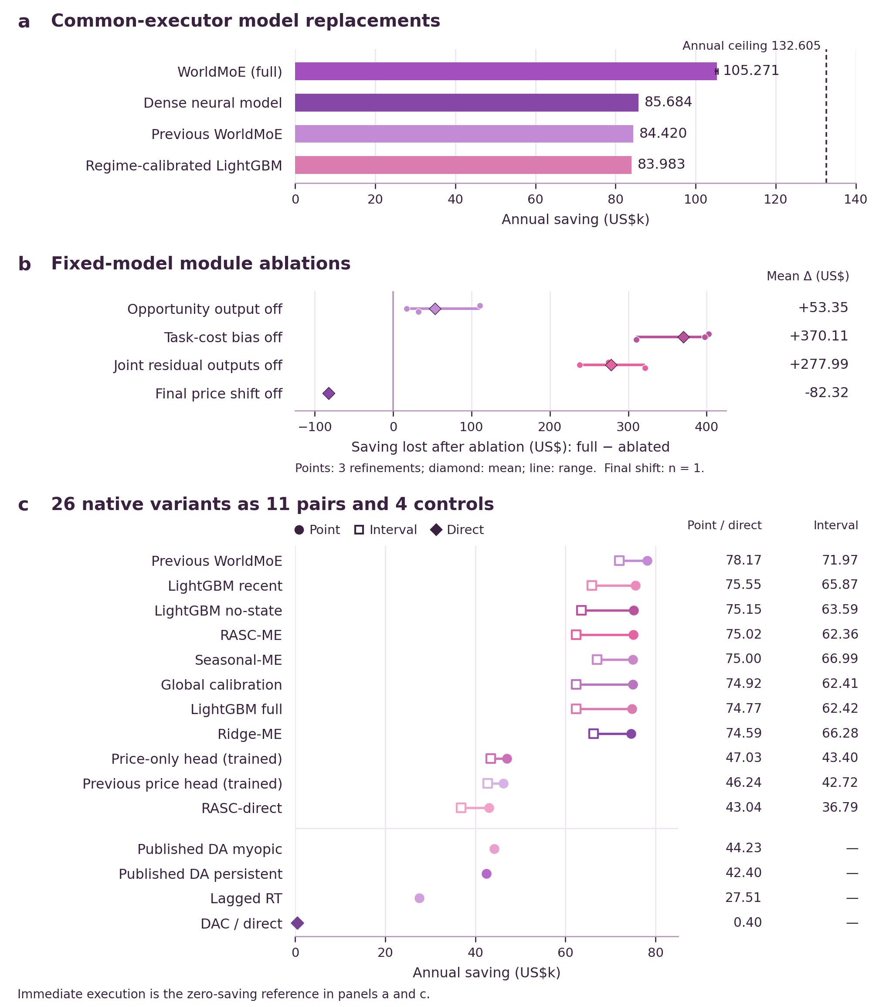
Supplementary Fig. 8 (original main Fig. 2). Completed comparisons and original WorldMoE ablations under nominal 24 h rights. (a) Common-executor replacements, with three-refinement means and ranges. (b) Full-minus-ablated paired changes; the final-shift intervention uses one refinement. Joint suppression of the opportunity, task-cost and cross-moment outputs retains APIC. (c) All 26 native variants: 11 matched pairs and four controls. Price heads are trained separately. Panels (a,c) use US$ thousand; panel (b) uses US dollars. All image pixels and the corresponding values in Tables 9, 10, 28 and 29 are unchanged. Dashed certificate annotations retain the historical reported ceiling, whose original verification status is described in S20–S24; S27 gives the new independently constructed conservative certificates.

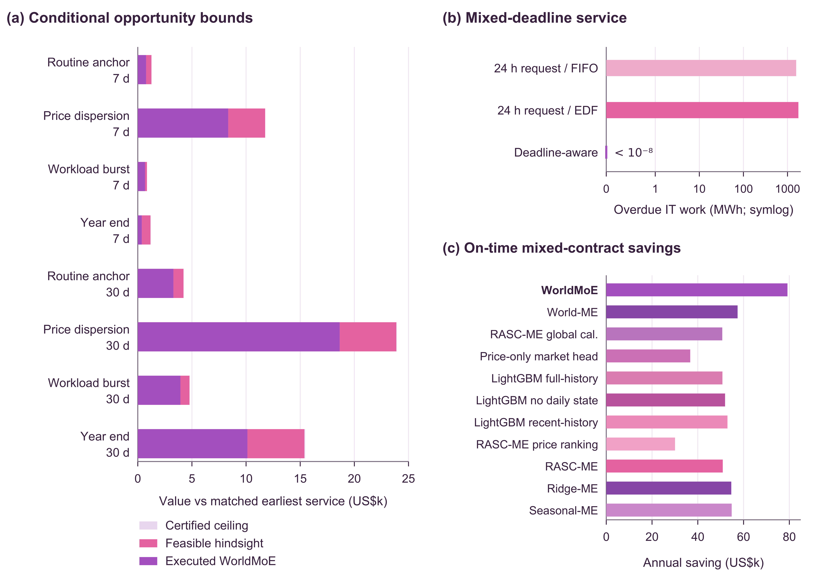
Supplementary Fig. 9 (original main Fig. 3). Historical opportunity and service-window comparisons. Operating savings, the reported hindsight candidate and historical ceilings are displayed with deadline outcomes for FIFO and EDF. The mixed service case assigns 25%, 50% and 25% to 4, 12 and 24 h rights. This image retains its original nearest-cent annotations and nominal hindsight endpoint. Exact feasibility and the full monetary correction govern its use as a lower endpoint (S20), while the original bound records and newly constructed S27 certificates are separate objects. The image does not turn historical opportunity into prospective expected value.

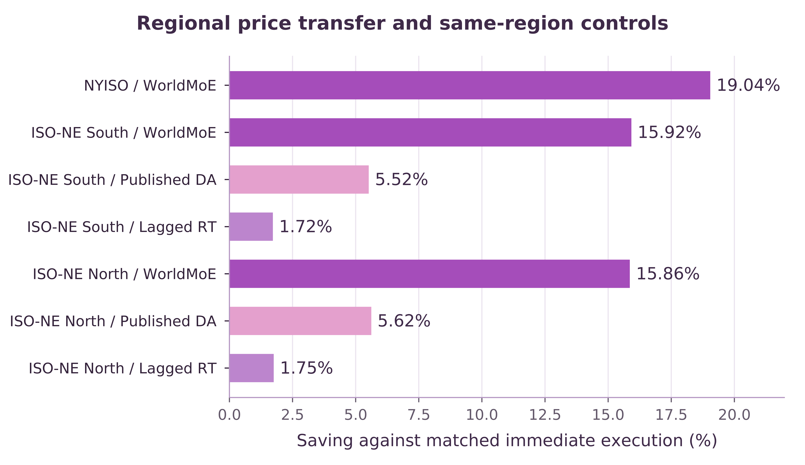
Supplementary Fig. 10 (original main Fig. 4). Fixed-weight ISO-NE transfer compared with DA and lagged-RT controls under matched facilities, workloads and settlement. The retained image documents the historical operating comparison; it is not an estimate of a future-calendar distribution or a tenant-compensation schedule.

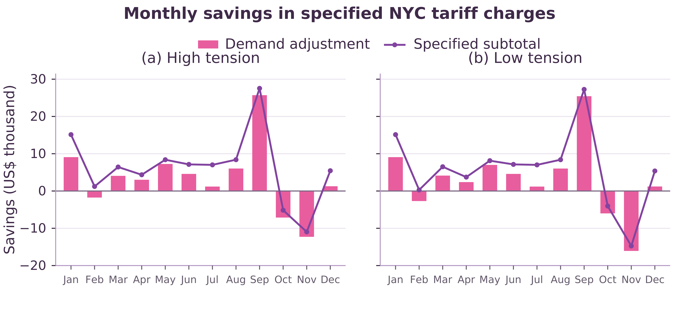
Supplementary Fig. 11 (original main Fig. 5). NYC SC9 monthly account sensitivity. Bars show demand-charge changes; lines show total saving under the rolling 30-minute demand calculation. Negative bars denote additional charges. The original illustrative tariff account and all figure values are preserved; the net contractual-value accounting in S25–S26 separately deducts additional compensation and implementation costs.

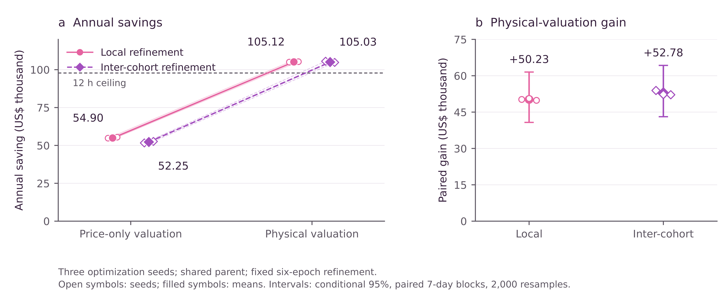
Supplementary Fig. 12 (original main Fig. 6). Annual operating savings and paired physical-valuation gains. Open markers denote refinements and filled markers their means. The dashed historical 12 h levels are US$97,802.42 for the original Lagrangian summary and US$97,796.42 for the original cumulative summary. Those nearest-cent labels are preserved as a historical snapshot; they are not the new S27 bounds. Displayed 95% intervals use the original paired seven-day bootstrap and remain conditional on the observed calendar. They do not supply confidence intervals for future-year contract upgrades or change the retained ablation values.

S29 Uniform feasible execution and the recovered annual witness

S29.1 Scope and statement
The result concerns the nominal divisible-work model with homogeneous 24 h rights, four fixed site assignments, zero initial queues, a unit service limit in each quarter-hour, the recorded static import limits, and the fixed realised price, PV and PUE path. The deadline of an arrival in slot $r$ excludes slot $r+96$. No ramp or nonpreemptive placement restriction is added to this nominal account. The original reference and import-deviation anchor are retained.
For one site, let $b=(b_{1},…,b_{N})$ be the stored immediate-service reference, $R_{t}$ its exact cumulative sum, and $e(t)$ the first unsaturated slot at or after $t$. Let $A(b)$ be the nonnegative finite binary64 admission arrays which generate $b$ under the documented round-to-nearest reference recurrence with zero initial queue. The four-site set is the product of these site sets. S27 establishes, uniformly over this set,
$$\text{max}(0,R_{t}−E)≤A_{t}≤R_{e(t)}+E, E=2.412×{10}^{−12}, A_{0}=0. \text{(S29.1)}$$
Every stored busy block contains at most 35 saturated slots followed by an unsaturated clearing slot. Its smallest clearing-capacity slack is 0.04137009475380182…, larger than $E$. The final reference queue clears inside the observed year. The exact original-cost calculation establishes a unit feasible capacity in every slot.
Proposition S29.1 (uniform constructive feasibility and value). Suppose the preceding conditions hold. Let the stored exact surrogate cumulative schedule satisfy
$$R_{e(\text{max}(0,t−95))}≤{\overset{‾}{X}}_{t}≤R_{t}, 0≤{\overset{‾}{X}}_{t}−{\overset{‾}{X}}_{t−1}≤1, {\overset{‾}{X}}_{0}=0, {\overset{‾}{X}}_{N}=R_{N}. \text{(S29.2)}$$
Then, for every $a∈A(b)$, the explicit construction below gives an execution $x(a)∈X_{24}(a)$ which completes all admitted work by $N$ and satisfies
$$\sum_{t=1}^{N}{|}x_{t}(a)−{\overset{‾}{x}}_{t}|≤2NE. \text{(S29.3)}$$
Across the four sites, original-cost settlement and the signed terminal-anchor allowance imply
$$∀a∈A(b), ∃x(a)∈X_{24}(a):C_{0}−C(x(a))≥H_{24}^{unif}≥130931.31 US\$. \text{(S29.4)}$$
The claim is an established existence and value theorem. Its quantifier order allows the exact execution to depend on the admitted stream. It does not exchange these quantifiers or assert that the value guarantee is achieved by a policy adapted to a decision-time filtration.

S29.2 Constructive proof
First establish nonemptiness of the exact corridor for each $a$. Define the exact earliest-service queue $Q_{t}=\text{max}(Q_{t−1}+a_{t}−1,0)$. This update is 1-Lipschitz in its queue argument. Comparing it with the documented floating recurrence and accumulating the outward error bound of S27 gives $|Q_{t}−q_{t}|≤E$. At each stored clearing slot $c$, its exact pre-service queue is at most $b_{c}+E<1$. Thus the exact queue also clears at $c$. Any work admitted in a source busy block is completed no later than its clearing slot, within at most 36 slots; work between busy blocks completes immediately. This is feasible for 96-slot rights, and the final clearing slot proves exact completion by $N$. This step proves feasibility for each compatible admission array without reconstructing that array from $b$.
For the selected $a$, form exact bounds
$$L_{t}=A_{\text{max}(0,t−95)}, U_{t}=A_{t}, L_{0}=U_{0}=0, L_{N}=U_{N}=A_{N}. \text{(S29.5)}$$
Setting $L_{N}=A_{N}$ selects a schedule which completes early; it does not redefine the original contract. Propagate the lower bound backwards and the upper bound forwards:
$$ℓ_{N}=L_{N}, ℓ_{t}=\text{max}(L_{t},ℓ_{t+1}−1), u_{0}=U_{0}, u_{t}=\text{min}(U_{t},u_{t−1}+1). \text{(S29.6)}$$
Exact earliest service proves that the propagated interval is nonempty: every feasible cumulative path lies between $ℓ_{t}$ and $u_{t}$. The propagated bounds are nondecreasing and their increments are at most one. Define
$$X_{t}(a)=\text{min}\{u_{t},\text{max}\{ℓ_{t},{\overset{‾}{X}}_{t}\}\}, x_{t}(a)=X_{t}(a)−X_{t−1}(a). \text{(S29.7)}$$
The minimum and maximum of nondecreasing sequences whose increments lie in $[0,1]$ retain those properties. Hence $0≤x_{t}(a)≤1$. The clamped path also obeys $L_{t}≤X_{t}(a)≤U_{t}$ and the initial and final equalities. For homogeneous deadlines, the release and due prefixes are equivalent to feasible earliest-deadline cohort allocation: execution cannot precede release, and every prefix of due cohorts has completed by its exclusive deadline. Consequently $x(a)∈X_{24}(a)$, with zero true terminal backlog. The exact import-cap condition already holds for every execution in the unit box.
To bound the displacement, Eq. (S29.1) and the strict surrogate corridor imply that every unpropagated release/deadline/endpoint violation of $\overset{‾}{X}$ is at most $E$. This remains true after capacity propagation. For example, $ℓ_{t}$ is a maximum of future lower bounds minus intervening capacity; since $\overset{‾}{X}$ has increments at most one, each term is at most ${\overset{‾}{X}}_{t}+E$. The forward argument gives $u_{t}≥{\overset{‾}{X}}_{t}−E$. Thus $|X_{t}(a)−{\overset{‾}{X}}_{t}|≤E$ for every prefix. Taking successive differences gives
t​|xt(a)−xt|≤t​(|Xt(a)−Xt|+|Xt−1(a)−Xt−1|)≤2NE. (S29.8)
Finally, the original import, curtailment and import-deviation slot cost is $M_{z}$-Lipschitz in work, with $M_{z}={\text{max}}_{t}[0.25k_{z}{PUE}_{zt}(|p_{zt}|+2)]$. The source signed terminal-anchor offset is $τ_{z}(R_{N}−A_{N})$, bounded in absolute value by $21E_{z}$. Therefore
C(x(a))≤C(x)+z​2NMzEz+21z​Ez. (S29.9)
The arrival-repair contribution is below US$0.000836657841429, and the signed terminal allowance is US$0.000000000202608. The exact downward reference enclosure and upward candidate-cost enclosure in S27 prove Eq. (S29.4). This completes the constructive proof.

S29.3 Materialisation using recovered source admissions
The revised evidence package now includes the original local external_validation/data/forcing_2025.npz, whose SHA-256 is c600c9e01e8236bd2e1cb4e2dc08591e3ee264d05f1c26b4c785ec355c3147c8. Its eagle_arrivals field is the admitted stream loaded by the archived context.configure function. Applying the unmodified reference recurrence reproduces every published reference_compute entry bit for bit and ends with a zero queue. Its RT prices, PV, PUE, work-power coefficients and idle loads are also bitwise identical to the released annual arrays, SHA-256 5be123c40f01b111cf6503b07882e703a4c2cc29a03dde3cfb7aa4321ce2cf72. This establishes a matched source ledger, rather than inferring arrivals by inversion of reference service.
materialize_actual_witness.py reads every stored binary64 input as an exact rational, applies Eq. (S29.7), saves the full exact execution and cumulative ledger, and checks every release, exclusive deadline, service-capacity and static-import constraint. The supplied four records each cover all 35,040 slots. For these recovered admissions, the stored surrogate already satisfies every exact constraint: all four repair $L^{1}$ norms are exactly zero. Admitted and reference totals coincide exactly, and each witness has zero true backlog and zero signed terminal-anchor offset. The smallest exact import slack is greater than 0.106672550152318 MW.
Exact original-account re-settlement gives the materialised annual saving enclosure
$$130931.31968120≤C_{0}−C(x(a^{src}))≤130931.31968149 US\$. \text{(S29.10)}$$
Both enclosing endpoints use complete-term directed monetary rounding. The main text retains the more general uniform floor US$130,931.31, so all reported rights-premium floors remain conservative. The earlier statement that the actual-admission execution could not be materialised is superseded by these supplied records. This recovery does not turn the hindsight construction into an information-adapted operating policy.
The evidence consists of actual_witness_results.json and four actual_admission_witness_zone*.json.gz files. Each compressed file contains exact arrivals, execution, cumulative arrivals and cumulative execution as rational strings, together with its surrogate provenance and repair amount. The verifier invokes no optimisation solver; the recorded hashes bind the recovered inputs and resulting full paths.

S30 Recovered historical trajectories and exact numerical service witnesses

S30.1 Provenance and relation to Table 2
We recovered the original nine annual WorldMoE service books from the local September 2026 archive: the 12 h, 16 h and 24 h runs for seeds 20260920, 20260921 and 20260922. The selected checkpoint epochs are 6, 2 and 0, respectively. For each seed, the checkpoint SHA256 is identical across all three service windows. The original summary files, in-year execution arrays, complete books and daily monetary records are included without modification. These files were absent from the earlier public evidence snapshot; their absence was a packaging gap, not evidence that the historical experiments had not retained trajectories.
The original forcing_2025.npz supplies 35,040 quarter-hour admission vectors for four sites. Its eagle_arrivals field is explicitly read by the archived evaluation source. The original earliest-service recurrence applied to these arrivals reproduces the published reference-compute array bit for bit. The observed price, PV, PUE, idle-power and work-power arrays also match the published account bit for bit. A source manifest records file hashes and original relative paths. This recovery permits the service and settlement checks below without reconstructing admissions from a non-identifying reference schedule.
Table 2 reports Historical paired policy results with recovered trajectory verification. The values describe frozen historical policy outcomes on one observed calendar. They are neither independent calendar replications nor estimates of a perfect-information contract optimum.

S30.2 Independent service and settlement audit
For each site, use zero-based slots $t=0,…,N−1$ and prefix boundaries $k=0,…,N$. Let $a_{t}$ be the recovered admissions and $x_{t}$ the saved service during slot $t$, and define
$$A_{k}=\sum_{s=0}^{k−1}{a_{s}}, X_{k}=\sum_{s=0}^{k−1}{x_{s}}, A_{0}=X_{0}=0, x_{t}=X_{t+1}−X_{t}.$$
A cohort released in slot $t$ with $D$ quarter-hour slots of service rights must finish by the end of slot $t+D−1$, namely boundary $t+D$. The zero-tail witnesses finish every cohort within the observed year, including cohorts whose contractual deadlines extend beyond it. Their complete conditions are
$$0≤x_{t}≤1 (0≤t<N), X_{k}≤A_{k} (0≤k≤N), X_{\text{min}(N,t+D)}≥A_{t+1} (0≤t<N), X_{N}=A_{N}.$$
The raw historical audit retains the 8,192 stored tail intervals in every complete book. All nine policy tails and all reference tails contain exactly zero service. The corresponding terminal cost differences are therefore zero. Reconstructed grid imports satisfy the original static import caps, and the source electricity account is independently evaluated from prices and physical arrays. The raw savings reproduce US$72,220.96961418838, US$86,038.55437473873 and US$105,271.06184163212 for the respective three-seed means. Same-seed 12-to-24 h contrasts average US$33,050.092227443754.
The raw schedules have nonzero floating-point residuals at approximately ${10}^{−11}$ work units or below under ordinary cumulative summation. We also accumulate each stored binary64 number as an exact dyadic rational and report its exact release, deadline and mass residuals. A tolerance pass is not relabelled as exact feasibility. The following separate repair provides exact feasible witnesses while preserving the historical files.

S30.3 Exact corridor repair
For the recovered admission path, define the corridor at prefix boundary $k$ by
$$L_{0}=0, L_{k}=A_{\text{max}(0,k−D+1)} (1≤k<N), L_{N}=A_{N}, U_{k}=A_{k} (0≤k≤N).$$
The index $k−D+1$ is required by the slot convention: at boundary $k$, all cohorts with release slots $t≤k−D$ are due, and their total is $A_{k−D+1}$. For example, when $D=1$, the corridor requires $X_{k}≥A_{k}$; together with release precedence this gives immediate service. The separate assignment $L_{N}=A_{N}$ imposes the verified zero-tail completion convention.
First clip each saved slot service to $[0,1]$, and let its cumulative boundary path be $Z_{k}$. Propagate the corridor backward from $ℓ_{N}=L_{N}$ and forward from $u_{0}=U_{0}$:
$$ℓ_{k}=\text{max}\{L_{k},ℓ_{k+1}−1\} (k=N−1,…,0), u_{k}=\text{min}\{U_{k},u_{k−1}+1\} (k=1,…,N).$$
The finite instance is checked to satisfy $ℓ_{k}≤u_{k}$ at every boundary. Each propagated boundary is nondecreasing with increments at most one. The repaired cumulative path and slot service are
$${\hat{X}}_{k}=\text{min}\{u_{k},\text{max}\{ℓ_{k},Z_{k}\}\} (0≤k≤N), {\hat{x}}_{t}={\hat{X}}_{t+1}−{\hat{X}}_{t} (0≤t<N).$$
is therefore nondecreasing with increments in [0,1], lies in the original corridor, and completes all admitted work. Integer arithmetic independently verifies every release, deadline, capacity and terminal condition for all nine exported witnesses. The physical data additionally satisfy the electrical import cap at service equal to one in every observed interval; hence the repaired unit-capacity service satisfies the electrical cap. These are finite-instance certificates for the recovered historical admissions.
The repaired schedules are numerical witnesses, not substituted historical policy outputs. The unchanged raw books remain the source of Table 2. No inference-time policy action, checkpoint or information pathway was recomputed by this procedure.

S30.4 Monetary effect and exact account reconciliation
For the original account with a US$1 per MWh import-deviation charge and a US$1 per MWh curtailment term, a site-wise Lipschitz bound is
$$M_{z}=\underset{t}{\text{max}}\frac{1}{4}k_{z} {PUE}_{tz}\left(|p_{tz}^{RT}|+2\right).$$
Consequently, with δz=t​|xtz−xtz|,
|J(x)−J(x)|≤z​Mzδz.
The program evaluates both this bound and the repaired account exactly as rational numbers. It also checks the actual objective difference against the bound. Across all nine runs the largest cost bound is US$ $1.65626764744×{10}^{−8}$. This is far below one cent; it is explicitly budgeted rather than ignored.
Contract | Exact repaired three-seed mean saving enclosure, US$
12 h | [72,220.969614188, 72,220.969614189]
16 h | [86,038.554374738, 86,038.554374739]
24 h | [105,271.061841632, 105,271.061841633]
12 h to 24 h paired increment | [33,050.092227443, 33,050.092227444]
The US$33,050.09 contrast is therefore supported by complete original execution records, recovered admissions, explicit terminal accounting and separate exact numerical feasibility witnesses. It remains a historical policy contrast. The reported perfect-information certificate increment concerns the difference between optimal feasible sets. These are different estimands and neither is a guaranteed ex-ante contract profit.
The 24 h feasible witnesses use the same recovered admissions, reference-cost account, physical arrays, service capacity, electrical cap and terminal convention as the contract-value analysis. Their exact saving enclosure supplies the operational numerator when reporting residual opportunity and capture relative to the 24 h perfect-information bound. The rounding repair does not alter those metrics at their reported precision.

S30.5 Remaining opportunity and operating capture
Let $S_{24}^{*}$ denote the optimal 24 h perfect-information saving for the same recovered admission path and account. Retain the conservative uniform value floor and annual ceiling $L=130931.31$ and $U=134437.85$ dollars, so that $L≤S_{24}^{*}≤U$. Let $P$ be the mean saving of the three separate exact feasible policy witnesses. Each witness is feasible under that same contract; hence its saving, and their mean, cannot exceed $S_{24}^{*}$. Exact rational evaluation followed by directed rounding gives
$$P_{lo}=\frac{105271061841632}{{10}^{9}}≤P≤\frac{105271061841633}{{10}^{9}}=P_{hi}.$$
These endpoints are computed by flooring and ceiling the exact rational mean after multiplication by ${10}^{9}$. Define remaining opportunity $G=S_{24}^{*}−P$. Subtracting endpoints in the correct directions gives
$$L−P_{hi}≤G≤U−P_{lo}.$$
Conservatively rounding the lower endpoint down and the upper endpoint up to cents yields
$$\frac{⌊100(L−P_{hi})⌋}{100}=25660.24≤G≤\frac{⌈100(U−P_{lo})⌉}{100}=29166.79 US\$.$$
Because $L>0$ and $P>0$, the opportunity capture fraction $κ=P/S_{24}^{*}$ satisfies
$$\frac{P_{lo}}{U}≤κ≤\frac{P_{hi}}{L}.$$
The percentages are approximately $78.30\%$ to $80.40\%$ when displayed to two decimal places. These approximate displayed percentages are distinguished from the exact endpoint ratios above. The residual opportunity describes the room between the feasible operating results and the bounded hindsight optimum on the observed calendar. It is not a guarantee that an implementable causal policy can capture the entire amount, nor a forecast of the value of buying longer service rights.

