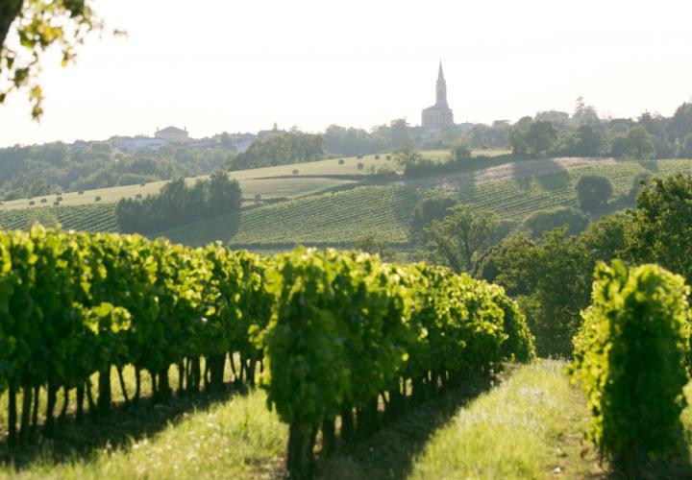

|  |  |
| --- | --- |
| Distinguished guests: | Antonio Compton |
| Agency: | American Express - Boston (HQ) |
| Agent: | Cassandra Angus |
|  | |
| **Duration:** | **1day / 0nights** |
| **Number of Persons:** | **2** |
|  | |
| Summary | |
| Welcome to France! | Page 4 |
| Your itinerary | Page 6 |
| Champagne | Page 9 |
| Paris | Page 13 |
| Detailed itinerary | Page 20 |
| Sales and terms conditions | Page 21 |

**Welcome to France!**

|  |  |
| --- | --- |
|  | France is as diverse as its landscapes: from the endless beaches of Normandy to the perched villages of Provence and the green hills of Auvergne to the turquoise bays of Corsica. Meet the real French for wine tastings and cooking classes, off-the-beaten-tracks visits, exclusive itineraries with our expert licensed guides that drive and more...  Discover the largest country of West Europe, more of half of France is composed of vast plains, beautiful coasts and France hosts Western Europe's highest peak in the Alps, Mont Blanc. The climate is temperate, except near the mountains or in the northeast, with cool winters and mild summers. Southern France is generally warm, with mild winters and hot summers.  French people are known for good fashion sense and good food. They are courteous people, but also frank and usually to the point. French is the official language of France, and it is important for you to learn a bit of French. Indeed, your trip will be more enjoyable if you are able to relate to French people. Also, it will be easier to understand the culture once you learn the language.  As for French manners, the handshake is commonly used in France when people meet another for the first time, in both social and business settings. Close friends greet each other by kissing each other on the cheek (Ia bise). People typically greet one another with bonjour (good morning), bonsoir (good afternoon) and au revoir (goodbye). Party guests are expected to bring a gift, such as flowers or a bottle of wine. |

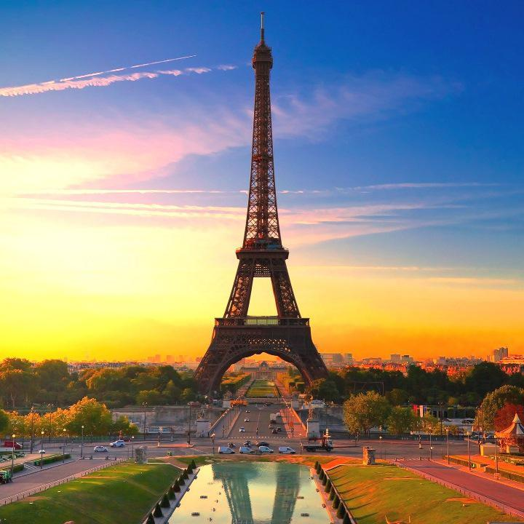

|  |  |  |  |  |  |  |  |
| --- | --- | --- | --- | --- | --- | --- | --- |
| **Your itinerary**   |  |  | | --- | --- | | Apr 08: | Arrival in Champagne And Paris | | Apr 08: | Luxury minivan with driver at disposal Full day excursion with a guide in Champagne Champagne Moet & Chandon | | Apr 08: | Departure Day | |  |

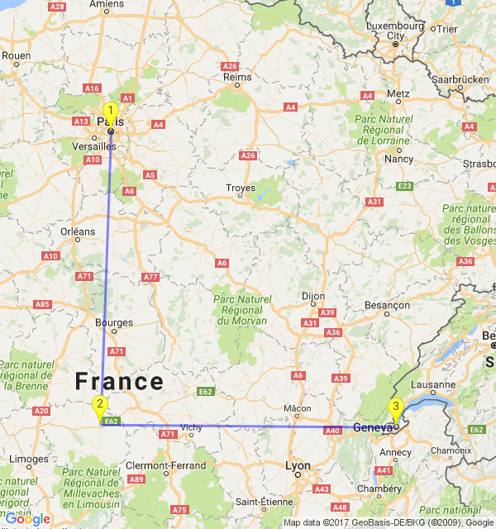

|  |
| --- |
|  |

|  |
| --- |
| **Champagne** |

**Discover Champagne**

|  |  |
| --- | --- |
|  | Champagne borders Ile-de-France in the south-west. Its name comes from the Romans who called it Campania, meaning literally "Land of the Plains". The rolling prairies that give the region its name are located in the south between Reims/Epernay and Troyes. Closer to the border with Belgium, the landscape becomes more rugged and deeply forested.  Champagne, lying south to the east of the Paris region, is one of the great historic provinces of France. As far back as the times of the Emperor Charlemagne, in the ninth century, Champagne was one of the great regions of Europe, a rich agricultural area that was famous for its fairs. Today, thanks to a type of sparkling wine to which the region has given its name, the word Champagne is known worldwide – even if many of those who know the drink do not know exactly where it comes from.  Champagne, that most delightful of sparkling wines, was not actually invented in the region. According to legend, it was monks who bought the method for making sparkling wine up from the Languedoc, in the south of France; but they soon discovered that the chalky soil and climatic conditions in the Champagne region produced a bright bubbly wine that was in many people's opinion better than the sparkling wines produced further south.  The traditional French Northern cooking is based on the products of the soil - known as Cuisine du Terroir - and emphasizes the French Art de la Table. You could appreciate an andouillette de Troyes or the Rhetel recipe of boudin blanc, classics of the traditional family meals in the Champagne region. For the vegetables' lovers, the typical pot-au-feu-like La Joute |

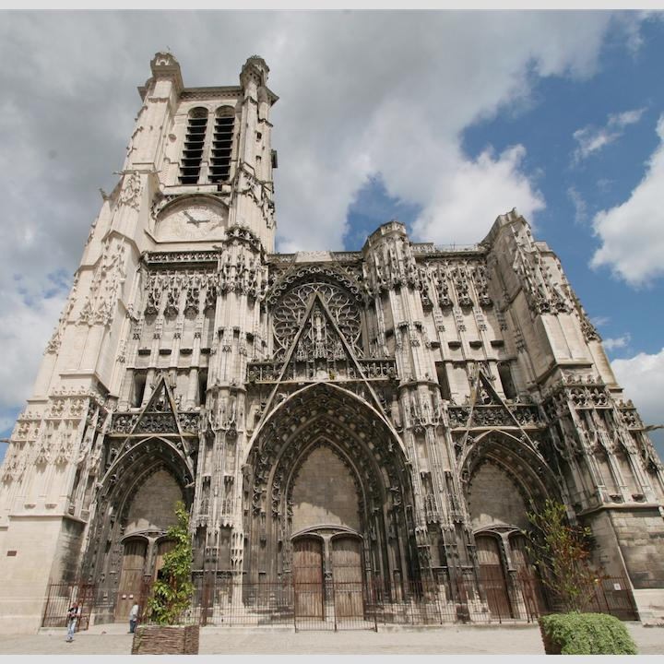

|  |
| --- |
|  |

|  |
| --- |
| **Paris** |

**Discover Paris!**

|  |  |
| --- | --- |
|  | Like all the world's great capitals, Paris lives at a fast pace, by day and night. It is divided into 20 districts that spiral out like a snail shell from the first, centered round the Louvre. Enjoy a stroll through Paris while on vacation and soak up the "art de vivre", it will feel as if you are walking through an open-air museum. Admire the city's regal buildings, gardens, fountains and places which have witnessed so monumental events & so fascinating history.  Paris is a place of iconic architecture, with its famous cloud-piercing Eiffel tower, Arc de Triomphe at the end of the most famous avenue of the world, les Champs-Elysees. Notre-Dame and its gargoyles, old bridges and Art Nouveau cafes are famously part of the City. Always evolving, the City now proudly shows the contemporary Centre Pompidou and the Musee du Quai Branly and its vegetal wall.  Paris is also famous for its cuisine. Anywhere from cosy bistros to three-star Michelin stars, you'll be able to find quality produces, with excellent presentation and preparation, always served with wine. Stop at the cheese shops, boulangeries, patisseries for top produces to take to a picnic in the city's parks and gardens.  Lastly, browse designer boutiques, flagship haute couture stores, concept stores to find the perfect dress. Wander in vintage shops and flea markets, original bookshops and bookseller on the banks of the Seine, antique dealers, gourmet food and wine shops galore! |

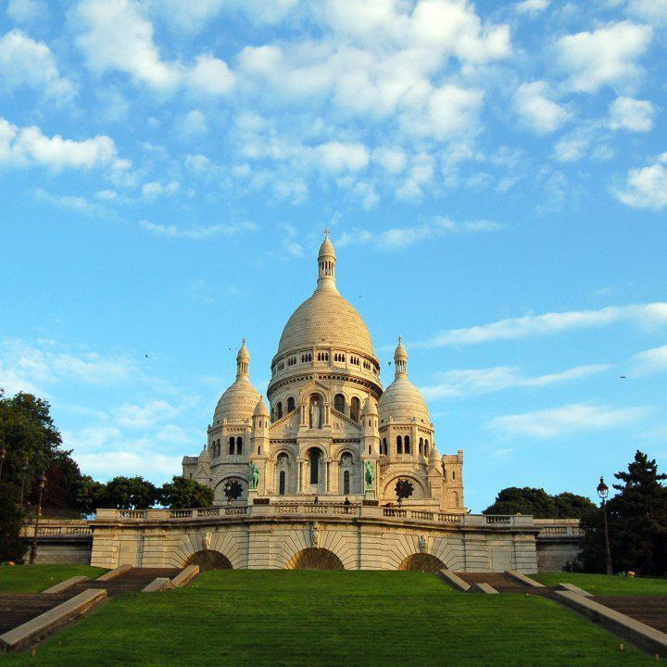

**APR 08, 2017 - YOUR MORNING VISIT IN CHAMPAGNE**

**Champagne Moet & Chandon**

|  |  |
| --- | --- |
|  | Moët et Chandon began as Moët et Cie (Moët & Co.), established by Épernay wine trader Claude Moët in 1743, and began shipping his winefrom Champagne to Paris. The reign of King Louis XV coincided with increased demand for sparkling wine. Soon after its foundation, and after son Claude-Louis joined Moët et Cie, the winery's clientele included nobles and aristocrats. Following the introduction of the concept of a vintage champagne in 1840, Moët marketed its first vintage in 1842. Their best-selling brand, Brut Imperial was introduced in the 1860s. Their best known label, Dom Perignon, is named for the Benedictine monk remembered in legend as the "Father of Champagne". Moët & Chandon merged with Hennessy Cognac in 1971 and with Louis Vuitton in 1987 to become LVMH (Louis-Vuitton-Moët-Hennessy), the largest luxury group in the world, netting over 16 billion euros in fiscal 2004. Moët & Chandon holds a Royal Warrant as supplier of champagne to Queen Elizabeth II. In 2006, Moët et Chandon Brut Impérial issued an extremely limited bottling of its champagne named "Be Fabulous", a special release of its original bottle with decorative Swarovski crystals, marking the elegance of Moët et Chandon. |

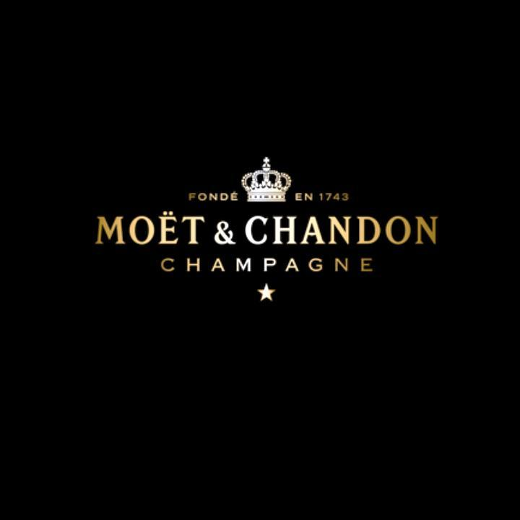

|  |
| --- |
|  |

|  |
| --- |
| **Services** |

|  |  |  |  |
| --- | --- | --- | --- |
| **Detailed itinerary**   |  | | --- | | **Apr 08** | | - 08:00 am : Luxury minivan with driver at disposal from Paris Orly airport to Shangri-La Hotel  - Full day excursion with a guide in Champagne 11:00 am : pick up at Champagne Ployez-Jacquemart 05:30 pm : drop off at End of tour  - Champagne Moet & Chandon" | |  |

|  |
| --- |
|  |

|  |  |
| --- | --- |
|  | **YOUR TRAVEL AGENT IN BOSTON**  Cassandra Angus American Express - Boston (HQ) |
|  | **YOUR TRAVEL AGENT IN FRANCE**  Ralp Decouvertes Découvertes |