

|  |  |
| --- | --- |
| Distinguished guests: | Families names |
| Agency: | Agency Name |
| Agent: | Agent Name |
|  | |
| **Duration:** | **2day / 1nights** |
| **Number of Persons:** | **5** |
|  | |
| Summary | |

|  |  |  |  |  |  |  |  |
| --- | --- | --- | --- | --- | --- | --- | --- |
| **Itinerary title**   |  |  | | --- | --- | | Apr 28: | Arrival in Tokyo | | Apr 29: | Hakone | | Apr 30: | Departure | |  |

|  |  |  |  |
| --- | --- | --- | --- |
| **Detailed itinerary title**   |  | | --- | | **Apr 28** | | Arrive at Narita/Haneda Airport independently  After entry procedures, meeting English speaking greeting service, and Japanese speaking driver  Drive to Tokyo  Transfer to the hotel (accommodation arranged directly by Tauck, not included in tour fare)  Transfers will be arranged and invoiced as supplements (not included in base tour fare) according to flight schedule.  Guests arriving on different flights cannot share greeting service or driver in case of delays.  Evening Cocktail Reception and Dinner (arranged directly by Tauck, not included in tour fare) | |  |

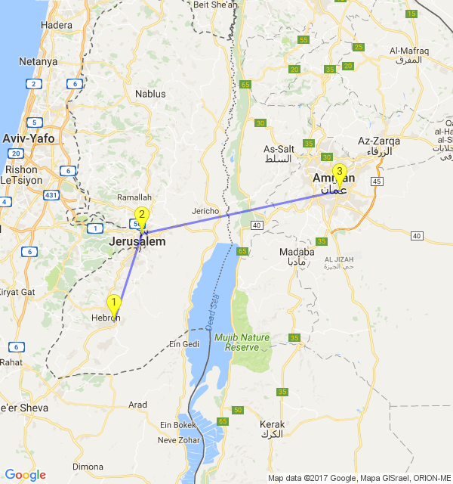

|  |  |
| --- | --- |
|  | **YOUR TRAVEL AGENT IN Netherlands**  Obama |
|  | **YOUR TRAVEL AGENT IN Israel**  Tramp |

**APR 08, 2532 - GOOOOOOD MORNING MARS**

**Mars Title**

|  |  |
| --- | --- |
|  | Mars is the fourth planet from the Sun and the second-smallest planet in the Solar System, after Mercury. Named after the Roman god of war, it is often referred to as the "Red Planet"[13][14] because the iron oxide prevalent on its surface gives it a reddish appearance.Mars is a terrestrial planet with a thin atmosphere, having surface features reminiscent both of the impact craters of the Moon and the valleys, deserts, and polar ice caps of Earth. |

|  |  |
| --- | --- |
|  | **Cancellation policy**  Mars is an extremely popular destination right now. Putting people on the Red Planet has been the big goal for NASA since 2010, and SpaceX CEO Elon Musk has made it very clear that his company is going to try to start a Martian colony as early as 2024. Mars One has managed to find hundreds of hopefuls who say they are willing to live out their last remaining days on Mars. Even Buzz Aldrin is encouraging us to get our asses there.  "A Martian colony is going to be more complicated than people realize"  But a Martian colony is going to be more complicated than people realize. We still haven’t invented many of the technologies needed to keep people alive — both during the journey to Mars and when we get there. Some tech has already been created, but we don’t know how it’ll hold up in space or even on another planet. That’s why we need to shift our gaze from Mars to a much closer neighbor: the Moon. |

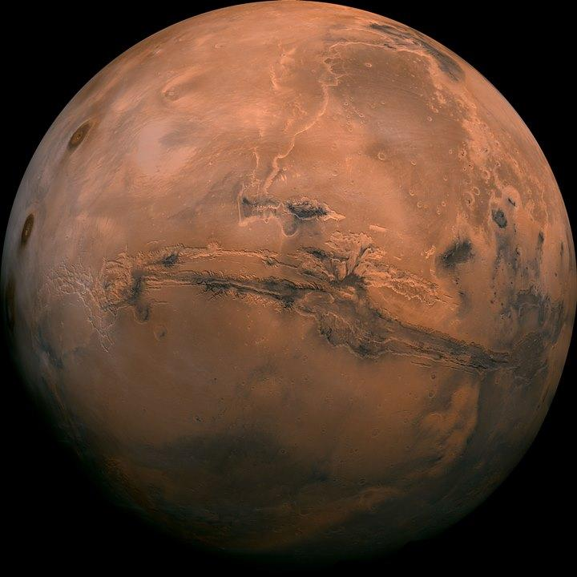

|  |
| --- |
|  |

|  |
| --- |
| **ARMAGEDDON IS COMING** |