Reptile

Team work project for JavaScript UI & DOM course June 2014

# Team “Reptile”

## Team members

We are:

|  |  |  |
| --- | --- | --- |
| **Name** | **Username** (from the student system) | **Github user** |
| Ventsislav Kulin | kulin_1987 | kulin1987 |
| Kalina Lazarova | anilak | kalinalazarova1 |
| Diana Stancheva | diana.stancheva | diana-stancheva |
| Nikolay Kichev | nkichev | nkichev |
| Deyan Valkanov | valkanov | valkanov |
| Samuil Petrov | staccobain | Samuil-Petrov |
| Andrei Blagoev | andreykata |  |

# Project explanation

## Summary

The game is based on the original ‘Super Mario. Mario can walk and jump over obstacles and collect bonuses. He also has to avoid the 'bad' mushrooms. To complete a level you only need to reach the flagpole.

## More details

1. **The Game**

The player can move **Right/Left** with the arrows and Jump on the left with **PgUp** and on the right with **PgDn**. In order to collect bonus Mario have to jump with **ArrowUp**. Mario has three lives and the purpose of the game is to gather as much coins as possible and to take the flag in the end of the level. The game also finishes when enemies kill the hero three times.

1. **Bonus**

* Coins – add 30 to score;
* Dead enemy – add 50 to score

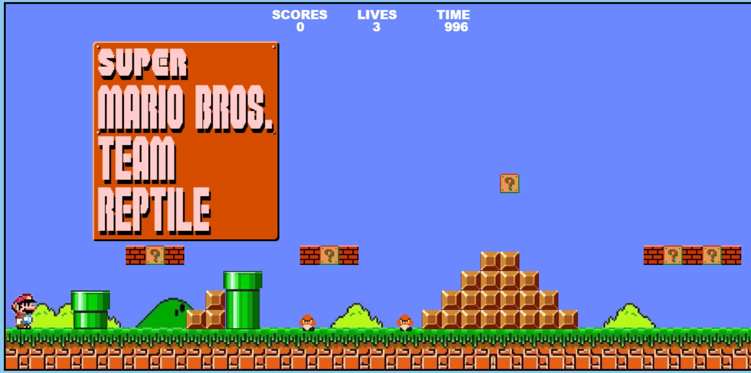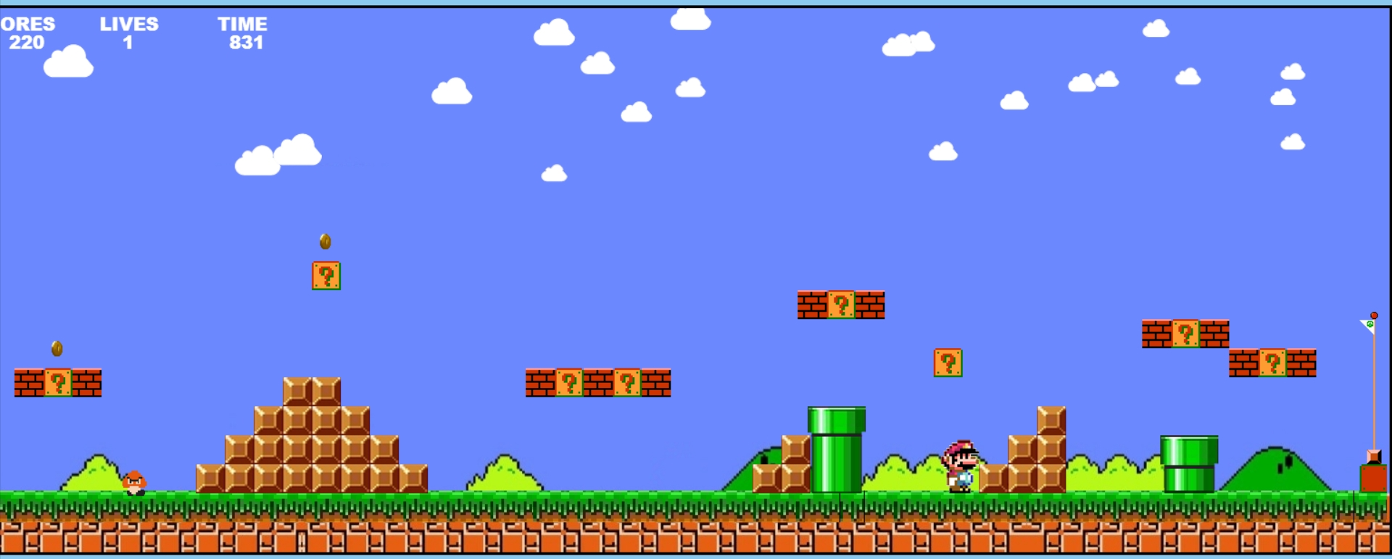

1. **Used technologies**

The most of the characters in the game are animated using canvas and KineticJS. For the background and the cloud animation is used SVG and RaphaelJS.

# GitHub Repository

# https://github.com/kalinalazarova1/TeamReptile.git

# Other information

* N/A