**Topic:** Display of special characters

**Pre-requisite knowledge:** Basic LCD interfacing, displaying strings on LCD

**Components required:** Firebird V with 8051 main adapter board

**Basic Concept:**

* **What is a seven segment display?**

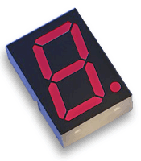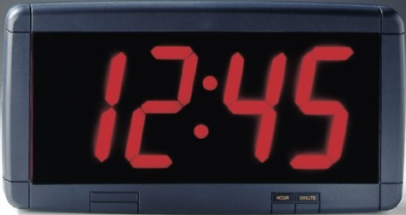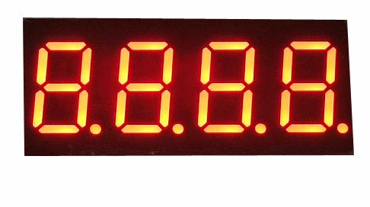A seven-segment display can be used to display the decimal numbers 0-9 and some alpha characters.

**Segment Identification:**

* A Seven-Segment Display (SSD) is simply a figure eight grouping of LEDs {include a decimal point (DP)}.
* Each Segment is labeled (a) to (g).
* SSDs are available in two configurations
  + Common Cathode (all LED cathodes are connected)
  + Common Anode (all LED anodes are connected)

**Common Cathode & Common Anode:**

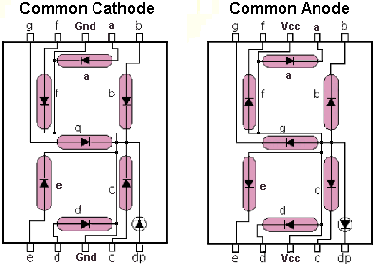

**SSD Display Possibilities:**

Simple Messages

**Display character:**

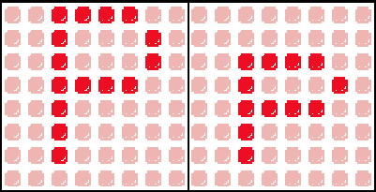

* A LCD works in a similar way as explained below:

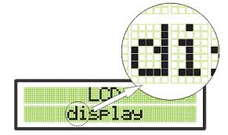

* A LCD is an arrangement of various 5x7 segment displays arranged in specific number of rows and columns so as to display more than one character at a time.
* A 16x2 LCD consists of 32 5x7 segment displays arranged in 2 rows and 16 columns allowing us to display 32 characters.

Now by writing program for individual segments we can display any character on the LCD.

For writing program first let us know memory mapping in a LCD.

**MEMORY MAPPING:**

The memory of the LCD divided into three parts:-

* DDRAM:-Display data ram is used for displaying character. A maximum 80 character can be stored in this out of which only 32 characters are visible.
* DDRAM memory address starts from 0x80 to 0xA7 in first row and 0xC0 to 0xCF in second row.
* CGROM:-This is the memory address where all the predefined patterns are stored.
* The patterns are drawn in this memory area during the time of manufacturing.
* The patterns are stored such that their memory address is equivalent to their ASCII code.
* CGRAM:-This area of LCD’s memory is used when the user wants to do his own animation on the LCD. Like: heart, smiley etc.

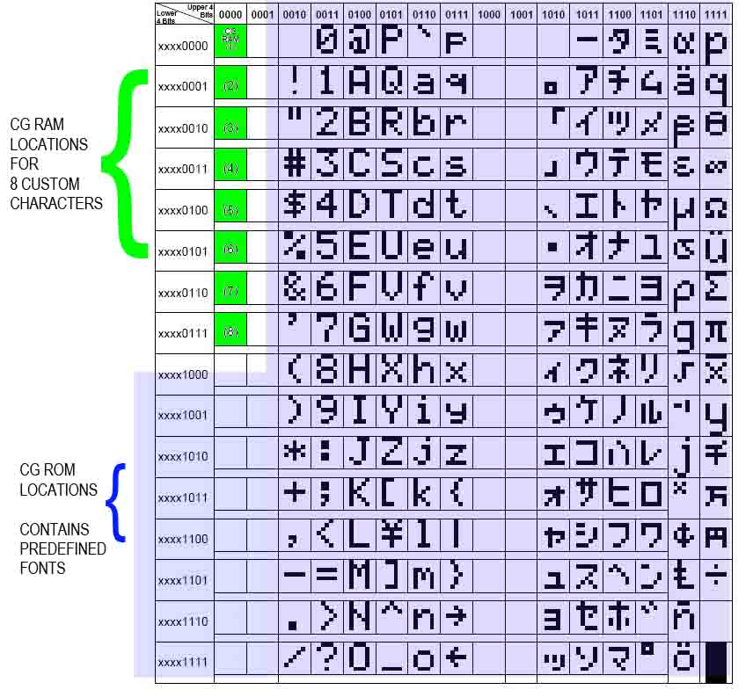

Now to design our own special characters we have to store it in CGRAM and to access it command 0x40 in hex or 64+addresses* in decimal is used(as given in previous LCD interfacing document).

**An example to display heart shape is given below:**

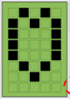

**16 8 4 2 1**

In order to draw pattern of this shape, following algorithm is used:

1. Initialize the LCD
2. Clear LCD screen
3. Store this shape in CGRAM by giving appropriate commands
4. Set the cursor on the desired location where you want to display character
5. Display it on the screen by giving appropriate command.

* **Code for the above and for many other special characters is given in the experiments folder.**