**Topic:** Motors and Types of Motors and related experiments

**Pre-requisites:** Basic IO interfacing

**Components Required:** Fire Bird V Robot with 8051 Adapter Board

**INTRODUCTION:**

* **What are Motors?**

Motors are devices which convert electrical energy into mechanical energy. These are of great use in locomotion of robots.

* **Motors used in Fire Bird V:** FIRE BIRD V robot has two DC geared motors for the locomotion. The robot has a top speed of 24cm/second. These motors are arranged in differential drive configuration.



* Other then dc motors some other types of motors are used for various purposes in robots. For example- servo motors, stepper motors etc.
* **DC Motors**

Fast, continuous rotation motors – Used for anything that needs to spin at a high RPM e.g. car wheels, fans etc.

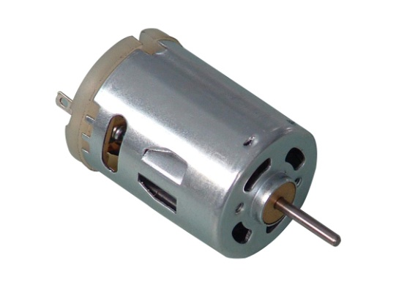

* **Servo Motors**

Fast, high torque, accurate rotation within a limited angle – Generally a high performance alternative to stepper motors, but more complicated setup with PWM tuning. Suited for robotic arms/legs or rudder control etc.

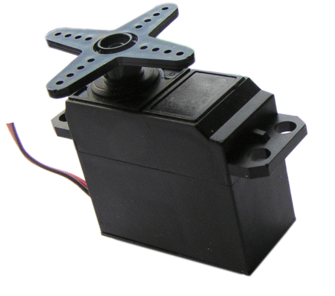

* **Stepper Motors**

Slow, precise rotation, easy set up & control – Advantage over servo motors in positional control. Where servos require a feedback mechanism and support circuitry to drive positioning, a stepper motor has positional control via its nature of rotation by fractional increments. Suited for 3D printers and similar devices where position is fundamental.

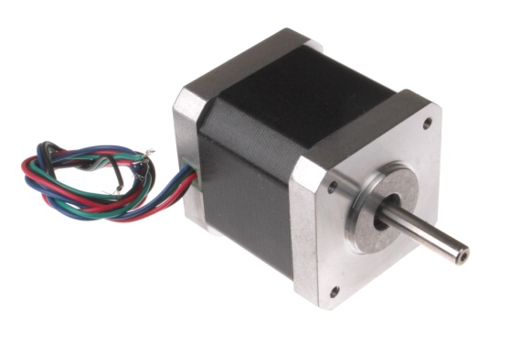

* In Firebird V, motors are controlled by **L293D motor driver IC**. To change

the direction of the motor, appropriate logic levels (High/Low) are applied to L293D’s direction control pins.

* Fire Bird V has onboard two L293D ICs to drive four DC motors.



* Using L293D, both direction and velocity of the robot can be controlled. Velocity control is done using **PWM (pulse width modulation)** which is covered in the next section.
* **Why Motor driver IC is required?**

Most microprocessors operate at low voltages and require a small amount of current to operate while the motors require a relatively higher voltages and current. Thus current cannot be supplied to the motors from the microprocessor. This is the primary need for the motor driver IC.

* To drive bigger robots using Firebird V main board, high power motor driver ICs like **Hercules 30 Amp. Mini Motor** Driver should be used.

**L293D and its working:**

The L293D IC receives signals from the microprocessor and transmits the relative signal to the motors. It has two voltage pins, one of which is used to draw current for the working of the L293D and the other is used to apply voltage to the motors. The L293D switches its output signal according to the input received from the microprocessor.  
For Example: If the microprocessor sends a 1(digital high) to the Input Pin of L293D, then the L293D transmits a 1(digital high) to the motor from its Output Pin. An important thing to note is that the L293D simply transmits the signal it receives. It does not change the signal in any case.

The L293D is a 16 pin IC, with eight pins, on each side, dedicated to the controlling of a motor. There are 2 INPUT pins, 2 OUTPUT pins and 1 ENABLE pin for each motor. L293D consist of two H-bridge. H-bridge is the simplest circuit for controlling a low current rated motor.

**L293D Pin Diagram:**

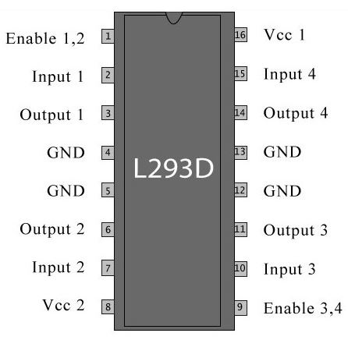

First students should know the pin configuration i.e. which pin of microcontroller is connected to which pin of L293D.



**Fig: Schematic of Motor Control circuit**

**Now logic level for the motor direction control is:**

**P1.3 (CEX0) – PWM for left motor (covered in next section)**

**P1.4 (CEX1) – PWM for right motor (covered in next section)**

**P1.0 – left motor direction control (backward)**

**P1.1 – left motor direction control (forward)**

**P1.2 – right motor direction control (forward)**

**P3.4 – right motor direction control (backward)**

Now these logic levels can be set high by giving logic one to the above pins.

**For example** – to move left motor forward, we should set P1.1 at logic 1 and to move it backward we should set P1.0 at logic 1.

Hope you can do it with right motor also in a similar manner.

**Problem:** Move the Robot forward for 2 seconds than backward for 1 sec and then right and left both for 3 seconds.

**Solution:**

**Algorithm-**

1. Set both left and right motors to move forward by giving logic 1 at P1.1 and P1.2
2. Give delay for 2 seconds
3. Set both motors to move back by giving high on P1.0 and P3.4
4. Give delay for 1 second
5. Now to move RIGHT (Left wheel forward, Right wheel backward) set P1.1 and P3.4 at logic 1
6. Give delay for 3 seconds
7. Move LEFT(Left wheel backward, Right wheel forward) by setting P1.0 and P1.2 at logic 1
8. Give delay for seconds
9. Stop(give logic 0 at all pins)
10. End

* **Reference code for the above is given in experiments folder**

**Extension:**

* Trace a square in clockwise direction by moving on each side for 2 seconds.
* Move the robot 3600 about its own axis counter clockwise.