Challenge # 1

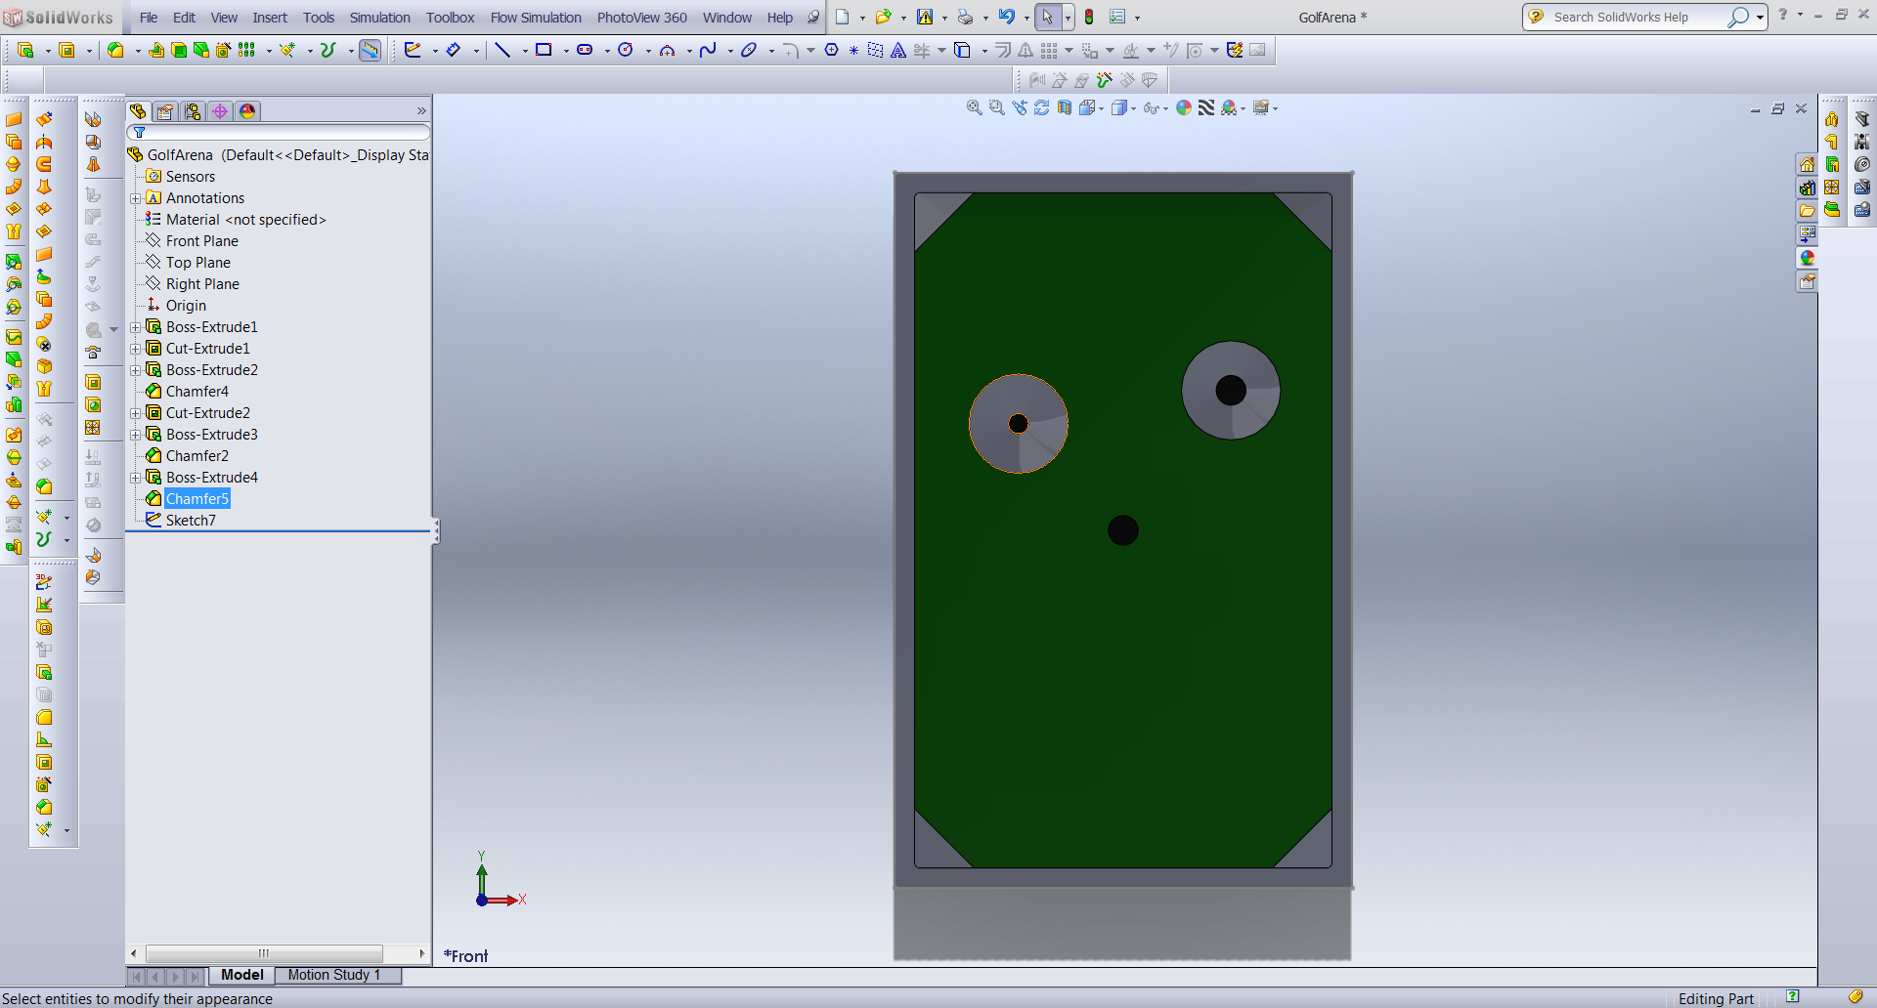

Challenge #2

