**The National Security Agency**

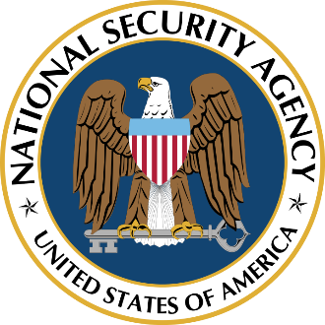

Memorandum [**Do Not Disseminate**]

To: John Trebeck, Director of Astrapi Operations, DOT

Cc: Anthony Foxx, Secretary, DOT  
Charlotte Vicenti, Under-Secretary, DOT  
Jeh Johnson, Director, DHS

From: Admiral Rogers, NSA

Date: 25 July 2015

Subject: Astrapi Post-Attack Analysis Update

Director Trebeck,

After investigating the PCAP file stored on the recovered Astrapi train, our team has determined that the hackers, upon successfully performing an SQL injection, disabled the SELinux security modules. From that point on, they bypassed the required proxy and communicated from a different IP address: 164.100.56.202.

Shortly after initiating this contact, they appear to have executed code to cause the system to report incorrect information back to the DOT monitors and to ignore all communication to it.

Sincerely,

Michael Rogers, Admiral  
Director  
National Security Agency