Dear Senator Dreyfus,

Sam, a young black male, and Alec, a young white male, had only thing in common. When coming home from a party they were stopped by the police[1]. The police found a small rock of crack on Sam, but on Alec they found over one-hundred dollars worth of cocaine[2]. Sam was sentenced to 6 months in prison. While all charges were dropped for Alec because he was white and had money[3].

In our society we need equal protection, rules, and laws. In our system, you should be able to trust senators, judges, firemen, generals, and policemen. Can we trust our current system? The answer is no. Racist cops are the malfunction in our current human police force. The answer is to fix this malfunction with a Robocop program.

In the movie Robocop, officer Alex Murphy is unbiased and unfeeling as a robot. His robotic programming rids him of hatred for certain kinds of people. He does not feel emotions like racism. Cops are supposed to make us feel safe. If a robocop were to arrest Sam and Alec, both boys would have been treated equal. Race would not be a major factor in the punishment. If we were to replace officer Alex Murphy with a human cop they might be racist and inhuman to some people. As a robocop, race does not matter at all. This is what our society needs to fix our unjust police system.

Senator Dreyfus, you might say racism is not a problem in our country. Yet, even within the film Robocop there is a sense that white is better than black. In the film, we first see Alex Murphy as a robot in a white suit. He appears pure, good, and full of emotion. Later, we seen Alex in a black suit. While in this black suit they started messing with his mind. He appears evil and dead. As the black robocop Alex murphy was under complete control of the government but as the white robocop he had freedom, his own feelings, and his own choices. Another example of racism from the film is when the rich wealthy whites have the Red Asset. Alex was controlled. The white owner of the Red Asset had power and was influencing society to his advantage and racks (lingo: he got bank). This shows once again our society is racist. Whites have more freedom than blacks.

The security of the country is more important than Alex’s freedom and control over his robot body. Alex from Robocop is better because he is not racist like some human cops. If human cops are racist to people, the people will not feel safe. A racist human cop defeats the reason for cops. A robot does not see race and they don’t have biased opinions. They don’t care in other words. Robocop will work to make sure that he does his job the right way, without race being a factor.

Citation: See Excerpt from Prisoners of War Graphic Novel

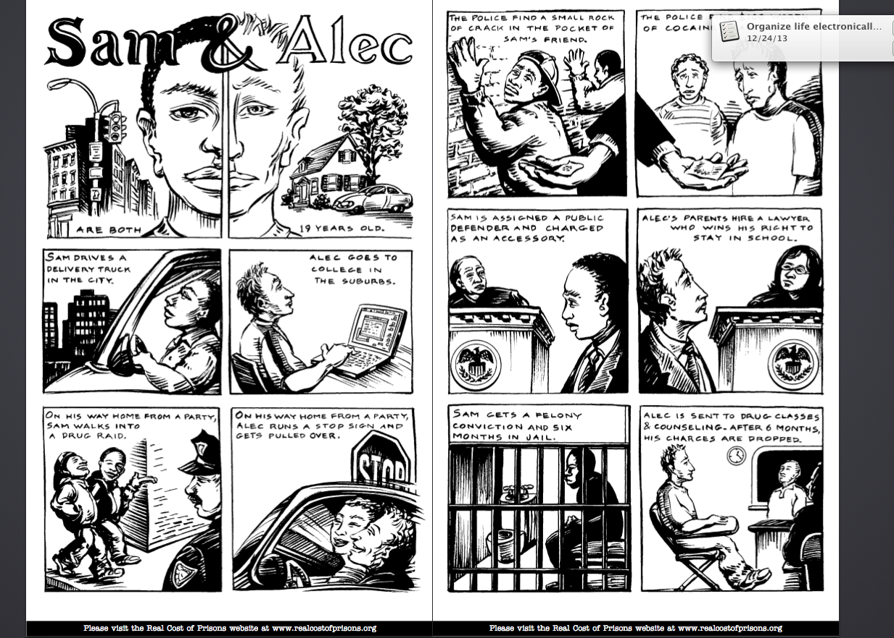

1. Prisoners of War
2. Prisoners of War
3. Prisoners of War