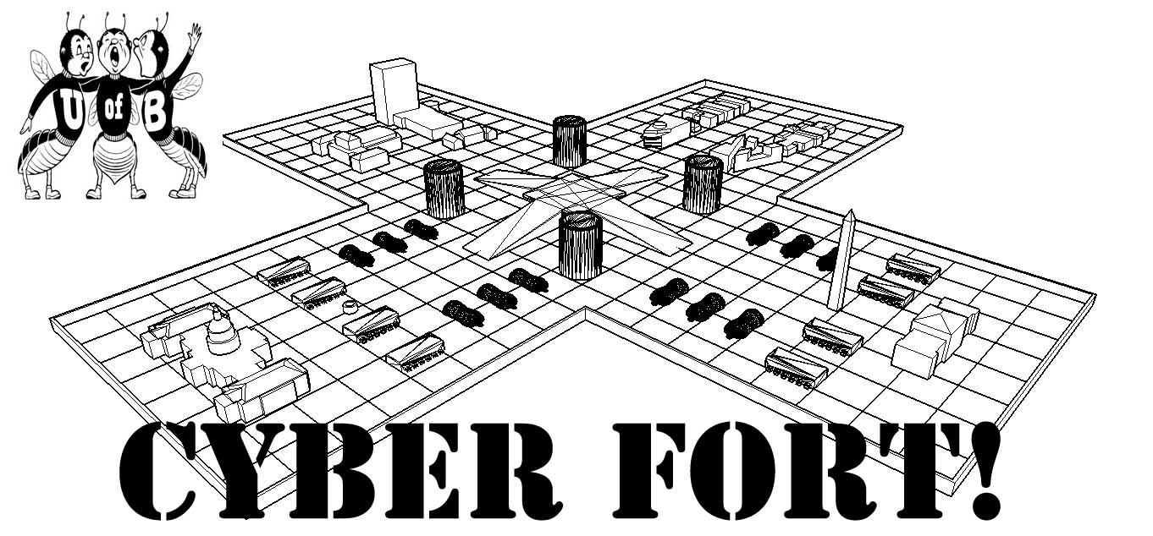

You have been asked to digitally design, then physically construct, a fortification to protect the marbles collected by your team's Boe-Bot. Using the 3-D surface modeling application called SketchUp (available for free at sketchup.google.com), you will generate a 3-D model. Next, you will receive a kit of supplies including chipboard for building the working version of your fort. You will hand in the 3D model of your building, and we will look at your physical fort to see how well you followed your plan. Adherence to your 3D model design will be judged.

Each fort should be a maximum length of 2 feet, with a total area not to exceed 1.5 square feet. Don't design anything too complex, as you will have to construct whatever you plan. You will use your fort during the final battle, and we will observe the effectiveness of your fort as a storage and protection site for your collected marbles.

Each team will be evaluated on:

* **Translation of Digital to Physical**
* **Construction and Design**
* **Functionality**
* **Originality and Aesthetics**

The fort is worth:

* **First Place - 100 points**
* **Second Place - 90 points**
* **Third Place - 80 points**
* **Fourth Place - 70 points**
* **Fifth Place - 60 points**

Deadline:

* **3D SketchUp model (digital) and physical fort due 9:00 am Saturday**