With compact and portable computing booming, extensive possibilities are available to improve daily life with sensors, data analysis, and connectivity. Even a device which is rapidly becoming obsolete such as a wristwatch can become relevant and helpful with modern sensors. Through the use of simple correlation, general relationships can be identified and capitalized upon.

One of the simplest forms of measuring immediate well-being is heart rate. By picking up electrical signals, a heart rate monitor could be easily integrated into a wristwatch and would provide simple measurements to determine more specific actions. For example, one could associate a heart rate of 70 beats per minute with sleep, or 120 with running. Such constant collection of data could aid greatly with stressful situations or major health problems. With online data, a rapidly declining heart rate indicating near-death could alert the nearest hospital with emergency information. Though only a single piece of information, the constant use of a heart rate monitor would greatly increase response times when in distress.

Similarly, a temperature sensor would be an easy indicator of general health. The average normal temperature of a human is 98.6 degrees Fareneheit, yet too high or too low of a reading would indicate illness. Below 95 degrees or over 100 would show signs of sickness, and rapid response with an alarm would signal employers or educators to remove an individual. Through such a technique the seasonal epidemics of influenza and strep throat could be minimized as administrators quickly stop the spread of viral and bacterial disease. In addition, hypothermic temperatures could signal a nearby hospital. With constant use, a baseline temperature can be calculated for each individual, personalizing the boundaries. Once again, a single number can indicate various situations and the benefit of connectivity opens new and helpful responses.

Next, GPS technology has advanced and moved in as a staple of advanced or “smart” devices. By implementing a positioning device into a wristwatch, many precise measurements and features can be added, once again including safety monitoring. Parents could more simply, or even discreetly, monitor the location of their children without a phone application, and boundaries could be set to initiate an alarm as the user leaves an area. Street safety could also be introduced, as marked criminals or offenders of the law could be announced as they enter a radial distance to the wearer. Also, restraining orders also might be more smoothly obeyed if warnings and distances are displayed. On the other side of the law, criminals on parole could be discreetly monitored to ensure that they do not leave the state or boundary to which they are restricted. Overall, GPS systems would greatly increase safety by increasing awareness of ones surroundings..

Another safety-oriented sensing system would be voice recognition and/or recording. With various pre-recognized words and phrases, the words “Help,” or screaming would notify officials of the location, heart rate, and basic information regarding the individual. Key words and phrases would be extremely helpful when notifying authorities, especially when facing crimes where the victim is singled out. Tone and volume could also be analyzed to determine emotions, and no matter how utilized, voice recognition is a vital and useful next-gen technology.

Electrochemical sensors are critical when identifying combustible gases and carbon monoxide. These sensors would be helpful safety indicators regardless of the environment in which one resides. However, with another small device called an intoxilyzer, blood alcohol level can be detected without the need for a chemical reaction. By using a small sensor with this infrared technology, blood alcohol level can be detected more simply and repeatedly with the same device. Randomly testing with breath could reduce drunk driving drastically by alerting authorities should a wearer begin driving.

Despite the vast daily uses for average citizens, a watch equipped with various sensors would also make a great tool for athletes. By using precise GPS, one could connect scores with player patterns in soccer or lacrosse to determine the best strategies. In addition, any gyroscopic capabilities could be put to use to correct movement. Biomechanics is a field rarely considered when new technology is introduced, yet the close contact of a watch would be able to carefully record movements of a player, and compare those to that of an optimal motion. In tandem with the heart rate, accuracy and success percentages could be calculated to find a goal heart rate for various exercises without the need for manual recording. Because of the many sensors with positioning, a watch with networking would be invaluable towards training and athletics as improvements can be made quickly and without as much error.

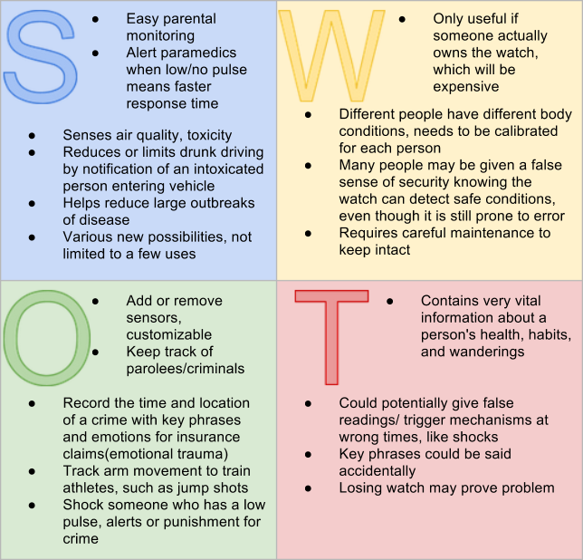Connecting a watch to the internet opens many, many possibilities for helpful daily tasks in addition to law enforcement and monitoring. However, consider the possible ideas utilizing existing technology. By combining sensors and their utilities, many useful measurements can be recorded in addition to cool features. Experimental yet revolutionary uses could include detecting sounds and events outside of the normal time periods, and even using weather patterns and atmospheric pressure to determine patterns of moods, emotions, and general social patterns. Though these are just a few ideas, the various sensors listed bring many options to the table, and by utilizing certain sensors in conjunction one can create interesting and useful functions.

Sources

"Pew Research Center's Internet & American Life Project." *Tracking for Health*. N.p., n.d. Web. 20 June 2013.

"Is the Clock Ticking for the Wristwatch? Survey Shows 1 in 7 of Us Have No Time for Them." *Mail Online*. N.p., n.d. Web. 20 June 2013.

"How Does a Blood Pressure Gauge (sphygmomanometer) Work? What Exactly Is Blood Pressure?" *HowStuffWorks*. N.p., n.d. Web. 20 June 2013.

"Heart Rate Monitors - How Do They Work?" *Heart Rate Monitors*. N.p., n.d. Web. 20 June 2013.

"How Breathalyzers Work." *HowStuffWorks*. N.p., n.d. Web. 20 June 2013.

"New Releases." *Normal Body Temperature : Rethinking the Normal Human Body Temperature*. N.p., n.d. Web. 20 June 2013.

"Restraining Orders." *State's Attorney*. N.p., n.d. Web. 20 June 2013.