The next-generation wristwatch, the xWATCH, records data using hundreds of precise sensors. They observe different lifestyle habits such as physical activity, medical and health information, and nutritional information. The xWATCH also includes a GPS tracker to record runs or find your position in real time. The data can be synced with mobile devices automatically for instant accessibility.

The physical activity monitored by the sensors is provided to track workouts and routines for exercise. Similar to the Nike Fuelband, the xWATCH measures steps taken and calories burned. Also included is a pulse and body temperature sensor to monitor intensity of workouts. The information can be easily accessed by personal trainers or physicians, or even weight monitoring programs. This data can be used to help improve the way one exercises, allowing for optimization of physical activity and for workouts to be easily logged.

Medical and health information is also recorded by the sensors. Data like blood pressure and even blood sugar levels, along with nutritional information can be taken from the sensors. Functions such as blood sugar can be used for people with medical conditions such as diabetes. The information is easily accessed by doctors, and medical researchers if necessary. Also, nutritional information such as a calorie counter and a monitor of food and water intake can be used by individuals to improve their weight and overall health. This information can be accessed by one’s personal nutritionist, and even nutrition programs like weight watchers. Weight Watchers Online has a mobile app for smartphones, and perhaps something like this could be used for the xWATCH. With this data, nutrition could be easily monitored and medical data could be easily managed.

Lastly, xWATCH has a GPS function that can locate the user’s place in the world and their relation to other points of interest. The GPS system works similarly to one on a smartphone, and can be accessed by voice recognition system. The xWATCH is similar to the Suunto Ambit2 GPS Multifunction Heart Rate Monitor, a watch-like device with many location functions, such as navigation and even weather, along with functions similar to the ones mentioned for exercise. This device reflects what the GPS function would be like on the xWATCH. This information gathered by the GPS can be accessed by policemen and satellites most likely, and be used to help track criminals if necessary and for security reasons.

|  |  |  |
| --- | --- | --- |
|  | Advantages | Disadvantages |
| **Internal** | **Strengths**   * Records personal data * Relays information to user’s devices * Provides data to certain key individuals such as doctorsand nutritionists * Allows for easy internet connectivity | **Weaknesses**   * User can become very dependent on device resulting in consequences upon system failure * Variables affecting the accuracy of data * Connectivity is dependent on location/service |
| **External** | **Opportunities**   * Whole new social network options * Quickly transmits data from user to appropriate personnel * Accurate measurments of intake/output of energy * Non-obtrusive form | **Threats**   * Personal information being intercepted * Third party purposely sabotaging data * Medical information being taken * Outside parties using information for financial gain |

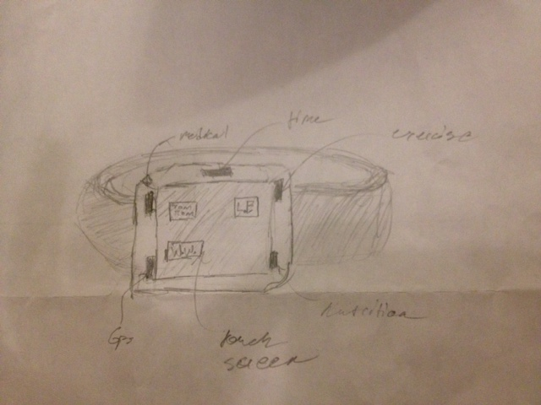

Here is a sketch of the xWATCH.