If a team was formed whose main goal is to spread propaganda to the educated public of Iran, some of the techniques that would be used by the team would be card stacking and transfer. When using card stacking one of the things we could say would be: while there may be many benefits to nuclear energy there are also many risks and the Iranian government is not equipped to handle a full nuclear melt-down. Another technique that should be used is transfer. This could work by talking about failed nuclear programs, like the one at Chernobyl, and showing pictures of the effects of nuclear radiation on the human body after what happened and then talking about how unprepared Iran’s government is to handle one of these situations.

Many things should be said in a topic as important as nuclear weapons. Some of the themes that should be stressed would be firstly the religious aspect. Iran’s population is 99.4% Muslim. Many Muslims believe nuclear weapons go against the Koran. For example, after the 1979 revolution, a nuclear weapons research program was disbanded by [Ayatollah Ruhollah Khomeini](https://en.wikipedia.org/wiki/Ayatollah_Ruhollah_Khomeini), who considered these weapons forbidden under Muslim ethics. A major theme that also should be stressed should be what happens when nuclear facilities melt-down. The affects on the populations of huge areas if not treated right away, and not treated properly, can be awful. Some of the affects radiation can have on the human body can be devastating.

One aspect that must be focused on is the demographic we are trying to reach. In Iran 97% of the 15-24 year olds are literate. These are the people whose minds can be changed. These are the people we should be trying to reach. These are the younger minds that can still be changed. The older generations will not want to change anything that requires that much effort and doesn’t directly affect them.

Iran’s media is heavily censored which makes the options of getting these messages to the public are very limited. One possible way would be dropping leaflets over the cities and towns of Iran telling of the horrors that nuclear weapons can do to people and how the president, Mahmoud Ahmadinejad, is ignoring other government’s pleas for help and endangering his entire countries population. This way the people could see the message before the government could censor it. If the people of Iran knew what really went on, the country would be a much different place. This is why we need to let them know of the dangers of nuclear facilities.



These pictures are from a nuclear accident that occurred in 1986 in Chernobyl, Ukraine. One of the reactors at the nuclear power plant over heated and exploded sending radioactive debris thousands of miles in all directions. The accident required an entire city of 50,000 people to be abandoned, thousands of acres of wildlife were destroyed, and there were many cases of birth defects as well as mutations that occurred to children living in the nearby city Pripyat. This is why a government unable to correctly run a nuclear program shouldn’t have one in the first place

This is one of the many mutations that happen when nations are unable to handle a nuclear melt-down.

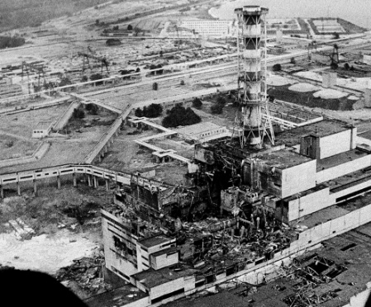

This is what is left of the nuclear reactor at the Chernobyl power plant.

This is one of that many ecosystems that has been destroyed

