May 31, 2012

Dear Mr. President:

Thank you for providing my team the honor of helping unify Afghanistan. We believe that we have developed effective strategies for persuading Afghan insurgents to stop harming their own country and to support the Afghanistan government. We will emphasize the providing of needed social services, like education and health, the need for a stable government, and repairing infrastructure, including rebuilding cities, providing utilities, and improving communication. It is our goal to convince the insurgents to put down their weapons, pick up their tools, and contribute to rebuilding Afghanistan.

To begin restoring Afghanistan, it is important to note the methods and media we will use. Since we are targeting insurgents of all ranks and ages, we are going to use a variety of media and propaganda techniques. We plan to use radio, television, and the internet to reach the insurgents. The primary techniques of propaganda that we will use are known as “glittering generosity”, “transfer”, and “band wagon”.

In our attempts to convince the insurgents, we will use media to accentuate the needs of Afghanistan, and show the amount of potential the country has. Commercials on radio and television will be made to persuade the rebels to work together with the government to build a new Afghanistan. We will provide information about the severe educational and medical needs. For example, the infant mortality rate and literacy rate are some of the worst in the Arab world. One child out of every five dies before the age of five, and only 28.1% of the total population is literate. In addition, we will attempt to unify them under Islam, the primary religion of Afghanistan. When Afghanistan was under communist rule, Islam served as a principle basis for opposition to the Soviet invasion. Whether they were Sunni or Shia, Islam was the banner they stood under to unite and rise against their enemy. With the internet, we will have a website that emphasizes the previous matters as well as the need for infrastructure. This includes modern buildings, roads, and guaranteed electrical power. A new communication network is a necessity as well, which includes cell phones and computer networks.

The following examples are a series of some of our proposed advertisements:

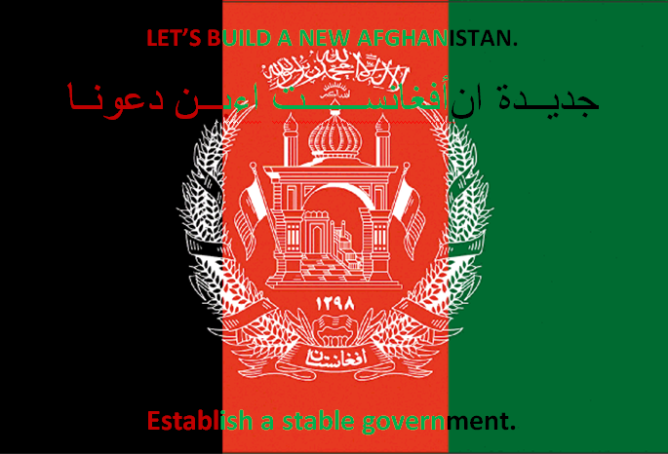

The above flag is an example of both band wagon and transfer.

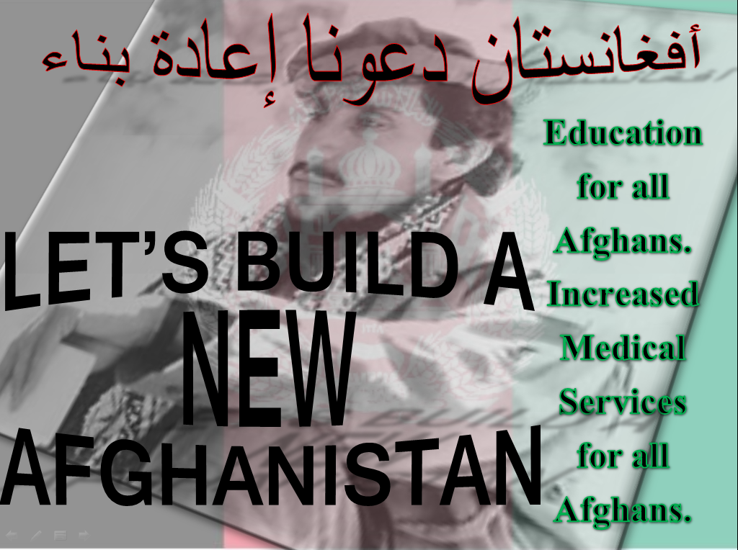

The above advertisement is an example of transfer and a glittering generality.

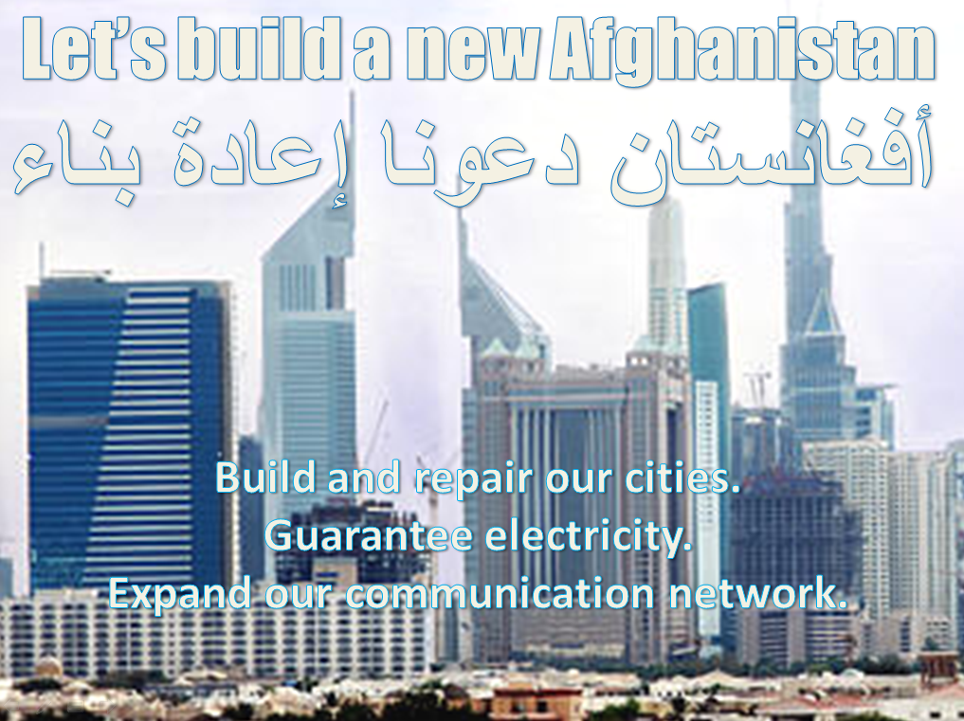

The above example incorporates transfer.

The final example is what could be a radio or television commercial script. It incorporates the technique of bandwagon.

“Let’s build a new Afghanistan. Our people are hurting. Our children are dying. Our cities are broken or destroyed. Our government is in shambles. Utilities are uncertain. Communication networks are virtually nonexistent. Let’s join forces to build a united Afghanistan. Lay down your arms. Pick up your tools. Let’s rebuild our cities and towns. Let’s build new schools and hospitals. Let’s build roads and streets. Let’s build businesses and factories. Let’s create jobs and improve our economy. It is time for a new Afghanistan.”

We have outlined our strategy to rebuild Afghanistan. We are confident that this propaganda campaign will convince insurgents to support and contribute to a newly created government. We’ve shown you the tools, techniques, and media we will use to successfully end all civil conflict within Afghanistan. We hope that the plan will satisfy your high standards.

Sincerely,

Your research team