Our goal is to create a propaganda campaign convincing the insurgents in Afghanistan to stop fighting and accept their new democratic government. The goal of propaganda is to influence people so we had to find a way to get through to them. As such, we have decided to reach them by first explaining that our troops will leave after they accept the new government, which will benefit them, and everything is settled. We also plan on using their religion to influence them. We have decided to use these themes because they clearly want us out of their country and they love their religion.

We will first show them how a democracy can help them. With a democracy, the insurgents now have the right to vote. If they do not agree with their leader, the citizens may try to vote them out and they will not be killed for voicing their opinion. Also, they can get what they want without having to commit a violent crime. We believe they will like this because they can still feel empowered to get rid of the government in power but can do it without violence. We will also point out that once Afghanistan has settled and accepts the new government we will leave the country. As such, they get two things they want; we leave and they have the right to change their government without getting shot.

To get this first message out, we plan to produce leaflets stating the message and drop them out of planes over villages and towns. The propaganda techniques we plan on using are plain folk and glittering generalities. We will use plain folk to relate to the insurgents as well as the common people. We will tell them that like them we are tired of fighting and are ready to go home. We will use glittering generalities to make this new democratic government seem more appealing.

Our second theme involves us incorporating their religion into our propaganda. Afghanistan is an Islamic country. We plan to use a quote from their prophet Mohammed. The quote says, “Beware of extremism, for verily, the nations before you were destroyed because of it.” We feel that this quote speaks directly to the insurgents because their attacks threaten to tear their country apart.

To get this second message out, we plan on using a testimonial approach. We plan on placing posters, featuring famous clerics who now support the government, near religious centers. The posters will feature the above-mentioned quote, a picture of the cleric, and the cleric’s explanation of what the quote means. We feel that this will attract the attention of our targeted audience and will force them to think about the positives that can come from not fighting against the new government. We want them to think about their attacks as harming, not helping, their country.

Propaganda piece 1: The Leaflet

Greetings People of Afghanistan:

We are not as different as you may think; we love our families and our way of life just as much as you do. We would love to have our troops come home just as much as you would love for them to leave. You should try to accept the new government. You can have a say in what it does and who is in charge. This, which you will love, will give you a sense of power, peace, and security.

* The Citizens of America

Propaganda piece 2: The Poster

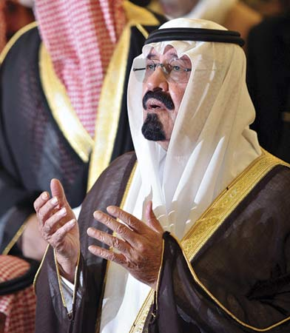

Cleric Gomaa says put down your weapons or, as Mohammed says, our nation could be destroyed.

**“Beware of extremism, for verily, the nations before you were destroyed because of it.”**

The Prophet Mohammed