The war in Afghanistan is the major conflict of the 21st century. Since Afghanistan people are misled to believe that the U.S. does not want to understand and support their way of life, we must convince the insurgency to relinquish their violence. I feel if we have an understanding of their laws and beliefs, they will respond . We should appeal to the Afghanis basic needs . Which are : to have access to land to grow food, clean water, and respect for their rights to practice their choice of religion.

“Bread not bombs, take a chance.” I feel that this slogan relates to Afghanistan because their diet consists mainly of unleavened flat bread and so it is very important to their way of life . So, the slogan tells them they should protect the bread and have peace among us. It is a bandwagon that highlights the Afghanis need to value their food more than resist another country. So by saying this, I think instead of them scrutinizing our government, they should realize what is in their own hands and realize that our country has had a better outcome.

Did you know that Afghanistan is amongst the most poorest and undeveloped countries in the world? So, we help them and all they do is criticize our government, our efforts seem futile . Within the Afghanistan villages, population size determines the amount of “gifts” their town possesses. Small villages have neither stores, schools, nor any representative of the government but larger villages do. Each one of the villages have three sources of authority: they have a malik which is the village headman, also a mirab which is the master of the water distribution. They have a mulluh, and is a teacher of Islamic laws and commonly a khan which is a large land owner that controls the whole village by assuming the role of both malik and mirab. So what is my point? They respect high levels of so why not respect the U.S.?

The conflict of this era must be brought to peace. Afghanistan disagrees with our government and our country because of what we stand for. What they don’t quite realize is they have a similar government structure just like us, so why hate us? Instead of hate why not choose the betterment of the people by ending bitter violence and preserving their culture. Or do they just love to hate us? If the insurgents would just lay there arms down, the U.S could possibly give them the things that will improve their quality of life.

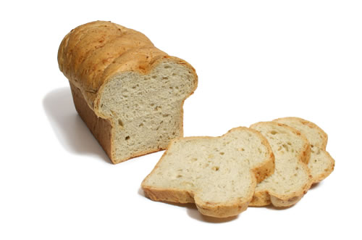NOT 