**MS Word Intro**

This lesson consists of a brief introduction into MS Word. This introduction uses MS Word 2007 as the platform. If you are using an earlier version of Word, the same functions described are applicable, but may be found in slightly different locations. The students will use Word to complete the Word Origins Assignment (see included example where origin of the word security is explored). The accompanying pdf shows suggested techniques to display information using Word.

**Word Origins Assignment:**

Last class the students discussed the origin of the word cyberspace. Have the students generate a list of cyber related words. Then each student can pick a word to investigate further. Have them use MS Word to display the information found. You can also use this opportunity to discuss reliable sources. Direct them to trusted sites like www.merriam-webster.com or www.britannica.com versus urbandictionary.com and Wikipedia.com. Let them know that Wikipedia is a good source to get an initial understanding of a topic, but due to its open source nature the information cannot be trusted as absolute fact. Also tell them to use Google scholar (which can be found under www.google.com, then click on more at the top left of the screen, there you will be able to click on Google scholar).

**Keyboard Shortcuts:**

The following is a table of key keyboard shortcuts that everyone should know. They work with MSWord as well as most every other computer program. You can find more keyboard shortcuts in the help feature of Word.

|  |  |  |
| --- | --- | --- |
| **Keys** | **Function** | **Description** |
| Ctrl + Z | Undo | Undoes the last thing completed |
| Ctrl + C | Copy | Copies highlighted section |
| Ctrl + X | Cut | Cuts highlighted section |
| Ctrl + V | Paste | Pastes section that was copied or pasted |
| Ctrl + P | Print | Brings up print window |
| Ctrl + S | Saves | Saves Document |
| Ctrl + B | Bold | Bolds words |
| Ctrl + I | Italics | Italicizes words |

**MS Word Interface:**

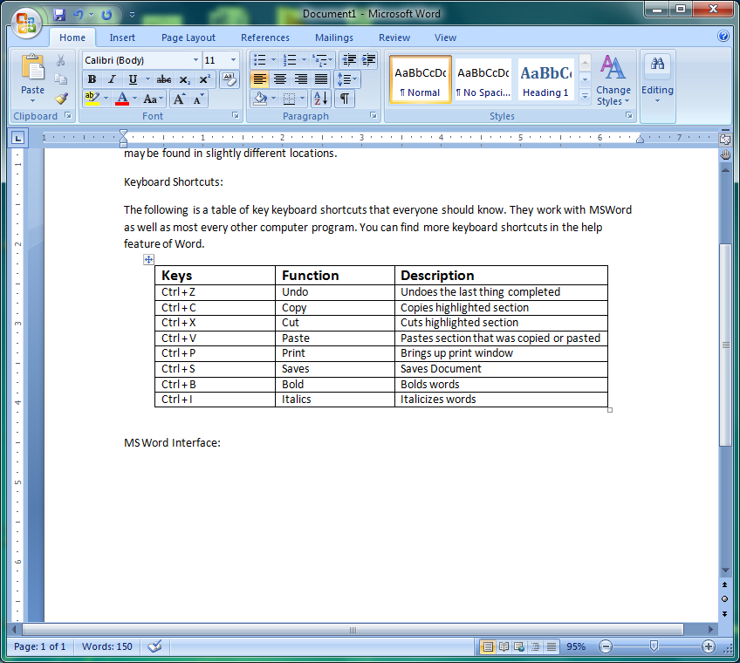

Navigating over the taskbar found at the top of the program will allow the user to complete any function desired. As you can see in the screen shot there are seven main tabs: Home, Insert, Page Layout, References, Mailings, Review, and View. For the purposes of this class you will mainly utilize Home, Insert, and Page Layout. You will also utilize hidden tab that appears when the user double clicks on a picture. This tab is called Format. Brief descriptions of the tabs are as follows:

**Home:** Most commonly used functions such as editing the form of words with font, font size, color and justification.

**Insert:** Houses insertion objects such as clip art, charts, page breaks, test boxes, etc.

**Page Layout:** Allows for any big picture page editing like margins, columns, borders, and spacing.

**Format:** Reveals all picture and object editing functions like crop, shadows, picture borders, etc.

Suggested Functions:

This next section pairs with the pdf document that highlights the poem “The Road Not Taken” by Robert Frost. Students can use some of these techniques in their Word Origins Assignment.

**Header:** A header is a simple feature to add onto a document. The header is always found in the top margin of a page. The user should simply double click top margin. This will take the user into the header/footer mode. You can type whatever necessary into the header navigating through the header with the tab button. The exit header mode, press the Esc button on your keyboard.

**Shape:** Click the Insert tab, and then click the shapes button. You effectively draw the shape in the desired location. To type in the shape, double click on the shape to where the shape is framed by blue squares then press 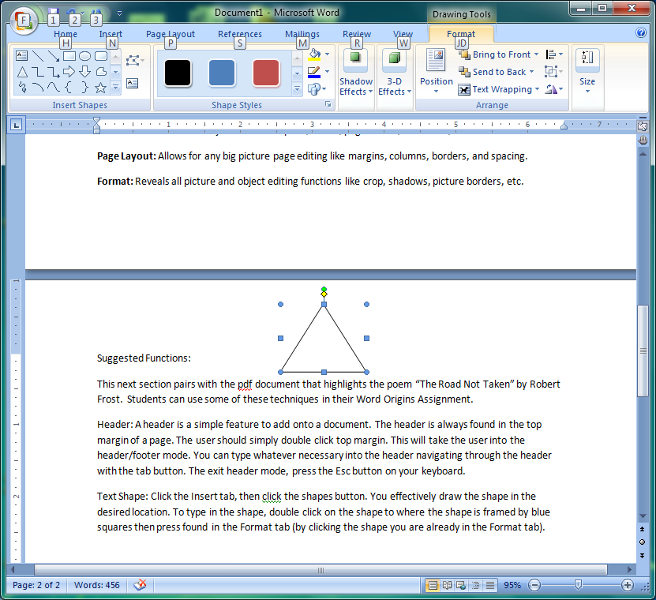found in the Format tab (by clicking the shape you are already in the Format tab). Then begin typing. Please also take note of the layout associated with the shape. In the format tab there is a button labeled Text Wrapping it is paired with an icon that looks like a dog in between some lines. Once you click this button different options for layout will be available. You will most likely use *square* or *tight*.

**Font:** To change the font, navigate to the home tab.



Changes Font Style

Changes Word Color

Highlights Words

Bold/Italicize/Underline

Word Justification

**Columns:** Click on Page Layout tab. Highlight text, and then click the columns button. Here you can choose the number of columns desired.

**Bullets:** In the home tab, there is a button that looks a lot like bullets. Highlight the text that is being bulleted then click this button. Notice the button next to the bullet button is very similar but instead of bullets it has numbers. If you prefer numbers instead of bullets, then click that button instead.

**Pictures:** There are many ways to place a picture into a document. You can simply copy a picture and paste it into your document (see keyboard shortcuts). Or you can go to the Insert tab click the picture button and search your computer for a saved picture that you would like to insert. Remember the layout discussion for inserting a shape also applies to the picture. Again you will most likely use the layout of *square* or *tight*. When you click once on a picture and it is framed by the little blue boxes in the corners, you can pull on the blue boxes to make the picture any size you desire (you can even make it fill your whole page to use it as a background). You can also resize a picture when you double click on it and the Format tab comes up. Unser the size section of the tab you can adjust the horizontal and vertical dimensions of the picture.

This is a short introduction in how to display information using MS Word. Use these suggestions as starting points, but the best way to learn more about word is to slick buttons. If you are curious about what a button does just click it and see what happens. Remember you always have CTRL + Z! Another very useful tip is to utilize the help feature. If you know of something you want to do but are not how to do it click the help button (small question mark button found in the top right hand corner). You can type in keywords into the search feature and it will reveal a list of items associated with the keywords. You should then be able to find how to get done what you wanted.