**Lesson 9: PowerPoint**

MS PowerPoint is a functional software commonly used as a presentation tool. However, PowerPoint has many other uses outside of simple presentations. For this class we will explore how to use PowerPoint to build flow charts.

Getting Started

The common flowchart symbols are embedded into the basic PowerPoint software. Please refer to the additional PowerPoint file for visuals that correspond to this lesson. Once you open PowerPoint, a large blank slide with suggested boxes for a title and subtitle is displayed. Since we are not using PowerPoint for a typical presentation go ahead and delete those boxes (click on their outline and hit delete).

Now, let’s make a flow chart! Click on the *insert* tab in the top left of the PowerPoint window. In the insert tab, you are given many options of things to insert onto your slide. For flowcharts, you want to click on the *shapes* option.

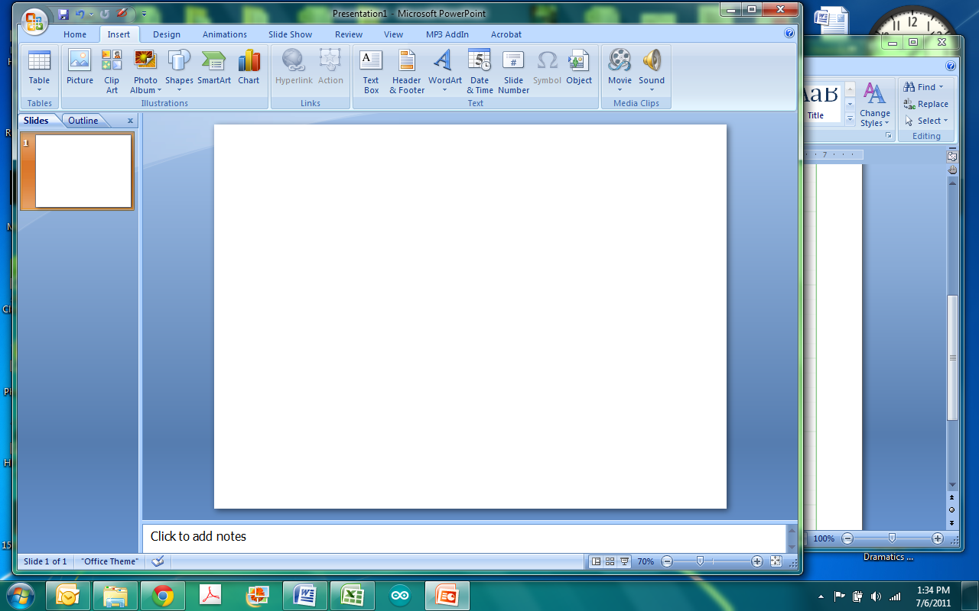

A dropdown list of options will appear after clicking the shapes button. You will use the list aptly entitled *Flowcharts*.

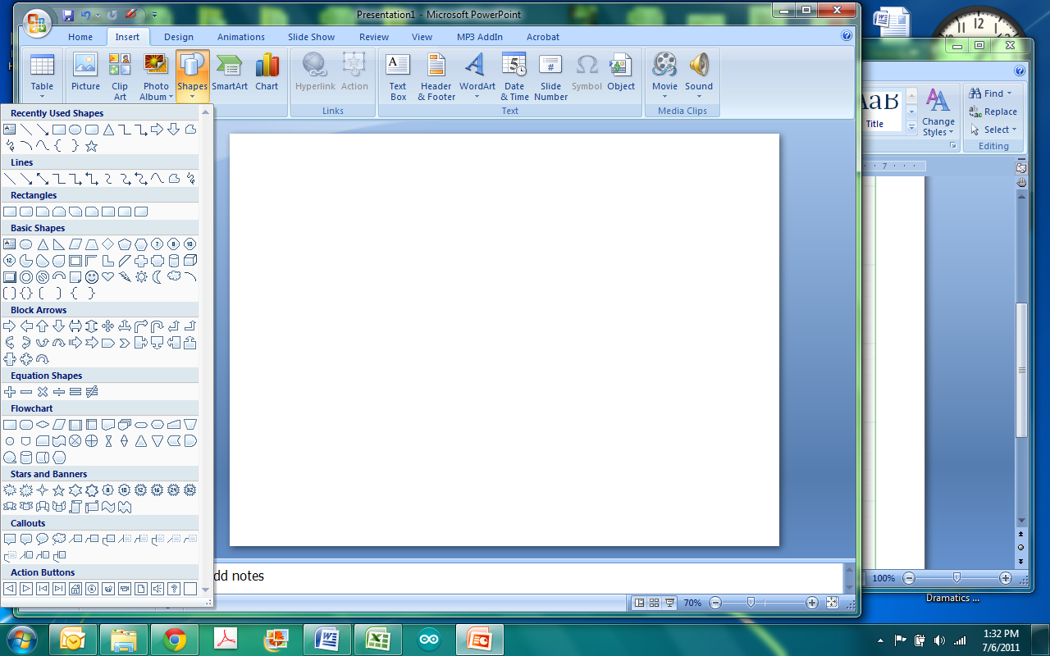

Under the list for Flowchart are the many shapes that you will want to use for creating a flowchart except for the connectors (the lines connecting the flowchart boxes). The connectors are found under the lines section of the drop down list. Because you are using the flowchart boxes, the lines for the connectors are made to easily snap into place. When you begin to draw the lines you will see the corners and middle sections of the flowchart boxes become read and the lines easily attach to them. In order to write the commands in the flowchart, you simply click the shape and start typing. If the text you wish to add does not belong in the flowchart box, but rather next to a connector, you will have to insert a text box.

PowerPoint Activity

**Scenario:** You have a lamp that is not emitting a light.

**Task:** Through a process of troubleshooting determine why the lamp is not working and what action needs to be taken (Refer to PowerPoint document for solution). Display the process by making a flowchart using PowerPoint.

Useful Tips

Because PowerPoint is a Microsoft Office product, the functionality is very much the same as any other MS Office product. The layout of all the MS software (i.e. MS Word) are similar, thus the actions to change font, colors, size, etc. are similar. Click the Home tab and all the commonly used formatting buttons are visible. However, note that some things will be found in slightly different locations. Encourage students to play around with the formatting by trial and error as well as using the help button.

On a side note, although this lesson focused mainly on making flowcharts, as mentioned before PowerPoint is a very useful presentation software. Keep in mind there are some key tips that everyone should abide by when making presentations using PowerPoint.

* Dark background and light letters pop i.e. dark blue and white (the reverse is also acceptable). Keep in mind that people are looking at the presentation and it should be easy on the eyes to see.
* You should not put paragraphs on a slide, just key phrases. Keep it simple.
* Animations should be used to a minimum. Animations can be very distracting and in most cases add very little value to the presentation. That’s not to say you should never use them, but use them only when appropriate.
* You should spend at least a minute on each slide.
* 18 point font is probably the smallest font visible and easy to read for an audience.
* If you insert graphs into a PowerPoint, make sure they are readable and clearly labeled.