**Lesson 10: Boe-Bot Input/Output**

Needed

* LED
* 220Ω Resistor
* 470Ω Resistor
* Whisker Circuit Supplies (see Lesson Plan)
* Computer with PBasic
* USB cable
* Multimeter

The Boe-Bot can respond to a series of inputs that can be programmed to yield a desired output. To illustrate this idea we are going to build a whisker circuit onto the Boe-Bot bread board. We will use the whisker as an input that will make the Boe-Bot know to turn on an LED also on the breadboard.

Whisker Circuitry:

First let’s look at the whisker circuit. Essentially the whiskers are a switch that can turn a circuit on and off. In particular, the whiskers are tactile switches; they use touch to turn on and off. There are many uses for tactile witches from simply counting objects on a production line, autonomous navigation, turning on an LED, etc. The whiskers are represented schematically as the following picture:

Using the book Robotics with the Boe-Bot that came with your Boe-Bot kit, follow the instructions on assembling the whiskers (Chapter 5 pg. 166-167). Once the whiskers are connected to the Boe-Bot, the circuitry associated with the whiskers can be assembled. Below is a diagram of the whisker circuit, Figure 1. Using Figure 1, create the circuit on your Boe-Bot breadboard (the schematic shows two whiskers hooked up to the Boe-Bot, for this project, you only need one whisker set up).

 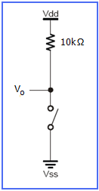

Figure 1: Diagram of Whisker Circuit Figure 2: Single Whisker

Testing the Whiskers

Once you finish the whisker circuit assembly, run the following program. This will check if your whisker circuit is functioning properly. The program specifies that pin 14 is the input pin (get it, IN for input?). The BIN1 is a formatter within the BASIC Stamp that tells the Debug Terminal to display values as 1 or 0 (on or off). The CRSRXY, 0, 1 is a format indicator. It designates how the DEBUG screen displays the result.

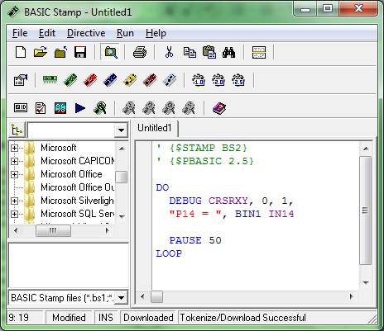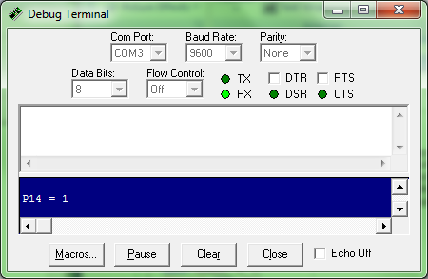

The DEBUG terminal should display P14 = 0 or 1 dependingif the whisker closes the circuit or not (1 if circuit is open and 0 if circuit is closed).

Now, hook a multimeter to monitor the voltage when the whiskers circuit is open and closed. The students can hook up the multimeter as shown in the picture with the wire coming from ground, or they could connect directly to the whisker.

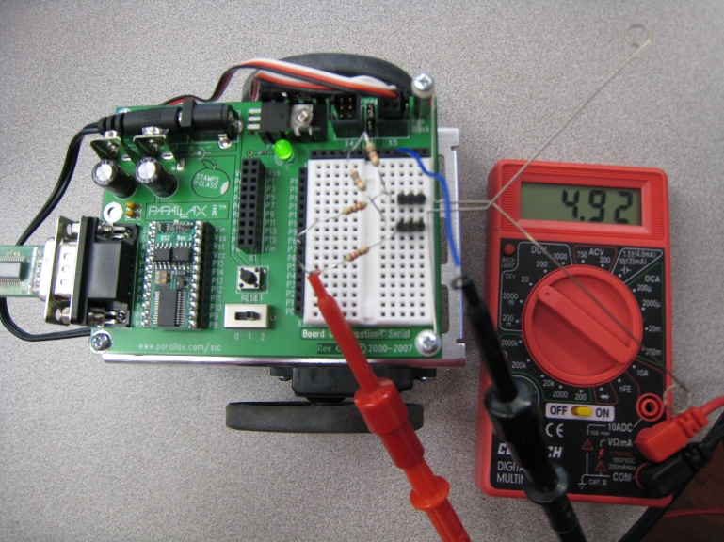

**Question:** Does the multimeter reading change when the whisker is pressed? Is this change reflected in the output of the program above?

**Answer:** Yes the multimeter reading does change when the whisker is pressed. When the whisker is not pressed the voltage reading is approximately 5V, and when the whisker is pressed the voltage reading drops to 0V. This is reflected in the program; in the Debug Terminal, when the whisker is pressed the corresponding pin output is a 0 and when it is not pressed the output is a 1.

**Discussion:** Let’s examine the circuit. You may have some questions that come to mind when looking at the circuit:

1. How do the 220Ω resistors affect the whisker circuit?
   1. They do not affect the circuit. They are only in the circuit for safety precautions to prevent damaging the BASIC Stamp for draining the batteries. (For example, if pin 7 goes to HIGH then we have a direct short to ground if the 220Ω resistor was absent.)
2. If the 220Ω resistors are only there for safety precautions how is the BASIC Stamp interpreting the portion of the circuit?
   1. The whisker circuit acts as though that portion of the circuit is not there. The Basic Stamp uses that portion of the circuit and acts as a multimeter measuring the Voltage, Vo (Figure 2).
3. So what is the Basic Stamp/multimeter measuring when the whiskers are pressed and not pressed?
   1. When the whisker(s) are pressed, the switch is closed, Vo will go to 0V (Vo is shortened to ground) and the Boe-Bot pin goes LOW.
   2. When the whisker(s) is not pressed, the switch is open, Vo builds to 5V and the Boe-Bot pin goes to HIGH.

LED Circuitry

Earlier we mentioned that for our class we will be using the whiskers to turn on an LED. In order to do this, we need set up the LED circuitry also. The circuitry follows the schematic below. The pin indicated in the schematic is Pin 0, however, you can use any pin for the circuit.



Let’s take a closer look at the two components in this circuit: the resistor and the LED.

**Resistor:** We have used resistor in previous classes, but how is that we know which resistor is which and what exactly the resistor does to a circuit. Simply stated, the resistor limit the flow of current through an electrical circuit. They come in a variety of sizes each having a specific color code indicating their size. The color stripes indicate information about the total value of the resistor. The following resistor table helps you to know the size of the resistor being used.

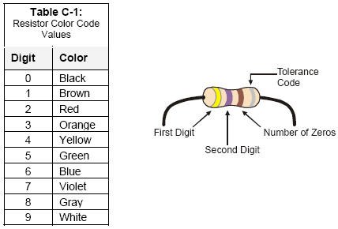By using the chart, you can determine the resistance of a resistor from its colored stripes.

The first stripe corresponds to the first digit, the second stripe relates to the second digit, and the third stripe corresponds to the number of zeros to the right of the second digit. The forth stripe is the tolerance of the resistor. The tolerance stripe is always a metallic color like gold or silver, so it is usually easy to distinguish which side of the resistor should be your first stripe. For example, a 470Ω (“Ω” = the Greek letter omega, which is used to represent ohms, the units of resistance) resistor would be yellow-violet-brown with a metallic fourth stripe, where yellow represents a 4, violet represents a 7, and brown represents 1 zero that follows the resistor values Putting them all together, we must have a resistor of “470” ohms.

Now let’s figure out what a 220Ω resistor would look like.

2-Red

2-Red

1 Zero-Brown

Thus, a 220Ω resistor will have the color stripes of: Red, Red, Brown.

Why is a resistor necessary for this circuit? When turning on an LED, a resistor must be in place; otherwise, we run the risk of supplying too much current that will in turn burn up the LED.

**LED:** LED stands for Light Emitting Diode, thus it is a diode that gives off light. But what is a diode? The most common function of a diode is to allow an electric current to travel in one direction and to block current in the opposite direction. The flow of current through the LED is unidirectional (meaning it can only travel in one direction), thus the LED must be positioned in the circuit properly.

How can you tell if the LED in set up properly?

There are two visual ways of determining the direction that an LED allows current to flow in:

1. The length of the leads - The short lead is connected to the lower potential (ground).
2. The LED plastic casing - The “flat” side on the base of the LED is connected to the lower potential or ground (This is useful to know when someone has previously cut one of the leads).

Programming

Now that we know a little bit about the different components of the circuit, lets program the LED to turn. Before trying to make the LED turn on using the whisker, let’s simply program the LED to turn on. To turn on an LED in the PBASIC programming is very simple. It follows the syntax:

HIGH #

The high tells the Basic Stamp to supply 5Volts to the pin number indicated after the letters HIGH.

To turn off the LED it is comparably simple. This follows the syntax:

LOW #

The LOW tells the Basic Stamp to supply 0Volts to the pin indicated after the letters LOW.

How long does the light stay on or off? This is indicated by a PUASE command after the HIGH or LOW commands. After HIGH # and LOW # indicate how long each one stays by typing PAUSE #, where the # indicates in milliseconds how long the HIGH or LOW should be held. The following example is as if the LED circuit is plugged into pin 11 and the one and off each last for 1 second. Notice the Do…LOOP which makes the program repeat the process.

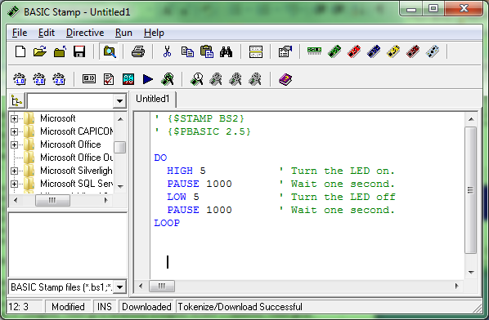

We can use this programming knowledge to help us program to use the input provided by the whiskers to turn on the LED. How do we make the BASIC Stamp process the touch of the whisker and know then to turn on the LED? We will have to use what is called an IF…THEN statement. This command allows the BASIC Stamp to make decision “if a certain condition, then do an action, else if a different condition, then perform a different action” and so on till you end the IF statement. Thus, the syntax for the command is:

IF (condition) THEN…{ELSEIF (condition)}…{ELSE}…ENDIF

Understanding the IF…THEN statement is important. It is a very useful programming tool that can be used in many different applications (i.e. automated telephone calls: for directions in English press 1, for directions in Spanish press 2. This is basically an IF…THEN command. IF 1(English) THEN go to directions in English, ELSEIF 2 (Spanish) THEN go to directions in Spanish, and so on).

From earlier, we know that when the circuit is closed (the whisker is pressed against the three pin header), then the input is 0. Thus we can use the IF…THEN statements to our advantage with something like: if pin14 equals 0 then turn on the LED else turn LED off.

Activity

Have the students use an IF…THEN statements to turn on the LED using the input from the whisker. Use the whisker input to make the LED blink in Morse code. For instance if a message of SOS is needed, the LED should blink in a pattern of three quick blinks, three long blinks, then three more quick blinks, •••———••• . The following chart shows corresponding letters and Morse code counterparts.

|  |  |
| --- | --- |
| A | •— |
| B | —••• |
| C | —•—• |
| D | —•• |
| E | • |
| F | ••—• |
| G | ——• |
| H | •••• |
| I | •• |
| J | •——— |
| K | —•— |
| L | •—•• |
| M | —— |
| N | —• |
| O | ——— |
| P | •——• |
| Q | ——•— |
| R | •—• |
| S | ••• |
| T | — |
| U | ••— |
| V | •••— |
| W | •—— |
| X | —••— |
| Y | —•—— |
| Z | ——•• |

Solution:

