**MS Excel Intro**

This lesson consists of a brief introduction into MS Excle. This introduction uses MS Excle 2007 as the platform. If you are using an earlier version of Excel, the same functions described are applicable, but may be found in slightly different locations. The accompanying Excel spreadsheet shows examples of the techniques discussed.

**Keyboard Shortcuts:**

As included in the MS Word intro, the same keyboard shortcuts are applicable to MS Excel. The following is a table of key keyboard shortcuts that everyone should know. You can find more keyboard shortcuts in the help feature of Excel.

|  |  |  |
| --- | --- | --- |
| **Keys** | **Function** | **Description** |
| Ctrl + Z | Undo | Undoes the last thing completed |
| Ctrl + C | Copy | Copies highlighted section |
| Ctrl + X | Cut | Cuts highlighted section |
| Ctrl + V | Paste | Pastes section that was copied or pasted |
| Ctrl + P | Print | Brings up print window |
| Ctrl + S | Saves | Saves Document |
| Ctrl + B | Bold | Bolds words |
| Ctrl + I | Italics | Italicizes words |

**MS Excel Interface:**

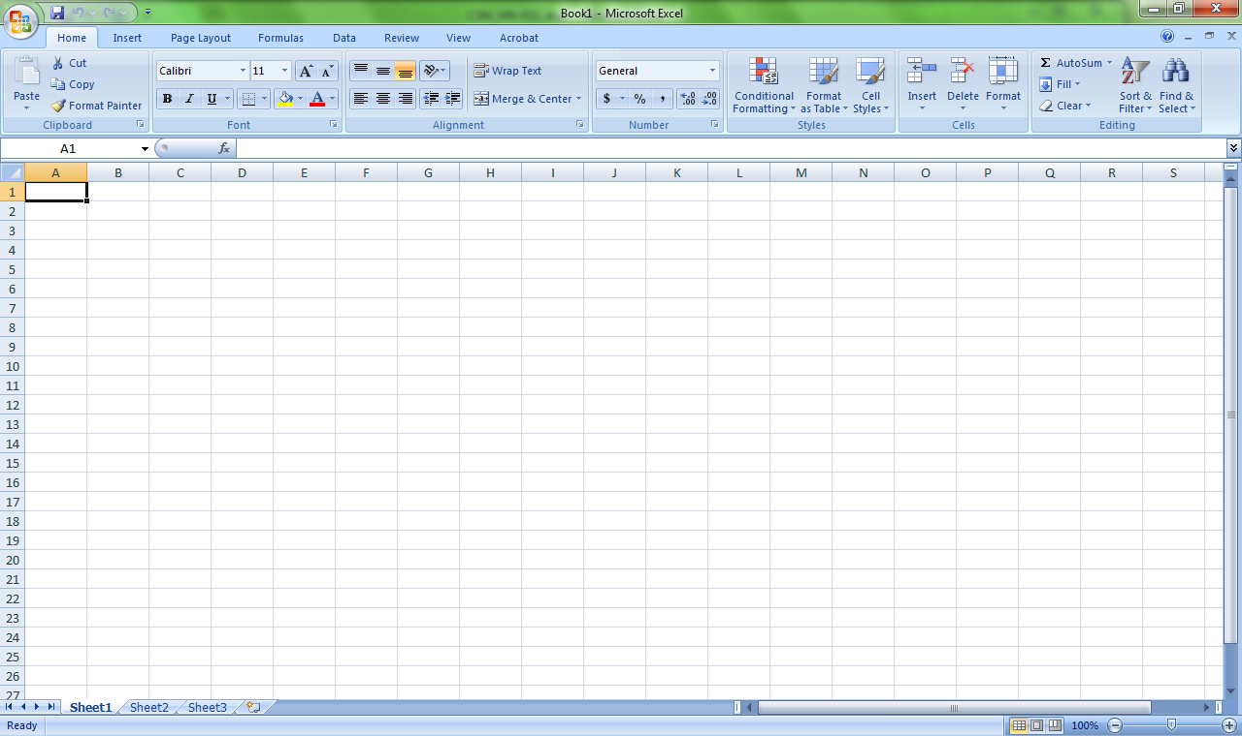

Much like MS Word, navigating over the taskbar found at the top of the program will allow the user to complete any function desired. For Excel there are eight main tabs: Home, Insert, Page Layout, Formulas, Data, Review, View, and Acrobat. For the purposes of this class you will mainly utilize Home, Insert, and Page Layout, Formulas, and Data.

**Home:** Most commonly used functions such as editing the form of words with font, font size, color and justification.

**Insert:** Houses insertion objects such as clip art, charts, page breaks, test boxes, etc.

**Page Layout:** Allows for any big picture page editing like margins, columns, print layout, etc.

**Formula:** Houses a library of function that can be inserted into your spreadsheet. However, you can also insert formulas into the spreadsheet while working under the Home tab.

**Data:** This tab allows the user to input any graphs or charts associated with the values in the spreadsheets.

**Excel Terminology:**

Every square in an Excel document is called a ***cell***. Within a cell, you can place numbers, words, formulas, pictures, etc. You can navigate through cells using the tab keys, arrow keys, or clicking on the cells with the mouse. Each sheet of cells within an excel document is called a ***spreadsheet***. The entire excel file, including every spreadsheet is referred to as ***workbook***. The power of Excel is found within its ability to organize information/data and also link cells together, whether to show emphasis or to make calculations. Below is a screen shot of an empty Excel Spreadsheet with different sections annotated.

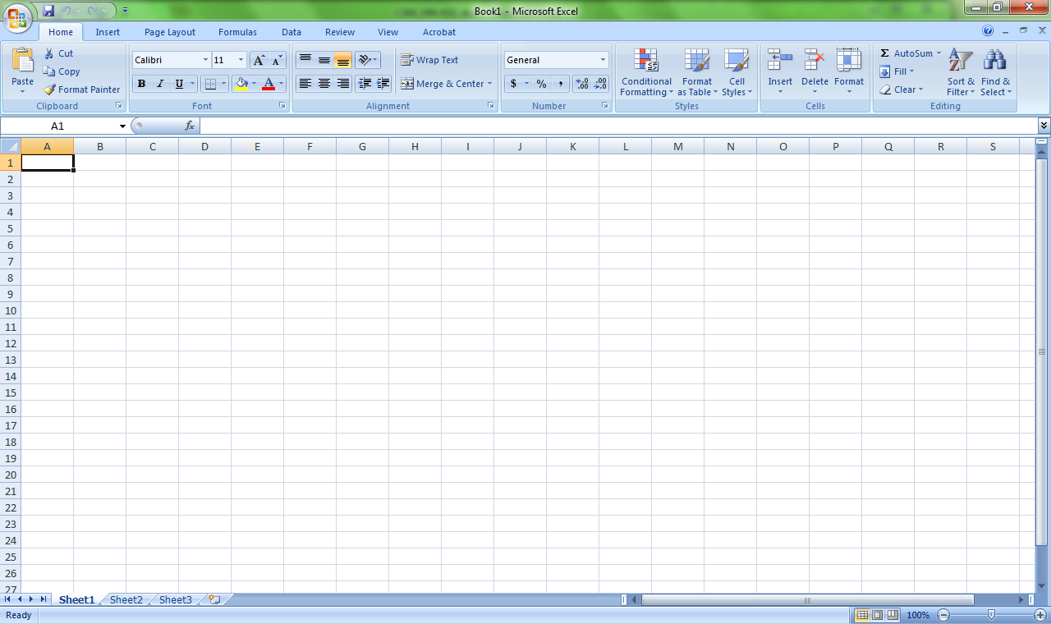

Different Spreadsheets within a workbook

Rows are labeled with Numbers and Columns are labeled with Letters

Identifies the cell the cursor has clicked on

**Excel Examples:**

After you understand how to navigate through an Excel workbook, you are ready to begin inputting information into a spreadsheet. Below are explanations for examples of things that can be done with Excel, paired with these examples is an excel documents.

***Basic Excel and Using Functions***

The first spreadsheet we will look at is called Grades. Notice how you can double click on the tab at the lower left of your Excel window that is initially called Sheet1 and change its name. In this case, it is called Grades. One thing to note, you can change the words to bold or the font style and type using the Home tab much like MS Word. Also you can **adjust the row and column size** by moving the cursor to the location in between the column or row heading press and hold the left mouse button and drag the column or row to the respective size desired or if you can double click in the same location and the row or column will size to fit the contents of the cell (see picture).

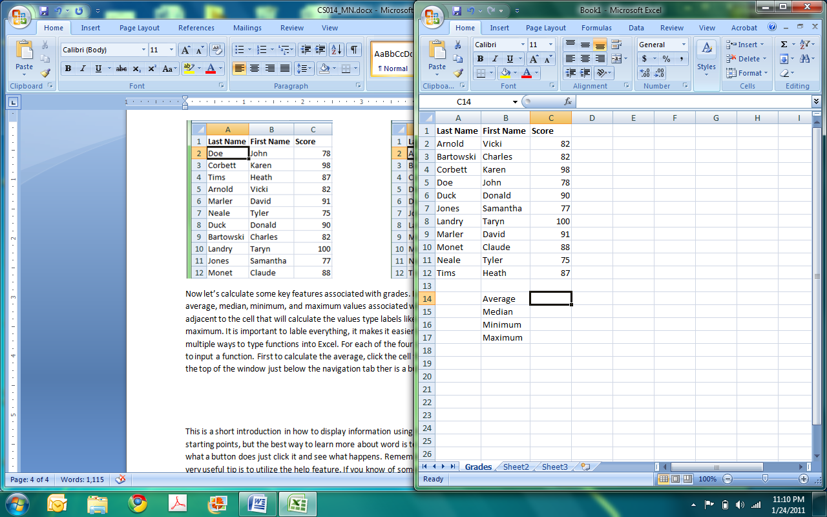

Sorting button

Place cursor here and hold the left mouse button and drag to change the size of the column or double click and column will size to fit contents in cells.

You can **sort** the contents of the cells by **ascending or descending** order using the sorting button. For the spreadsheet accompanying this document we will sort by last names alphabetically. You click the cell with the current top last name then click the sorting button. You will have the option to specify ascending or descending, click the appropriate option (descending) and your table will be sorted.

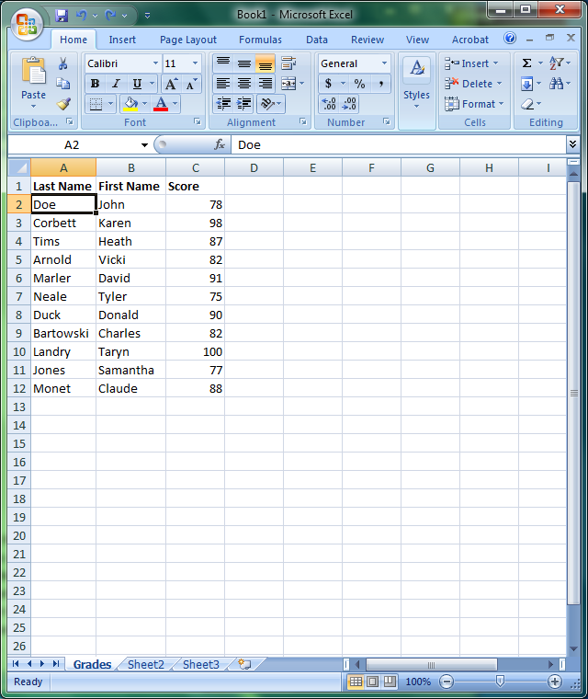 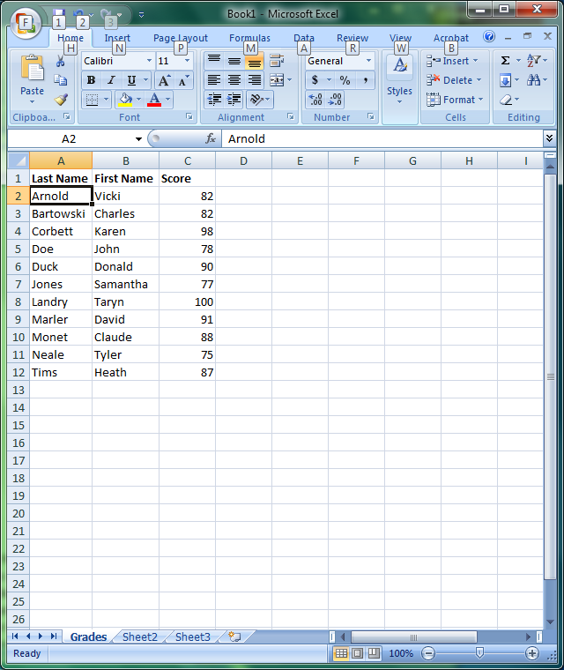

Now let’s calculate some key features associated with grades. Let’suse the function feature to calcualte **average, median, minimum, and maximum** values associated with the Grades spreadsheet. In the cell adjacent to the cell that will calculate the values type labels like average, median, minimum, and maximum. It is important to lable everything, it makes it easier to understand the spreasheet. There are multiple ways to type functions into Excel. For each of the four options we will explore different means to input a function. First to calculate the **average**, click the cell that that will house the calulation then at the top of the window just below the navigation tab ther is a button that looks like . Click this button and a window will pop up. Under Search for a function: you will be guided to input a description of the fucntion you are trying to implement. In this case we are looking for the average so type average. A few avaerage option will appear. Since this is simply the average of a sample set the first average thet is found ini the list will be the function we will use. Click on AVERAGE and then press ok. Another window will appear. This is where you will highlight the cells that contains the test scores. Click on the first cell, hold the left mouse button, then drag the cursor to the last cell. When you highlight the last cell containing data release the mouse button and the window should indicate the cells that are used to calulate the average. Clikc ok and the caclulated average will appear.

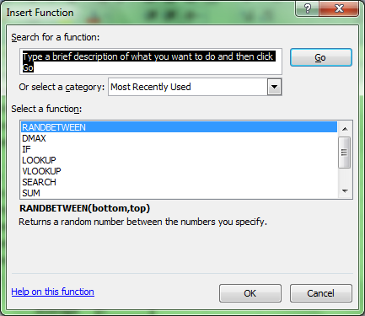 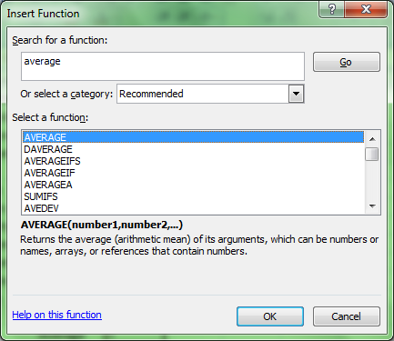

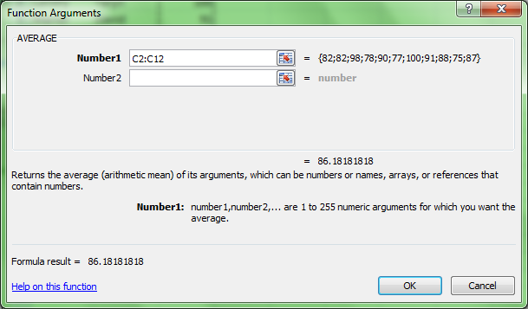

To calculate the **median**, we will use a slightly different method. Click on the cell that the median will be calculted in. The click in the white space next to the  button. Begin typing =me and Excel will infer that you want =median (this will show up as you type) click on the median option. In the white typing space it will appear as =median( and the parrenthesis you want to put in the cells that will calulate the median. This is done using the the sam click and drag method. Once you have all the cells highlighted, close the parenthesis and hit enter and the median will appear.

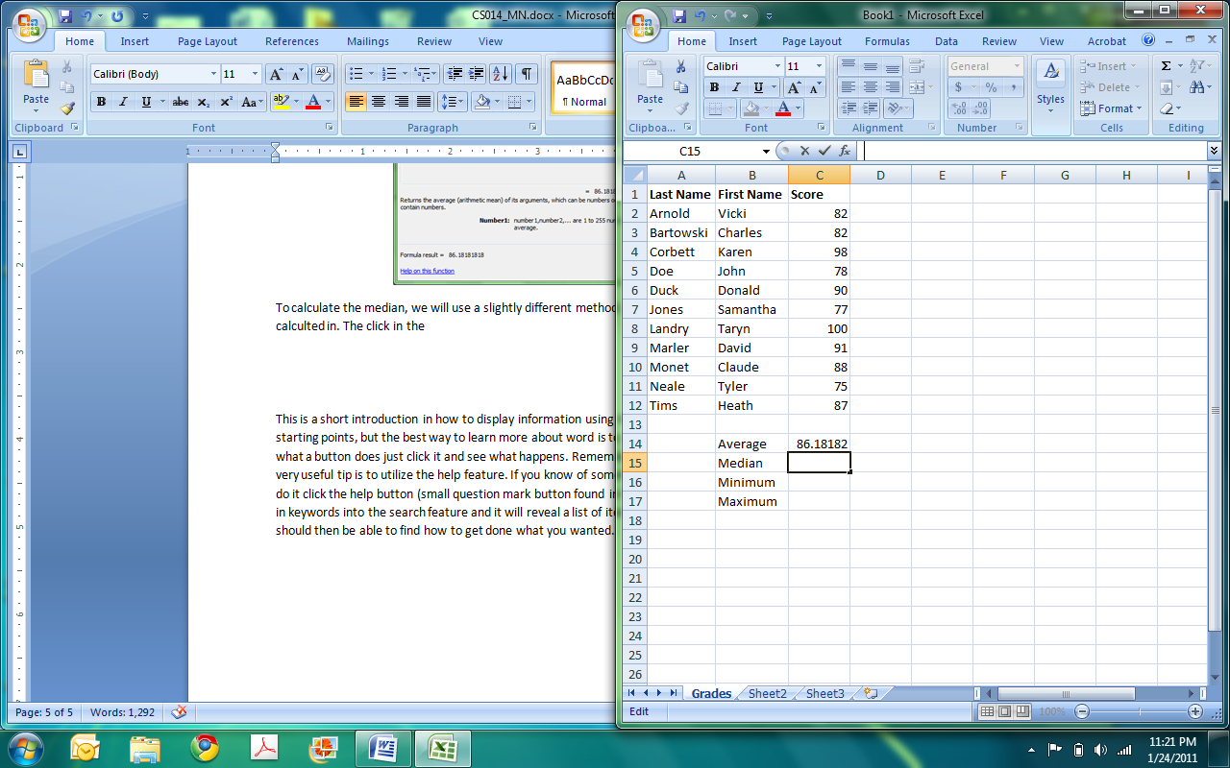

Now let’s calculate the **minimum**. Click the cell, and type =Min as you are typing option will appear click the option that says min. =min( will appear in the cell and fill in the cells with the data using the click and drag method as before then close the parenthesis. Press enter and the min will appear. You can use the same method for the maximum.

Any of these methods are great for inputting functions. The first method describes is best when you are not sure what the function is called in Excel. If you have an idea then the other methods are a good short cut.

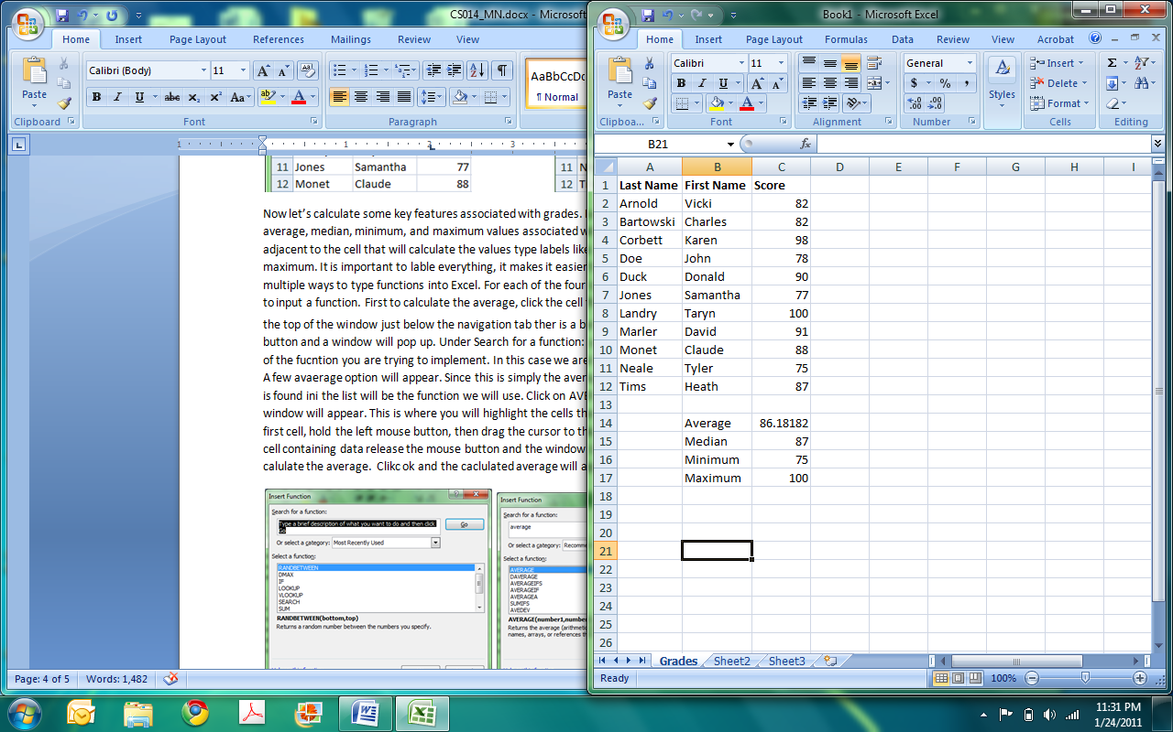

Another function that is useful is a **randomizing function**. Say, for instance that for confidentiality reason each student had to be assigned a random number. In our spreadsheet let’s place the number in a new column to the left of the names. To insert a new column you must right mouse click on the column that you are inserting next to then click insert. A new column will appear. Type a title in the first cell, “random number,” then click on the first cell to hold the random number. After clicking the cell, click the function button (). In the window that pops up, you can type random under the section that asks for a description. A few options will be listed. Sift through them, read their description to see which one is the best option. “RANDBETWEEN” is the function we used for assigning random numbers to the students.

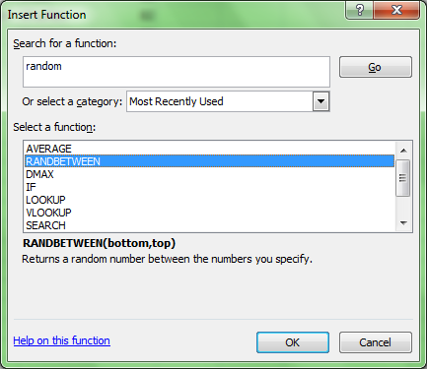

Description of function

After clicking the appropriate function, click okay. The RANDBETWEEN asks for a top and bottom limit to the random number that is placed in the cell. It follows the syntax =RANDBETWEEN(bottom, top). A window should pop up prompting for the top and bottom values. Choose your top and bottom limit (for this spreadsheet, it is 1000-2000). Type these values in appropriately and then click press okay. A random number between your limits should appear in the cell next to the first name on the list, but each student needs a random number. You don’t have to go through that process for each student. All you have to do now is click on the cell that the formula was just put into; the cell will have a black boarder around it (indicating that it is selected). In the bottom right corner of the cell is a small black square.Click this square using the left mouse button, hold the button and drag the square all the way to the last cell that should hold the formula. Once you release the button the cells are automatically filled with a random number.

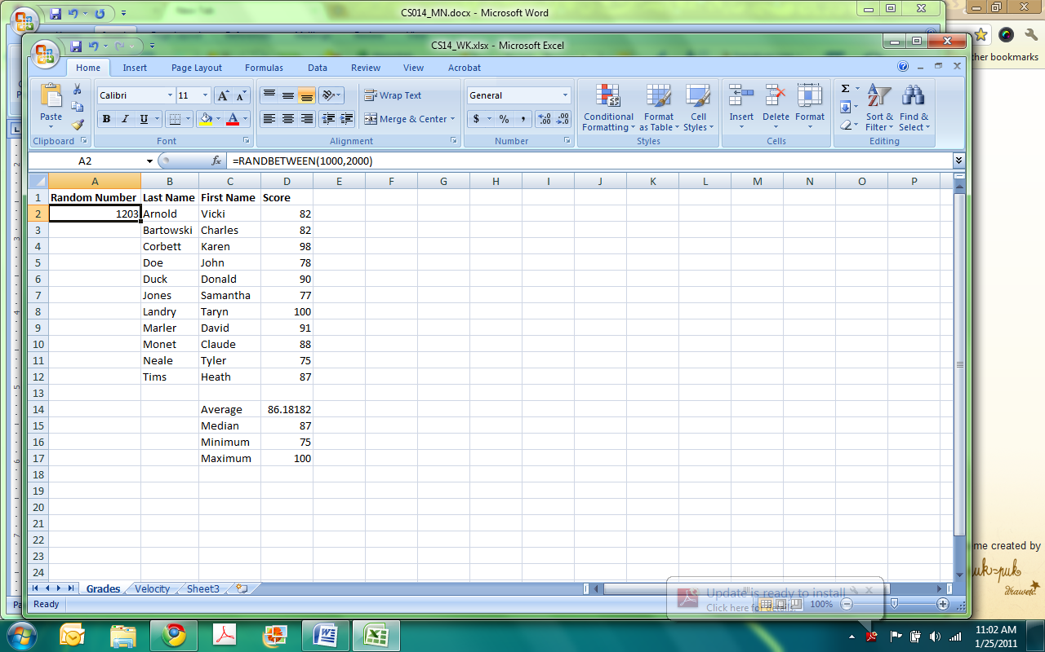

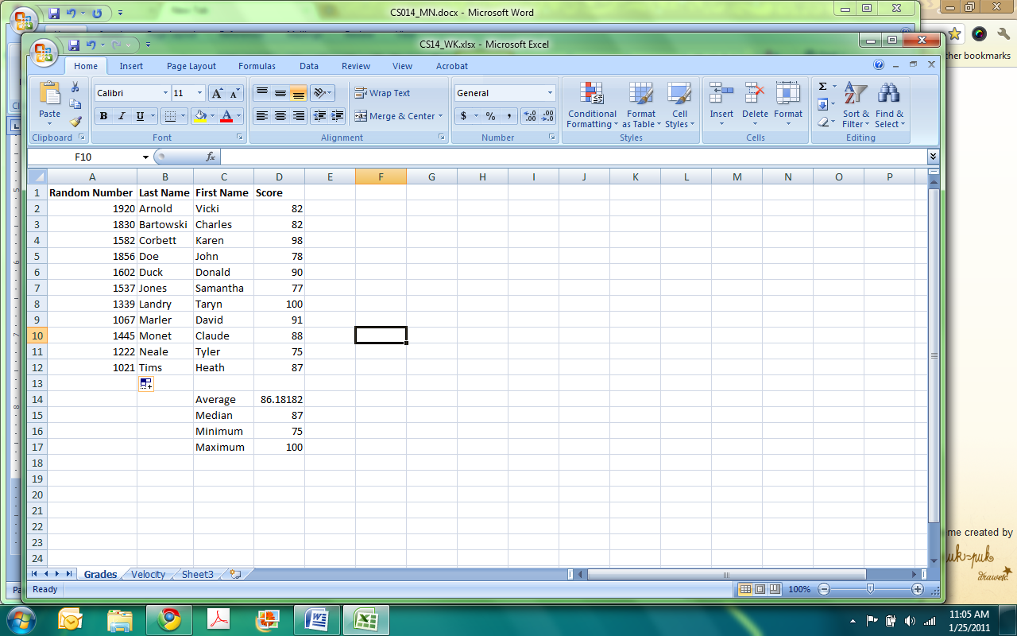

***Plotting in Excel***

Next, move to the velocity spreadsheet (click on the tab at the bottom left named velocity). This spread sheet records, displays information pertaining to an object falling at for 15 seconds and the associated velocity that it falls given the time at which it is falling.

First, label headings including units (this is a good time to tell students of the importance of keeping things neat, organized, and labeled). The time begins from 0 to 15 seconds. In the first cell type a zero, the second cell type a 1, the third cell type a 2. You do not have to continue typing all of the values into the cells up to 15. After you have three values in place, Excel will know that you are putting number in order with increments of 1. Much like the random function from the Grades tab, highlight the three cells that have the values in them, click and hold the little square in the bottom right corner of the cells and drag the cells down until you have the desired number in the cells. This allows you tot easy and quickly **fill in cells**.

Now that you have your time, you want to use Excel to calculate velocity. You do this by **inputting an equation**. The velocity equation is V(t)=Vo+gt, where Vo is the initial velocity in this case 0m/s, g is acceleration due to gravity (9.81m/s2), and t is the time (sec). In the first cell next to time = 0seconds type “=0+9.81*” after the 9.81 click on the cell with time = 0. In the cell with the formula, the cell reference will appear. It will look like =0+9.81*A2. Press enter and the velocity will appear in the cell (it should be 0m/s).

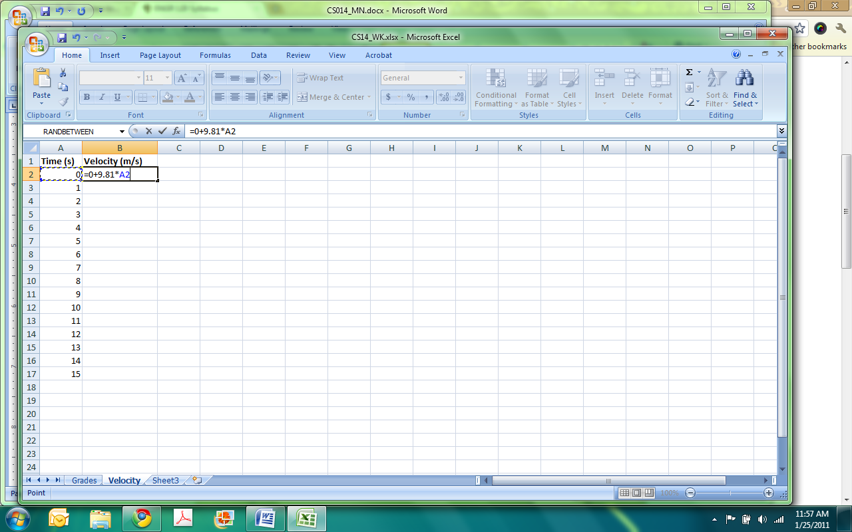

Click on the cell, click on the bottom right square in the cell and drag to fill all the cells below it up to the 15s mark. Release the mouse button and you velocities should be filled in (Note: you don’t have to type 0 for the initial velocity and 9.81 for the acceleration into the equation. You could put them in separate cells and use what is called “absolute reference.” For more information on absolute versus relative referencing, see the Excel Help guide).

Another feature in Excel is **displaying information graphically**. This information is displayed using a scatter plot. To place data in a graph, click on the insert tab at the top taskbar. You want to use a **scatter plot** not a line plot. Click the bottom that is labeled Scatter.

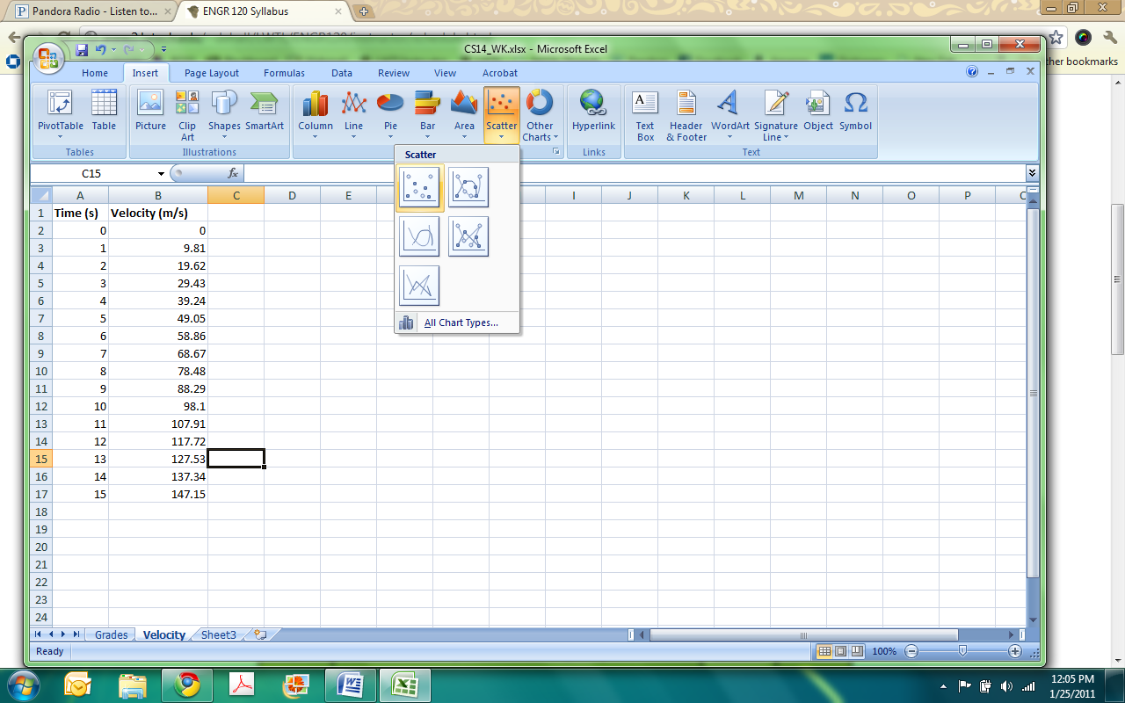

After you click scatter, click on the first scatter plot option (it has not lines just data point). After you click this plot type, Excel will infer what information you want to be in the plot. If it is correctly done, great, but many times it does not grab the right information. If this is the case you want to double click on the plot. In the top of the taskbar there is a button called **Select Data**; click this button.

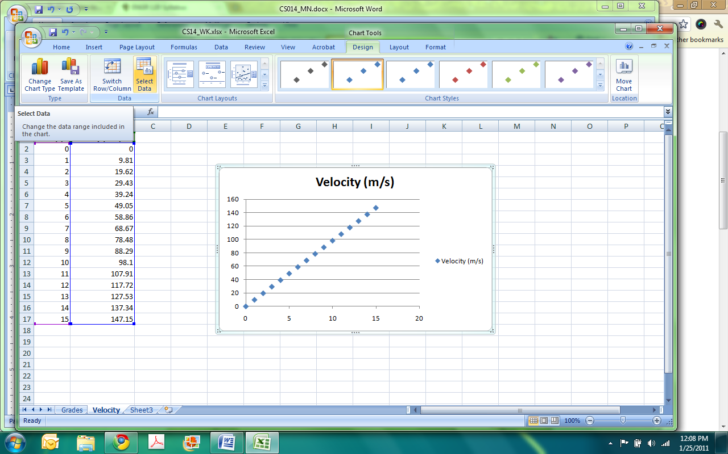

A window will pop up, you should click on the data that in the list of Series and then click the Remove button. Now, you should add the appropriate information, click the Add button. Another window will pop up prompting for the series name. You can call it whatever you want, usually the y-axis vers the x-axis is a good name (Velocity vs Time). Then highlight the cells for the x values (the time values) and do the same for the y values (velocity). Click okay and your plot should be made.

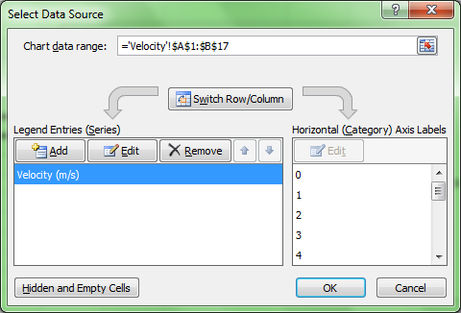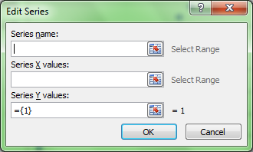

However, you may want to format the plot differently with axes labels, gridlines, etc. Excel has great templates for such formatting. Double click on the plot, the top task bar you should have options for **Chart Layouts** click on some of the various layouts that have shadowboxes of things you would like to see on your plot (Pick different ones see what they do, remember you can always Ctrl+Z). The first one is a good option; it has some gridlines and places for axes labels. Double click the location of the axes label and type the title that it should have. You can also use the **Chart Styles** section in the top taskbar to change colors. Experiment, make you plot look nice, but do not forget its purpose. You want to convey information to a reader; do not make you chart so formatted that it is indecipherable (Note: If you right click on the chart and click on **Format Chart Area…** in the list that comes up, you can do a lot of formatting techniques. Also if you right click on the data points, you can format the points if you click Format **Data Series…** from the list, lick change the marker style).

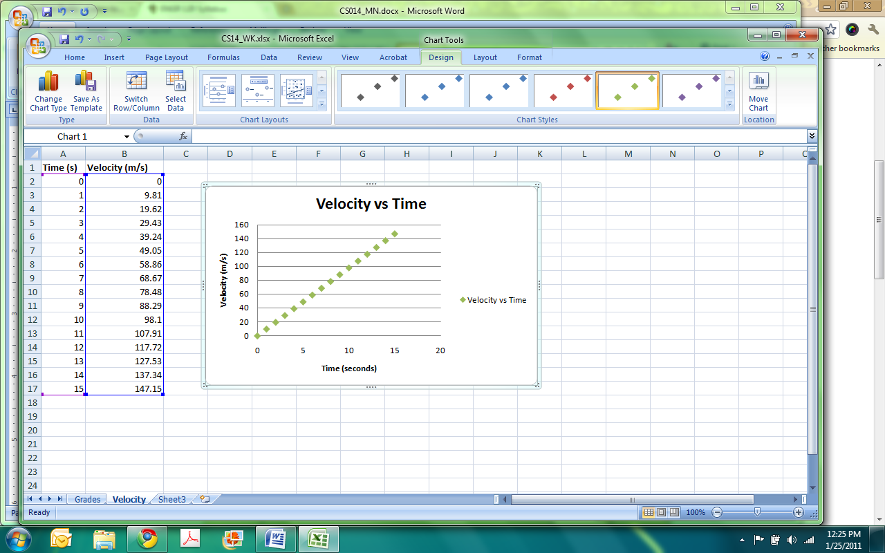

This is a short introduction in how to use MS Excel. Like MS Word and MS PowerPoint, the best way to learn more about word is to click buttons. If you are curious about what a button does just a click it and see what happens. Remember you always have CTRL + Z! Another very useful tip is to utilize the help feature. If you know of something you want to do but are not how to do it click the help button (small question mark button found in the top right hand corner). You can type in keywords into the search feature and it will reveal a list of items associated with the keywords. You should then be able to find how to get done what you wanted.