**Lesson 26: Dead Reckoning**

Needed

* Boe-Bot
* Computer with BASIC Stamp Editor program
* USB cable
* Maze

Today we are going to program the Boe-Bot to navigate through the maze using what is called dead reckoning. Dead Reckoning is the process of estimating current positioning based upon a previous pre-determined set location. Generally stated, when you are programming your Boe-Bot to navigate through the maze you will be estimating its process to reach the ending position based upon the designated starting location.

In order to make the Boe-Bot perform this operation, we must first calibrate our Bot-bots. Calibrating is noting the measurement precisely in relation to a standard measurement. The calibration will be conducted by measuring the Boe-Bot speed and the distance the Boe-Bot travels. Know these components you will be able to obtain the servo run time. This principal is based on the concept that time is equal to distance divided by speed. As it applies to the Boe-Bot equation, we can state:

$$Servo Run Time=\frac{Boe-Bot Distance}{Boe-Bot Speed}$$

Knowing this equation is a big help in understanding what to do for your calibration. If you have your Boe-Bot set next to a ruler you can program the Boe-Bot to travel forward for one second. This will give you the distance and speed that the Boe-Bot traveled. From this information, you can calculate the servo run time for one second of Boe-Bot motion.

Hint: The unit of Boe-Bot speed is the unit of measurement (inches or centimeters) divided by time (seconds).

The following is a program that makes the Boe-Bot move forward for one second. The students can use this for the calibration:

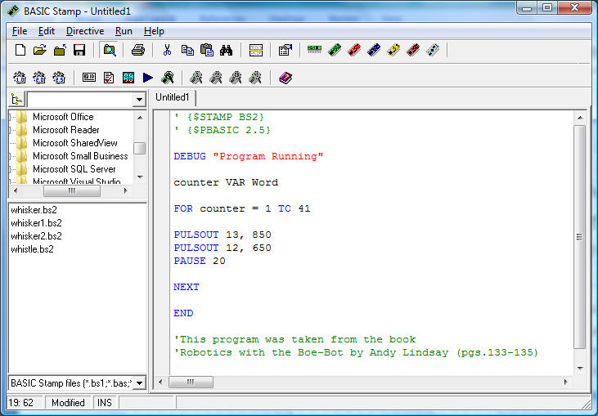

Knowing this information allows you to program your Boe-Bot through the maze. You can figure out how long you need to set the Boe-Bot to travel a certain distance before it needs to change direction, thus, navigating through the maze.

The remaining time in the class will be for calibration and programming the Boe-Bot to navigate through the maze. Reveal the maze to the students; let them take measurements of the turns and distances. Provide them with a sheet identifying the maze dimensions. In four class periods the dead reckoning competition will commence.

Note: Teachers are responsible for making the maze.