**Lesson 30: Dead Reckoning & Photoresistors**

Needed

* Boe-Bot
* Computer with BASIC Stamp Editor program
* USB cable
* Maze

Dead Reckoning Competition

We are going to put your skills to the test to see who was able to most efficiently program their Boe-Bot to navigate through the maze based solely on their ability to estimate an ending location in respect to beginning location through means of calibration. You have a starting location and a set ending location with various turns in between.

General Setup of Maze Competition

* 10 minute testing/refining period
* 20 minutes for every team to run the maze once
  + After first run on maze groups can go back to computers to make necessary adjustments.
* 20 minutes for every team to run the maze again

The winning team will be determined by who reaches the ending location in the fastest time. In the event that no one reaches the ending location, the winner will be the group that travels the farthest in the maze.

*If you have a projector (or even just a computer) in the class**room, you can**navigate to:*

*www.online-stopwatch.com*

*Use the large stopwatch on the projector or computer screen so everyone can see the time for each team’s run.*

Photoresistors

Photoresistors are light dependent resistors (LDR). LDRs have resistance values that vary dependent upon the amount of light that is reflecting off the light detecting surface. In many instances a photoresistor can be used. Some common uses of photoresistors are in camera light meters and street lights. Photoresistors can also be used as a means of providing an input to the Boe-Bot so that a certain output is performed. Photoresistors can be used to aid the Boe-Bot in identifying a path to travel. Next class we will have our Boe-Bots use the photoresistor to measure light intensity which will then tell the Boe-Bot the frequency output it should provide.

Before we begin controlling the sound output due to light intensity, let’s look quickly at the circuitry behind the photoresistor setup. The following schematic applies to the pohotoresistor circuitry. Students should create this circuit on their Boe-Bot breadboards.

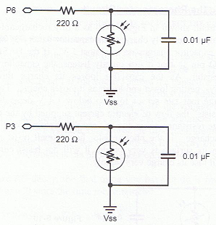

This symbol represents the photoresistor. Another unfamiliar symbol, , represents a capacitor. Capacitors are mainly used to store charge. There are many sizes of capacitors; knowing the right one to use is important. Capacitance is represented in units of Farads. For the purpose of our class, capacitors of degree Farads(F) are too large for practical use with the Boe-Bots. Therefore, we will use capacitors containing a fraction of the Farad to the millionth degree, a microfarad (µF). For the above schematic a 0.01μF capacitor is used.

In order to use the photoresistor to make the Boe-Bot perform a function, the programming must be such that the capacitor conducts a sequence of charging and discharging. In order to do so the command utilized is the RCTIME command. The syntax for the command reads as follows.

RCTIME Pin, State, Duration

Dissecting the syntax, the pin represents the pin at which the circuit is connected to and is being measured. The state will either be a 1 or 0. If the state is a 1, then the voltage across the capacitor starts at a value greater than 1.4V and will decay. On the other hand, if the state is indicated as a 0, then the voltage across the capacitor is less than 1.4V and will show growth upward. The duration is the variable that will store the time that is being measure. This time measurement will be stored in units of 2µs.