**Lesson 30: Dead Reckoning & Piezospeakers**

Needed

* Boe-Bot
* Computer with BASIC Stamp Editor program
* USB cable
* Maze

Dead Reckoning Competition

We are going to put your skills to the test to see who was able to most efficiently program their Boe-Bot to navigate through the maze based solely on their ability to estimate an ending location in respect to beginning location through means of calibration. You have a starting location and a set ending location with various turns in between.

General Setup of Maze Competition

* 10 minute testing/refining period
* 20 minutes for every team to run the maze once
  + After first run on maze groups can go back to computers to make necessary adjustments.
* 20 minutes for every team to run the maze again

The winning team will be determined by who reaches the ending location in the fastest time. In the event that no one reaches the ending location, the winner will be the group that travels the farthest in the maze.

*If you have a projector (or even just a computer) in the class**room, you can**navigate to:*

*www.online-stopwatch.com*

*Use the large stopwatch on the projector or computer screen so everyone can see the time for each team’s run.*

Piezospeakers

Next class we will implement a photoresistor circuit, which will be discussed next class, in conjunction with a piezospeaker to have the Boe-Bot change frequency output based upon the amount of light intensity the photoresistor detects. In order to complete this task, lets first look at the piezospeaker circuit. Students can install the circuitry while each component is being discussed.

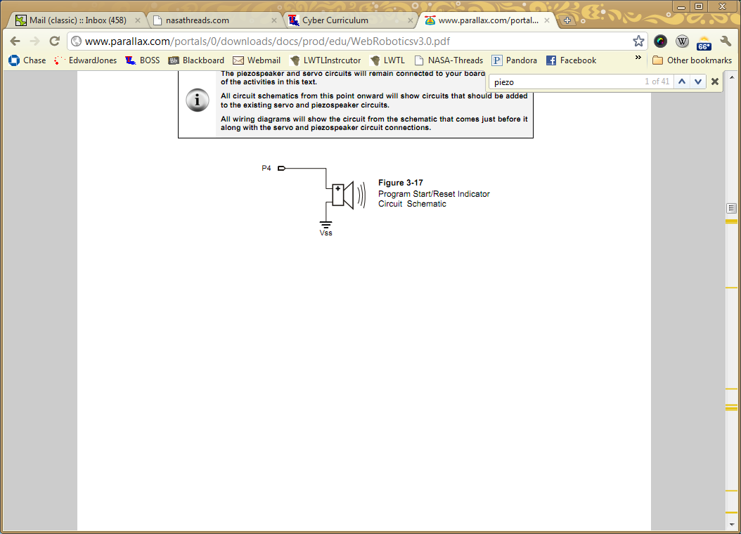

Piezospeaker symbol

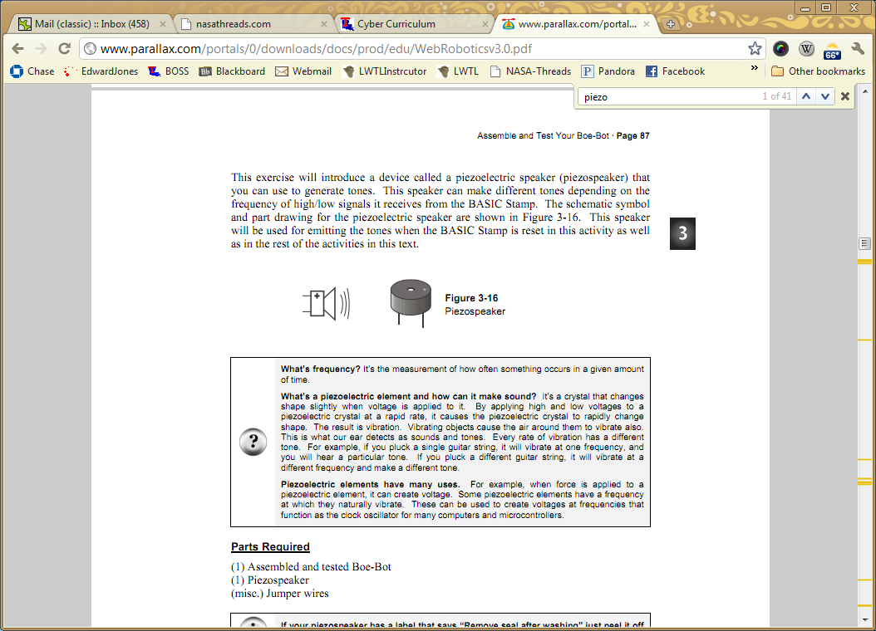

The circuitry is quite simple, the only components are the piezospeaker and jumper wires. The key to successfully building the circuit is proper placement of the jumper wires. In the Boe-Bot kit the piezospeaker may have a white sticker on the top of the speaker, if so, have the students peel the sticker off and discard. Notice at the top of the speaker there is a plus sign etched into the speaker. This plus sign will guide the building process of the circuit. Have the students follow the circuit schematic. Chose a pin (the schematic shows pin4), make sure the jumper wire connecting the pin to the piezospeaker connects to the pin on the piezospeaker that is associated with the plus sign on the top of the speaker. The jumper wire connecting the speaker to ground (Vss) must come from the opposing pin, opposite the plus sign, on the piezospeaker. Once this is successfully completed the circuit is built. Students should test that they have the circuitry build properly using a FREQOUT command. The FREQOUT command follows the syntax:

FREQOUT Pin, Duration, Freq1

Where the Pin is the number of the pin that the circuitry is connected to (schematic pin4), duration is how long the high/low signals will last in milliseconds, and Freq1 is the frequency output of the speaker in Hertz.

Have the students connect the Boe-Bots with the piezospeaker circuit to their computers and test the speakers by typing FREQOUT Pin, 2000, 3000. If the piezospeaker works the circuit is installed properly, If not, the students most likely do not have the jumper wires in the correct position. Change the duration values and frequency values to see how different numbers affect the output of the piezospeaker.

If possible, have the students leave the piezospeaker circuit set up on their Boe-Bots.