**Lesson 35: Photoresistors**

Needed

* Boe-Bot
* Computer with BASIC Stamp Editor program
* USB cable
* Jumper wires
* 0.01μF capacitors
* 220Ω resistor
* Poster with Black Line

Following a Line with Two Photoresistors

In four class periods, students will compete in a task that requires their Boe-Bots to use photoresistors to navigate over a black line. Introduce the task to the students here. Throughout the week students can work on their program and be ready to make their Boe-Bot complete the task in four classes.

The task follows the below procedure:

1. Students should install a second photoresistor circuit as shown in the below schematic (they can remove the piezospeaker now if they want).

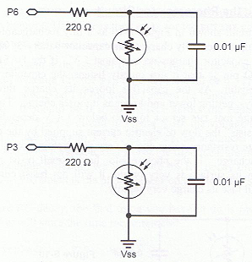 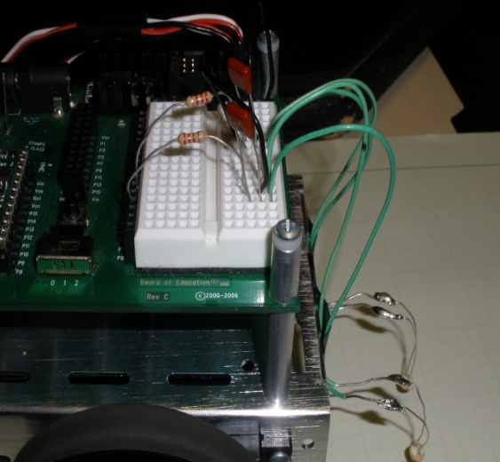

**Teachers:** Our intention here is that prior to this class you would have constructed this course for the students. A suggestion is to use white poster board material as the base for the course. The bright with color of the boards will provide a good contrast and will make it easier for the Boe-Bot to stay on task.

1. Obtain a course made from black electrical tape that is intended for the Boe-Bot to follow. It must be a continuous line. A suggestion is to Use 3-4 lines of tape to make the line wider. This will help in navigation. The line should have at least one straight section, one right turn, and one left turn.
2. Calibrate your Boe-Bot to the light reflected by the tape and the light reflected by surface the course is mapped out on.
3. Place the Boe-Bot with both photoresistor over the line of tape and run same calibration program from the following a flashlight activity. Record the values of timeLeft and timeRight.
4. Place the Boe-Bot with both photoresistor over the floor or table. Record the values of timeLeft and timeRight
5. Average the two values for each photoresistor.
6. This value will be the constant value for the left and right (similar to the light intensity frequency program).

**Teachers:** Because you will have the students working on the calibration at the same time, it might be helpful to provide each student/student group with a small sample of the course. For instance cut out pieces of a poster board and have the students place some black electrical tape on the poster board for their calibration. It is important that the calibration is performed on as similar of a surface as the actual course so that no other influences are introduced during the calibration. To expand on this, if the students were to perform the calibration on a dark wooden desk and the course is on poster board then the Boe-Bot would not perform the operation properly, because it would be reading the light differently.

1. Write a program that will make the Boe-Bot follow the line on the course. The program should resemble the frequency due to light intensity program. For this activity however, the Boe-Bot is following the darkness instead of outputting a frequency due to light intensity.

Important Questions/Hints for the Program:

* Does the fact that the Boe-Bot is following the darkness instead of the brightness affect the inequality signs in the IF/THEN statements?
* How does it affect the direction the Boe-Bot turns when the light changes?
* Examine the two situations and find the differences between them?
* Reflect these differences in your program and the Boe-Bot will follow the line.

Have the student groups compete with their peers to see whose program navigates over the line the fastest. Use the rules similar to that of the dead reckoning competition. For an extra challenge have the students use only one sensor to navigate over the line.