**Lesson 36: Whisker Navigation**

Needed

* Boe-Bot
* Computer with BASIC Stamp Editor program
* USB Cable
* 2 – Whisker Wires
* 2 - 220Ω 2 – 10kΩ Resistors
* 2 – 7/8” Screws
* 2 – ½” Spacers
* Nylon washers
* 2 – 3 pin Headers
* Jumper wires

Whisker Circuit

Recall the whisker circuit from earlier in the class. Essentially the whiskers are a switch that can turn a circuit on and off. In particular, the whiskers are tactile switches; they use touch to turn on and off. There are many uses for tactile switches from simply counting objects on a production line to what we will be using them for: autonomous navigation.

Using the book Robotics with the Boe-Bot that came with your Boe-Bot kit, follow the instructions on assembling the whiskers (Chapter 5 pg. 166-167). Once the whiskers are connected onto the Boe-Bot, the circuitry associated with the whiskers can be assembled. Below is a diagram of the whisker circuit, Figure 1. Using Figure 1, create the circuit on your Boe-Bot breadboard.

 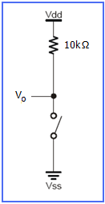

**Figure 1:** Diagram of Whisker Circuit **Figure 2:** Single Whisker

Once you finish the whisker circuit assembly, run the following program. This will check if your whisker circuit is functioning properly. The program specifies that pin 5 and 7 are input pins by IN5 and IN7. The BIN1 is a formatter within the BASIC Stamp that tells the Debug Terminal to display values as 1 or 0 (on or off).

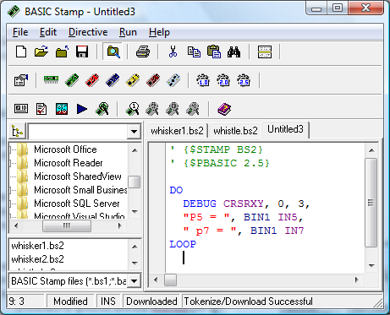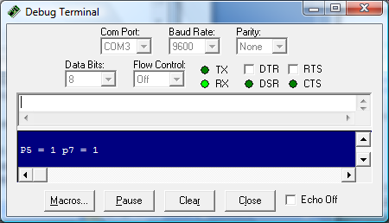

Whisker Navigation

Earlier we mentioned that for our class we will be using the whiskers as a navigation tool. In order to do this, we need is to be able to use the tactile ability of the whiskers to process being touched and then change the Boe-Bot motion. This might sound difficult, but we are already half way there! We have already created a program that shows that the BASIC Stamp can detect when a whisker is being pressed. Now we need to write the program that can take that information and process it to change the Boe-Bot motion, thus, navigating by touch autonomously.

How do we make the BASIC Stamp process the touch and then change motion? We will have to use what is called an IF…THEN statement. This command allows the BASIC Stamp to make decision “if a certain condition, then do an action, else if a different condition, then perform a different action” and so on till you end the IF statement. Thus, the syntax for the command is:

IF (condition) THEN…{ELSEIF (condition)}…{ELSE}…ENDIF

Understanding the IF…THEN statement is important. It is a very useful programming tool that can be used in many different applications. For example, automated telephone calls use IF…THEN statements: for directions in English press 1, for directions in Spanish press 2. This is basically an IF…THEN command. IF 1(English) THEN go to directions in English, ELSEIF 2 (Spanish) THEN go to directions in Spanish, and so on.

Let’s put this program into our BASIC Stamp to see how the IF…THEN statement helps us navigate the Boe-Bot using the whiskers.

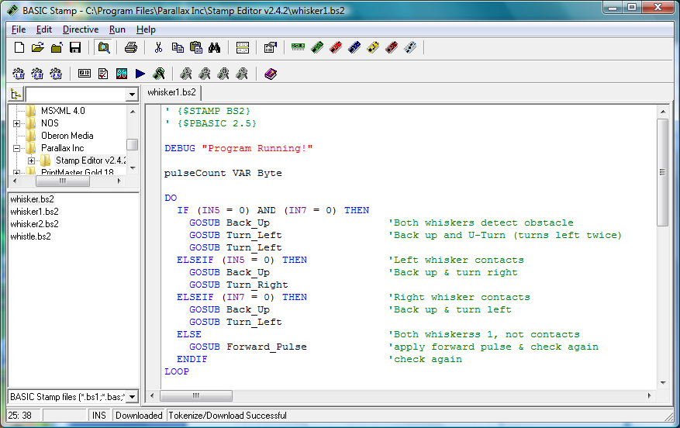

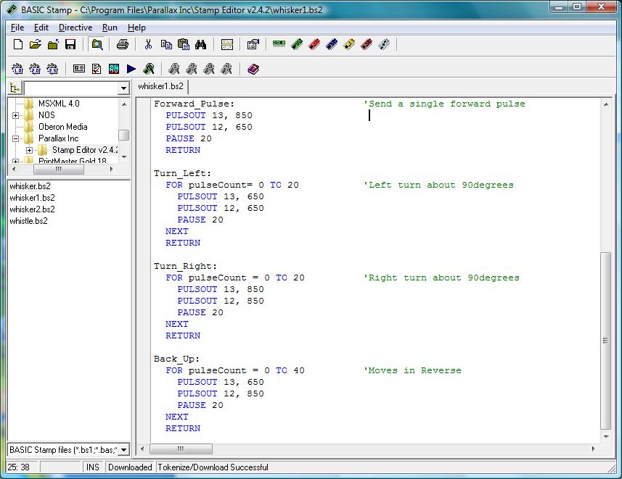

**Teachers:**

You might give the students just the program without the comments and have them comment their own programs. This will help to enforce how the IF…THEN statement works and ensures that the students understand the program. Also note that this program calls for subroutines. Students should be able to write these themselves. So you could just give them the top half of the program.

Students can use this program as a starting point for the whisker navigation program. Have student complete the whisker navigation program so that the Boe-Bot navigates through the maze (you can use the same maze as the Dead Reckoning program). Before the class is over, students should have their Boe-Bots complete the maze. You can use the rules similar to the Dead Reckoning completion (see Class 30 notes).