**Lesson 55: Keypad II**

Needed

* Boe-Bot
* Computer with BASIC Stamp Editor program
* USB cable
* 10kΩ resistors
* Jumper wires
* Push buttons
* LEDs

Keypad

In lesson 51, student broke the codes to a keypad created by the instructor. They should have also begun building the circuitry for their own keypads and possibly even begun the programming of the keypads. Once their keypad codes are complete, the students should begin working on a separate program that allows them to hook another Boe-Bot up to the keypads and will run through the various code options eventually breaking the codes. Once students have perfected the breaking of the code using another Boe-Bot they should switch Bots with classmates and try to use their code breaking Bot to break their peers’ codes (since this lesson requires two Boe-Bots, it is encouraged that the students work in teams of two, using one Bot for the keypad and the other Bot for the code breaking Bot).

For programming and circuitry building assistance refer back to Lesson 51.

A few hints to give the students:

1. The program should be set such that it runs through all possible combinations of codes. A staggering for loop is a great way to have a program run though the all combinations (see solution).
2. Make sure a delay is put in so that when a pin is turned on you allow the microcontroller time to read that it is on and also that it is turned off (much like pushing a button on and then releasing it).
3. Remember that creating messages through out your program using the debug screen can help keep track of what your program is doing. It might be useful to have the program debug all the numbers being attempted. This will help ensure that the program is coded such that no combinations are skipped.

(Solution can be found at the end of this document)

How to connect the Boe-Bots

The connecting of the Code Breaking Bot to the Keypad Bot is quite simple. You want to connect the pins of the Code Breaking Bot with the corresponding pins of the keypad Bot (Pin 1 on the Code Breaking Bot should be connected to Pin1 of the Keypad Bot, Pin 2 of the Code Breaking BOt should be connected with Pin 2 of the Keypad Bot and so on). Thankfully the board on the Bots have two locations for pin inputs. This way you will not have to try and put two wires in one of the breadboard holes, refer to picture. Also, because the green LED on Keypad Bot indicates a correct code combination, the Code breaking Bot needs to know when this LED is lit. So a wire must be connected from the pin associated with the green LED on Keypad Bot to the same pin on the Code Breaking Bot. And Finally, an additional wire that HAS to be connected is the common ground wire. You simply connect one wire from the Vss of the Code Breaking Bot with the Vss of the Keypad Bot.

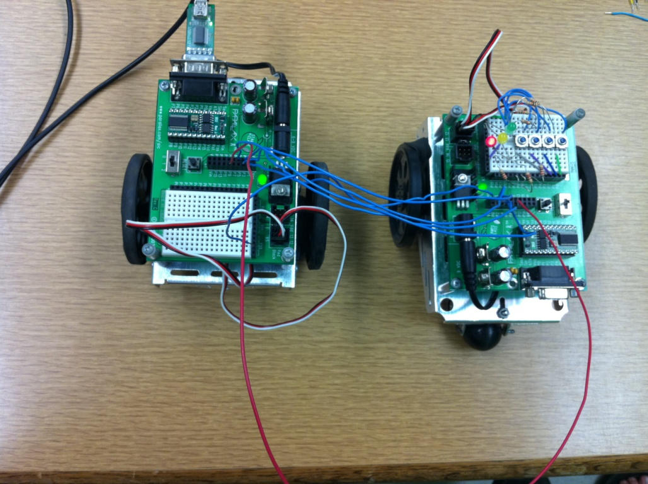 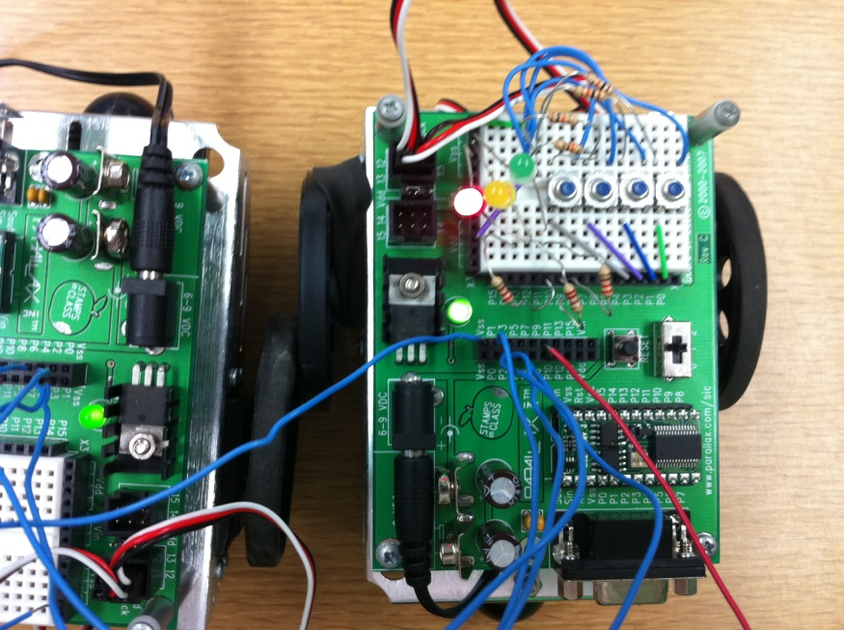

Code Breaking Solution

' {$STAMP BS2}

' {$PBASIC 2.5}

GREEN_LED PIN 9

a VAR Byte

b VAR Byte

c VAR Byte

d VAR Byte

sit VAR Byte

sit = 200

FOR a = 1 TO 4

FOR b = 1 TO 4

FOR c = 1 TO 4

FOR d = 1 TO 4

GOSUB check

NEXT

NEXT

NEXT

NEXT

END

check:

' Push and release a

HIGH a

PAUSE sit

LOW a

PAUSE sit

' Push and release b

HIGH b

PAUSE sit

LOW b

PAUSE sit

' Push and release c

HIGH c

PAUSE sit

LOW c

PAUSE sit

' Push and release d

HIGH d

PAUSE sit

LOW d

PAUSE sit

IF IN9 = 1 THEN

DEBUG CLS, "Code Found = ", DEC a," ", DEC b," ", DEC c," ", DEC d

ELSE

DEBUG CLS, "Trying = ", DEC a," ", DEC b," ", DEC c," ", DEC d

RETURN

ENDIF

