Lesson 5: Boe-Bot Motion
Needed
- Boe-Bot
- Computer with BASIC Stamp Editor program
- USB cable
Today we are going to make our Boe-Bots move. Before we can program the Boe-Bot to move, we must first understand some of the mechanics behind the Boe-Bot motion.

First, let’s look at the servos. A basic diagram of the servo is shown below. It illustrates the external component of the servo.
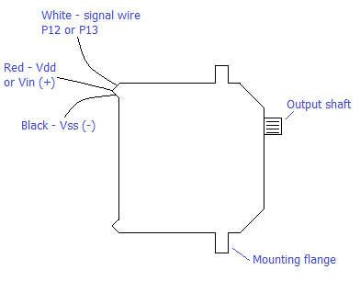
Three main components that make up the servo:
- Small DC motor
- Gear Box with small plastic gears to reduce the RPM and increase output torque
- Special electronics inside the servo interpret a pulse signal and deliver power to the motor

For this lesson, we will focus more on the third component in the servos: the electronics. In later lessons, we will go into more detail about the DC motor and the gear box.

As mentioned earlier, the servo contains special electronics that interpret a pulse signal and deliver power to the motor. There are two types of servos:
- Standard servo: the pulse signal tells the servo what position to hold.
- Continuous servo: interprets the pulse signal to spin a certain direction and the speed at which to spin.
The standard servo is useful for positioning an object, but has very limited rotational motion. Thus, we will be using a continuous servo.

The pulse signal that controls the servo is represented by the graph below. As you can see, the graph plots voltage versus time. In a full speed rotation, the pulse width will vary between 1.3 ms and 1.7 ms depending if the shaft is spinning clockwise or counterclockwise, respectively. It is also important to note that between pulses there is a 20 ms time elapse.
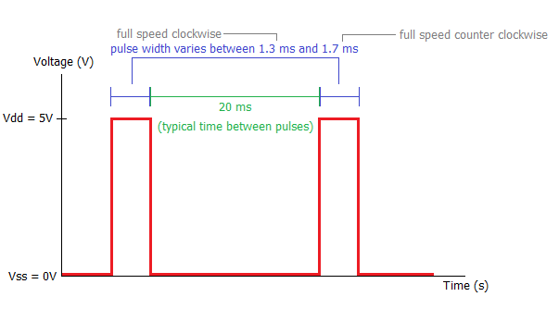
In order to control the motion of the Boe-Bot, you have to set the pulse using the Basic Stamp Editor program. The following command is used:
PULSOUT 12, 650
It indicates that 12 is the pin number the servo is attached to and 650 is the pulse duration. An important note is that when specifying the duration in our program, the value placed in that section is representing the number of 2 μs intervals. 650 times 2 μs = 1300 μs, or 1.3 ms, the value for a full speed clockwise.

A similar command is:
PULSOUT 12, 850
It indicates that the servo is attached to pin 12, and the duration is specified to be 850 times 2 μs or 1.7 ms.

Generally the command is: PULSOUT pin, duration.

What if we wanted to change the speed of the motion? We would have to manipulate the pulse duration.
Duration | Pulse Width (ms) | Servo Action
650 | 1.3 | Full Speed CW
700 | 1.4 | ½ Speed CW
750 | 1.5 | Stopped
800 | 1.6 | ½ Speed CCW
850 | 1.7 | Full Speed CCW

Hands On
Let’s look at this program that makes a Boe-Bot move forward at full speed and then sharply turn left:
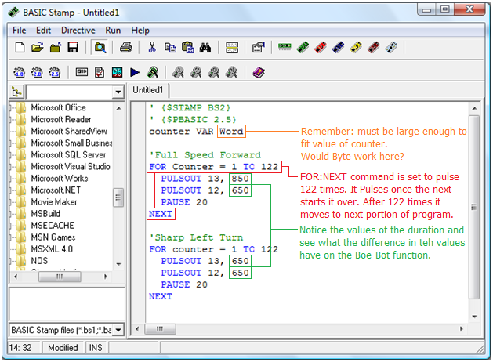

Put this program into your BASIC Stamp Editor and experiment with the duration and counter components of the program.

Now that you have a program that can move forward full speed and make a sharp left turn, try to add to this program so that you make your Boe-Bot reverse and turn sharply right.

Solution:
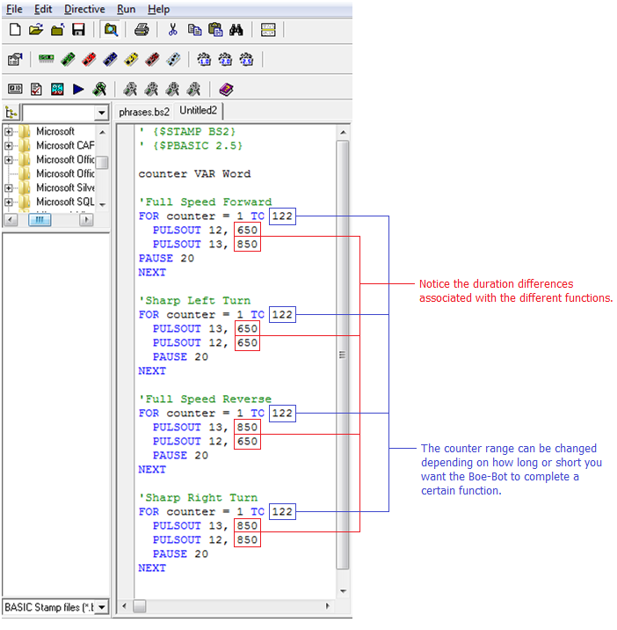

Activity – Maneuver around a Pencil
This activity will require the Boe-Bot to perform a simple forward and turning motion. Try to make the Boe-Bot move around a pencil (this project should be done in teams of two).

Setup: Clear everything from your table except a Boe-Bot and a laptop for each group. Place two books (or notebooks) on the table 11 inches apart (the length of a standard sheet of paper) near one edge of the table.

Objective: Program your Boe-Bot to leave from a starting point between the notebooks and around the pencil. Return to the area between or behind the notebooks and stop before running off of the table. Use subroutines for the various moves (forward, left turn, etc.). Have the instructor check to see that your program is working before leaving class. If you do not finish in class, you can complete the program at home for homework. If you have to do it for homework, the project can become an individual assignment.

Suggestion: Have your students create a flow chart of the needed motion for the Boe-Bot to complete the task.

