Loop Structures
In previous lectures, we talked about basic control flow concepts. For example, we discussed the functionality and syntax of decision making via an IF statement. Remember that an IF statement allows us to perform some action depending on the value of a variable and directly correlates to the diamond in flowcharts:

IF someVariable > 5 THEN
' do something
ENDIF

We also looked at a variety of extensions to the IF statement that allow alternative cases. In the following example, we “perform action a” if someVariable is less than 5 and “perform action b” otherwise:

IF someVariable < 5 THEN
' perform action a
ELSE
' perform action b
ENDIF

In the following example, we “perform action a” if someVariable is less than 5, “perform action b” if someVariable is equal to 5, and “perform action c” otherwise:

IF someVariable < 5 THEN
' perform action a
ELSEIF someVariable = 5 THEN
' perform action b
ELSE
' perform action c
ENDIF

So far, this is pretty basic. But we may want to perform a task in our programs more than one time. For example, we might want to move our Boe-Bots forward many times before making a right-hand turn. To accomplish this, we introduce loop structures that provide a method for us to perform the same task many times without having to explicitly program that task over and over again. PBASIC provides a number of different loop structures to help us with this kind of task

The FOR loop is used to execute a task a fixed (or known) number of times. For example, suppose we wish to find and display all the prime numbers from 2 to 9. We can easily figure out what they are ourselves (2, 3, 5, and 7). Remember that a prime number is a number that is only divisible by 1 and itself. The first prime number is 2. To accomplish this task, we first want to select the number 2, determine if it is prime, and display it if so. Then we want to pic the number 3 and do the same thing again. We keep going, selecting the number 4, then 5, all the way through to the number 9. At this point we don't care how we programmatically check if a number is prime, but one way to accomplish this task is as follows (remember, we first devise a solution using a flowchart; then we “translate” that to PBASIC):
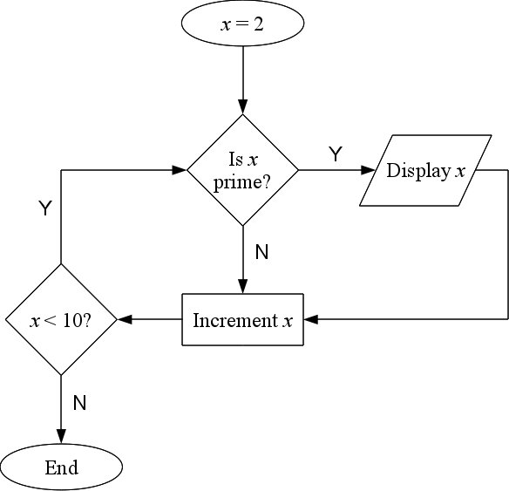
In PBASIC:

FOR x = 2 TO 9
' check if the number is prime
NEXT

Notice that we use the variable x to iterate over all the numbers from 2 to 9 (inclusive). This for loop will execute exactly 8 times.

What if we have no idea how many times we wish to perform a specific task? We might want to perform the task until some condition is true or false. Or while a condition is true or false. PBASIC provides another loop structure called REPEAT-UNTIL to allow us to repeat a task until a condition is true. Suppose the task is to mix some soup until it is thoroughly mixed. A flowchart for a solution to this problem might look like the following:

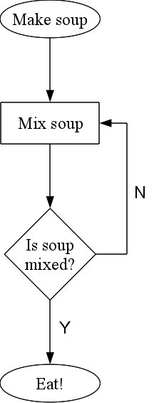
In PBASIC, REPEAT-UNTIL looks like the following:

x=1
DO
x = x * 2
LOOP UNTIL x >= 10

How many times will this loop execute? Remember that x is initially assigned the value 1. Each time we “enter” the loop and a task is performed, x is doubled. The first time it is doubled, it is assigned the value 2; the next time, the value 4; and so on. In total, this loop will execute 4 times. Notice that the REPEAT-UNTIL ensures that we execute the tasks within the loop at least one time!

Similar to the REPEAT-UNTIL is another loop structure called the DO-WHILE. We can think of it as the reverse of a REPEAT-UNTIL in that instead of repeating a task until some condition is true, we repeat a task while some condition is true. For example, suppose that the task is to heat some soup. Clearly, we want to keep heating the soup while it is cold. A flowchart of a solution to this problem is as follows:

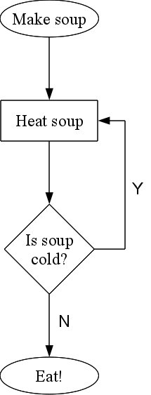
In PBASIC the DO-WHILE loop structure looks like this:

x = 1
DO
x = x + 1
LOOP WHILE x < 10

In this example, how many times are the statements in the loop executed? The answer is 9 times.

Again, note that the statements within the loop will be executed at least once. But what if we don't necessarily want to execute the statements one time. We may wish to test the condition prior to executing any statements. For this, PBASIC provides another loop construct called the WHILE-DO. As in the DO-WILE, it is used to repeat a task while some condition is true, but it is possible that the task may never be executed at all! Take a look at this example where, again, the task is to heat some soup:

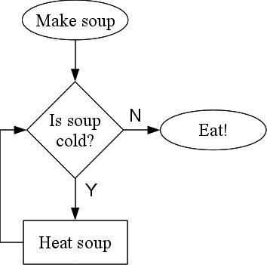
Notice that we are checking the condition (is soup cold?) before we perform the task of heating the soup. In PBASIC, the WHILE-DO looks like this:

x = 1
DO WHILE x < 10
x = x + 1
LOOP

How might we modify the WHILE-DO code above so that the statements in the loop are never executed? One way is to change the initial value of x. This does not work the same as with the DO-WHILE construct. What is the difference between the following two snippets of code?

x = 10 x = 10
DO WHILE x < 10 DO
x = x + 1 x = x + 1
LOOP LOOP WHILE x < 10

In the code on the left, the value of x after the loop is 10. In the code on the right, it is 11. Why is that?

So loops allow us to perform the same task over and over again either (1) a fixed (or known) number of times; (2) until some condition is true; or (3) while a condition is true. We can also control if the task is performed at least once by using either the REPEAT-UNTIL or the DO-WHILE constructs.

Subroutines
Suppose we want to make our Boe-Bot go forward a little, make a right-hand turn, then go forward a little more. We might code the solution like this:

FOR x = 1 TO 40
PULSOUT 13, 850
PULSOUT 12, 650
PAUSE 20
NEXT
FOR x = 1 TO 20
PULSOUT 13, 850
PULSOUT 12, 750
PAUSE 20
NEXT
FOR x = 1 TO 40
PULSOUT 13, 850
PULSOUT 12, 650
PAUSE 20
NEXT

Note that your pins and frequency values may differ. Now suppose that we want to perform the exact same action (forward a little, right-hand turn, forward a little more) later in our program. We would have to insert the exact same code a second time. And if we wanted to perform this task even more times, we would have to insert the code at a lot of different places in our program. That's a lot of redundancy and a waste of space. To help us deal with this situation, PBASIC allows us to encapsulate a series of tasks (or statements) into a unit called the SUBROUTINE. Every subroutine has a name that we use to call it into action when we need to perform the task. The action of performing the task or calling a subroutine is possible by using the GOSUB keyword which stands for “go to subroutine.” Once the subroutine is executed, we RETURN from it back to our program. RETURN is another keyword in PBASIC that lets the microcontroller know to go back to the instruction after the subroutine was called.

For the previous example of forward-right-forward, we might call one subroutine FORWARD and another RIGHTTURN. Using subroutines, our program might look like this:

FOR x = 1 TO 40
GOSUB FORWARD
NEXT
FOR x = 1 TO 20
GOSUB RIGHTTURN
NEXT
FOR x = 1 TO 40
GOSUB FORWARD
NEXT

FORWARD:
PULSOUT 13, 850
PULSOUT 12, 650
PAUSE 20
RETURN

RIGHTTURN:
PULSOUT 13, 850
PULSOUT 12, 750
PAUSE 20
RETURN

Note that subroutine names are followed by a colon (:) and that every subroutine ends with the keyword RETURN.

So subroutines are very useful to us, particularly when we need to repeat the same task many times. In general, they are used to group a set of instructions.

Problem Solving
If you were asked to solve the problem of determining which numbers from 2 through 9 are prime, how might you go about doing that?

[Let the students provide their solutions briefly. Entertain some of them if applicable.]

One way might be to try to divide the number we want to check if prime by every number from 2 to one less than it. For example, to determine if 7 is prime, we would divide it by 2, 3, 4, 5, and 6. If any of these numbers divides it evenly (without a remainder), then 7 is not prime. Of course, we know that 7 is prime because none of those numbers divides it evenly; every time, we have some remainder. There are other (more complicated) approaches to solving this problem, but the point is that, given a problem, how might we go about solving it?

In order to do that well, we must first understand the problem. If we do not, then how could we possibly ever solve it? Suppose the problem were to find the birth date of the youngest person in the room? What is the problem?

[Let the students provide their versions of what they think the problem is. Entertain some of them if applicable.]

Note that we're not trying to find the youngest person in the room. The problem is asking us to find the birth date of the youngest person in the room!

How would you solve this problem?

[Let the students provide their solutions briefly. Entertain some of them if applicable.]

There are many approaches to solving this problem. For example, we might have every student write his or her birth date down. Then we might look at all the birth dates and eliminate those that have a lower or smaller year (e.g. 1985 is lower than 1990). Then we could eliminate the birth dates with the same year whose month is lower (e.g. January is lower than August). Finally, we could eliminate the birth dates with the same month whose day is lower (e.g. the 3rd is lower than the 27th). Ultimately, we would be left with the birth date of the youngest person in the room.

Another approach might be to sort the dates first in descending order by year, then month, and finally day. A list of 5 students' birth dates might look like this:

March 15, 1994
June 7, 1995
December 22, 1995
June 13, 1995
January 20, 1994

And sorted, they would look like this:

December 22, 1995
June 13, 1995
June 7, 1995
March 15, 1994
January 20, 1994

And then we would pick the one on top: the birth date of the youngest student in the room.

But these example solutions are not necessarily the most efficient ways of solving the problem. For example, we could ask each student, one at a time, his or her birth date. Each time, we only keep track of the birth date that is more recent (i.e. of the younger student). Once we've asked all the students, we are left with a single birth date (the most recent one). Therefore we have found the birth date of the youngest student in the class! Let's take a look at a flowchart for this solution to the problem:

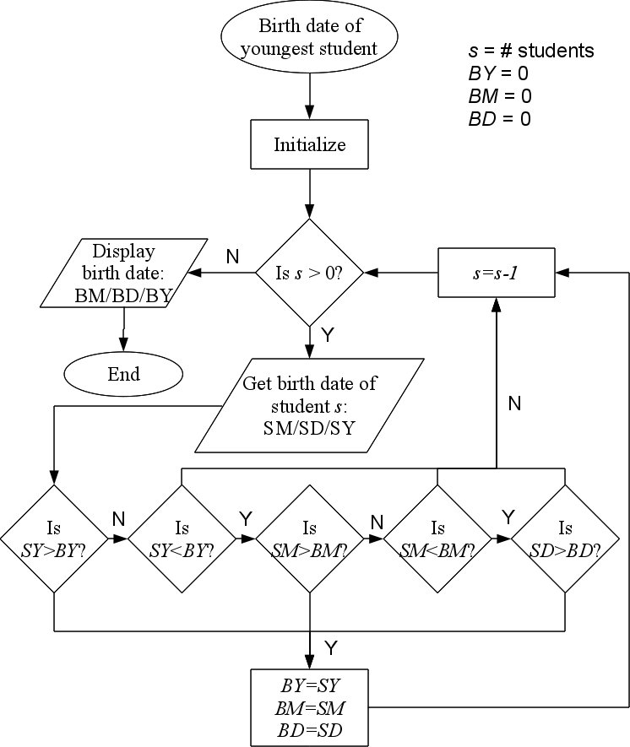
In this flowchart, BY, BM and BD are “best year,” “best month,” and “best day” respectively. Also SY, SM and SD are “student year,” “student month,” and “student day” (for each student) respectively. The strategy is to ask each student, one at a time, their birth date. We “store” this information into the variables SY, SM and SD. We compare these to BY, BM and BD to determine which is the more recent birth date. If the current student has a more recent birth date, we store SY, SM and SD into BY, BM and BD (i.e., we have found a more recent birth date and thus a younger student). We continue with the next student; and so on until we have asked every student for his or her birth date. In the end, the birth date of the youngest student will be stored in BY, BM and BD.

[Go through the flowchart with a few students to see how it works.]

LED/Whisker Binary Counter
For this project, we are interested in using the Boe-Bot as a visual binary counter. Its whiskers will be used as inputs to either increase or decrease the current value. A series of 8 LEDs will be used to display the current value in binary. When we push one of the whiskers (let's say the left one), that should increment the value (a variable in our program) by 1. Pushing the right whisker should decrement the value by 1. Subsequently, we want to output this value in binary by lighting a series of 8 LEDs in a row. The 8 LEDs form a series of 8 bits. For example, to display the number 1, we simply have to “light” the right-most LED (the 8th LED) in the 8-LED series. Which LEDs would need to be lit to display the number 9?

[Let the students provide their input.]

To display the number 13 (00001001 in binary), we would have to light the 5th and 8th LEDs.

How would we display the number 255?

[Let the students provide their input.]

To display the number 255 (11111111 in binary), we would have to light all of the LEDs.

How would we display the number 0?

[Let the students provide their input.]

To display the number 0 (00000000 in binary), none of the LEDs would be lit.

Each time we push on the left whisker, the value should increment by 1 and should be appropriately displayed using the LEDs. Each time we push on the right whisker, the value should decrement by 1. What might happen if the number displayed is 255 and we push on the left whisker to increment the value by 1? How might we handle this event?

[Let the students provide their input.]

There are a variety of ways we might handle this case. We could, for example, simply ignore any increment if the value is 255. Likewise, we could ignore any decrement if the value is 0. Another solution is to wrap around. By that we mean that if the value is 255 and we want to increment the value by 1, we simply wrap around back to 0. So 255 + 1 = 0 in this case. We call this an overflow: we have overflowed the binary number (we only have 8 bits and we're trying to display a number that is too large). Likewise, if the value is 0 and we want to decrement the value by 1, we simply wrap around back to 255. So 0 – 1 = 255 in this case. We call this an underflow.

We can also make things interesting by detecting a push of both whiskers simultaneously. In this case, we might interpret this as a reset and reset the value back to 0. For example, if the current value is 144 and both whiskers are pressed, we reset the value to 0. You may implement this feature for bonus points.

Your assignment is to implement a binary counter using the Boe-Bot platform. The whiskers will act as inputs (to increment and decrement the counter by 1), and the LEDs will act as outputs to display the current counter.

So, in order to help us solve this problem, we need to use the problem solving techniques we discussed earlier. What is the problem?

[Have the students provide their version and understanding of the problem. Correct them if necessary.]

[Discuss strategies and problem solving approaches with the students without using PBASIC code. Flowcharts are acceptable at this point.]

[Discuss a basic flowchart representing a high level solution with the students.]

