An algorithm is essentially a series of instructions needed to solve a task. There are several steps to solving a problem. One key step is to take a problem often stated or inspired by a real world application and abstract it into a more mathematical problem that a computer can solve. Note that a computer is best at crunching numbers. Another is to describe the actual algorithm.
For this there are many approaches, but the most common are to use plain human prose or pseudo-code, a combination of prose and a computer programming language. Such solutions are not meant to be coded directly but converted into an appropriate programming language – such as PBASIC, Java, or C. Or one could take an intermediate step and convert the algorithm into a Flowchart representation. We shall take the more natural prose form in this discussion.

For this sequence of activities, let us analyze some of the most classic problems, ones that appear nearly ubiquitously in computer science in some form or another. These topics focus on the notions of sorting, searching, and (time-permitting) selecting from a set of numbers.

Activity 1: Shortest to Tallest (Sorting by Height)

For this activity, have a portion of the students (as going above 10 might add considerable time to the task) stand up in a line at the front of the room. The task is simply to order the students by height. Abstractly, this process of ordering a set of items is known as sorting the set. In this example the set is the students.

For the first round, just have the students not standing give you, the instructor/computer, specific instructions on whom to move where. Encourage the class to think about and remember exactly why they performed a particular move. Now ask if they can describe what approach they were using. Don't necessarily expect them to describe it correctly. More than likely every one of them could perform the task if need be but they might find it harder to describe exactly how they accomplish it. The goal is to come up with a particular strategy – an algorithm – to perform the task of ordering by height.

From a human perspective, the task seems easy. One can usually sort such a small number of items (people) almost instantaneously by merely scanning with the eyes across the list. But (the description of) an algorithm needs to be more exact and, even more importantly, a computer must be given explicit instructions in the form of a program.

Abstraction: How can we describe this problem in a way that is better suited for a computer? First, we need the notion of how a computer stores more than a few numbers. This is accomplished via a data structure known as an array. An array A is just a list of items. In our pseudo-language we shall use A[1], A[2], A[3], …, A[i] to refer to the first, second, third, and i-th element in the array. Note that although there is a specific ordering to the elements, there is no initial meaningful ordering. Just like the students standing in line at the beginning of the activity, they were in order but not ordered by height – they were ordered by who chose to stand where first. The task of sorting is to place a meaningful ordering on the elements, be that by height, age, strength, or even shoe size.

Sorting then requires that there be a means to compare two elements in the array. In our example, we compared two students by examining their heights.
“Is Student i taller than Student j?”
The algorithm would be identical if we asked the following question:
“Is Student i older than Student j?”
But our resulting ordering would most likely not be the same. To abstract the problem, we can in fact just treat the students as numbers and store them as an array. The question now becomes:
“Is Student i larger than Student j” or (in array notation) is “A[i] > A[j]”?
The problem abstracted is now the following:
Given an array A of n numbers, arrange the elements in A in increasing order such that A[1] ≤ A[2] ≤ A[3] ≤ … ≤ A[n]).

Activity 2: Smallest to Largest (Sorting by value)

Have the students that are standing (or if you wish a new group of students) write down any number they wish (from say 1 to 1 million). Hand out note cards and pencils for them to write the number down but to not reveal it to the class yet. Now ask the class to arrange the students from the smallest number to the largest number.

The process is no longer as obvious especially without seeing all of the numbers at once. But this is exactly how a computer has to deal with the problem. Further, a computer receives a set of instructions and must follow them repeatedly. Therefore, the class must first design the strategy and then execute the program. You, the instructor, shall again act as the computer. To simplify (or confound) things, you also operate under strict rules. You can't simply read every number, memorize them, and sort them in your head. You must instead look at any two elements (students) compare their numbers and do something about it. And of course the program (algorithm) you use must be defined before you start.

Have the students try to determine an algorithm, either in words or as a flowchart. Help guide them to a good solution. There are 3 classic approaches, which for completeness we describe further down: selection sort, bubble sort, and insertion sort. After describing the algorithm in words, create a flowchart to describe your approach and lay out your program. Then simulate the sorting program. You will need to keep track of a few variables, like “i” and “j” and can either write them on the board or use other students to act as variables storing and recalling numbers for you. For each iteration, the variables will identify which two students you are comparing. Ask the two students to reveal their numbers, determine which is smaller/larger and perform the appropriate response (based on the algorithm/flowchart).

You should only do one of these algorithms (preferably Selection Sort) as otherwise time might become an issue. We describe the others to illustrate their differences. And also because we recommend giving Bubble Sort (converting from prose to Flowchart) as an assignment.

Selection Sort: As selection sort is probably the most natural approach, we describe it in detail first. In selection sort, the program scans through the list from the first element to the last element and identifies the smallest element in the list (keeping track of that element's index). That element is swapped with the first element. The process repeats starting with the second element to the last element – swapping the next smallest for the second element. And continues to repeat this on ever smaller list sizes until the last element (and hence largest) is in place.

An example of the swapping process for a list of numbers looks like the following with the underlined items marking the portion of the list that is sorted:
7 9 3 5 1 (swap 1st and 5th elements)
1 9 3 5 7 (swap 2nd and 3rd elements)
1 3 9 5 7 (swap 3rd and 4th elements)
1 3 5 9 7 (swap 4th and 5th elements)
1 3 5 7 9 (the final sorted list)

Bubble Sort: Bubble sort works by repeatedly comparing two neighboring elements “i” and “i+1”. If the two neighboring elements are out of order, it swaps them. The program advances “i” and repeats. If at the end of one pass of the entire list, any swaps were done, the process is repeated. If no swaps were done, it means the list must be in sorted order and the process finishes. The following is an example, with the underlined elements showing where the comparisons are made each iteration:

7 9 3 5 1 no swap (7 < 9)
7 9 3 5 1 swap (9 > 3)
7 3 9 5 1 swap (9 > 5)
7 3 5 9 1 swap (9 > 1)
Repeat (swaps were made)
7 3 5 1 9 swap
3 7 5 1 9 swap
3 5 7 1 9 swap
3 5 1 7 9 no swap
Repeat
3 5 1 7 9 no swap
3 5 1 7 9 swap
3 1 5 7 9 no swap
3 1 5 7 9 no swap
Repeat
3 1 5 7 9 swap
1 3 5 7 9 no swap
1 3 5 7 9 no swap
1 3 5 7 9 no swap
Repeat
The next pass will do no swaps since the list is sorted.

Note (Jean): technically, bubble sort does not go to the end of the list each time (as the largest bubbles to the end). So on the first pass, the final number in the list is in its final position, so the next pass will only check through n-1 (n being the index of the last number in the list). (Duncan): Agreed. But this optimization step doesn't improve the asymptotics and adds one extra layer of explanation that I didn't feel like discussing. :-)

Insertion Sort: Insertion sort works by maintaining a sorted list of the first “i” entries and then repeatedly inserting the “i+1”-th element into the correct slot by shifting over the other entries. This is done by swapping the neighboring elements. Again, an example iteration best illustrates the process. Here the underline represents the (nearly) sorted list with the bold faced item representing the one currently being inserted.

7 9 3 5 1 (inserting 9)
7 9 3 5 1 (inserting 3)
7 3 9 5 1
3 7 9 5 1
3 7 9 5 1 (inserting 5)
3 7 5 9 1
3 5 7 9 1
3 5 7 9 1 (inserting 1)
3 5 7 1 9
3 5 1 7 9
3 1 5 7 9
1 3 5 7 9

The flowcharts for each technique are shown at the end of this lesson.

Activity 3: Guess a number between 1 and a billion!

There is a difference between describing an algorithm and describing why the algorithm works or how efficient it is. In fact, there are often two questions that arise when creating an algorithm: Does the algorithm work? How fast will it be?

Neither of these questions need to be answered too rigorously at this level, but it helps to at least think about them when it comes to picking out a strategy. One can, as we just demonstrated, simulate the algorithm to get an intuition to how the algorithm works (and how fast) but that still is not a perfect guarantee. Maybe it just worked well for those specific inputs but not for others. Try Bubble Sort or Insertion sort on a list that is already sorted. They work extremely well.

In this activity, we'll explore the difference between a strategy that works and one that works very well.

Start by explaining the basic rules of the “Guess a number between 1 and 100.” That is, one person X (the instructor) chooses some number between 1 and 100. The other person Y (or persons) tries to guess the number in as few tries as possible. At each guess, person X responds that the number is either too high or too low or is the correct one.

Explain to the students one approach that definitely works. Guess 1, if too low, guess 2, if too low, guess 3, etc. That is, set i=1. Guess i. If it is the correct guess, we are done. If too low, set i=i+1 and repeat. Ask them if it works. Sure. But is it fast? No. Why not? Is there something faster?

Ask the students what they think the first guess should be (they should say 50) and why (because it is right in the middle). If they didn't get this, try to steer them towards this response. What do they guess next if it is too low or too high? Ideally at each stage they should be finding a point in the middle of the possible range of numbers. By now, most of the students should actually know the best approach even if they don't know how to describe it exactly (or how well it really works!).

Try a few numbers on them. And then ask in how many guesses they can get it in the absolute worst case. It should be around 7 guesses.

Example: X decides on 64 (this is about as bad as it can get.).

Y: Is it 50? (1-100)

X: Too low.

Y: Is it 75? (51-100)

X: Too high.

Y: Is it 62? (51-74)

X: Too low.

Y: Is it 68? (63-74)

X: Too high.

Y: Is it 65? (63-67)

X: Too high.

Y: Is it 63? (63-64)

X: Too low.

Y: Is it 64? (64-64)

X: Bingo.
It took you 7 guesses.

This algorithm is known as binary search. And some form of it is used in many different types of data searching. Is this strategy that much better than just doing it one number at a time? Try asking if the number is between 1 and 1 billion! (Not actually doing it just contemplating how long it would take.) The first guess again would be 500 million. One might be surprised to learn that you can get the answer in just 30 guesses!!!

But why? The answer lies in the fact that each guess shrinks the search space (the range of possible choices) by at least a half. So, we need to know how many times you can divide a number N in half (the range) before getting down to 1 (or smaller). For example start with 10, 10/2=5, 5/2=2.5, 2.5/2=1.25, 1.25/2<1. This turns out for those that know it to be the logarithm of a number base 2. That is, log₂4 = 2, log₂16=4, log₂1024=10, log₂(1 billion) < 29.9!

Note, the effectiveness of this strategy in searching for an item requires that the numbers be in some sorted order.

Try this: Ask the students how they would find the telephone number of “John Smith” in the phone book. There are two key strategies. The first, binary search, open in the middle, and go closer to the front or back depending on what is on that page. A faster technique actually is to open to the letter S first – which might even be marked in the book. And start the search between S and T. But both approaches rely on the fact that the phone book is alphabetically ordered by last name!

Now ask the students to find the person whose number is 555-5673 (or some actual number of your choosing.) Now, the best strategy is to still look through each entry one at a time (called sequential search). Or maybe the answer is simply to go online and use a reverse directory search – but does that program do a sequential search? Of course not, it would be too time consuming. Instead, it preprocesses the data by sorting each entry (name/number) by number instead of name. This is just like how a phone book is preprocessed to be in alphabetical order. Then it can use a much faster search technique like binary search.

Activity 4: Middle Aged (Time Permitting)

If you have some time, this is another enlightening activity related to sorting and searching. This topic deals with find the median of an array of elements.

Many of us have heard of the term, the middle-child-syndrome. In this activity we shall determine the middle (by age) student in the class. Have a group of students stand in a line. Ideally, you have an odd number of students as it makes the middle explicit, at least 9 to make it interesting enough, and in fact unlike the sorting activity the larger number the better. Now, the task is to devise a quick strategy to determine the middle-aged student. Essentially, this is the median of their ages, but that requires the ages to be sorted, correct?

Well not exactly. But let us first make sure we have the median down. So let us look at it abstractly first. Let us have an array of numbers (unsorted):
7 9 3 5 1

The median of this list is 5. Why? Because if the list were sorted it would be: 1 3 5 7 9 (see the sorting examples). And the middle value is 5.

So, we can easily apply sorting and then just take the middle value. But sorting can be quite costly in terms of computational time and memory. We can do something faster – and something that is similar to a combination of sorting and binary search but does not actually sort.

Now, back to the student age. An interesting aspect of finding the median age is that it is not necessarily apparent which student is older – as opposed to height – where a quick glance might determine it. Here when you compare two students you will be comparing their birth dates. Since most students will be roughly the same age in years, you would break ties by looking at their month and possibly day to determine who is older/younger.

Finding the median without relying on completely sorting is not a process that seems immediately obvious, by the way. So the suggestion is more to describe it and see if the students can follow why and how it works.

This algorithm is known as the quickselect algorithm (as it is similar to the quicksort algorithm considered to be one of the best sorting algorithms available). As the algorithm proceeds, you will be grouping students into 5 groups which we call A, B, C, D, E. The students in group A will represent all students known to be less than (we will assume no ties – otherwise ask what time they were born!) the median age. The students in group E will represent all students known to be greater than the median age. The students in group C will represent students not classified and which at least initially contains the median age. The roles of B and D will become apparent shortly. Initially all students are in group C. You can represent this activity by having 5 locations (in order) for each group and starting each student in group C. It should be crowded in that group by the way.

Start by picking any student from group C at random. Call this student S (in quickselect the student is referred to as the pivot). Now for every other student in C compare that student with S by asking their birth dates. Place all students younger than S in group B (not A yet). Place all students older than S in group D (not E yet). This process can actually be fairly fast as an exercise by writing the pivot student's birthdate on the board, explaining to the class that a single computer would compare each student individually, and have the students themselves pivot themselves since they know their birthday and hopefully are able to determine if they are older or younger than the given pivot student.

Now look at the number of students in A and B combined and the number of students in D and E combined. If they are the same, then S is in fact the median (the middle-aged student). If they are different (most likely but you could have gotten very lucky) then you repeat on the subgroup with the most students. That is, assume that A and B have more students combined. Since we know A to already be below the median (we shall see why this holds in a minute), the median must be in B. So, move all the students in group B to group C again. And importantly move all the students in D to E. Why? Because all the students in D are now known to be older than the median age. Student S is also placed in E. If D and E contained more, then the reverse would happen. That is, students in D would move to C. Students in B and student S would join with those in A. Repeat the process with the now smaller group C. Notice each iteration the group shrinks – possibly quite considerably.

The power of this technique is that one can show that, if a random student is chosen, the group size will most likely shrink by a large amount nearly every time, but that is a bit beyond the scope of this lesson. For the curious, this runs in linear time (with high probability). That is, if there are n elements (students) it will most likely take no more than 4*n comparisons.
So, let us see this activity on paper. After each pivot is performed the group (B or D) that contains the median is underlined – except the last iteration where the median is the pivot.

Pivot (S) | A | B | C | D | E
19 |  |  | 11, 5, 3, 9, 8, 1, 6, 23, 36, 19, 2
19 |  | 11,5,3,9,8,1,6,2 |  | 23,36
5 |  |  | 11,5,3,9,8,1,6,2 |  | 19,23,36
5 |  | 3,1,2 |  | 11,9,8,6 | 19,23,36
8 | 3,1,2,5 |  | 11,9,8,6 |  | 19,23,36
8 | 3,1,2,5 | 6 |  | 11,9 | 19,23,36

Flowcharts

What follows are flowcharts for the 3 sorting algorithms.

Note, however, as I don't have the specific tool used for the first one, I can't create them identical to the first one. I was under the impression it used OpenOffice but I seem unable to edit it directly here. This might be an issue with converting to DOC causing the drawing itself to be lost. So, I will have to add this after I find out what Jean used – and figure out a way to add them so that the version others used can still be edited.

Note (Jean): I used OpenOffice (Draw) to create the flowcharts. I then grouped the elements in a flowchart and exported the selection (entire group) to a JPG image. I then added this (picture->from file) to the document.

Note (Duncan): Excellent. That way I at least use the same program and the drawings will be identical. These additional flowcharts will have to be tabled until I get back but then I can do them fairly quickly.
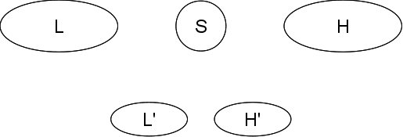
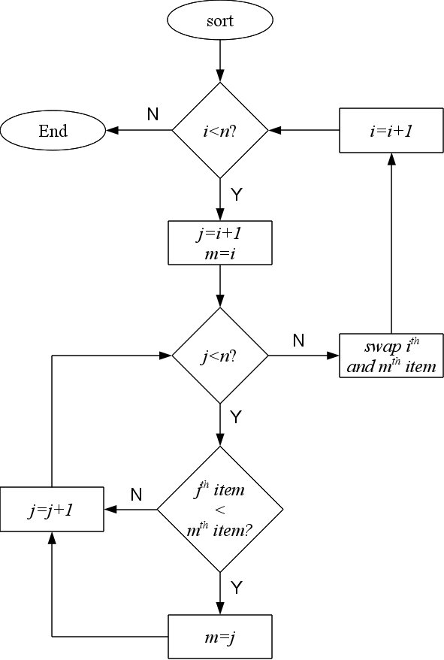Flowchart 1: Select Sort

