LAB 3

1- Write a program that takes two integers from the user and determines whether they are equal or not.

Examples:
Input: 6 6 Input: 4 6
Output: Yes Output: No

2- Write a program that takes an integer from the user and then determines it can be exactly divided by 5, or not.


Examples:
Input: 22 Input: 35 Input: 700
Output: False Output: True Output: True

3- Write a program that takes the time on a 24 hour clock, and then convert it to the time on a 12 hour clock (AM/PM).

Example:
Inputs: 9 30 (9:30)

Output: 9:30 AM

Inputs: 11 8 (11:8)
Output: 11:8 AM

Inputs: 17 12 (17:12)
Output: 5:12 PM

4- Write a program that reads the height and weight values from the user and prints the weight status on the screen.

Body Mass Index | Weight Status
Smaller 18.5 | Thin
18.5 – 24.9 | Normal
25 – 29.9 | Fat
30 and up | Obese
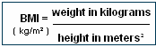



Example:
Input : height = 1.8 weight = 90 ( 90/(1.8*1.8)=27.7 )
Output: Fat

Input : height = 1.8 weight = 80 ( 80/(1.8*1.8)=24.69 )
Output: Normal

5- Write a program that finds the result of the following mathematical formula.

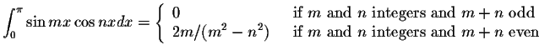


Example:
Inputs: m=4 n=5
Output: 0

Inputs: m=6 n=2
Output: 0,375



6- Write a program that takes three integers from the user and then displays the number of distinct values (1, 2, or 3) among these integers.

Examples:
Input: 760 4300 4300 Input: 65 65 65
Output: 2 distinct values. Output: 1 distinct value.


7- Write a program that takes two integers M and D and prints the season corresponding to month M (1 = January, 12 = December) and day D.

SEASON | FROM | TO
Spring | March 21 | June 20
Summer | June 21 | September 22
Fall | September 23 | December 21
Winter | December 21 | March 20

8- The Reynolds number is the most important dimensionless number in fluid mechanics.
It is calculated as:
d * v * den / vis
where d is diameter, v is velocity, den is density and vis is viscosity.

Write a program that takes diameter, velocity, density, viscosity values from the user and then displays “laminar flow” if the Reynold's number is less than 2000, prints “transient flow” if it's between 2000 and 4000, shows “turbulent flow” if it's more than 4000.
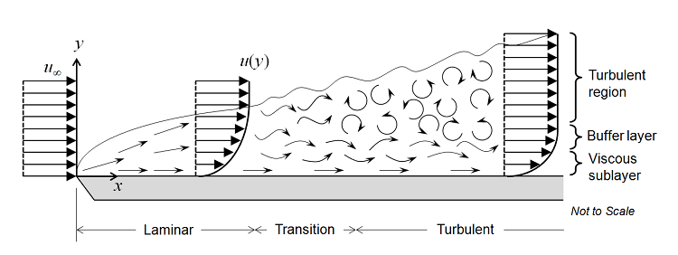

Example:
Inputs: Velocity = 2.5 m/s
Viscosity = 0.4 Ns/m²
Density = 900 Kg/m³
Diameter = 20 × 10⁻³ m
Output: laminar flow

900 × 2.5 × 20×10⁻³ / 0.4 = 112.5
Reynolds number is less than 2000, so the flow of liquid is laminar.

