LAB 4

1- Write a program that takes the number of sides in a polygon, from the user, and then prints the name of the polygon.

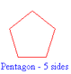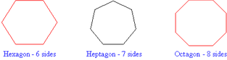

Note: Use switch-case structure

Example:
Input: 6
Output: Hexagon

2- Write a loop that prints the following output on the screen.

3 10 17 24 31 38 45 52 59 66 73 80 87

Note: Use for loop

3- Write a loop that prints the following output on the screen

3 10 17 24 31 38 45 52 59 66 73 80 87

Note: Use while loop

4- Write a program that prints the following time information.


12 midnight
1am
2am
...
12 noon
1pm
...
11pm

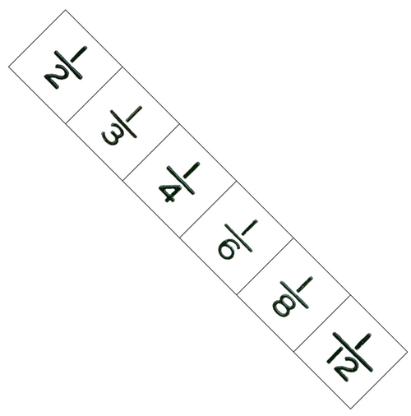
5- Write a program that takes a number n from the user and then finds the result of the following formula for n terms.

1 + 1/2 + 1/3 + 1/4 + ...

Note: Use “while loop”

6- Write a program that rolls a dice and prints “how many times the dice rolled before it comes up 6.

The program should also show the results of all rolls.

Note: Use do while loop

Example:
Output:
1. try 3
2. try 4
3. try 1
4. try 1
5. try 5
6. try 2
7. try 6

It came up after 7 tries.
7- Write a program that takes n numbers from the user and prints out the minimum odd number.

Example:
Inputs: 11 26 7 45 2 34 19
Output: 7

------------------------------------------------------------------------------------------------------------------------------------------------

Solve the following questions at home (after the course).

8- Write a program that takes a digit (between 1 and 9) from the user and finds the type of the digit.

Note: Use switch-case structure.
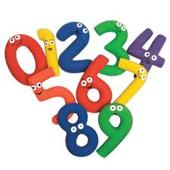
Digit | Type
1, 4, 9 | Perfect Square
2, 6, 8 | Even number
3, 5, 7 | Prime number

Example:
Input: 4
Output: Perfect Square

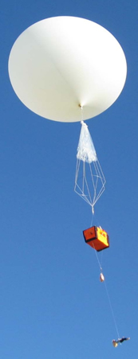
9- Write a program that prints the height of a weather balloon during 10 hours.

h(t) = 0.12t⁴ + 12t³ - 380t² + 4100t + 220 represents the height of a weather balloon at time t measured in hours.

Output:
Height at the 1th hour= 3952.12
Height at the 2th hour= 6997.92
Height at the 3th hour= 9433.72
Height at the 4th hour= 11338.72
Height at the 5th hour= 12795
Height at the 6th hour= 13887.52
Height at the 7th hour= 14704.12
Height at the 8th hour= 15335.52
Height at the 9th hour= 15875.32
Height at the 10th hour= 16420

10- Write a program to play a game. The program should generate a random number between 1 and 99. The player inputs his/her guess and the program should give a response as:
- "please enter a higher number",
- "please enter a lower number" or
- "you guessed the number after n attempts".

Example:
Inputs Outputs
50
Please enter a higher number
70
Please enter a higher number
92
Please enter a lower number
85
You guessed the number after 4 attempts.

11- Write a program which that takes the value of m from the user and calculates the result of the following mathematical formula:

