LAB 6

1- Assume that we declared the following array.

Names = {ali, ayşe, ayşe, sibel, zeynep, ayşe, can, zeynep}

Write a program that determines how many times a given name occurs in the array.

Example:
Input : ayşe
Output: 3

Input : sibel
Output: 1

2- Assume that there are two arrays: Turkish array and English array.
Write a dictionary program that takes an English word from the user and translate into Turkish.

Note: Don’t take the values of arrays from the user. Assign them in the code.


Examples:
string[] English = {"Apple", "Pear", "Cherry", "Banana", "Melon", "Apricot"};
string[] Turkish = {"Elma", "Armut", "Kiraz", "Muz", "Kavun", "Kayısı"};

Input : Cherry
Output: Kiraz

Input : Melon
Output: Kavun


3- Write a program that prints the numbers in the existing array such that they can be exactly divided by 3.

Note: Don’t take the values of arrays from the user. Assign them in the code.

Example:
int[] numbers = {4, 17, 3, 12, 1, 14, 15, 55, 9, 61};

Output: 3 12 15 9


4- Write a program that prints the percentage of numbers greater than the average in given n numbers.

Note: Don’t take the elements of the arrays from the user, assign them in the code.

int[] numbers = { -1, 5, 6, 2, 9, -6, 4, 3, 8, 0};

5- Write a program that switches the order of values in an array in a pairwise fashion. In other words, it should switch the order of the first two values, then switch the order of the next two, switch the order of the next two, and so on.

Example:
string[] a = {"derya", "deniz", "nehir", "ırmak", "su", "yağmur"]
Output: deniz derya ırmak nehir yağmur su

6- Write a program that prints the integers in an array, except repeated values.

Example:
int[] numbers = { 1, 7, 7, 12, 1, 5, 1, 1, 12, 12, 12, 7, 1, 1};
Output: 1 7 12 5

7- Write a program that prints "true" if arr2 is the sub array of arr1, otherwise prints "false".

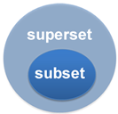
Example:
char[] arr1 = { 'a', 'b', 'c', 'd', 'e', 'f', 'g' };
char[] arr2 = { 'b', 'e', 'g' };
Output: true

Example:
char[] arr1 = { 'a', 'b', 'c', 'd', 'e', 'f', 'g' };
char[] arr2 = { 'b', 'e', 'g', 'k' };
Output: false
-----------------------------------------------------------------------------------------------------------------------------------------
Solve the following questions at home (after the course).

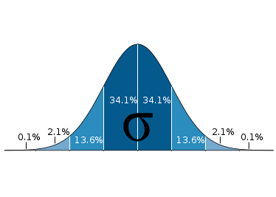
8- Write a program that finds the standard deviation (square root of the sum of the squares of their differences from the average, divided by N - 1) of n numbers.

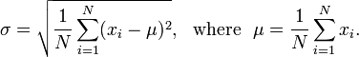
Example:
int[] numbers = { 50, 51, 56, 53};
Output: The standard deviation is 2.29128784747792

9- Write a program to add two very large integers: 179.534.672.198 and 211.145.070.230
Store each integer (whose elements is a block of numbers) in an array, then add the integers element by element, carrying from one to the next when necessary.

Don’t take the elements of the arrays from the user, insted, assign them in the program code.

int[] number1 = { 179, 534, 672, 898 };
int[] number2 = { 211, 145, 070, 230 };
int[] sum = { 0, 0, 0, 0 };

Output: sum = { 390, 679, 743, 128 }

