**LAB 1**

**If-Then Question**

**1-** Write a program that takes three integers from the user and determines whether the object with given three edges is a ***triangle*** or not.

a+b>c a+c>b b+c>a

a-b<c a-c<b b-c<a

**Example:**

Inputs: a=3 b=7 c=32

Output: It is not a triangle

Inputs: a=3 b=4 c=5

Output: It is a triangle

**Loop Question**

**2-** Write a **java program** that prints the following shape by using nested loops.

*

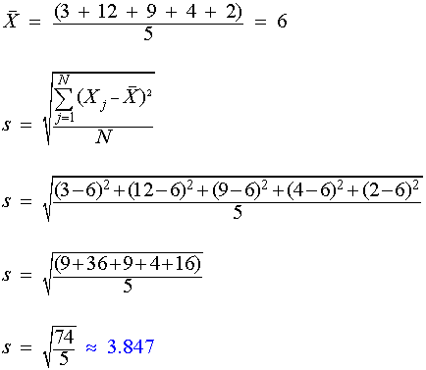 ***

*****

*******

*********

***********

**Array Question**

**3-** Write a **java program** that finds the standard deviation of an array.

{3, 12, 9, 4, 2}

Output: 3.847

**4-** Write a **java program** that determines a given matrix is a *signature matrix* or not.

A ***signature matrix*** is a diagonal matrix whose diagonal elements are plus or minus 1.

A=\begin{pmatrix}
\pm 1   & 0       & \cdots & 0       & 0      \\
0       & \pm 1   & \cdots & 0       & 0      \\
\vdots  & \vdots  & \ddots & \vdots  & \vdots \\
0       & 0       & \cdots & \pm 1   & 0      \\
0       & 0       & \cdots & 0       & \pm 1  
\end{pmatrix}

**Example:**

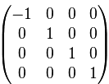 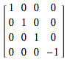 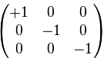

{{1,0,0,0,0},{0,-1,0,0,0},{0,0,1,0,0},{0,0,0,1,0},{0,0,0,0,-1}}

Output: true

**String Question**

**5-** Write a Java program that displays plural form of each word in the text.

instead of “y”, add "ies”

instead of “s”, “c”, “ch”, or “sh”, add “es”

all other cases, add “s”

**Example:**

string str = " bus city country girl";

Output: "buses cities countries girls"

**Function Question**

**6-** Write a ***cube(x)*** function that calculates x*x*x.

Write a ***sumofcubes(n)*** function that calculates the sum of 1 cubed + 2 cubed + ... + *n* cubed.

**Example:**

Input: 4

Output: 100 (1*1*1 + 2*2*2 + 3*3*3 + 4*4*4 = 100)

Input: 7

Output: 784 (1*1*1 + 2*2*2 + 3*3*3 + 4*4*4 + 5*5*5 + 6*6*6 + 7*7*7 = 784)