**LAB 2**

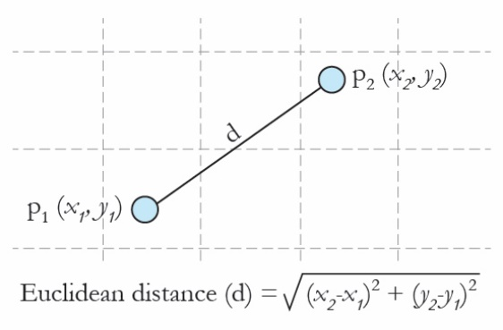**1-** Define a ***Point*** class with:

* Two attributes: *x* and *y*
* One constructor method to construct a point at given coord (*x*, *y*) values
* Get/set methods
* Display method

Write a **main method** that

* creates two point objects (2,1) and (6,4)
* update the second point as (8, 5)
* display points
* finds Euclidean distance between these points.

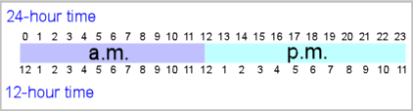**2-** Define a ***Time*** class with:

* Two attributes: *hour* and *minute*.
* One constructor method which receives a string input in 24-hour format

**hour:minute** such as 14:50

* Get / Set methods
* Display method (in 24-hour format)
* Convert methodthat converts a time stamp from 24-hour format to 12-hour format

Write a **main method** that

* creates a time object 14:50
* calls *convert()* method to produce the following output format: 2:50 p.m.
* creates another time object 01:40
* calls *convert()* method to produce the following output format: 1:40 a.m.

**3-** Write an object oriented program that allows users to manage the members of DEU Fitness Center.

The program should store all members’ information (i.e. name, surname, height, weight, etc.).

Create a ***Member*** class with:

* Several attributes: name, surname, heigth, weight etc.
* One constructor method which receives all parameters
* Get / Set methods
* Display method
* BMI method (calculates Body Mass Index of the member)
* WeightStatus method (returns the weight status of the member by calling BMI method)

|  |  |
| --- | --- |
| **Body Mass Index** | **Weight Status** |
| Smaller 18.5 | Thin |
| 18.5 – 24.9 | Normal |
| 25 – 29.9 | Fat |
| 30 and up | Obese |



Create a ***SportCenter*** class with:

* Several attributes: name of the sport center, *Member[]* members, count, etc.
* One constructor
* *addMember(Member m)* method
* *search(String name, String surname)* method
* *printAllMembers()* method

Write a **main method** that

* add yourself as a member
* add your two friends as members
* call *printAllMembers()* method
* call *weightStatus()* method for you to learn your status
* call *search()* method to learn the weight and height information of a member

**--------------------------------------------------------------------------------------------------------------------------------------------**

**Solve the following question at home (after the course).**

**4-** Write an object-oriented program that takes the momentum (*px*, *py*, *pz*) and mass (*m*) values of a 3D particle from the user and finds kinetic energy.

Create a ***Particle*** class with:

* Attributes: momentum (*px*, *py*, *pz*) and mass (*m*)
* 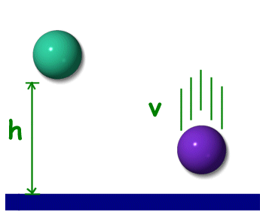One constructor
* Get / Set methods
* *kineticEnergy* method

velocity (*vx*, *vy*, *vz*) is calculated as:

vx = px / mass

vy = py / mass

vz = pz / mass

kinetic energy = 1/2 m (vx2 + vy2 + vz2)

Write a **main method** that

* creates a particle
* calls *kineticEnergy* method