**COMPUTER APPRECIATION AND APPLICATION**

**1.0 Introduction**

Computer is a device that transforms data into meaningful information. Data can be anything like marks obtained by you in various subjects. It can also be name, age, sex, weight, height, etc. of all the students in a class. The computer follows a predefined set of actions to ‘process’ (analyze) this data into a form that informed decisions can be made. The original objective for inventing a computer was to create a fast calculating machine. However, more than 80% of work done by computers today is of non-mathematical or non-numerical nature.

**1.1 What is a Computer:** A computer is a programmable machine which allows the user to store all sorts of information and then ‘process’ that information, or data, or carry out actions with the information, such as calculating numbers or organizing words.There have been several definitions given to the computer, some of which we will outline below:

* A computer is a set of interrelated and interactive devices, which uses electronic components to perform a predefined operation with accuracy.
* A computer is a machine that can receive and store information and change or process it.
* Computer can also be defined in terms of the functions it can perform. A computer can accept data, store data, process data as desired, and retrieve the stored data as and when required and print the result in desired format following a set predefined instructions.

**Program:**

* *A computer* ***Program*** *is a set of related instructions written in the language of the computer & is used to make the computer perform a specific task (or, to direct the computer on what to do).*
* *A set of related instructions which specify how the data is to be processed.*
* *A set of instructions used to guide a computer through a process.*

**Data:**

***Data*** is a collection of raw facts, figures or instructions that do not have much meaning to the user.

Data may be in form of numbers, alphabets/letters or symbols, and can be processed to produce information.

**Data Processing:**

* It is the process of collecting all items of data together & converting them into information.
* *Processing* refers to the way the data is manipulated (or handled) to turn it into information.

The processing may involve calculation, comparison or any other logic to produce the required result. The processing of the data usually results in some meaningful information being produced.

**Information:**

*Information* is the data which has been refined, summarized & manipulated in the way you want it, or into a more meaningful form for decision-making.

The information must be accurate, timely, complete and relevant.

**Comparison between Data and Information.**

|  |  |
| --- | --- |
| **Data** | **Information** |
| 1. Unprocessed (raw) facts or figures. 2. Not arranged. 3. Does not have much meaning to the user. 4. Cannot be used for decision-making. | 1. It is the end-product of data processing (processed data) 2. Arranged into a meaningful format. 3. More meaningful to the user. 4. Can be used to make decisions. |

**1.2 CHARACTERISTICS OF COMPUTERS**

* **Automatic:** An automatic machine works by itself without human intervention. Computers are automatic machines because once a job is started, they carry out the job until it is finished.
* **Speed:** A computer is a very fast device. It can perform in a few seconds, the amount of work that a human being can do in an entire year. The speed of a computer is measured in **Fractions of seconds**.

Millisecond - a thousandth of a second (10-3)

Microsecond - a millionth of a second (10-6)

Nanosecond - a thousand millionth of a second (10-9)

Picosecond - a million millionth of a second (10-12)

* **Accuracy:** A computer performs operations with accuracy for very long periods without going wrong. However, when an error occurs the computer has a number of in-built, self-checking features in their electronic components that can detect & correct such errors.

Usually errors are committed by the users entering the data to the computer, thus the saying **Garbage in Garbage Out** (**GIGO**).

This means that, if you enter incorrect data into the computer and have it processed, the computer will give you misleading information.

* **Diligence:** Unlike human being, a computer is free from monotony, tiredness, and lack of concentration. It can continuously work for hours without creating any error and without grumbling.
* **Versatility:** Versatility is one of the most wonderful thing about a computer. One moment it is preparing results of an examination, next moment it is busy preparing electricity bills, and in between, it may be helping an office secretary to trace an important letter in seconds.
* **Power of Remembering:** A computer can store and recall any amount of information because of its secondary storage capability. It can retain a piece of information as long as a user desires and the user can retrieve the information whenever required.
* **No I.Q:** A computer is not a magical device. It possesses no intelligence of its own. Its I.Q is zero, at least until today. Only a user determines what tasks a computer will perform. A computer cannot take its own decision in this regard.

**1.3 USES OF COMPUTERS**

Over time, Computers have been evolved and specialized into devices that can be used for different purposes and in many fields, which include but not limited to the following:

1. Banking
2. Medicine
3. Education
4. Gaming
5. Graphic Design
6. Software Development

REVIEW QUESTIONS:

1. What is a Computer?
2. Why is a computer referred to as an electronic device?
3. Define the following terms as used in computer science.
   1. Data.
   2. Programs.
   3. Data processing.
   4. Information.
4. **(a)** Briefly explain the two forms of data.

**(b)** Give THREE differences between Data and Information.

1. The speed of a computer is measured in ___________.
2. What does the term GIGO stands for?
3. List and explain 4 salient features/ properties of a computer.

**2.0 CLASSIFICATION OF COMPUTERS**

There are several types of Computers, thus to fully classify them becomes a difficult task, however, some criteria were used in classifying computers and they may sometimes overlap. They are outlined and discussed briefly:

1. Classification by types,
2. Classification by size,
3. Classification by purpose and
4. Classification by generation

**2.1 CLASSIFICATION ACCORDING TO TYPE/TECHNOLOGY**

* Analog Computers
* Digital Computers
* Hybrid Computers

**Analog Computers:** these are machines that are used for simple data collection and they work by measuring the changes in continuous physical or electric states, that is, they respond to an analogue signal. For example a speedometer responding to an increase or decrease in acceleration, or a mercury thermometer measuring temperature.

These computers recognize data as a continuous measurement of a physical property (voltage, pressure, speed and temperature).

The output from analogue computers is in form of smooth graphs produced by a plotting pen or a trace on a Cathode Ray Tube (CRT) from which the information can be read.

*Examples of analogue devices:*

* + **A Bathroom scale.**

It uses the weight of a person to move a pointer smoothly/continuously over calibrated scale, which shows the person’s weight.

* + **Thermometer.**

It uses a volume of Mercury to show temperature. The Thermometer is calibrated to give an exact temperature reading.

* + **Speedometer.**

In Speedometer, the rotation of the wheel is converted to a voltage, which causes a pointer to rotate over a dial calibrated in Km/h or Miles/h.

* + A **Petrol pump** measures the rate of flow of Gasoline (petrol) & converts the volume delivered to 2 readings; one showing the volume & the other showing the cost.

**Digital Computers:** these are high speed programmable electronic devices that both its input and internal representations are in binary digits.

They recognize data by counting discrete signal (0s and 1s) representing either a high or low voltage state of electricity signifying “ON” & “OFF”.

Therefore, any data to be manipulated by a digital computer must first be converted to digital form. Their output is usually in form of numbers, alphabets, & symbols.

Examples: Digital Wrist watches, calculators and all microcomputers.

**Hybrid Computers:** this is a computer that combines the functions and processing capability of both analog and digital computer to work as a single system. Hybrid computers are designed by interconnecting the elements of a digital computer & analogue computer directly into one processor, using a suitable interfacing circuitry.

*Example;*

In a hospital **Intensive Care Unit**, an analogue device may be used to measure the functioning of a patient’s heart, temperature and other vital signs. These measurements may then be converted into numbers and send to a digital device, which may send an immediate signal to the nurses’ station if any abnormal readings are detected.

**2.2 CLASSIFICATION ACCORDING TO SIZE**

There are four main computers that fall within this category which include: **Supercomputers:** Supercomputers are the fastest problem solvers available. They work at extremely high speeds. Often, they process data in “parallel,” breaking a complicated problem into smaller units, each of which is handled by a part of the computer, then combined to produce the final result.

Supercomputers are very large & heavy, and are usually kept under special environmental conditions (i.e., in a special room).

***Areas where supercomputers are used:***

Supercomputers are mainly used for complex scientific applications that involve many calculations & require a lot of computational power. Some of the applications that use supercomputers include;

* Weather forecasting.
* Petroleum research.
* Defence and weapon analysis.
* Aerodynamic design and simulation.

**Note**. These tasks use large amounts of data, which need to be manipulated within a very short time.

*Examples of Supercomputers:*

* CRAY T3D, NEC-500.

**Mainframe Computers**: these are powerful multi-user computers that  
support concurrent programs, which means, they can perform different actions or  
‘processes’ at the same time. Many large companies use it to manage the huge amounts of data required to keep their operations running. Many users need access to this shared data and programs, as such it is capable of supporting hundreds, or even thousands, of users simultaneously. In some ways, mainframes are more “powerful” than supercomputers because they support more simultaneous programs using the concept of **time sharing** but supercomputers can execute a single program faster than a mainframe.

***Areas where mainframe computers are used:***

Mainframe computers are mostly found in government departments, big organizations and companies which have large information processing needs, e.g., they are used;

* In Banks & Hospitals for preparing bills, Payrolls, etc.
* In communication networks such as the **Internet** where they act as Servers.
* By Airline reservation systems where information of all the flights is stored.

*Examples of Mainframes:*

* IBM 4381.
* ICL 39 Series.
* CDC Cyber series.

**Minicomputers:**are smaller, less powerful, and less expensive than the mainframe and give computing power without adding the cost associated with larger systems. Today, minicomputers are being used in organizations where large amount of data are processed, they can serve a number ranging up to 40,000 users and it is generally easier to use. Minicomputers usually have multiple terminals but not as much as that of the Mainframe.

Minicomputers are used mainly in:

* Scientific laboratories & research institutions.
* Engineering plants/factories to control of chemical or mechanical processes.
* Space industry.
* Insurance companies & Banks for accounting purposes.
* Smaller organizations as Network **Servers**.

*Example of Minicomputer:*

* PDP-8 built in 1965 by **D**igital **E**quipment **C**orporation in U.S.

**Microcomputers, or Personal Computers**: is the smallest, least expensive of all the computers. The term *microcomputer* is generally synonymous with personal computer, or a computer that depends on a microprocessor and it comes in a wide variety of styles and sizes. Some are designed for the desktop, with a cathode ray tube or LCD monitor separate from the rest of the computer. Laptop computers and Personal Digital Assistants (PDAs) grow lighter and sturdier with each new version. Laptops are compact with built in liquid crystal display monitors that provide crisp displays. Most hand-held computers are used for a specific purpose, such as taking notes and sending/receiving messages. Their portability makes them ideal for business professionals who travel a great deal. Tablet PCs, such as the Apple iPad, are another type of portable computer that use touchscreens to input and manipulate data.

* They are single user in nature (only one person can use at a time)

Examples: Desktop, Laptop, Palmtop (PDA – Personal Digital Assistant) Apple Macintosh, Dells, Compaq,

**2.3 CLASSIFICATION ACCORDING TO PURPOSE**

**General Purpose Computers**

A ‘General Purpose Computer’ is a machine that is capable of carrying out some general data processing or operations under program control available on them. However, the versatility is dependent on the storage capacity, processing speed and application package present in the system. A single computer can be used to process documents, perform calculations, process the Payroll, simulate the loading on a bridge, process Insurance policies, and play games, among others. The programs used in a general-purpose computer are exchangeable. This means that, to perform a particular task, the appropriate set of instructions required to perform that particular task are loaded into the computer memory.

Thus virtually all computers from microcomputers, mini computers and mainframe are general purpose.

**Special purpose Computers**

These are computers that are designed to operate on a restricted class of problems, that is, it is designed for only one kind of task or application. They are usually not flexible and are usually single user.

Example:

* Robots used in a manufacturing industry for production only.
* Computers used in Washing machines.
* An Automatic pilot – a computer dedicated to the task of operating an aircraft.
* Industrial Process Control systems
* Data Communication Satellite Tracking Systems.

**2.4 CLASSIFICATION ACCORDING TO GENERATIONS**

Generation in computer terminology is the grouping of the gradual developments in the computer technology. The historical events are not considered in terms of individual years, but are classified in durations (a period of more than a year).

**1st GENERATION** (**The Vacuum Tube Technology1946-1959):** The computers were built using **Vacuum tubes**, and the speed was measured in **Milliseconds**. E.g., a computer could perform 5,000 additions & 300 multiplications per second.

㿷ᛇΐ

***Vacuum tube***

**The main features of First Generation are:**

* The tubes consumed a lot power, and generated a lot of heat during processing due to overheating as such Air Conditioning was needed.
* The computers constantly broke down due to the excessive heat generated, hence were short-lived, and were not very reliable.
* They supported Machine language only
* They were very costly - - they costed millions of dollars.
* Slow Input/Output device - Cards were used to enter data into the computers.
* Huge size (weighing up to 200 tons) as such they were Non portable
* Their internal memory capacity was limited. The maximum memory size was approx. 2 KB (2,000 bytes).

**Examples:** *Examples of 1ST Generation computers:*

**ENIAC** (**E**lectronic **N**umerical **I**ntegrator **A**nd **C**alculator) built in 1946 for use in World War II. It contained 18,000 Vacuum tubes.

**EDVAC** (**E**lectronic **D**iscrete **V**ariable **A**utomatic **C**omputer) developed in 1945 by Dr. John Von Neumann. It was the first computer that used instructions stored in memory.

**UNIVAC** (**UNIV**ersal **A**utomatic **C**omputer).

**IBM 650**.

**LEO** (**L**yon’s **E**lectronic **O**ffice).

IBM 700 series

**2nd GENERATION COMPUTER (The Transistor Technology, 1959 - 1964):** The technology, which gave the distinguishing characteristics of the second –generation computers, was the **transistor** technology. These transistors replaced the bulky vacuum tubes. In addition to doing everything that the vacuum tube could do, the transistors would do so with greater reliability, with less power requirement, generate less heat, less costly to manufacture and much smaller in size. Their operation speeds increased & were measured in **Microseconds**. E.g., a computer could perform 1 million additions per second.

㿷ᛇΐ

***Transistor***

Examples: **IBM 7030, 7070, 7090, 7094, Boroughs 200 series, UNIVAC III, Honey-well800,** CDC-6600 Mainframe computers etc. The development of high level programming languages like FORTRAN and COBOL was another innovation brought by the second-generation computers and were10 times faster than the first.

**The main features of Second Generation are:**

* Use of transistors
* Reliable as compared to First generation computers
* Smaller size as compared to First generation computers
* Generate less heat as compared to First generation though A.C. is needed
* Consumed less electricity as compared to First generation computers
* RAM Memory size expanded to 32 KB.
* Their operation speed increased to between 200,000 – 300,000 instructions per second. Their speeds were measured in **Microseconds**. E.g., a computer could perform 1 million additions per second, which was comparatively higher than that of the 1st generation computers.
* Still very costly
* Support machine and assembly languages

**3rd GENERATION COMPUTERS (Integrated Circuit Technology, 1964 – 1971):** the third generation of computer is marked by the use of **Integrated Circuits** (IC's) in place of transistors. A single I.C has many transistors, resistors and capacitors along with the associated circuitry. The I.C was invented by Jack Kilby. This development made computers smaller in size, reliable and efficient. This technology came progressively from Small Scale Integration (SSI), which contained about twenty interconnected transistors and diodes. The speed increased to tens of millions of operations per second.

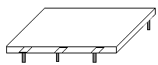

***Integrated Circuit***

**Examples: IBM 31360 - 31370 series, CDC 6600, 7600, BoroughsB5000 and PDP II series.**

High level language (FORTRAN-II TO IV, COBOL, PASCAL PL/1, BASIC, ALGOL-68 etc.) were used during this generation.

**The main features of Third Generation are:**

* Integrated Circuit Technology used
* The storage capacity of the computers (i.e., the RAM memory sizes) expanded to 2 MB.
* More reliable
* Smaller size
* Generate less heat
* Faster
* Lesser maintenance
* Still costly
* A.C needed
* Consumed lesser electricity
* Support high level language

**4th GENERATION (Very Large Scale Integrated Circuit, 1971-1980):** VLSIC having about 5000 and 50,000 transistors and other circuit elements and their associated circuits on a single chip (**Microprocessor** measuring about 1.3cm or 0.5in) made it possible to have microcomputers. Fourth Generation computers became more powerful, compact, reliable, and affordable. As a result, it gave rise to personal computer (PC) revolution. This generation also produced a wide variety of software packages like word processing packages, graphics, games, spreadsheet packages and database management systems. Networking capabilities were also enhanced in this era. **Examples include the IBM 3033, HP 3000 mini computers, Apple II, Boroughs B7700.**

All the Higher level languages like C and C++, DBASE etc. were used in this generation.

**The main features of Fourth Generation are:**

* VLSIC technology used
* Very cheap, portable and reliable
* Use of PC's
* Very small size
* Pipeline processing
* No A.C. needed
* Concept of internet was introduced
* Computers became easily available

**5th GENERATION (Era of Artificial Intelligence, 1980-till date):**

In the fifth generation, the VLSI technology became ULSI (Ultra Large Scale Integration) technology, resulting in the production of microprocessor chips having ten million electronic components.

This generation is based on AI (Artificial Intelligence is an emerging branch in computer science, which interprets means and method of making computers think like human beings), Speech Processing, Pattern Recognition and Expert System. The distinguishing characteristics of this generation of computer are their tremendous speed and power. The computer speeds are now measured in **Nanoseconds** & **Picoseconds**.

They are able to perform parallel (or multi-processing) whereby a single task is split among a number of processors.

The memory sizes range between 1 Gigabyte & 1 Terabyte.

All the Higher level languages like C and C++, Java, .Net etc. are used in this generation.

**The main features of Fifth Generation are:**

* ULSI technology
* Development of true artificial intelligence
* Development of Natural language processing
* Advancement in Superconductor technology
* More user friendly interfaces with multimedia features
* Availability of very powerful and compact computers at cheaper rates

Some computer types of this generation are: Desktop, Laptop, NoteBook, UltraBook, ChromeBook

1. What is Artificial Intelligence?
2. Give four characteristics of First generation computer.
3. **(a).** What do you mean by computer generations?

**(b).** Describe the FIVE generations of computers in terms of technology used and give an example of a computer developed in each generation.

|  |  |
| --- | --- |
| **Generation** | **Technology** |
| First generation | * 1. Very Large Integrated Circuit |
| Second generation | * 1. Thermionic valves (Vacuum tubes) |
| Third generation | * 1. Transistors |
| Fourth generation | * 1. Integrated Circuits |

**3.0 COMPONENTS OF COMPUTER**

The components of the computer are divided into Hardware and Software.

**3.1 COMPUTER HARDWARE**

The physical equipment required to create, use, manipulate and store electronic data. This refers to all the pieces of physical equipment that make up a computer system or simply put the physical part of the Computer that can be touched, handled and seen. It is further sub-divided into:

* Input Unit
* Output Unit
* Central Processing Unit
* Memory Unit

**3.2 INPUT UNIT:** the devices that allow data and instructions to enter a computer from the user. The devices that fall into this category serve as interface between the user and the computer system. Some of these devices include:

**Keyboard:** A keyboard (as shown in figure below) is the most common input device. Several kinds of keyboards are available, but they resemble each other with minor variations. The keyboard in most common use is the QWERTY board. Generally standard keyboard has 104 keys. In these keyboards, the cursor control keys are duplicated to allow easier use of the numeric pad. The special keys (such as the Function, Ctrl (control), and Alt keys are used alone or in combinations to cause programs to perform action. It has a layout similar to that of a typewriter, but has several extra keys. It allows the user to pass information to the computer, by typing in letters and commands on the keyboard.

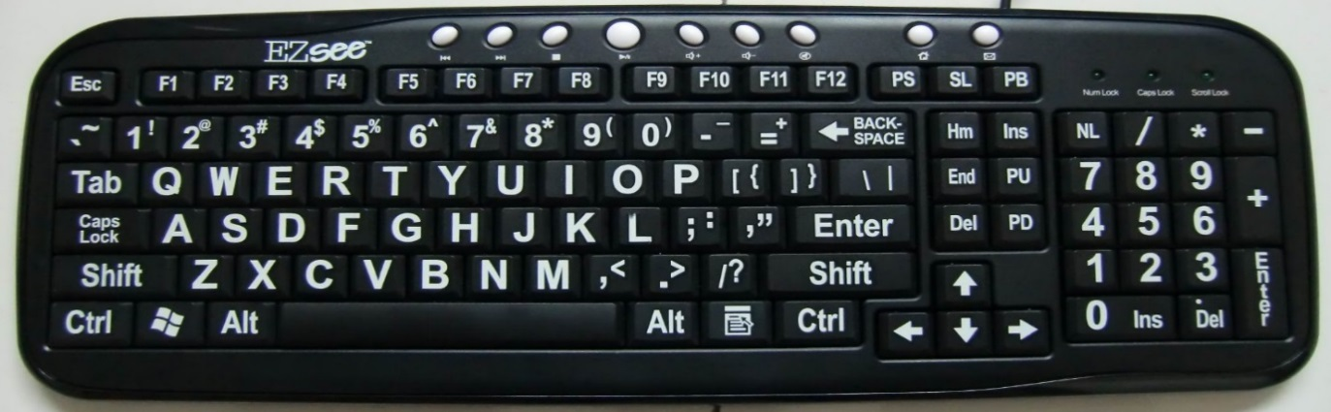

1. **Function/ Command keys.**

These are the keys located along the top of the Keyboard marked F1 up to F12. They are used to issue commands into the computer.

Each of these keys is used to perform a special function in various application packages, e.g., **F1** is used in most applications for **help**.

Function keys are used differently by different applications, i.e. their functions vary with different programs, and are therefore sometimes called **Programmable Keys**.

1. **Alphanumeric keys.**

This section consists of alphabetic & numeric keys. Alphanumeric keys are mostly used for typing of text.

It has the 26 letters of the English alphabet marked on them in capital letters, and Number keys arranged in their natural order from 0 – 9. Along with these keys are *Punctuation marks* (comma, full-stop, etc) and some Symbols.

At the bottom of the alphanumeric keys, is the **Space bar**, which is used to separate words or sentences from each other (or to create a blank space after typing each word).

1. **Numeric Keypad keys.**

It is on the rightmost part of the Keyboard. It has keys with digits (numbers) 0 - 9 marked on them in rows from the bottom upwards.

The keypad also has some mathematical symbols marked on its keys. They include: the multiplication sign (*), subtraction sign (-), addition sign (+), division sign (/) & the decimal point (.).

The Keypad is used for fast entry of numeric data into the computer.

**Note**. The numbers on the Numeric keypad can only be used when the **Num Lock** key is turned on.

1. **Directional** (or **Cursor positioning**) **keys.**

They are used to move the Cursor (insertion point) within the window of an application.

They include; *Page Up*, *Page Down, Home, End,* & the four *Arrow Keys*.

* ***Arrow keys:***

To move the cursor one character to the right in a Word processing document, press the *Right arrow* key; to move the cursor one character to the left, press the *Left arrow* key.

To move the cursor one line up, press the *Up arrow* key; to move the cursor one line down, press the *Down arrow* key.

* ***Page Up & Page Down:***

To move the cursor up one page in case the document has many pages, press the *Page Up* key; to move the cursor down one page, press the *Page Down* key.

* ***Home & End keys:***

To move the cursor to the beginning of the current line, press the *Home* key; to move the cursor to the end of the current line, press the *End key*.

**Editing keys.**

They are used to delete or insert characters in a document. These are:

1. **Backspace key.**

It has a backward arrow (**🠠**) marked on it.

* Used to erase characters to the left of the cursor (i.e., from right to left on the same line).

When pressed, it makes the cursor move one space backwards and the immediate letter or number to the left is erased.

1. **Delete (Del) key.**

It is used to erase characters to the right of the cursor, (i.e., from left to right).

1. **Insert (Ins) key.**

* Used in a word processor to switch between the **Insert mode** & **Overtype mode**. When pressed, it helps the user to insert text in the middle of a sentence or replace a character at the cursor position (i.e., overwrite the text).

1. **Special PC operation keys.**

They are used in combination with the other keys or on their own to perform special functions/tasks, or to give special instructions to the computer.

Examples; Esc, Tab, Caps Lock, Shift, Ctrl, Alt, Enter, Num Lock, Scroll Lock.

**TAB key ( ).**

It is used in certain programs such as Word processors to move the text cursor or a certain text at set intervals on the same line to the required position on the screen, e.g., 10mm, 20mm, etc.

A **Cursor** is a blinking underscore ( **__** ) or a vertical beam (**I** ) that shows where the next character to be typed will appear.

**CAPS Lock.**

Used to switch between capital (uppercase) letters & small (lowercase) letters.

When pressed ***on,*** an indicator with a Green light appears on the top-right hand corner of the Keyboard, and all the text typed will appear in capital letters. When pressed ***off***, all the text typed will appear in small letters.

**SHIFT key ( ).**

This special key works in combination with other keys.

* It can be used to get single capital letters. Hold down the *SHIFT key* & press an alphabet key to get the letter in its capital form.
* It is used to get the punctuation marks on top of the Number keys or the symbols on top of certain keys especially on the alphanumeric section.

To get the punctuation mark on top of a number key or the symbol on top of a certain key; press & hold down the **SHIFT key** before pressing the required key.

**ENTER key (↵).**

* It is used as a *RETURN* key. When pressed at the end of a text line or paragraph in a word processor, it forces the text cursor to move to the start/ beginning of the next line or paragraph.
* It is used to issue completion commands to the computer. It is used to instruct the computer to carry out (execute) a command that has been typed or selected on the screen.

**ESCAPE (ESC) key.**

It generates special code for the computer. In some programs, it is used when you want to quit doing some task, i.e. escape from or to cancel a task.

**CONTROL (CTRL) key.**

It controls various functions in combination with other keys, e.g. **CTRL**+”**S**” is used to give the command for saving the text/object.

**The mouse:** is an input device that you use to control a pointer that displays on the monitor. A wide variety of mouse pointing devices exists. Some are moved over a surface and may be wireless; some let you use your thumb or fingers to roll a ball that moves the pointer; others, especially on laptop computers, work when you drag your finger across a small screen called a touch pad.

Regardless of the mouse type, when the pointer is located at the spot where you want the software to respond, you click the left button once (click), the right button (right-click), or the left button twice rapidly (double-click).

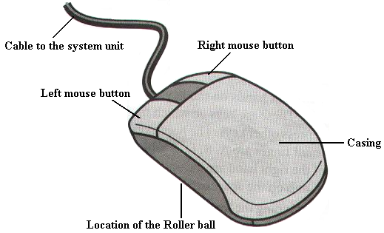

Mouse, Scanner Bar code reader, Microphone

Others may include: joystick, camera, Optical Mark Reader

***Descriptive Questions.***

1. Define a Keyboard.
2. **(a) S**tate and briefly explain the functions of five categories of keys found on a standard keyboard.
3. State the use of each the following section or combination of keys on the keyboard:
4. Function keys.
5. Numeric keypad.
6. Arrow keys.
7. Control key.
8. Name 3 main sections of the Keyboard that are used in typing.
9. What is the difference between Function keys and Special PC operation keys?
10. State the functions of the following keys on the keyboard.
11. Caps Lock.
12. Spacebar.
13. Shift Key.
14. Enter Key.
15. Backspace.
16. Delete.
17. Escape.
18. Num Lock.

**3.3 OUTPUT UNIT:** the devices that allow information to be represented (that is, given out) to the user, such as a display screen or printer).This serves as the interface through which results of computer processing and activities are displayed and communicated to the user. Some of these devices include:

**Monitor:** it can also be called the visual display unit or the screen. It is an output device responsible for displaying any information after being processed. It displays input and the results of processing.

Two basic types of monitors are used with microcomputers, which are as follows:

Cathode Ray Tube (CRT): CRT or Cathode Ray Tube Monitor is the typical monitor that you see on a desktop computer. It looks a lot like a television screen, and works the same way. This type uses a large vacuum tube, called cathode ray tube (CRT).

Liquid Crystal Displays (LCD): This type of monitors are also known as flat panel monitor. Most of these employ liquid crystal displays (LCDs) to render images. These days LCD monitor are very popular.

Others include:

Printer, Speakers, Graph plotters, Projectors etc.

**CENTRAL PROCESSING UNIT** (System Unit): It is where the refining/processing of the raw data into tangible/understandable form is done. The CPU (Central Processing Unit) is a chip, located on the motherboard, which performs mathematical calculations and logic functions (determining if one value is greater than another, and so on). The CPU is often referred to as the brain of the computer because it administers the functions of the other components.

It does the function by organizing circuits into two main units, called Arithmetic logic unit and control unit.

**The Control Unit:** this part of the CPU controls and coordinates the activities and functions of the computer. It performs this function by generating control signals which in turn controls the operations of the other hardware like activating the appropriate circuits necessary for inputs and output devices which causes the entire computer system to operate in an automatic manner.

**Arithmetic Logic Unit (ALU):** The ALU contains arithmetic circuits that can subtract multiply and divide two numbers. More complex operations such as finding the square root of a number are done by sequence of their basic operations. The ALU has logic circuits that can compare two numbers to determine if they are equal or if one number is greater than storage locations called storage registers for storing numbers used in calculations and for storing the results of calculations.

**The Primary Memory:** It is also known as the internal storage device and it is used to store programs and data currently being processed by CPU. Primary storage circuits need electricity to stay on, if the power to the computer is turned off, all the circuits will turn off and all data in primary storage will be lost. This type of primary storage is called RANDOM ACCESS MEMORY or RAM. RAM is the main type of primary storage used with computers

**RAM (RANDOM ACCESS MEMORY):** this is used for storing programs (data and instructions) that are currently running. In other words, this section holds programs, instruction and data being processed and stores intermediate results of processed data awaiting transfer to the output device or storage device. The data are stored in a random manner. The RAM is volatile, that is, when there is an electric power outage, the data or instructions stored on it are lost. Example: DRAM, SRAM, and SDRAM.

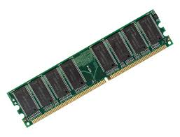**RAM**

**ROM (READ ONLY MEMORY):** it is a non-volatile form of storage that holds sequence of instruction required to properly boot up the computer. The instructions are usually specified by the manufacturers, it can be read from as many times as needed, but the contents cannot be tempered with, that is the ROM is non-volatile storage which means that when the power to the computer is turned off, the content of the ROM is not lost it holds information permanently, thus the name Read Only Memory.

**Example:**

**PROM** – Programmable Read Only Memory – In this type of ROM, data or program can be stored once in PROM but never changed.

**EPROM** – Erasable Programmable Read Only Memory – In this type of ROM, data or program can be erased by removing the device and exposed it to ultraviolet light.

**EEPROM** – Electrically Erasable Programmable Read Only Memory – data or program can be completely erased using a special device and new programs or new data can be stored in it.

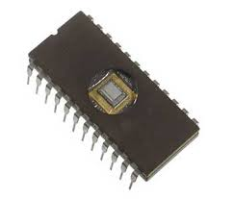**ROM**

**Difference between ROM and RAM**

**ROM RAM**

ROM is nonvolatile RAM is volatile

ROM is cheaper than RAM RAM is very expensive

The contents of ROM are always known and can be The contents are not verified known

ROM cannot be updated or corrected RAM can be updated and corrected

ROM serves as permanent data storage RAM can serve as temporary data storage

**Secondary Storage/Auxiliary Memory:** as we discussed above, the ROM is a read only memory device and the RAM is volatile, this shows that there is a need for a device to make up for the lapse/ limitation of the main memory. Secondary Storage is an optional attachment, which is cable –connected to the CPU. It is a nonvolatile storage and any data or programs stored in secondary storage stays there, even with the computer power turned off, unless someone purposely erases them. They are used to back up the RAM, but note that before data or instructions in an auxiliary memory are processed, they must first be copied to the RAM.

Example: Hard disk, DVD, CD –ROM, Magnetic Tapes, Flash drive

**Basic Units of Measurement**

**Bit (binary digit)**

•Two possible values (0 or 1)

**Byte** = 8 bits

**Word**

•The number of adjacent bits that can be stored and manipulated as a unit

• can either be 32, 64 for home computers, 128 for the most powerful

**Large Units of Measurement (Memory, Storage)**

•Note: powers of two are used because computer memory and storage are based on the basic unit (bit). •Kilobyte (kB) –a thousand bytes (1,024 = 210)

•Megabyte (MB) -a million (1,048,576 = 220)

•Gigabyte (GB) –a billion (1,073,741,824 = 230)

•Terabyte (TB) –a trillion (1,099,511,627,776 = 240)

**3.2 COMPUTER SOFTWARE**

The Computer hardware cannot be able to do anything on its own that is to say the hardware cannot function without the software been installed on it to instruct it on what to do. To fully understand or grasp what computer software is we will first define a computer program. A **computer program** is a sequence/set of instructions that can be executed by a computer to carry out a process.

For software (the instructions) to perform various functions, it must be programmed. That is, the instructions need to be written in a programming language that the computer can understand. Without a program, a computer is useless.

***Programming language****: An artificial set of rules, vocabulary and syntax used to instruct the computer to execute certain tasks. BASIC, FORTRAN, PASCAL, C++, JAVA, and so on.*

*The language the computer actually understands is called* ***machine language****, which comprises numbers only. This language (Machine Language) is used by the computer to understand the programming language and translate the terms into executable instructions*

**Software** refers to a set of programs that makes the hardware perform a particular set of tasks in particular order. In other language we can say it is a collection of computer programs and related data or associated documentation that provides the instructions telling a computer what to do. Also, they are computerized instructions that operate a computer, manipulate the data and execute particular functions or tasks. It is the component of the computer that cannot be felt but its actions can be observed when executed.

There are two types of software:

1. System Software
2. Application Software

**SYSTEM SOFTWARE:** This is the control software that is designed, implemented and installed and it operates the hardware and provides the platform for applications to run. It coordinates the overall activities and performance of the computer system. The System Software is further sub-divided into:

* Operating System
* Translators
* Utility programs

**OPERATING SYSTEM:** is a system software that provides an interface for a user to communicate with the computer, manages hardware devices (disk drives, keyboard, monitor, etc), manages and maintains disk file systems and supports application programs**.** It provides an interface with which the user can interact conveniently with the computer so as to use computer resources. The most important program that runs on a computer is the operating system. Every general-purpose computer must have an operating system in order to run other programs. This includes controlling functions such as the coordination of the hardware and applications software, allocating storage facilities, controlling the input and output devices and managing time sharing for linked or networked computers. Examples include UNIX, LINUX, MS-DOS, Windows 2000, Windows XP, Windows 7, Windows 8, etc.

**Types of Operating System**

* Command Driven (or Disk Operating System)

This is a single program or tasking operating system, that is, it can only execute/run a single user application at a time. This requires the user to type in text based commands and it has to be in the correct syntax, errors were common, as such it is not user friendly. It is more adaptable than Windows when used by an experienced user.

* Windows, Icons, Mouse and pull down menus

It was originally developed by Apple for the Macintosh but was later developed by Microsoft. It makes use of a graphical user interface (GUI) that makes the software user friendly. This operating system allows for **multi-tasking**, by this we mean that the system can run more than one program or application at a time

***User friendly:*** *Computer software or hardware that is simple to set up, run and use*

**TRANSLATORS:** these are software that converts a computer program written in High level languages or Assembly language (i.e. human understandable language) to machine understandable codes (Machine language). Some types of translators include: Compilers, Interpreters and Assemblers

**Assignment:** write brief notes (behind) on Compilers, Interpreters and Assemblers and also state their differences.

**UTILITY PROGRAMS:** these are specially designed to enhance the general performance of the computer system. It performs specific but very vital tasks in the computer. Utility programs perform the following functions:

1. Recovery of lost files
2. Maintenance and management of storage units for efficiency
3. Diagnosis of system problems and initiating system repair procedures
4. Partitioning of bad sectors in storage devices
5. Security using identification and passwords
6. Virus checking and cleaning

**APPLICATION SOFTWARE**

These are software that are designed and implemented to meet the needs or solve real life problems of a computer user. Applications software differs from systems software, in that they do not control how the system works, instead they allow you to do your everyday tasks on the computer such as writing a letter, sending an email, making a poster or downloading a web page

Application software work through the operating system to gain access to the hardware.

**Word processing** is the most common applications software. The great advantage of word processing over using a typewriter is that you can make changes without retyping the entire document. Word processors make it easy to manipulate and format documents.

**Spreadsheets** are computer programs that let people electronically create and manipulate spreadsheets (tables of values arranged in rows and columns with predefined relationships to each other). Spreadsheets are used for mathematical calculations such as accounts, budgets, statistics and so on.

**Presentation packages and graphics** are computer programs that enable users to create highly stylized images for slide presentations and reports. They can also be used to produce various types of charts and graphs. Many software applications include graphics components including: paint programs, desktop publishing applications and so on.

Application software can be classified in different categories:

* **Custom software** (also known as **bespoke software** or **tailor-made software**) is software that is specially developed for a specific organization or other user. They are developed to meet an organizations’/users’ particular preferences and expectations as such, the software is privately owned and controlled
* **Off-the-shelf software** are software specially designed to solve particular problems or perform particular tasks that are general to many users and are available from software vendors. For example, in word processing, the general need will be to type, format, edit and print documents, software like Microsoft Word, Open office etc. can satisfy these needs.

Typical software applications that you might use are:

* **Word processors**: Microsoft Word or the free OpenOffice Writer
* **Spreadsheet software:** Microsoft Excel or OpenOfficeCalc, Smart, Lotus-1-2-3, Quattro Pro, Symphony
* **Graphics software:** Microsoft Paint, Adobe Photoshop, Corel, Paintshop Pro
* **Accounting**, Peach Tree Accounting, Accounting solution
* **Desktop Publishing**, MS-Publisher, PageMaker, CorelDraw, Jetsetter, Macromedia Fireworks
* **Communication**, MS-Outlook, Endura
* **Database,** FoxPro, MS-Access, DbaseIV
* **Games**, Chess, Solitaire, Wolf
* **Web design software**, for example, Adobe Dreamweaver

**4.0 COMPUTER NETWORKING**

**Network:** a network can be seen to be as a link or connection between two or more points (terminals) and those points can be able to exchange information. As such a computer network may simply be inferred to be a link connecting two or more computers.

**What is a Computer Network?**

A computer network is a system in which multiple computers are connected to each other to share information and resources. In other words, the inter-connection of a group of two or more computers for the purpose of sharing resources and communication is referred to as a computer network. This is made possible by the use of electrical and electronic devices located at distances where human contact is (or may) not feasible. Depending on the device, the information can be represented, transferred or conveyed in three basic forms:

* Voice
* Text
* Image



Computer

Network

Workstations

(Local Processing)

File Servers

Application Servers

*Client-Server Model*



**Characteristics of Computer Networks**

* Share resources, documents and data from one computer to another
* access information and services supported on the World Wide Web
* Create files and store them in one computer, access those files from the other computer(s) connected over the network
* Connect a printer, scanner, or a fax machine to one computer within the network and let other computers of the network use the machines available over network.

Computer networks can be classified into many categories, but only three of these will be considered

1. Local Area Network (LAN)
2. Metropolitan Area Network (MAN)
3. Wide Area Network (WAN)

**Local Area Network (LAN)**

A LAN is a network that comprises computers, printers, and other located within a relatively limited area such as a building, agency or university campus. These computers and others devices interconnected can share resources and interact with each other; however, for a network to be considered to be a LAN, the farthest distance must be less than 10km.

**Metropolitan Area Network (MAN)**

A MAN is network that is geographically limited to the area of a city. A MAN can interconnect LANs that use different hardware and transmission media.

**Wide Area Network (WAN)**

A WAN is a type of network that connects locations that are geographically separated by making use of telecommunication services. This type of network interconnects LANs and MANs. It provides long-transmission of data, voice, image etc. over long geographic distances that may comprise a country, a continent or even the whole world, as such the distance between the locations must be greater than 1000km to qualify to be a WAN.

*A computer network can be simple and limited to a small  
number of computers or complex, linking a large number of  
computers.*

**INTERNET**

The internet is a network of several millions of computers all around the world connected to each other for the purpose of resource or information sharing. In other words, The Internet is a collection of networks connected by interconnecting devices (usually called routers).

The internet has evolved over the years to become a major means of information exchange and its advent has revolutionized how computers are used and perceived. Nowadays, many individuals depend on the internet to gain access to information and also communicate with others in a matter of seconds for research purposes, learning, entertainment etc.

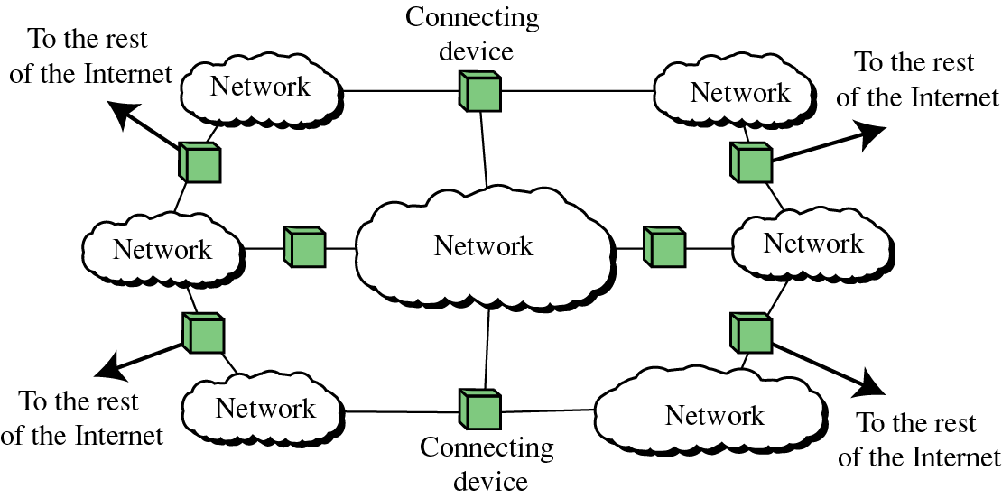

**THE WEB**

The World-Wide Web (W3) allows access to the universe of online information using simple user interface operations. It operates without regard to where information is, how it is stored, or what system is used to manage it.

This is the part of the internet that most users are familiar with, such that some users use the term Internet to mean web (i.e. Web, or WWW – World Wide Web) or vice versa, but this is not so as the internet also includes other services such as e-mail, newsgroups and file sharing. You can send e-mail or participate in a newsgroup without using the web.

The web usually displays information in a colorful and visually appealing format, and these can be placed on a single web page. Each page is much like the page of a magazine and a collection of pages interconnected together is referred to as a **website** and the connection between one web page and another is referred to as hyperlink (or usually referred as link).

**USES OF THE INTERNET**

**Communication:** the internet allows users from different locations to communicate with each other at a relatively inexpensive cost within the shortest time possible. E-mail is one of the most popular means of communicating on the internet. You can send an e-mail to anyone, anywhere so long as the person has an e-mail address and it will arrive almost immediately in the recipients e-mail inbox- even though the person is connected or not.

Another famous means of communication is the Instant Messaging (IM) or chatting as popularly referred, it allows you to have real time conversation with someone or a group of people. When you type and send the message, the other participants are able to view the message almost instantaneously, but unlike e-mail, the participants have to all be online, that is, they have to be connected to the internet and in front of their PCs.

Forums and Newsgroups allow you to participate in a text-based discussion (where you can share ideas, post questions or answers etc.) with other computer users who have the same areas of interest as you, the participants are usually referred to as a community.

**E-Commerce:** the web can be used to buy and sell several items whether new or used ones. The things sold can range from house hold wares, to cars, electronics etc.

**Information searching:** as said earlier, enormous amount of information is available on the internet which is far much more than the world’s largest library can contain. You can search for reference sources such as encyclopedia and dictionaries or historical documents and classic literature. But you should note that not all information sources on the web are reliable, some may be inaccurate, obsolete or incomplete. Always verify and check the source and information also.

**Entertainment:**  the web can be used to stream songs, videos or even play games online.

**File Sharing:** the web allows users to share files, images, songs. A user can upload such files and allow friends, family or other users to gain access by visiting the web site.

**5.0 WORD PROCESSING**

Word processing is the typing, editing, formatting/manipulation and printing of information that is mostly textual in nature using a computer and done under the control of a word processing package.

The primary processes involved are the initial preparation of the letters, memos or reports that are to be typed into the computer. The typed document is then edited, either to correct errors or to change the layout of the text (formatting). The draft of the document is then saved in the memory for future amendments, or printing out hard copies or sending as email attachments. The window (edit mode) of the word processor allows the user to type and see the corresponding key strokes. The cursor keeps changing position on the screen as the characters are been entered/typed. The movement of the cursor can be controlled by the arrow keys (as discussed in keyboard).

**SAVING A DOCUMENT**

Click on the Window icon on the left side

Hover down to Save as and select document format and click

Type in the preferred name in the dialog box and click save

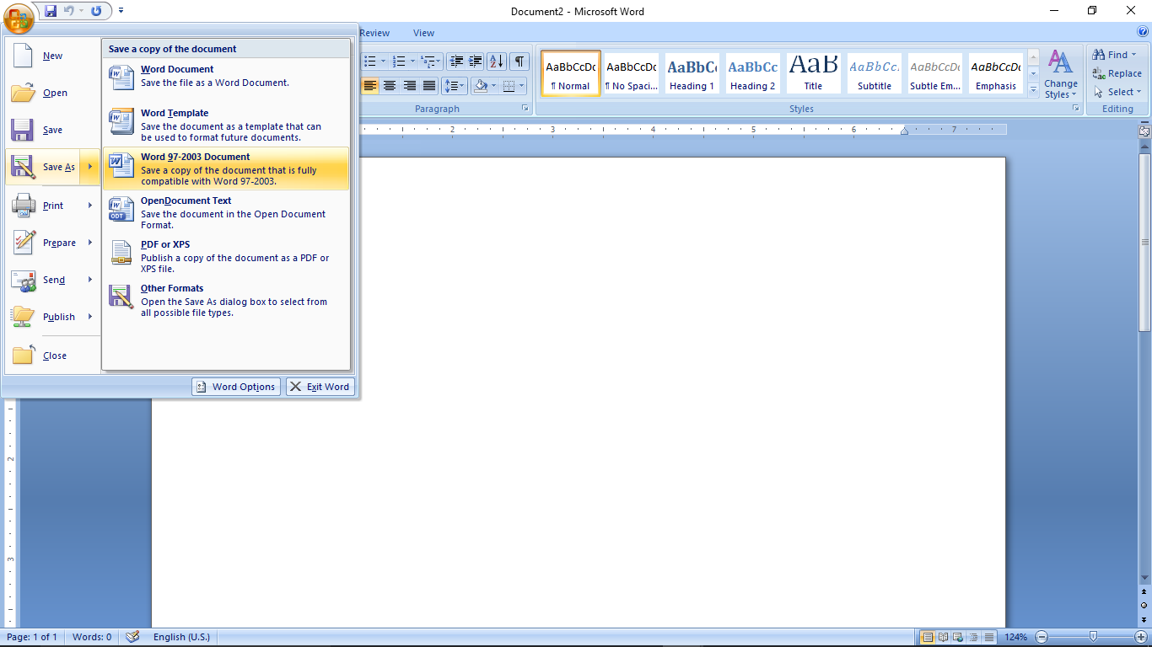

**Terminologies involved in Word Processing**

* **Cursor:** this a small vertical bar that blinks on the screen and it shows the exact location where a character pressed on the keyboard will appear.
* **Scrolling:** this is moving up/down or right/left on the word processing window so as to display data/information that is not within view
* **Editing:** this is the process of correcting words that were incorrectly typed. It could involve deletion of some characters, a word or even several lines.
* **Word wrap:** this is the process whereby the word processing software automatically shifts the insertion point (cursor) to the next line because the maximum number of characters allowed on the line has been reached.
* **Format:** this is the ability to adjust the appearance of some textual features of the document. It involves changing font, font size, bold, italic etc. (generally called character formatting) or to change paragraph alignment, paragraph spacing etc. (generally referred to as paragraph formatting).
* **WYSIWYG:** serves as an acronym for “What You See Is What You Get”, this means that almost or exactly what is displayed on the screen is what will be printed.

**Examples of Word Processing Packages**

Microsoft Word developed by Microsoft Corporation

Word Perfect developed by Corel Corporation

Word Pro by Lotus Corporation

Others include but not limited to Ability, MultiMate, Word Star, Stage PC Write, Side Kick, Supper Writer, Display Writer etc.

**6.0 SPREADSHEET**

A spreadsheet consists of cells arranged in rows and columns. Each cell can hold text, a number, or a mathematical formula. A cell is referred to by column and row, e.g., the upper left cell is cell **A1**. The cell right below that is **A2**, etc. Column width and row height can be adjusted by dragging the separation line between columns (or rows) to the desired size.

It sounds complicated, but it's not. Here is a typical blank spreadsheet grid:

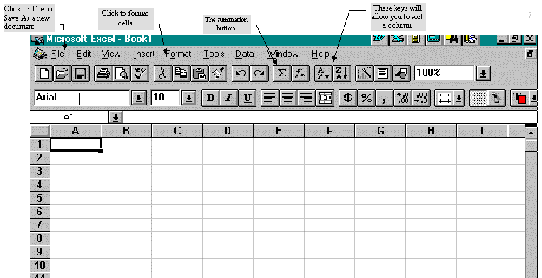

Basically, we can use this grid to add, subtract, multiply and divide numbers. We can do percentages. Columns or rows can be sorted alphabetically, or numerically. That makes a spreadsheet a powerful tool that will make your life easier whenever you must deal with large blocks of information or numbers.

If you have a large group of names, for example, a spreadsheet allows you to sort them or keep track of them. If you have a budget or financial data, the program can help you analyze the numbers.

**Entering data**

To keep things simple, we're going to look at a spreadsheet with just a few columns and rows. With Excel Version 7, you actually have 16,000 rows (labelled from 1, 2, 3…65536) and columns (labelled A, B, C …. IV).

To enter a number or other information, just click in a cell with your left mouse. Let's start in cell A3 with some data from the Roseland municipal budget:

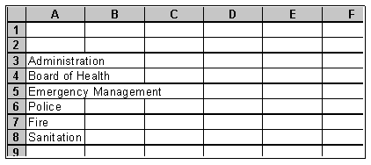

As you can see, the cell is not large enough to fit the words. But we can make the columns larger by moving the mouse to the line between columns.

You then click and hold on the line and drag it out to make it larger:

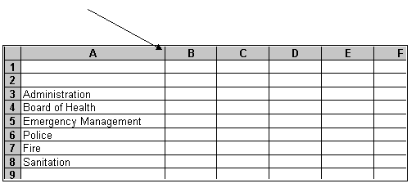

Now go to cell B3 and enter numbers the same way. Don't worry about putting in commas, percent signs or currency signs. We can format the whole column after we're finished:

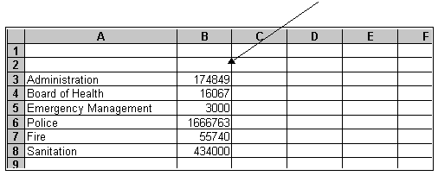

**Formatting Data**

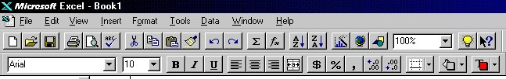 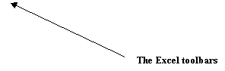

To format the column, click on the column header, which in this case is the grey square with a B at the top. Click in the square with your left mouse button and the entire column will be highlighted. Then go to the top of the tool bar and click on Format, then click on Cells in the submenu, and click on Number to format the numbers in the cells. Here, we will click on Currency within the numbers submenu to put dollar signs and commas in the appropriate places:

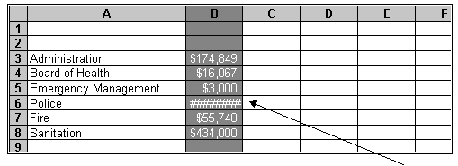

Once we do that, however, you see something has happened to the cells: You get a #### in some of the cells. That's the program's way of telling you the column isn't wide enough. To fix it, click and drag on the | between B and C like we did earlier, and widen the column again.

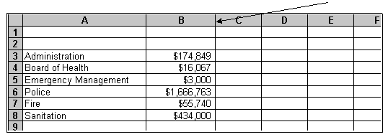

Now let's add another column of numbers, again by simply clicking in the cell and working down. We already have the 1997 budget figures. Let's enter the 1996 numbers as a comparison:

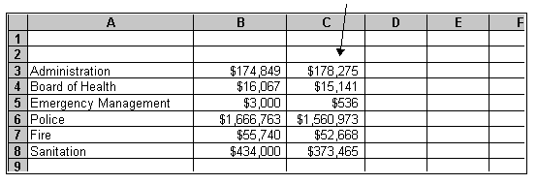

**Calculating Changes**

Here's where we put the program to work. If you wanted to, you could take a calculator and add up those columns yourself. You could then subtract the difference between the two years of figures in each column, and get an idea of where expenses are heading.

With Excel, the program will do it for you. Start by adding up each column. Click in cell B9. What we want to do is tell the program what numbers to add up. In Excel, we tell the computer we are about to enter a formula by starting with an = sign. Remember, every cell has a unique address. We want to add up cells B3, B4, and all the way to B8. We could do that by entering the formula **=B3+B4+B5+B6+B7+B8**. That will work, but it means entering a lot of numbers and the whole point of this program is to save us work. So we can tell the program to simply add up the column by entering **=SUM(B3:B8)** Another shortcut, and we love shortcuts, is to click on the bottom of the column and then click on the Sigma, or **Summation** sign in the top toolbar. That will enter the formula for you. Just make sure there isn't a data at the top of the column, or the date will be added to your total.

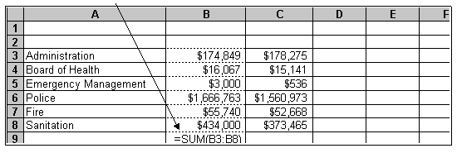

Do the same in both columns, and you get totals. Add the years to the top of the columns, to identify them. We can calculate the difference between the two years the same way by entering a formula in Column D. Click on D3. To subtract last year's Administration expenses from this year's, just enter the formula: =B3-C3.

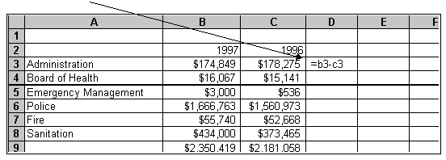

Once you enter the formula, you can repeat the formula for other rows without retyping it by clicking in the cell. You can copy the formula and the spreadsheet is smart enough to change the cell addresses automatically. To copy the formula in D3, click on the cell. Then look for the small square in the lower right corner of the cell border. This is called a **Fill Handle.** Click on the square and hold, and the drag it down through D9:

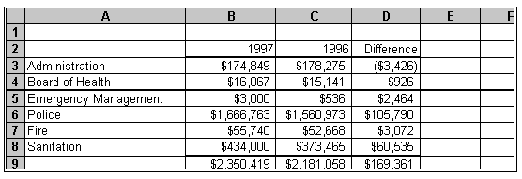

That tells us more than the town did when they gave us the budget, but let's look at it further. What is the percentage increase or decrease between the two years? Again, this is pretty simple to figure out. Enter a formula in the next column the same way. A percentage is a simple ratio. Here, we want to know the percentage increase, so the ratio would be the difference between the two years, over what the budget number had been. We've already calculated the difference in Column D. The budget figure for the previous year had been the number in Column C. The percentage, then, would be D3/C3. We format the box as a percentage, the same way we formatted earlier as currency.

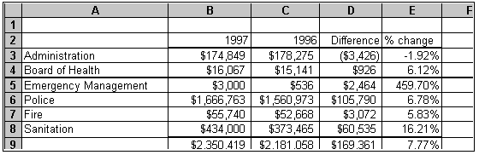

The next step is to pick out the area of greatest change. With a small spreadsheet like this example, it's pretty easy. But what if there were hundreds of numbers. Excel will handle that automatically with the sort function. To use it, highlight all the rows and columns you want sorted. Then click on Data in the top toolbar, and then Sort in the submenu. The program will prompt you, asking what column you want sorted, and whether it should be in ascending or descending order. Her, we will sort by Column D to find who got the biggest spending increase last year:

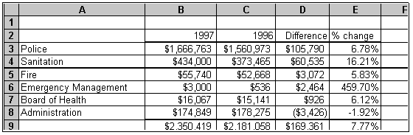

**7.0 PROTECTING AGAINST VIRUSES**

***Virus:* virus** is a program that performs one or more tasks that the user doesn’t  
expect. Some viruses are designed to do real harm, such as delete files, slow  
down network traffic, disable programs, or allow an unauthorized person to  
access the victim’s computer.

Most viruses are designed to hide themselves, avoiding detection by the victim  
for as long as possible. If a virus is copied to your computer, the machine is said  
to be “infected.” A virus can infect your computer in a number of ways. You might  
receive an infected disc from a friend. You might download an infected file from  
a Web site or receive it attached to an e-mail message. Most viruses can affect  
only the operating system in which they were written. However, they can spread  
from one computer to another. It is important that you always run antivirus  
software, such as Norton, on your computer.

**Trojan horse**

is a program that does something useful but at the same time, hidden from view, does something destructive. It can damage the system it enters, including erasing all the data on a hard drive. A Trojan horse might come in the form of a simple game. The victim plays the game; however, the program does something else in the background, such as opening a port on the computer. Someone can then use this port to  
access the computer through the Internet

**Worm**A computer virus commonly hidden inside another program.