FAKE NEWS DETECTION USING NLP(phase4)

# **Problem Statement:**

Begin building the fake news detection model by loading and preprocessing the dataset. Load the fake news data set and preprocess the textual data.

# **Data Cleaning:**



Data cleaning is a process of removing inconsistencies in the dataset and incorrect values .It also in involves handling missing values either by removing them or assigning them average values. It helps to improve the efficiency of the model.

* In the first step, we will only remove the unnecessary data points from The dataset which does not helps in improving the model performance.

Initially we import the necessary packages for our data cleaning process and also in the future purposes,

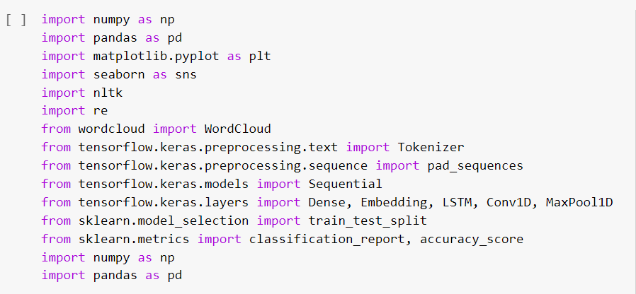

We use these packages invarious stages of our cleaning process and also in the future in which we need to build models.

Here , we read the .csv file so true and fake news and then explore the count value so their subjects

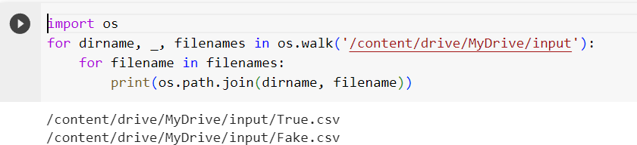

[]fake_news=pd.read_csv('/content/drive/MyDrive/input/Fake.csv')fake_news.head()

**title textsubject date**

**0** DonaldTrump Sends Out EmbarrassingNew Year'... DonaldTrumpjustcouldn t wishallAmericans... NewsDecember31,2017 DrunkBraggingTrumpStafferStartedRussian...HouseIntelligenceCommitteeChairmanDevinNu... NewsDecember31,2017

1. SheriffDavidClarkeBecomesAnInternetJoke... OnFriday,itwasrevealedthatformerMilwauk... NewsDecember30,2017
2. TrumpIsSoObsessedHeEvenHasObama'sName...OnChristmasday,DonaldTrumpannouncedthat... NewsDecember29,2017
3. PopeFrancisJustCalledOutDonaldTrumpDur...PopeFrancisusedhisannualChristmasDaymes... NewsDecember25,2017

[] fakenews.columns

Index(['title','text','subject','date'],dtype='object')

[]fake_news['subject'].value_counts()

|  |  |
| --- | --- |
| News | 9050 |
| politics | 6841 |
| left-news | 4459 |
| GovernmentNews | 1570 |
| USNews | 783 |
| Middle-east | 778 |

Name:subject,dtype:int64

plt.figure(figsize=(10,6)) sns.countplot(x='subject',data=fake_ne1 s)

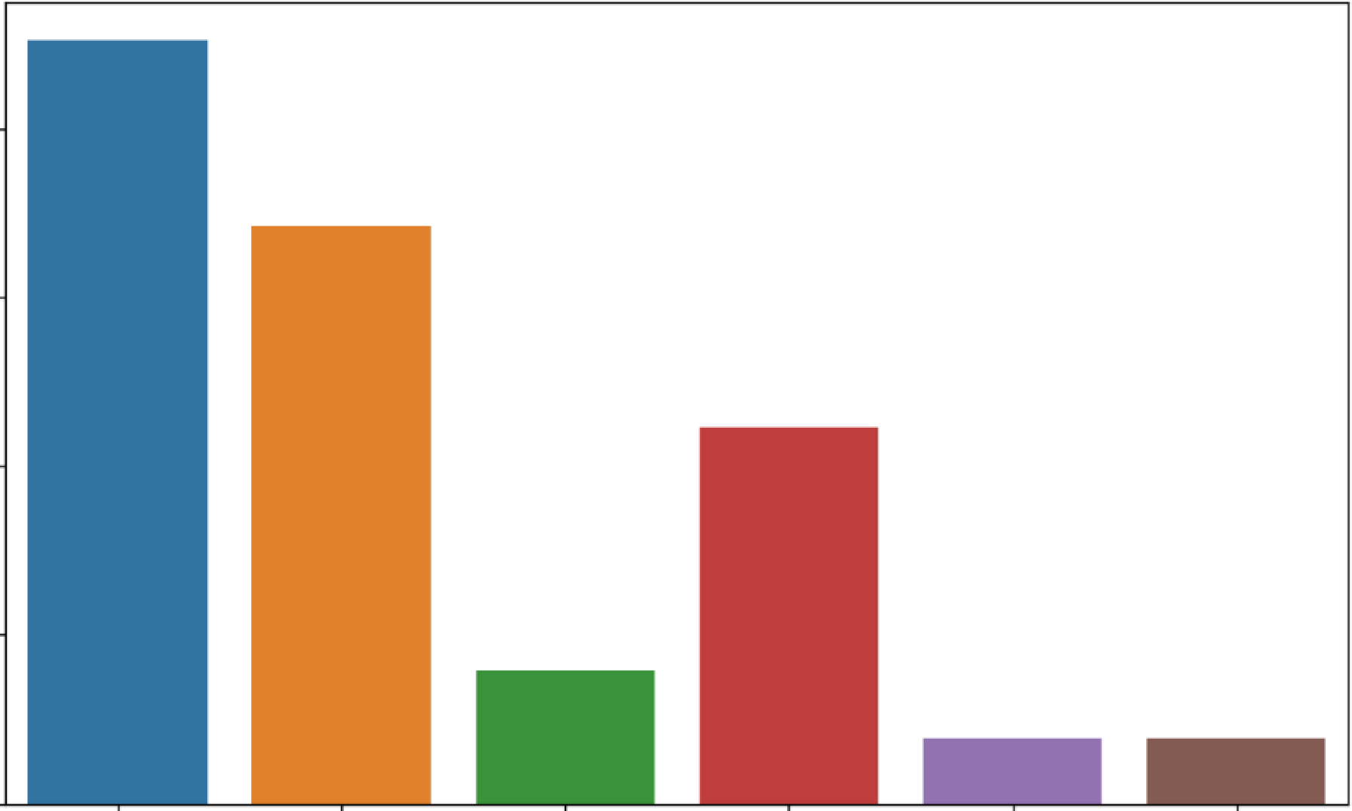<Axes:xlabel='subject',ylabel='count'>

**8000**

**6000**

......

:,

**4000**

**2000**

**0**

**News politics GovernmentNews left-news**

**subject**

**usNews Middle-east**

Here, we have used word cloud to see that which word has mostly used for the fake news. By seeing that we can make a conclusion that which topic(about a person, event or anything) is mostly contains fake news).We also do the same for true news.

# **Word Cloud for Fake News:**

**Word cloud for True News:**

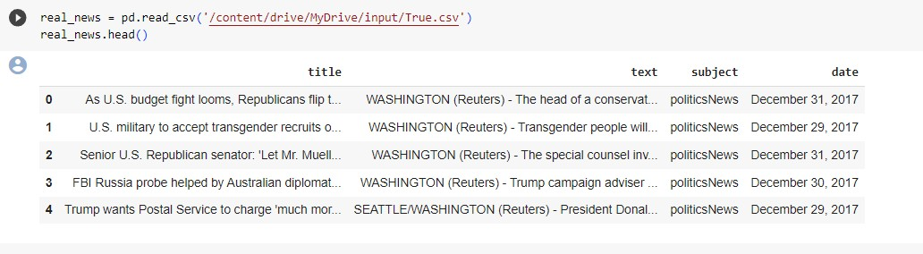

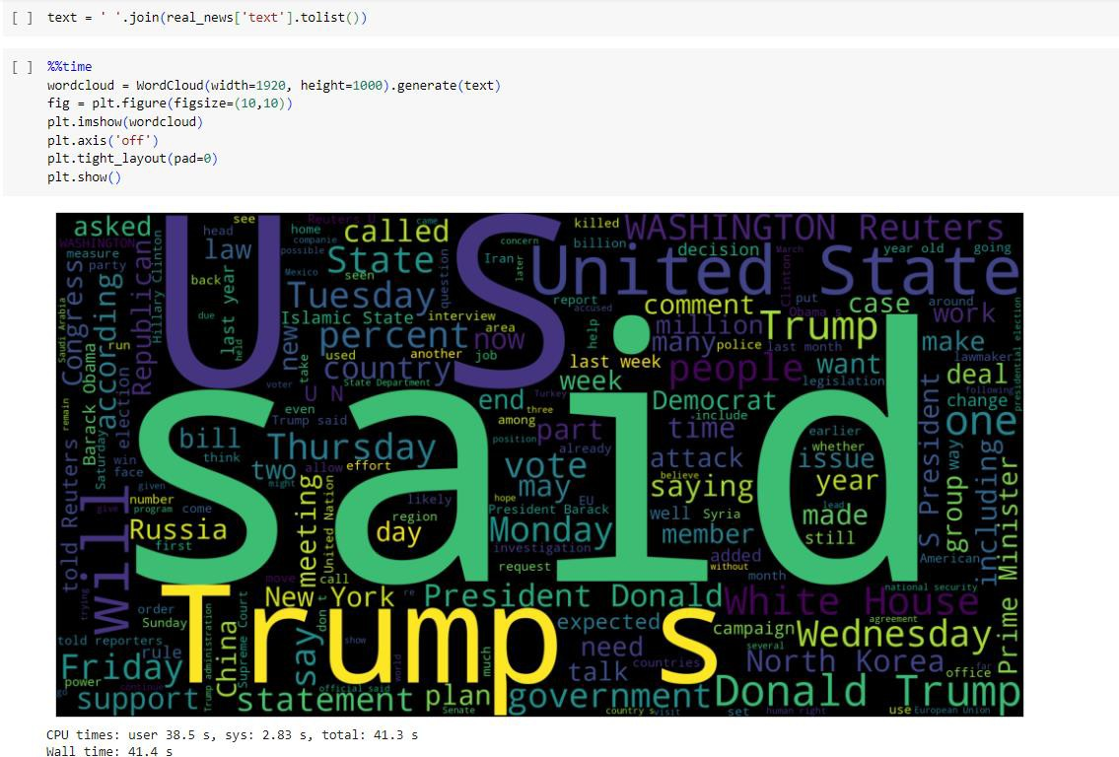

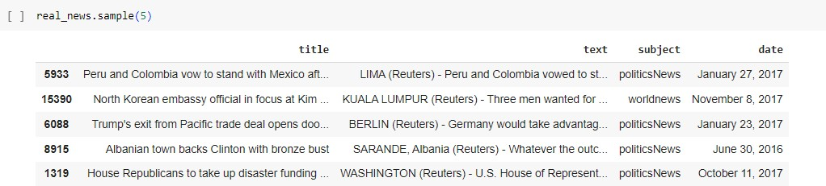

Let’s create a list of news lists in real_news.csv with unknown publishers by using the following code snippets

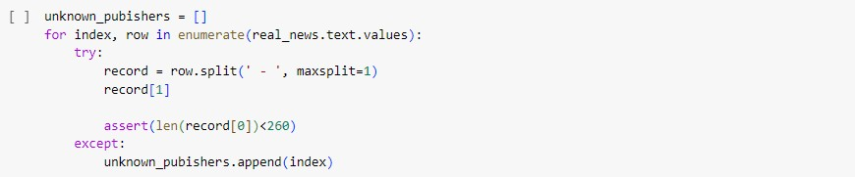

[] len(unknrn..in_pubishers)

35

real_news.iloc[unknown_pubishers].t:ext

|  |  |  |  |  |  |  |  |
| --- | --- | --- | --- | --- | --- | --- | --- |
| 2922 | Thefollmdingstatementswerepostedtotheve... | | | | | | |
| 3488 | Thel•lhit:eHouseoril,lednesdaydis,closedagroup... | | | | | | |
| 3782 | Thefollmingstatementswerepostedtotheve... | | | | | | |
| 4358 | NeilGorsuch,Pr.esidentDonaldTrump'sappoint... | | | | | | |
| 4465 | l•IASHINGTQNTheclockbeganrunningoutthiswe... | | | | | | |
| 5290 | The | follmding | statementswere | posted | to | the | ve... |
| 5379 | The | follmding | statementswere | posted | to | the | ve... |
| 5412 | The | follming | statementswere | posted | to | the | ve... |
| 5504 | The | follmding | statementswere | posted | to | the | ve... |
| 5538 | The | follmding | statementswere | posted | to | the | ve... |
| 5588 | The | follmding | statementswere | posted | to | the | ve... |
| 5593 | The | follmding | statementswere | posted | to | the | ve... |

5761 Thefollowingbulletpoints arefromtheU.S.5784 Federalappeals rnurtjudgeNeilGorsuch,the 6026 ThefollowingbulletpointsarefromtheU.S.

61.84 Thefo1lmdingbulletpointsarefromtheU.S.6660 RepublicanmembersofCongr.essar<ecomplaining... 6823 OverthecourseoftheU.S.presidential,campa... 7922 AftergoingthroughaweekreminiscentofNapo... 8194) Thefollmdingtimelinechartstheoriginands...

81.95 Globalhealthofficialsareracingtobetteru... 8247 lJ.,S.,Pr.esidentBarackObamavisitedastreetm... 8465 ALGONAC,rincH.-Parlk:erFox driftedout:oftheD.. . 8481 Globalhealthofficialsareracingtobetteru... 8482 Thefo1lmdingtimelinechartstheoriginands... 8505 Globalhealthofficialsareracingtobetteru... 8506 Thefo1lmdingtimeline chartstheoriginands... 8771 Inaspeech1,1eightedi,ithAmericaJscomplicate.. . 8970

9008

9009

9307

9618

9737

10479

Name:

Thefo1lmdingtimelinechartstheoriginands... Globalhealthofficialsareracingtobetteru... It'sthenearfuture,andNorthKor<ea''sre,gime... GOPleadershaveunleasheda stunninglevelof.. . CaitlynJennerpostedavideoonl•lednesday(Ap... TheDemocraticandRepublicannomineesforthe...

text,dtype:object

publisher=[]

tmp_text=[]

forindex,roviinenumerate(real_nev1s.te·xt.values):

ifindexinunkno in_pubishe•rs: tmp_text.append(rrn,1) publi.sher.append{'l!Jnkno1 n')

else:

record=row.split('-',maxsplit=1) publisher.append(record[0].strip()) tmp_text.append(record[l].strip())

[]re•al_news['publisher·]=publishe•r real_news[ 'text']=tmp_text

[]real_ne1s.headO

[Ireal_news.head()

title

*text*

subject date publisher

AsU.S.budgetfigMlooms.Republicansfiipt..

U.S.militarytoaccepttransgenderrecruitso...SeniorU.S.Republicansenator:'LetMr.Muell...

TheheadofaconservativeRepublicanfaction.politicsNewsDecember31,2017Tr:ansgenderpeople will beallowed for thefir...politicsNewsDecember29, 2017Thespecialcounselinvestigationoflinksbet..politicsNewsDecember31,2017

WASHINGTON(Reuters)WASHINGTON(Reuters)WASHINGTON(Reuters)

1. FBIRussiaprobehelpedbyAustraliandiplomat...TrumpcampaignadviserGeorgePapadopoulostol..politicsNewsDecember30,2017 WASHINGTON(Reuters)
2. Trumpwants PostalServicetocharge'muchmor... PresidentDonaldTrumpcalledontheu.sPost..politicsNewsDecember29,2017SEATTLE/WASHINGTON(Reuters)

[]real_news.shape

(21417,5)

[]ernpty_fake_index[indexforindex,textinenumerate(fake_nei,,Js.text.tolist())ifstr(text).strip{)==""]

[]fake_news.iloc[empty_fake_index]

titletextsubject date

|  |  |  |  |
| --- | --- | --- | --- |
| **10923** | TAKEOURPOLLWhoDoYouThinkPresidentTrum... | politics | May10,2017 |
| **11041** | JoeScartJoroughBERATESMikaBrzezinskiOver· | politics | Apr26,2017 |
| **11190** | WATCHTUCKERCARLSONScorchSanctuaryCityMay... | politics | Apr6,2017 |
| **11225** | MAYOROFSANCTUARYCITY:TrumpTryingToMake.. | politics | Apr2,2017 |
| **11236** | SHOCKERPublicSchoolTurnsComputerLabInto... | polillcs | Apr**1,**2017 |
| **21816** | BALTIMOREBURNS:MARYLANDGOVERNORBRINGS**INN..** | left-news | **Apr**27,2015 |
| **21826** | FULLVIDEO:THEBLOCKBUSTERINVESTIGATIONINTO... | left-news | **Apr**25,2015 |
| **21827** | (VIDEO)HILLARYCLINTONRELIGIOUSBELIEFSMUS | left-news | **Apr**25,2015 |
| **21857** | (VIDEO)ICEPROTECTINGOBAMAWON'TRELEASENAM... | left-news | **Apr**14,2015 |
| **21873** | (VIDEO)HYSTERICALSNLTAKEONHILLARY'SANNOU... | left-news | **Apr**12,2015 |

630rowsx4columns

{]real_news['text']=real_news['title']+""+real_news['text')[]fake_news['text']..fake_news['title']+""+fake_news['text']

[]real_news('text']=real_nei,s('text'].apply(lambdax:str(x).lower())fake_news('text']=fake_nei,s('text'].apply(lambdax:str(x).lower())

[]real_news['class']=1fake_news['class']=0

[]real_news.columns

Index(['title','text','subject','date','publisher','class'],dtype-'object')

0real= real_ne\s[['text','class']]fake=fake_ne\s[['text','class']]

0data= real.append(fake,ignore_index=True)data.head()

e <ipython-input-33-8770c2a2a545>:1:FutureNarning:Theframe.appendmethodisdeprecatedandwillberemovedfrompandasinafutureversion.Usepandas.concatinstead.data=real.append(fake,ignore_index=True)

textclass

**o** asu.s.budgetfightlooms.republicansmpt...

u.smilitarytoaccepttransgenderrecruitso

senioru.s.republicansenator'letmr.muell...

-3 fbirussiaprobehelpedbyaustraliandip{omat...

**4**trumpwantspostalselVicetocharge'muchmor...

0!pipinstallspacy==2.2.3

!python-mspacydownloaden_core_web_sm

!pipinstallbeautifulsoup4==4.9.1!

!pipinstalltextblob==B.15.3

!pipinstallgitthttps://github.co111/laxmi11erit/preprocesskgptalkie.git--upgrade--force-reinstall

enote:Thiserrororiginatesfromasubprocess,andislikelynotaproblemwithpip.

2.023-10-1616:41:23-.058566:\tensorflow/compiler/tf2tensorrt/utils/py_utils.cc:38]TF-TRTWarning:Couldnotfind TensorRT

Collectingen-core-web-sm==3.6.0

Downloadingntlithub.com/exRlosion/sRacy-models/releases/dowriload/encorewebsm-3.6.0/encoreiebsm-3.6.9-py?.-none-anY..J'ihl(12.8HB)

12.8/12.8MB21.61B/seta0:00:00

Requirementalreadysatisfied:spacy<3.7.0,>..3.6.0in/usr/local/lib/python3.10/dist-pdckages(fromen-core-web-sm....3.6.0)(3.6.1)

Requirement.already satisfied:spacy-legacyG.1.0,>=3.0.11 in /usr/local/lib/python3.10/dist-p.ackages(fromspacy<3.7.0,>=3.6.0->en-core-web-sm==3.6.0)(3.0.12)RequirementcJlready scJtisfied:spacy-loggers<2.0.0,>•1.0.0 in /usr/local/lib/python3.10/dist-packages(fromspacy<3.7.0,)..3.6.0->en-core-web-sm,...3.6.0)(1.0.5)Requirementdlready scJtisfied:murmurhash<l.1.0,)..0.28.0in/usr/local/lib/python3.10/dist-packages(fromspdcy<3.7.0, )..3.6.0->en-core-web-sm..,.3.6.0)(1.0.10)

Requirement.alreadys.atisfied:cymem<2 .1.0,>..2.0.2in/usr/local/lib/python3.10/dist-p.ackages(fromspacy<3.7.0,>..3.6.0->en-core-web-sm...3.6.0)(2.0.8}

Requirement.alreadysatisfied:preshed<3.1.0,>=3.0.2in/usr/local/lib/python3.10/dist-packages(fromspacy<3.7.0,>=3.6.0->en-core-web-sra==3.6.0)(3.0.9)

Requirement.alreadysatisfied:thinc<8.2.0,>=8.1.8in/usr/local/lib/python3.le/dist-p.ackages{fromspacy<3.7.0,>=3.6.0->en-core-web-s111==3.6.0)(8.1.12)

Requirement.alreadysatisfied:wasabi<l.2..0,>=0.9.1in/usr/local/lib/python3.10/dist-packages(fromspacy<3.7.0,>=3.6.0->en-core-web-sm==3.6.0){1.1.2)

Requirement.alreadys.atisfied:srslyo.e.0,>=2.4.3in/usr/local/lib/python3.10/dist-packages{fromspacy<3.7.0,>=3.6.0->en-core-web-sm==3.6.0)(2.4.8)

Requirement.alreadys.atisfied:catalogue<2.1.0,>=2.0.6in/usr/local/lib/python3.10/dist-packages{fromspacy<3.7.0,*>=3.*6.0->en-core-web-sm==3.6.0)(2.0.10)

Requirementalready satisfied:typer<0.10.0,>..0.3.0in /usr/local/lib/python3.10/dist-packages(fromspacy<3.7.0,>•3.6.0->en-core-web-sm....3.6.0)(0.9.0)RequirementcJlready scJtisfied:pathy>..0.10.0in/usr/local/lib/python3.10/dist-packages(fromspacy<3.7.0, >..3.6.0->en-core-web-sm 3.6.0) {9.10.2)

RequirementcJlready scJtisfied:smart-open<7.0.0,>..5.2.1 in /usr/local/lib/python3.19/dist-packages(fromspacy<3.7.0,>•3.6.0->en-core-web-sm.,..J_6.0)(6.4.0)Requirement.already satisfied:tqdm<5.0.0,*>=4.*38.0in/usr/local/lib/python3.10/dist-p.ackages(fromspacy<3.7.0,>=3.6.0->en-core-web-s111==3.6.0)(4.66.1)Requirement.already satisfied:numpy>=l.15.0in/usr/local/lib/python3.10/dist-packages(fromspacy<3.7.8,>=3.6.0->en-core-web-sm==3.6.8){1.23.5)Requirement.alreadysatisfied:requestsG.8.0,>=2.13.0in/usr/local/lib/python3.18/dist-packages(fromspacy<3.7.0,*>=3.*6.8->en-core-web-sm==3.6.0)(2.31.0)

Requirement.alreadysatisfied:pydantic!=1.8,!=1.8.1,<3.0.0,*>=1.*7.4in/usr/local/lib/python3.10/dist-packages(fromspacy<3.7.0,>=3.6.0->en-core-web-sm==3.6.0)(1.10.13)

Requirement.alreadys.atisfied:jinja2in/usr/local/lib/python3.10/dist-packages{fromspacyo.7.0,>=3.6.0->en-core-web-sm==3.6.0)(3.1.2)

Requirement.alreadys.atisfied:setuptoolsin/usr/local/lib/python3.10/dist-packages{fromspacy<3.7.0,>=3.6.0->en-core-web-sm==3.6.0)(67.7.2)

Requirementalreadysatisfied:packaging>..20.0in/usr/local/lib/python3.19/dist-packages(fromspacy<3.7.0,>•3.6.9->en-core-web-sm.,,.J.6.0)(23.2)

RequirementcJlreadyscJtisfied:langcodes<4.0.0,)..3.2.0in/usr/local/lib/python3.18/dist-packages{fromspacy<3.7.e,)..3.6.0->en-core-web-sm....3.6.0)(3.3.0)

RequirementcJlreadyscJtisfied:typing-extensions>..4.2.0in /usr/Jocal/lib/python3.19/dist-packages(frompydcJntic!-1.8,!..1.s.1,<3.0.0,>"1.7.4->spacy<3.7.0,)..3.6.9->en-core-web-sm....3.6.0)(4.5.9)Requirement.already satisfied:charset-norm.alizer<4,>=2 in /usr/local/lib/python3.10/dist-pack.ages(fromrequests<3.0.0,>=2.13.0->spacy<3.7.0,>=3.6.0->en-core-web-sm==3.6.0)(3.3.0)

Requirement.already satisfied:idna<4,>=2.5in/usr/loc.al/lib/python3.10/dist-packages(fromrequestsG.8.0,>=2.13.0->spacyG.7.0,>=3.6.0->en-core-web-sm==3.6.0)(3.4)Requirement.already satisfied:urllib3<3,>=1.21.1in/usr/local/lib/python3.10/dist-packages(fromrequests<3.0.0,>=2.13.0->spacy<3.7.0,>=3.6.0->en-core-web-sm==3.6.0) {2.0.6)

Requirement.already s.atisfied:certifi>=2.017.4.17 in /usr/local/lib/python3.10/dist-packages(fromrequests<3.0.0,>=2.13.0->spacy<3.7.0, >=3.6.0->en-core-web-sm==3.6.0)(2023.7.22)Requirement.alreadys.atisfied:blis<0.8.0,>=0.7.8in/usr/local/lib/python3.10/dist-packages(fromthinc<8.2.0,>=8.1.8->spacyo.7.0,>=3.6.0->en-core-web-sm==3.6.e)(0.7.11)

Requirement.already s.atisfied:confection<!.0.0,>=0.0.1in /usr/local/lib/python3.10/dist-packages(fromthinc<8.2.0,>=8.1.8->spacy<3.7.0,>=3.6.0->en-core-web-sm==3.6.0)(0.1.3)RequirementcJlready scJtisfied:click<9.e.0,*>..]*.1.1 in/usr/local/lib/python3.10/dist-pdckages(fromtyper<0.10.0,)•0.3.0->spacy<3.7.0,>"3.6.0->en-core-web-sm....3.6.0)(8.1.7)RequirementcJlready scJtisfied:HarkupSafe>..2.0in /usr/local/lib/python3.10/dist-packages(from jinja2->spacy<3.7.e,)..3.6.0->en-core-web-sm....3.6.0)(2.1.3}

[]importpreprocess_kgptalkieasps

[]data['text') data['text'].apply(lambdax:ps.re,move_special_chars**(x))**

[]fr<Jmgooglae.colabimportdrivedrive.mount('/conte,nt/drive')

Drivealreadymountedat/content/drive;toattempttoforciblyreioount,calldf'ive.mountC/content/drive'",force_re11ount•True).

0irrportgaenim

[]y-data["class·].values

[]X-[d.s?lit()for*d*indata["text'].tolist()]

[]type(X)list

I]type(X(0])list

[]print(X[0))

['as',·us',"budget','fight",'lOMs','republicans",'flip','their',"fiscal',·script',"the','head','of",'a','conservative',"republican','faction','in','the',"us','congress','who",'voted','this',"month','for',·a·,'hl

[]DIMa 100

w2v_model*=*gensim.madels.l•/ord2Vec(sentences=X,vector_size=DIM,windm,=10,min_count=l)

[lw2v_model.N['india']

|  |  |  |  |  |
| --- | --- | --- | --- | --- |
| array([1.717186 | 0.09980671, | -0.54519814, | 2.873516 | 1.1529748, |
| -1.612415 | -0.4013639, | 1.5510874 | -1.9637966, | 1.7516707, |
| 2.3293521 | 1.0115958, | -1.7413545, | 2.1367438, | 0.30087247, |
| 2.0449893 | 0.7790712, | 3.5431712, | -3.6178732, | -2.512199 |
| 1.1306514 | 1.4577612, | 1.4371244, | -2.7274785, | 0.8482319, |
| -0.56985384, | 0.39158794, | -0.17285-948, | -1.384397 | -0.29015785, |
| 3.9670284, | -0.66227573, | -0.49190876, | 1.5287828, | -0.3802559, |
| 4.286491 | -1.8598944, | 0.12558945, | 2.3769717, | 2.274344 |
| -0.06563634, | -2.254771 | 2.0082936, | -0.8159753, | -2.254789 |
| -0.83319783, | 1.6255909, | 0.84546375, | -2.1749024, | -0.4050095, |
| -0.20788828, | 1.3658859, | 3.4065766 | -0.53475 | 0.80121416, |
| 0.32413623, | 1.7693163, | 0.5977933 | 0.2685584, | -1.3846186, |
| 0.9586846, | 1.2754706, | -2.076492 | 0.3734416, | 1.1651148, |
| 2.8482974, | 0.03156389, | 0.2842725, | 2.050075 | 0.03186256, |
| -0.09902999, | -3.034646 | 1.9252772, | 1.1805288, | 2.0976923, |
| 0.19032483, | -0.4042304, | 0.23345727, | 0.96000504, | -1.2318734, |
| -0.84461105, | 1.195374 | -0.26830855, | -0.28300276, | 1.791177 |
| -1.8392042, | 0.61264 | 0.73491406, | -1.7531322, | 1.2770014, |
| 3.557539 | 2.2037764, | -0.4719132 | 1.6767381, | 2_088745 |
| 0.7665555,  dtype=float32) | 0.39926797, | -2.281819 | -1.1530005, | 1.840919], |

[]1a2v_rnodel.,iv.rnost_similar('india')

[(•pakistan·,0.7414124011993408),

('malaysia·,0.6891069412231445),

('china',0.6626362204551697),

(•australia·,0.645916759967804),

(•beijings·,0.6376063227653503),

(•non,ray·,0.6274385452278508),

(·japan·,0.611946702003479),

(•controlchina·,0.6110749244689941),

(•indian·,0.6049240827568425),

(•indias·,0.5988717079162598)]

[I1,12v_model.,iv.most_similar('china')[('beijing·,0.8647976517677307),

('tai"an',0.8008958101272583),

(·chinas·,0.7648460268974304),

('pyongyang',0.6972832679748535),

('chinese·,0.6958582401275635),

('india',0.6626362204551697),

(·japan·,0.6597095131874084),

('beijings·,0.6444934010505676),

('xi·,0.6359792947769165),

('1<ater"ay',0.6162828803862439)]

[]**w2v_model.i,,N.most_similar('usa')**

[('mcculloughthis·,0.5617169141769409),

('1<irecom·,0.5184991955757141),

(•nl2nlgc0i1·,0.510539718521698),

('pacsharyl',0.4913540482521057),

(•pict1<ittercomsfe6zfdoli·,0.48563042283058167),( 'orgs ·,0.4720892906188965),

(•pict1<ittercomzkutv76j11·,0.4677456021308899),

('biz',0.4658149182796478),

('flopped',0.4636586606502533),

(·gospel·,0.4619619846343994)]

[]w2v_model.,iv.most_similar('gandhi·)[('rahul',0.7698065638542175),

(•75yearold·,0.6625608801841736),('cristina',0.6558746099472046),

('oza"a',0.6513022184371948),

('tounes',0.641105592250824),

('sobotka',0.6337205171585083),

('grillo',0.6289705038070679),

('loyalist·,0.6274853944778442),

('mediashy',0.6266793012619019),

(•pastrana·,0.6204155683517456)]

[]tokenizer=Tokenizer()tokenizer.fit_on_texts(X)

[]**X** tokenizer.texts_to_sequences(X)

**0** plt.hist([len(x)forxinX],bins=700)plt.show()

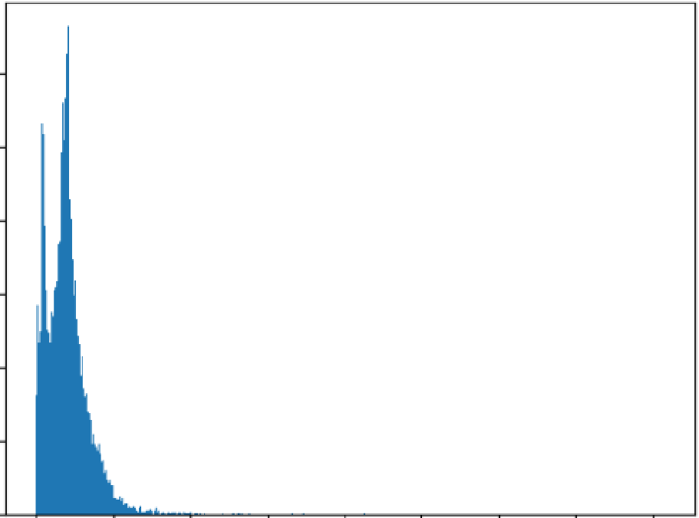**e**

|  |  |  |  |  |
| --- | --- | --- | --- | --- |
| ***uoo*** |  | | | |
| **1000** |  |  |  |  |
| **800** |  |  |  |  |
| **600** |  |  |  |  |
| 400 |  |  |  |  |
| 200 |  |  |  |  |
| 0 | 0 | 100020003000 4000 | 5000 | 600070008000 |

[]nos "np.array([len(x)forxinX])len(nos[nos>1000])

1580

[]maxlen•1000

X=pad_sequences(X,maxlen=rnaxlen)

[]len(X[101])1000

(]vocab_size=len(tokenizer.word_index)+lvoeab=tokeni zer .1,ror-d_index

[]defget_weight_matrix(rnodel)::

weight_matrix=np.zeros{(vocab_size,DIM))

for1tJOrdiinvocab.items{):1,,1eight_matrix[i]=model.i..N{word}

returnweight_matrix

(]embedding_vectors=get_weight_111atrix(w2v_model)

[]embedding_vectors.shape(231850,100)

[]model=Sequential()

mode1.add(Embedding{vocab_size,output_dim=DIM,,eights=[embedding_vectors],input_length=maxlen,trainable=False))model.add(LSTM(units,.128))

model.add(Dense(1,activation'"''sigmoid'))

mode1.compile(optirnizer=•adam',loss=·binary_crossentropy',metrics=['ace'])

[]modelsummary()

|  |  |  |
| --- | --- | --- |
| Model:"sequential" |  | |
| Layer(type) | OutputShape | Param # |
| embedding(Embedding) | (None,1000,100) | 23185000 |
| lstm(LSTM) | (None,128) | 117248 |
| dense(Dense) | (None,1) | 129 |

Totalparams:23302377{88.89MB)

Trainableparams:117377(458.50KB)

Non-trainableparams:23185000(88.44MB)

[]:X_train,:X_test,y_train,y_test..train_test_s.plit(X,y)

0model.fit(X_train,y_train,validation_split•0.2,epochs=-1)

842/842[..............................................]-42s41ms/steploss:0.1594-ace:0.9393val_loss:0.0484-val_acc:0.9841

<keras.src.callbacks.Historyat0x7afc6234f5e0>

[]y_predO(model.predict(X_test)*>"*0.5).astype(int)351/351[ ]-8s23ms/step

[]accuracy_score(y_test,y_pred)

0.9824498886414254

[]print(f"accuracy_score:{accuracy_score(y_test,y_pred).round(**4)**•100}%")accuracy_score:98.24000000000001%

**0** print(classification_report(y_test,y_pred))

**e**

|  |  |  |  |  |
| --- | --- | --- | --- | --- |
|  | precision | recall | fl-score | support |
| 0 | 0.99 | 0.98 | 0.98 | 5966 |
| **1** | 0.97 | 0.99 | 0.98 | 5259 |
| accuracy |  |  | 0.98 | 11225 |
| macroavg | 0.98 | 0.98 | 0.98 | 11225 |
| weightedavg | 0.98 | 0.98 | 0.98 | 11225 |

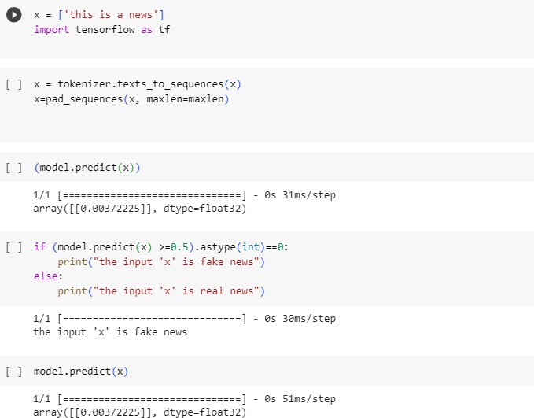

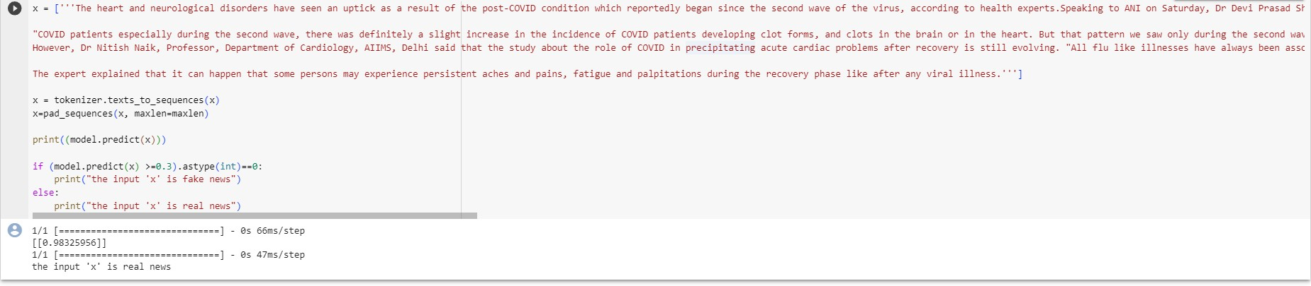

# **Conclusion:**

In conclusion utilizing Natural Language Processing(NLP) techniques for fake news detection has proven to be a significant advancement in combating misinformation. The model developed demonstrates the potential of machine learning in identifying deceptive content, contributing to the on going efforts to maintain the integrity of information on line .By leveraging NLP algorithms, the accuracy and efficiency of fake news detection have been greatly enhanced, empowering users to make in formed decisions and fostering a more reliable digitalin formation ecosystem.

THANK YOU